On the Unrest in Iran: Does it have revolutionary potential?
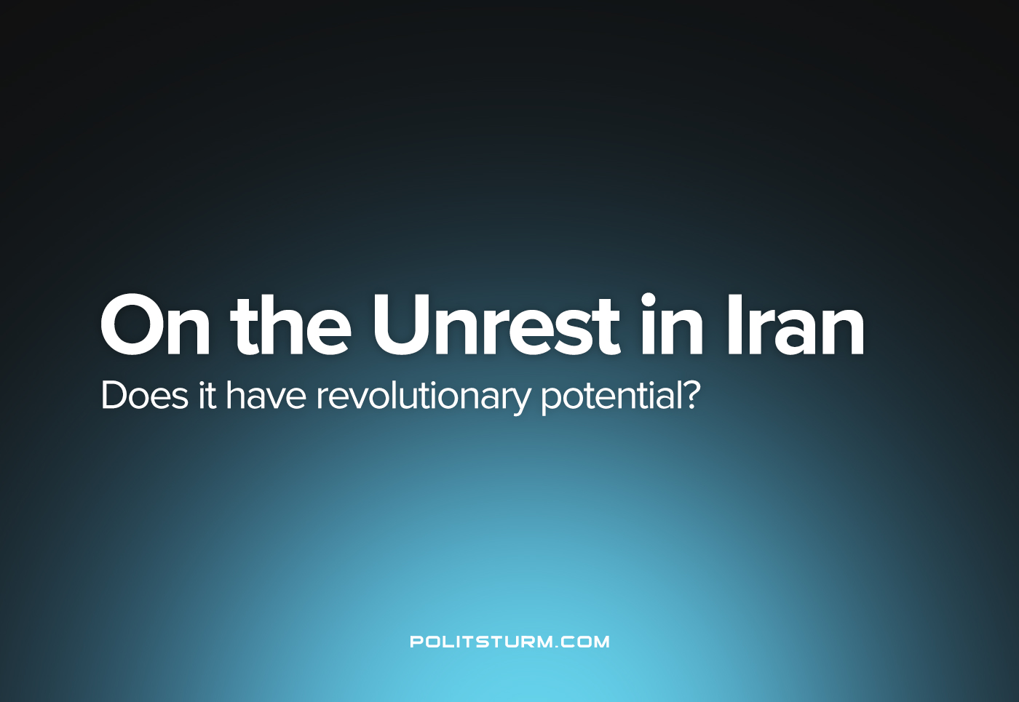

Original article
2022-10-12
9 min read

On the 14th of September 2022, a young Kurdish Iranian woman, Mahsa Amini, was rushed to hospital for emergency treatment of reportedly severe head trauma. The morality police in Tehran had arrested her a few days earlier for violating the religious laws of the country by the improper wearing of a headscarf. Official Iranian sources insist upon the narrative of her ‘pre-existing conditions’, citing a number of doctors who blame her death on a heart attack, as well as a childhood brain surgery, while police deny that she had been injured or subjected to torture in custody. After two days in a coma, Amini passed away, giving her name to over three weeks of intermittent protests throughout Iran.
Since September 16th, hundreds of protesters have been killed in the Islamic Republic as street protests have rocked the country for the past three weeks, many in open opposition to the sitting government. The facts of Amini’s death have quickly become irrelevant amid the widening fight against police violence, the repressive laws against women, and the disastrous trend in economic conditions. To understand the situation, one must see these protests as the latest in a series going back at least to 2017, followed by a wave of strikes until 2019, and again in 2021 with workers protesting price hikes exacerbated by sanctions and the pandemic. It is clear that the ruling Iranian capitalists and clergy are facing a drawn-out crisis, and the protests over the previous month have not been limited to a particular issue. They are manifestations of a building trend, which produced protest demonstrations from workers to students to farmers by the tens of thousands. To reveal the essential character of events in Iran, it is necessary to analyse the situation scientifically from many different angles: only then can the correct attitudes and policies be formulated to aid the progressive struggle by Iranians against Iran’s bourgeoisie which seeks to keep itself afloat on the old wave of reaction.
Error loading image
Strike supporters and police, 2022.
Western propaganda has been quick to portray these protests as a feminist movement violently suppressed by the ultra-conservative ruling class. The truth is that the oppression of women in Iran is particularly acute in comparison to other capitalist nations of its level of education and development. Women are routinely harassed by men, they make on average 18% less than their male counterparts in wages despite increasing numbers of Iranian women in higher education compared to men. In addition, certain professions are formally or informally barred to women, effectively segregating certain industries (most notably the oil sector). Women are harangued by the “morality police” which are tasked with enforcing the conservative social policies of the theocratic republic: laws related to the veil, laws on where women are allowed to be, and with who, etc.
Error loading image
Students at Tehran University holding a vigil for Jina (Mahsa) Amini
The question of women’s liberation is of particular importance to Marxists. In recent times, coming out of decades of the dominance of bourgeois reaction, some trends in the Left movement have begun to dismiss feminism as bourgeois or to claim that Marxism is inherently feminist and therefore there needs not be any particular attention paid towards the subordination of women in modern society. Whilst it may be true that Marxism never ignored the plight of women, the dismissal of the analysis and theoretical focus on the female question is a gross opportunism which only goes to rupture the proletarian movement as a whole, to sever it from the women’s movement in particular, and from the internal progressive developments by Iranians. This inevitably is a major setback in the struggle against capital as it dilutes the involvement of half of the population from the united struggle and makes the triumph of the proletariat all but impossible.
Thus it is of paramount importance that correct, scientific analysis be made on the situation of women in Iran, as the threats to women in general. The Bolsheviks, being staunch and principled Marxists, knew this and laboured intensely to draw women into the revolutionary movement. Some of the most celebrated of all revolutionaries in the proletarian movement have been women: the daughters of Marx (Eleanor, Caroline and Laura); Rosa Luxemburg; Clara Zetkin; Nadezhda Krupskaya; Dolores Ibarruru, and many others. Opportunists inevitably seek to disrupt this principled position of unity within the working-class and thereby sow confusion, doubt and discord by denying and distorting this alliance. Since this year’s protests erupted, opportunists who anyway distort Marx, Engels and Lenin have openly demonstrated their chauvinism by decrying those that support the protests in Iran as agents of American imperialism. They state falsely that because Iran opposes US-allied activity, and is allied with Russia and China in the goal to create a “multi-polar” world, this means they are true anti-imperialists and that the Iranian ruling-class must be supported despite its open chauvinism and its suppression of the Iranian worker’s movement: they state that to attack the Iranian bourgeoisie and clergy for their reactionary policies is “Western chauvinism”! Such policies stymy proletarian international unity and simply defend the forces of reaction from their own citizens. In a world totally dominated by the bourgeoisie, we as Communists cannot stand to oppose protest anytime it appears outside America’s sphere of influence.
Error loading image
Farmers rally in protest over state water management in Isfahan, 2021
It is clear these protests are not isolated within a student movement for the rights of women. The national aspirations of Iran’s minority groups have been suppressed, and they emerge as a growing contingent for the state’s political crisis. From the outset, numerous national minorities began voicing their opposition to current policy that suppresses their cultural rights. Mahsa Amini for instance, was an ethnic Kurd and her birth name is Jina Amini but was named Mahsa as non-Persian names are not officially allowed. The broad scope of the opposition is evident from its national spread and social basis. Protests started in the Kurdistan region in Jina’s hometown of Saqqez after her funeral and the city of Sanandaj where security forces used violent tactics to break up the protests. Within days protests had spread to Tehran and 15 other provinces out of a total of 31, including: ‘Alborz, East Azerbaijan, Fars, Gilan, Golestan, Hormozgan, Ilam, Isfahan, Kerman, Kermanshah, Kurdistan, Mazandaran, Qazvin, Razavi Khorasan and West Azerbaijan.’ This has since led to calls for increasing minority rights in Balochistan and Khuzestan, home to sizable Balochi and Arab populations respectfully.
The repression of the these groups by the Iranian has been swift and violent. The core of the original protests were in Iranian Kurdistan which faces particularly acute suppression due to their active movement for greater rights. One cannot divorce this from the events which sparked the current crisis: Jina was most likely targeted not just due to her sex but due to her ethnicity too, for Kurds and Kurdish women face particular oppression compared to Persians. Of the most violent responses against the Iranian proletariat, many were targeted against minority groups in Iran who have faced a disproportionate level of injuries and deaths at the hand of the Iranian police: 90 reputed fatalities have occurred in the Sistan and Baluchestan province alone, 27 in the Mazandaran province, 12 in the Gilan province, 16 spread over Kurdish inhabited provinces and around 16 deaths in Azeri inhabited provinces. Due to the internet blackout it is almost impossible to ascertain the full scope of the crackdowns and the true numbers of those that died at the hands of the Iranian police. Over the weekend of Oct 8th, unrest erupted again in the Kurdistan regional capital of Sanandaj, with the use of live ammunition, tear gas and the death of protesters reported – in the darkness of Monday morning, gunfire continued to be exchanged. Extreme violence has not daunted the minority protesters. Emboldened by the tactical unity demonstrated between different groups against Persian and religious chauvinism, the protests have continued and undoubtedly has led to a tangible fear that the clergy and the bourgeoisie’s rule is threatened by this unity.
Error loading image
The necessity to recognise this current in the protests cannot be overstated. Capitalist rule seeks to stratify the workers of countries based on ethnic and racial differences. In doing so they hope to divide the workers’ movement and maintain their dictatorship of misery and exploitation by favouring a certain group over another. Marxists-Leninists were one of the first to recognise the grave danger that this poses to the struggle of the proletariat in the campaign to smash the bourgeois state. The objective, scientific analysis of the national question was vindicated by the success of the October Revolution which united the many ethnic and national groups of Russia under the red banner of the proletariat against White reaction which sought to reinstate the Tsarist Prison of Nations. The disunity of different ethnic groups who are all overwhelmingly proletarian, just as the disunity of men and women proletarians, makes the success of revolution a non-starter and aids the bourgeoisie in maintaining its dictatorship. The recognition of the rights of ethnic groups is, therefore, a key principle for communists who seek to liberate the working masses and strengthen the dictatorship of the proletariat should social revolution be successful.
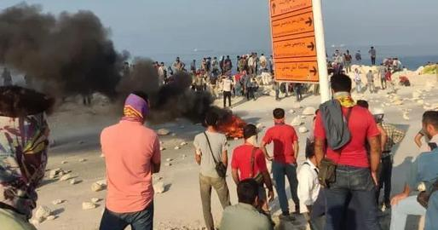
Oil workers in Iran on strike, 2022
Having discussed two important currents within the wave of protests, it is necessary to analyse what has enabled it to be such a threat to the rule of the Iranian ruling-classes and explain how it has become a widespread phenomenon touching all areas of the country: the role of the proletariat.
As all principled Marxists have emphasised; the proletariat is the most progressive class and as such is the driver of the struggle to end capitalism and usher in socialism. Without the revolutionary energy of the working-class as a whole, these separate movements would have been isolated and crushed by the state’s policing apparatus. As stated above, the Iranian establishment has been faced with major protests for years now over deteriorating economic conditions, and the trend shows that the proletariat is growing more militant by the day. This is demonstrated by the recent developments that, despite the brutal response, the protests show no sign of abating precisely due to the drive of the working-class as a whole which is taking on a prominent role in the movement befitting its revolutionary nature.
By the 23rd of September, heavy fighting was being reported after dark between protesters and the police in numerous cities. On the 27th of September, The Organizing Council of Oil Contract Workers threatened strike action in solidarity with their fellow workers should the government continue to crackdown on protesters: crippling the Iranian oil sector in the process and cutting off much needed revenue for the country (petroleum exports make up 11% Iran’s total exports) worth one billion dollars. In addition, unconfirmed reports of generals, police officers and other trade unions voicing their opposition to the ruling clique of Iran have come to light. The mere threat of proletarian revolt is enough to shake the foundations of bourgeois rule.
At the time of writing, the flame of protest has not gone out. State security forces crack down with increasing violence, firing live ammunition into crowds as well as beating 16-year-old Nika Shakarami, leading to her death. The Ayatollah recently commented on the crisis after almost three weeks of silence, condemning them as a Western plot:
‘I say explicitly that these riots and this insecurity were a design by the US and the occupying, fake Zionist regime and those who are paid by them, and some traitorous Iranians abroad helped them.’
On the morning of October 10, the workers of the oil sector acted upon their warnings to Tehran and a strike began after workers at the Asaluyeh Complex in the Bushehr province walked out. Hours later they were followed by fellow petroleum workers in Abadan, Khuzestan who went on strike in solidarity. Videos posted on social media show workers chanting ‘This year is the year of blood, Seyed Ali Khamenei is done!’ and ‘Down with the Dictator’ in front of government buildings. Similar videos that show workers chanting ‘Long live Iran! Long live Lurs, Turks, Kurds, Arabs and Bakhtiari’s!’ demonstrate the noble internationalism of the Iranian proletariat. It has been additionally reported that drivers of bitumen tankers have also begun striking, further extending the scope of the opposition. One video shows Iranian government workers being jeered-at by schoolgirls, and 5 leading Iranian economists have criticised the government’s response to the protests.
The workers of Iran are forced into increasing militancy by the repressive laws and policing of the theocratic government. After years of increasing unemployment, repression, immiseration, hunger and thirst, the promises of the ruling clique in Tehran become hollow. But the people still face enormous hurdles. There is not a functioning workers’ party in the country and socialists are heavily oppressed, the masses are therefore directionless. This can be seen by the movement itself, there is no single organisation that leads these people and the protests are therefore overall spontaneous and rudderless. What will inevitably follow is either the increasing repression of these protests, or their co-option towards reform and dissolution. Either way, it is essential to treat these developments with the openness and seriousness that they deserve.
Source: 1, 2, 3, 4, 5, 6.

Original article

