On the Situation in Nagorny Karabakh
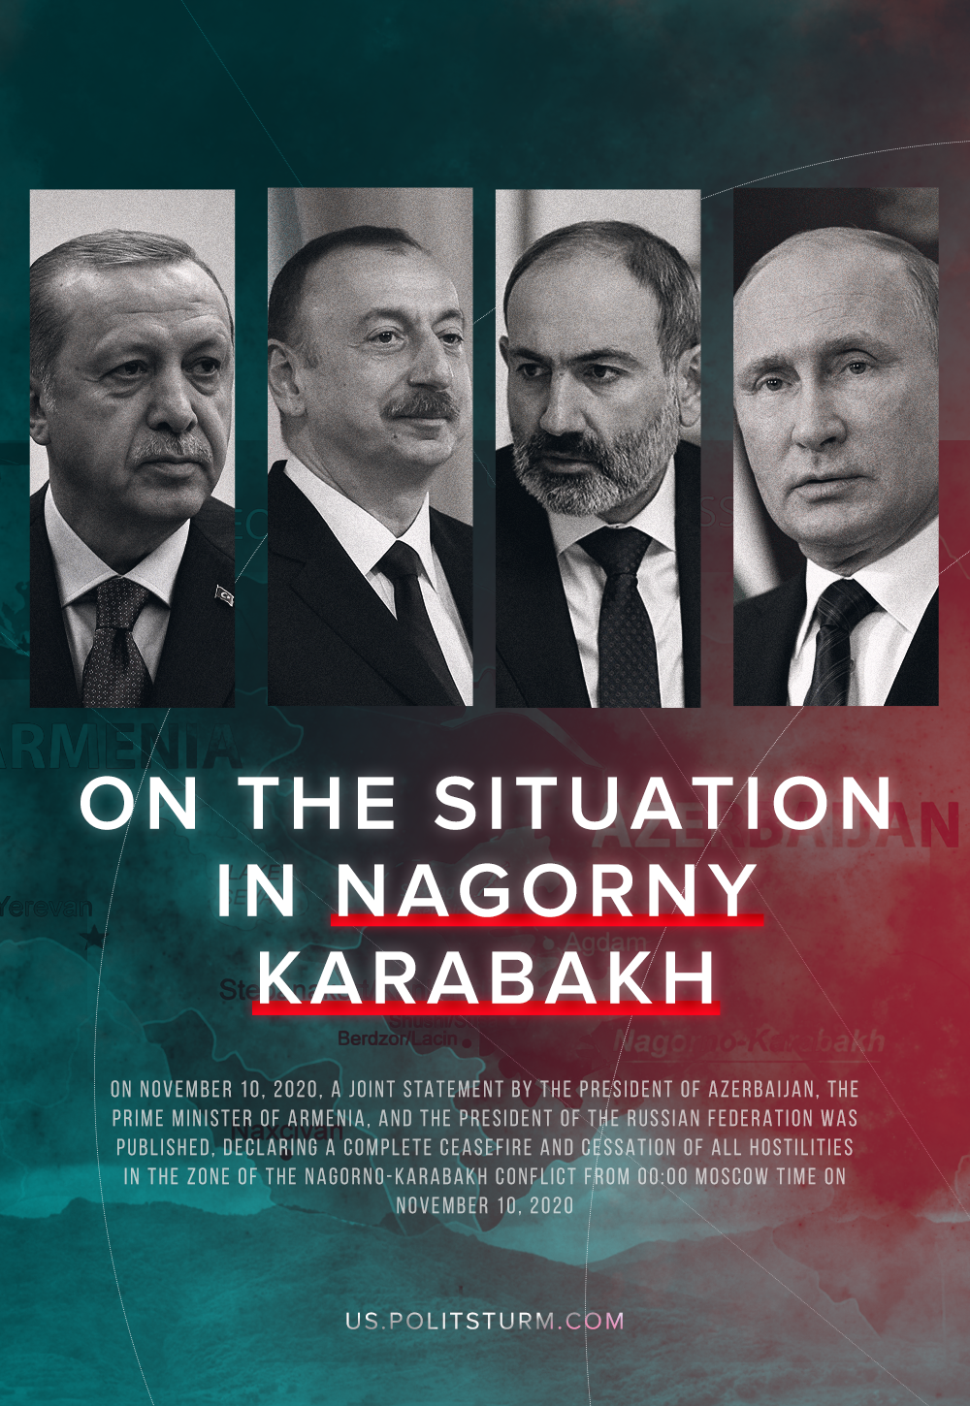

Original article
2020-11-17
18 min read

Few could have foreseen that the escalation of the conflict in Nagorno-Karabakh, which began on September 27, would develop into a full-fledged war between the Artsakh Defense Army of the Nagorno-Karabakh Republic and the Armed Forces of Azerbaijan.
From the resumption of hostilities to now it is clear that the war was initiated by the Baku regime with the direct military and political support of its main ally (supplier of military equipment, advisors and instructors) – Turkey. Now there is no doubt that with the help of the Turkish authorities their so-called Syrian militants were brought into the conflict[1].
However, something happened which wasn’t anticipated either in Armenia or in Russia. During the hostilities, the Azerbaijani armed formations advanced significantly in the southern and southeastern sectors of the front – in the direction of Aghdam, Martuni, Zangelan, Kubatly and reached the city of Shushi.
On November 8, Azerbaijani President Ilham Aliyev declared the capture of the city of Shushi. On the evening of November 9th, the Azerbaijan Ministry of Defense published footage from the city of Shushi. This was the confirmation that the units of the Azerbaijani army really controlled much of the region. Later, the press secretary of the Artsakh (NKR) leader confirmed that the Armenian forces no longer controlled Shusha, and that the enemy “is on the outskirts of Stepanakert, and the existence of the capital is already under threat” [2].
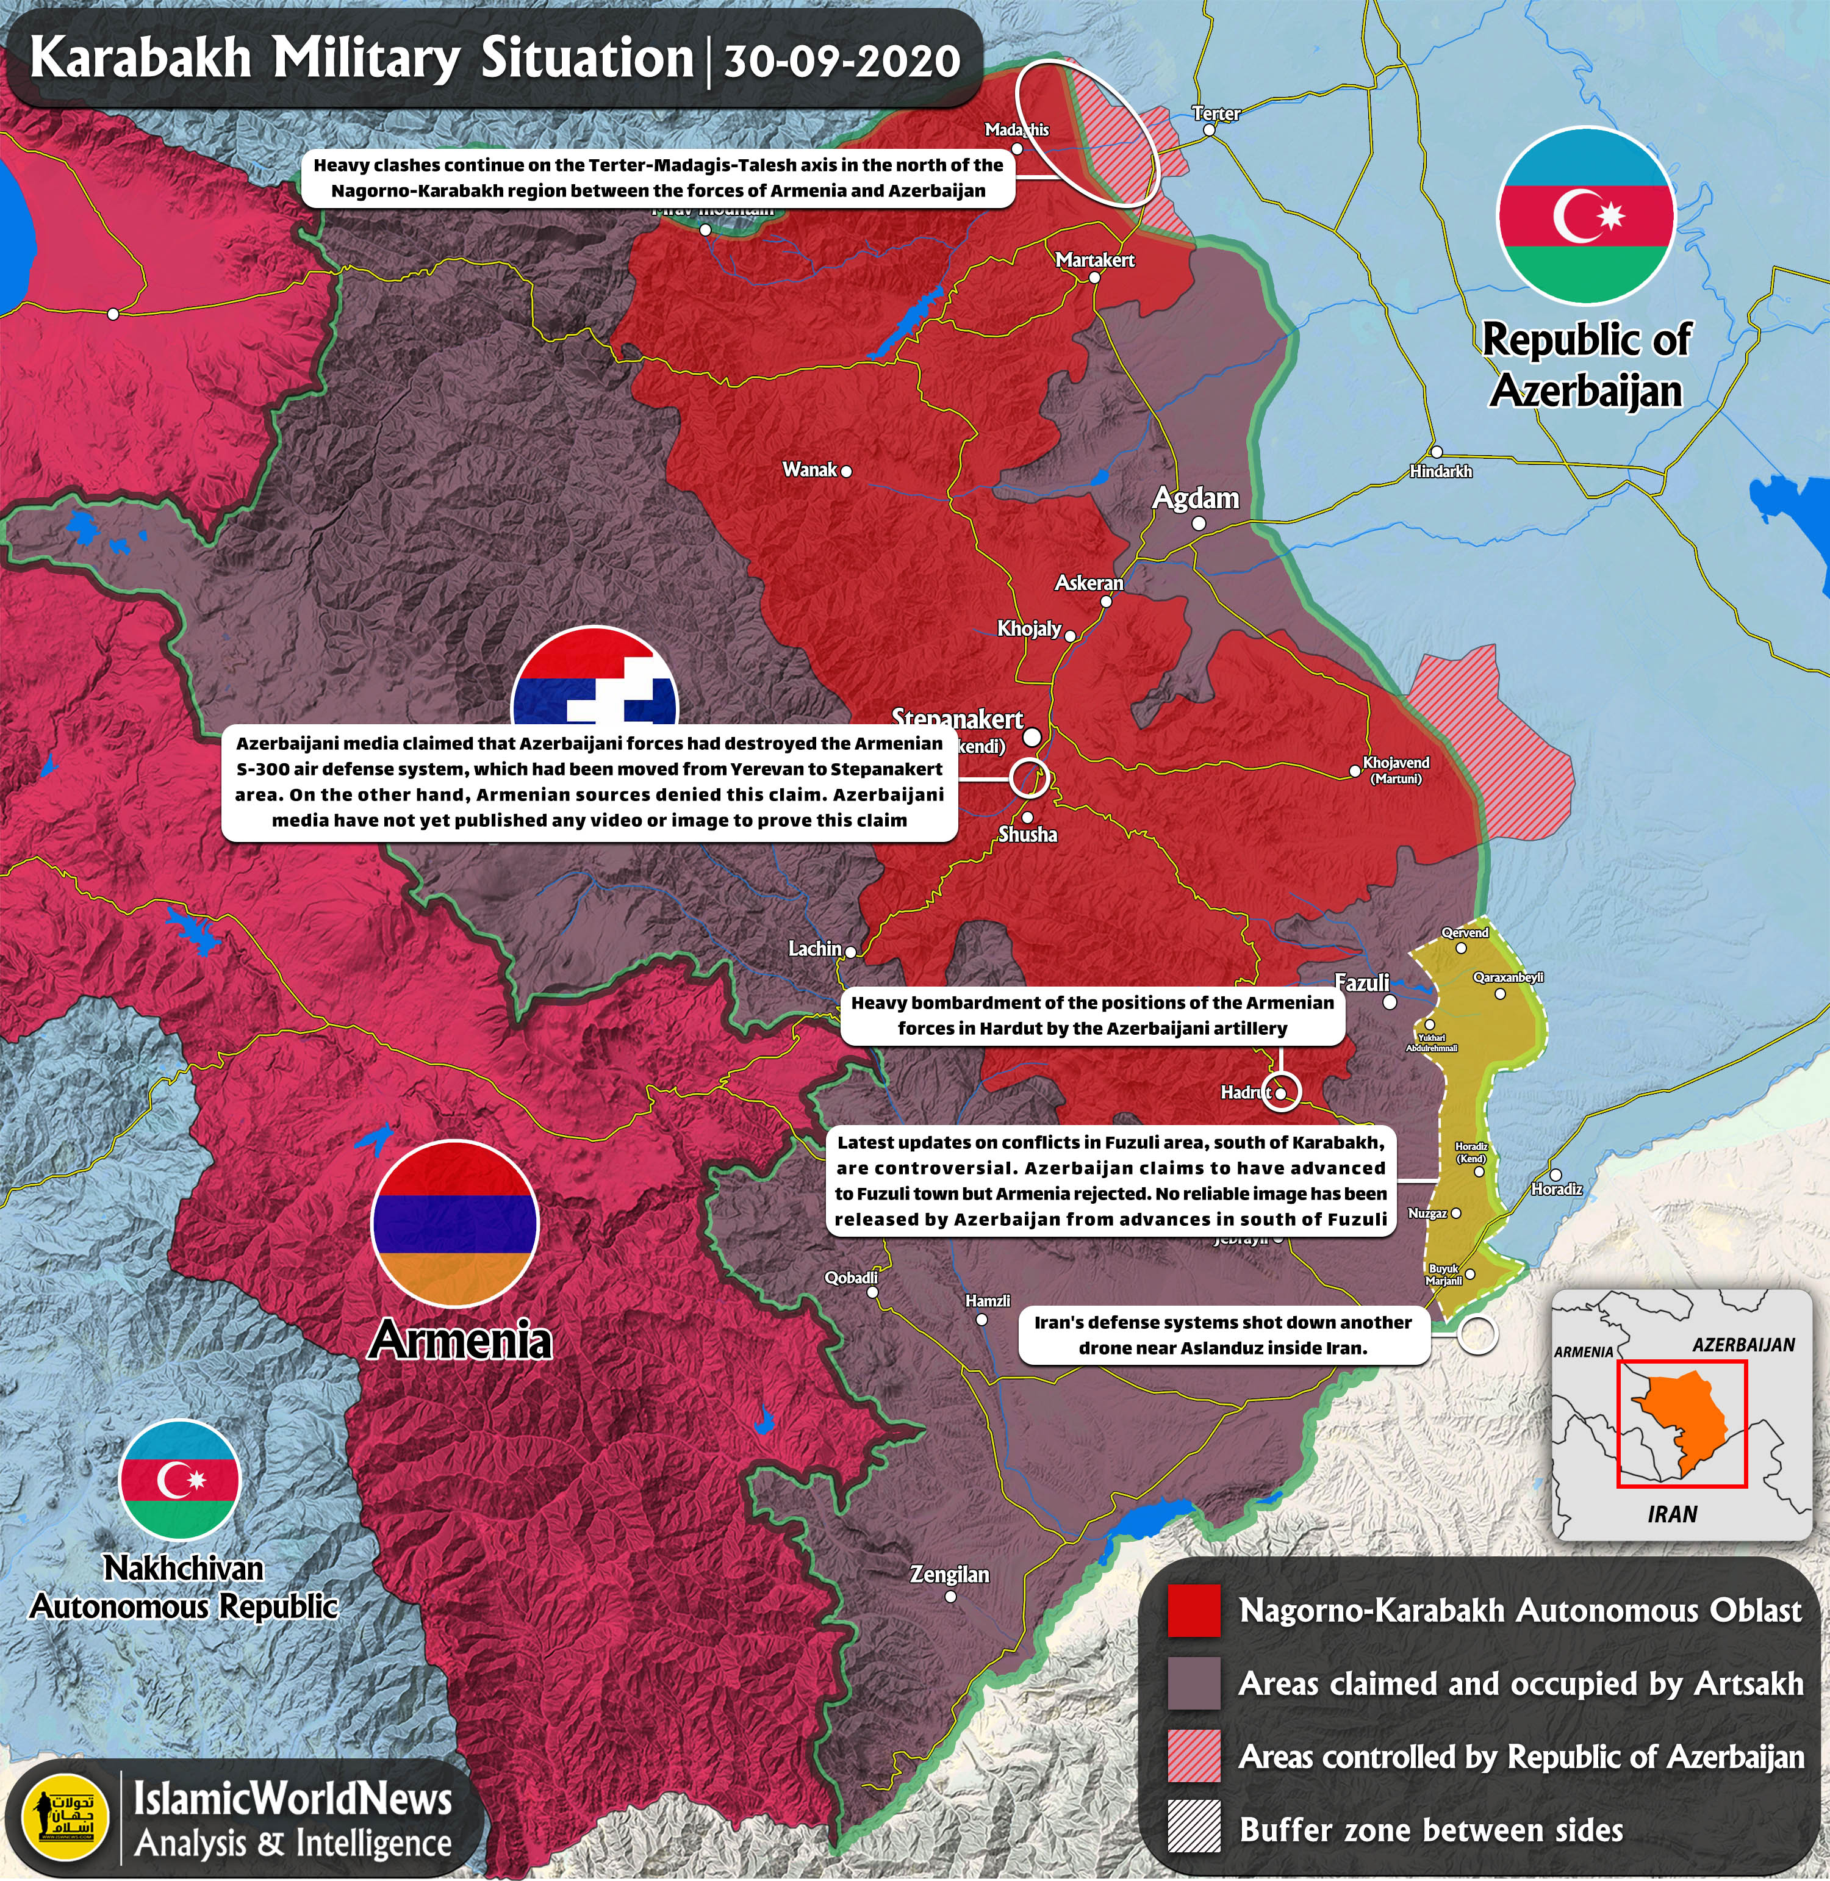
On November 10, 2020, a joint statement by the President of Azerbaijan, the Prime Minister of Armenia, and the President of the Russian Federation was published, declaring a complete ceasefire and cessation of all hostilities in the zone of the Nagorno-Karabakh conflict from 00:00 Moscow time on November 10, 2020 – practically ceding the captured territory of the NKR to Azerbaijan.
This caused major unrest in Yerevan, the Armenian capital. Around 2:30 AM local time (1:30 Moscow time), the protesters broke into the building of the Armenian government, looking for the Prime Minister of Armenia Nikol Pashinyan [3], while the Speaker of Parliament was assaulted on the street.
In keeping with his agreement, Putin deployed peacekeepers along the line of contact in Nagorno-Karabakh and along the corridor of land connecting the unrecognized republic of mostly ethnic Armenians with Armenia.
After signing the agreement, all the transport hubs in the region will be unblocked, particularly through Armenia to the Azerbaijani enclave of Nakhchivan.
Some provisions of the Agreement:
- Aghdam region and territories controlled by the Armenian side in the Gazakh region of Azerbaijan must be returned to Azerbaijani control by November 20, 2020
- The Russian peacekeeping contingent is to be deployed along the line of contact in Nagorno-Karabakh and along the Lachin corridor, the number of this contingent will be 1,960 soldiers with small arms, 90 armored personnel carriers, 380 automobiles and special equipment. At the same time, the duration of the stay of the peacekeeping contingent of the Russian Federation is set at 5 years with an automatic extension for the next 5-year periods, if none of the parties to the agreement declares their intention to terminate the application of this provision 6 months before the expiration of the term
- Armenia pledged to return the Kelbajar region to Azerbaijan by November 15, 2020, and the Lachin region by December 1, 2020, while the Lachin corridor, 5 km wide, will remain with Armenia, ensuring the connection of Nagorno-Karabakh with Armenia. The city of Shusha, however, will remain under Azerbaijani control
- Over the next three years, a plan for the construction of a new traffic route along the Lachin corridor will be determined, which will provide communication between Stepanakert and Armenia, with the subsequent redeployment of the Russian peacekeeping contingent to protect this route. At the same time, Azerbaijan gives guarantees of traffic safety along the Lachin corridor for citizens, vehicles and goods in both directions
- Internally displaced persons and refugees will return to the territory of Nagorno-Karabakh and adjacent areas under the control of the Office of the United Nations High Commissioner for Refugees
- An exchange of prisoners of war and other detainees, as well as the bodies of the dead.
- All economic and transport links in the region are to remain unblocked Armenia has pledged to provide transport links between the western regions of Azerbaijan and the Nakhichevan Autonomous Republic for the unimpeded movement of citizens, vehicles and goods in both directions. The control over transport communication will be carried out by the Border Service of the Russian FSB. By agreement of the parties, the construction of new transport communications will be provided, which will connect the Nakhichevan Autonomous Republic with the western regions of Azerbaijan.
Given the terms of the above Agreement, the Armenian Republic has clearly lost the war and was forced to concede with these unfavourable conditions.
These onerous terms resemble the provisions of the Treaty of Alexandropol, concluded exactly one hundred years ago by the Dashnaks and Turks, only this time there are no Bolsheviks and no Soviet Russia to recognize Armenia and win more favourable terms for Armenians.
The beneficiaries of this result are NATO’s Turkish imperialist state and its allied Azeri oil barons, which will be able to temporarily obscure the heightening class contradictions in their countries. With luck, this will ensure the place of the Aliyevs in power for another thirty years.
The situation is similar for the Erdogan regime, which, by pursuing an aggressive foreign policy and expanding its sphere of influence in the region, is trying to resolve the worsening internal contradictions of Turkish society.
The revanchist goals set by the Azerbaijani bourgeoisie have been largely accomplished. But it is by all rights that Baku needed to return the territories of the Nagorno-Karabakh Republic and the security belt, control over which was lost during the 1992-1994 Karabakh war.
The victory of Turkish imperialism in a regional war – and it is a Turkish victory since the dependent Azerbaijani state is now moving even closer – means an increase in reaction. This is a victory for increased fascization and continued suppression of left and democratic forces in Turkey itself.
Azerbaijan, having enlisted the support of the Turkish imperialists, essentially surrendered its people to the Turkish capitalists: the Aliyev regime keeps Shushi and strengthens the power of its clan, while Turkey gets the raw material base (so necessary for its military expansion in the region) of Azerbaijan. The Azeri regime has begun to weaken its sovereignty to the imperialist clique.
Transcaucasia remains an arena for the competing imperialist countries of the region, which will use the aggravated national conflicts to protect their economic interests.
The interests of two great imperial powers – Turkey and Russia – clashed in the region. If the first took an active part in the conflict, then the second strategically chose not to directly intervene.
Turkish peacekeepers may be able to deploy in Nagorno-Karabakh, to receive direct automobile communication through Nakhichevan with Azerbaijan, which the pan-Turkists have long sought for. Turkish fascism successfully stretches its influence over the entire Transcaucasus and gains its foothold there. [3]
The Russian imperialists will also be able to obtain another military base in the Transcaucasus. Most likely, with the help of the part of the Armenian bourgeoisie oriented towards the Russian capital, the inconvenient Nikol Pashinyan will be removed from power and, of course, Russian imperialism will gain full political sway over Armenia.
However, despite what has been said, Russia, or rather the Russian capitalists, have lost more than they have gained. Turkey has invaded their traditional sphere of influence and redrawn the map of the region in their image.
Sections of the Armenian bourgeoisie, as mentioned above, will resolve their political issues. Nikol Pashinyan will be made a scapegoat, although Nikol himself is a product of the current Armenian society; brought to power with the support of the nationalists and liberals.
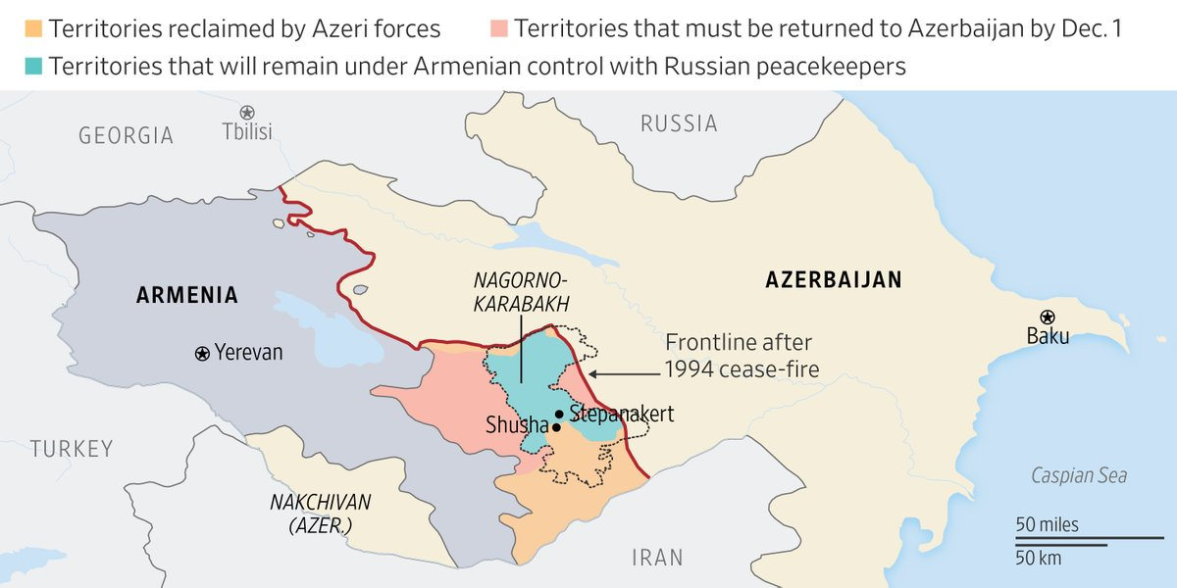
The so-called Velvet Revolution excited the population towards action, and the high level of populism and morbid patriotism that reigned in society began to grow out of proportion. For a long time, Armenian nationalists believed that with the help of heroism, courage, sacrifice and “unity” all enemies could be destroyed.
However, in addition to heroism, they have found that one also requires resources, influential allies, UAVs, and a realistic conception of the circumstances.
Azerbaijan’s rapid victory can be explained not only by the participation of Turkey, but also by the lack of real support for the NKR from Armenian forces, who apparently didn’t directly engage in the conflict, so as not to provoke an attack by Turkey on Armenia proper. Such a development would place the Russian Federation in an untenable position, and oblige it to intervene.
The quick, almost instantaneous announcement of a ceasefire by the three presidents after the capture of Shushi is suggestive of the underlying political machinations. One gets the impression that the Turkish and Russian imperialists had agreed in advance on the terms of an Azeri military cessation, even contingent on the surrender of the city since it is of critical strategic importance for control of Nagorno-Karabakh (and not only the stated cultural reasons, as some naively believe).
Considering that Shushi was surrendered so quickly; without street fights, infrastructure loss, etc., it’s most likely the leadership of Armenia and Artsakh knew they had to agree to these ceasefire conditions.
Error loading image
The Russian Federation could not allow the complete defeat of the Armenian armed forces, so the compromise option was limited to the surrender of Shushi and by extension the NKR itself. For the Azerbaijani bourgeoisie, this is an acceptable outcome of the war that is being celebrated in Baku; enough to proclaim victory and the surrender of the Armenians.
The current situation reminds us of the Syrian events around Idlib, where Turkey and Russia delimited spheres of influence.
It is noteworthy that at the end of October, Turkey made a number of concessions on the Syrian issue. Turkish forces abandoned some of their observation posts in Idlib, including the deployment points created under agreements with Russia [4].
We can say with confidence that there has here been carried out a conspiracy by the regional imperialists, with the participation of their local representatives from the national bourgeoisie, in order to dictate their spheres of influence in the Transcaucasus.
The small nation-states, which have shown the complete collapse of their sovereignty, act as bargaining chips in this costly regional game.
Why the Russian imperialists and the Armenian bourgeoisie so easily entered into an agreement with the Turks and surrendered territories on unfavorable terms is a question that we can hardly answer. Perhaps this is a miscalculation, or perhaps Erdogan promised something in return.
The global crisis of capitalism is leading to the division of the world by the leading imperialist powers. After a series of territorial and market redistributions, a situation mirroring the preconditions of the First World War may well develop. The contradictions between the imperialists can reach such heights that it will be only possible to overcome them through a large global war.
What Lenin described a hundred years ago is now more relevant than ever, with only amendments needed for the particular modern circumstances.
Of course, some have thoughtlessly applied the century-old formulas and slogans to this conflict. They do not realize that at the moment the world is not in a state of world war, as it was in Lenin’s time at the beginning of the 20th century.
Now, we can only discuss a local war between small states in which there is no revolutionary situation, there is no labour movement conscious of its class interests, nor a nationwide crisis of severe total war.
Neither Armenia nor Azerbaijan have real communist parties, and the society of the two countries is thoroughly saturated by nationalism. Not to mention the collapse of Artsakh will lead to ethnic cleansing.
In this situation, calls to turn arms against the oppressors will not be taken seriously by the broad masses.
The Nagorno-Karabakh conflict and its aggravation reveals the unfeasibility of small national states, but also many flaws of the left movement.
All countries had their own social-chauvinists calling themselves communists who passively and sometimes even actively supported the demagogic rhetoric of their bourgeoisie.
Armenia defended itself in this war, but some Armenian “communists” began to portray events within the scope of nationalist rhetoric and, in fact, dogged behind the right-wing parties in this way. Nothing had prevented them from taking a class-based position except their own opportunism.
In Azerbaijan, local pseudo-leftists and “communists” justified or openly supported the military offensive of the Azerbaijani army in Nagorno-Karabakh.
Those who believe or pretend that Aliyev will grant “cultural autonomy” to the Armenians are especially adorable, or deplorable depending on your view.
On the example of the Nagorno-Karabakh conflict, we state the inability of many “communists” to adequately apply the theory of Marxism-Leninism in practice and an absolute lack of understanding of the essence its approach to the national question.
The Karabakh issue, of course, is a national issue, and it should be considered only in accordance with the Leninist principle of the nation’s right to self-determination:
“The class-conscious workers do not advocate secession. They know the advantages of large states and the amalgamation of large masses of workers. But large states can be democratic only if there is complete equality among the nations; that equality implies the right to secede.”
Lenin, More about “Nationalism”
30 years ago, despite the controversies of the Karabakh movement led by Armenian nationalists, the struggle there had the properties of a national liberation movement and was therefore progressive.
Citizens’ demands for the secession of the Nagorno-Karabakh Autonomous Region (Artsakh) from the Azerbaijan SSR arose in the context of perestroika, the restoration of capitalist relations in the USSR and inaction by central authorities. At the end of the 1980s, these processes became irreversible; that is, in such conditions the question of preserving socialism did not arise specifically for the Armenians of Karabakh. In the background of the anti-Armenian pogroms in Baku and Sumgait, other questions arose.
The key topic was not the issue of equality for citizens of different nationalities, but the physical survival of the Karabakh Armenians, who, under the conditions of the establishment of a nationalist regime in Azerbaijan, thereby exercised their right to self-determination.
Out of the nationalistic stock of the Karabakh movement, the Armenians of the Nagorno-Karabakh Autonomous Region (Artsakh) had implemented the Leninist principle of the nation’s right to self-determination.
Despite this it is unlikely that the Armenian and Azerbaijani communists will be able to unite for a joint struggle against their common enemy – capitalism – if the latter will deny the former’s right to live in a separate state.
These people who try to keep the Armenians of Artsakh under their rule by force cannot be called communists.

What is to be done?
Despite the fact that Armenia essentially surrendered, the conflict in Karabakh has not been resolved. At the moment, we are seeing its indefinite postponement.
Firstly, the status of Artsakh has not been determined. Even Armenia did not recognize its independence, and the Azerbaijanis still see it as their territory while Russian peacekeepers will be deployed.
Thirdly, the level of nationalism and chauvinism in Armenia and Azerbaijan is only growing, and in all likelihood will reach extreme heights, in the former’s case because of defeat, and in the latter’s because of the patriotic upsurge of success. This means that ordinary Azerbaijanis and Armenians will continue to foster ethnic hatred.
Fourth, because of the defeat, radicalization and revanchist sentiments will only increase among Armenians, which are excellent conditions for the parasitism of the nationalists.
However, Armenia alone will not be able to return the territories, since the Turkish factor will have an influence in the region for the foreseeable future. Even if it is possible to return some lands, Baku will not reconcile with this.
Revanche will not solve the problem, it isn’t worth the lives of ordinary people.
From the above, we state the fact: the modern capitalist system and the imperialist and national states based on it are not capable and not interested in resolving the conflict.
The nationalism of both countries will produce endless mutual indemnity. Armenians, Georgians, Azerbaijanis, Turks will not back down from one another naturally. The peoples will have to find ways to coexist.
Such an inter-ethnic peace contrasts with the business interests of the regional capitalists, who, consciously or unconsciously, are forced to conduct an aggressive foreign policy in the competitive struggle, and to further pit Armenians and Azerbaijanis against each other.
Even the most patriotic-minded of the national bourgeoisie will betray their people and come to an agreement with the enemy if it aligns with their profit. This is especially noticeable in Armenia where representatives of the bourgeoisie, who have strongly promoted Armenian patriotism over the past 30 years, have conspired with the imperialists at Armenia’s expense. Decades of capitalist rule and the growing power of the oligarchs have led Armenia to a nationalistic society of poverty and utter degradation.
The capitalists don’t care about any of their “martyrs” who died in the war, they are only interested in personal benefit and the benefit of their bourgeois friends. If one part of the bourgeoisie in power uses an external threat to gloss over class contradictions and rally the oppressed to their oppressors, then another rival bourgeois group will speculate on the failures of the armed forces. We see such a situation in Armenia.
Who kills who in modern war? Simple workers of different nationalities and sects, high on the chauvinistic propaganda of their local capitalists. The children of Armenian capitalists or Azeri oligarchs don’t die in these battles- it’s the children of the common people who are dying.
The victory of Azerbaijan in the war and the defeat of Armenia will not eradicate injustice and socio-economic stratification in any one country.
Capitalism does not have a peaceful solution to the Karabakh issue. It is naive to hope for peace and tranquility in the region where one of the leading powers is the present regime of Turkey. National states bring the nations only mutual destruction, or the total eradication of the “historical enemy”.
The losers in this war are the Azerbaijani and Armenian workers, who at the expense of their lives resolve the political issues of their capitalists.
Understanding the essence of capitalism and the class interests of working people will open their way to true freedom from this situation. It’s only by starting to study Marxist-Leninist theory that these common people may comprehend the forces which gave rise to this conflict and the ways to solve it. Otherwise, the Armenian and Azerbaijani workers will continue to make the same mistakes, and their children will continue to live in fear of death from rocket fire.
The task of the working people, together with the communists, in the current conditions, is to fight for a revolutionary transformation in all spheres of social life throughout the region on the basis of an alliance of all working peoples against the capitalists.

Original article

