On the Situation in Iran
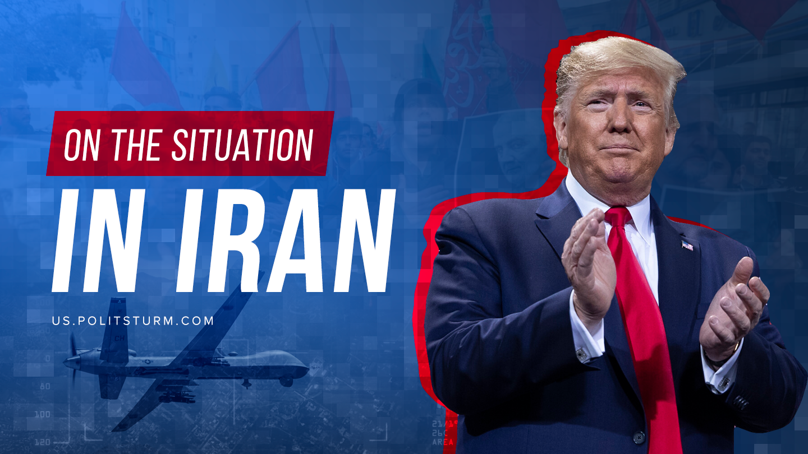

Original article
2020-01-22
6 min read

After the elimination of General Quasem Souleimani, Iran had launched a rocket strike at 2 American Military Bases in Iraq.
Following the usual excuse of the “War on Terrorism,” the United States presented Soleimani, and Iran as a whole, as an embodiment of evil or as a single incarnation of the 4 horsemen of the Apocalypse bearing destruction and death all over the Middle East.
Iran, on the other hand, used the escalation as a way to strengthen militarism in Iranian society and to justify the expansionist rhetoric of different Shia Leaders in Syria, Lebanon, Yemen and Iraq.

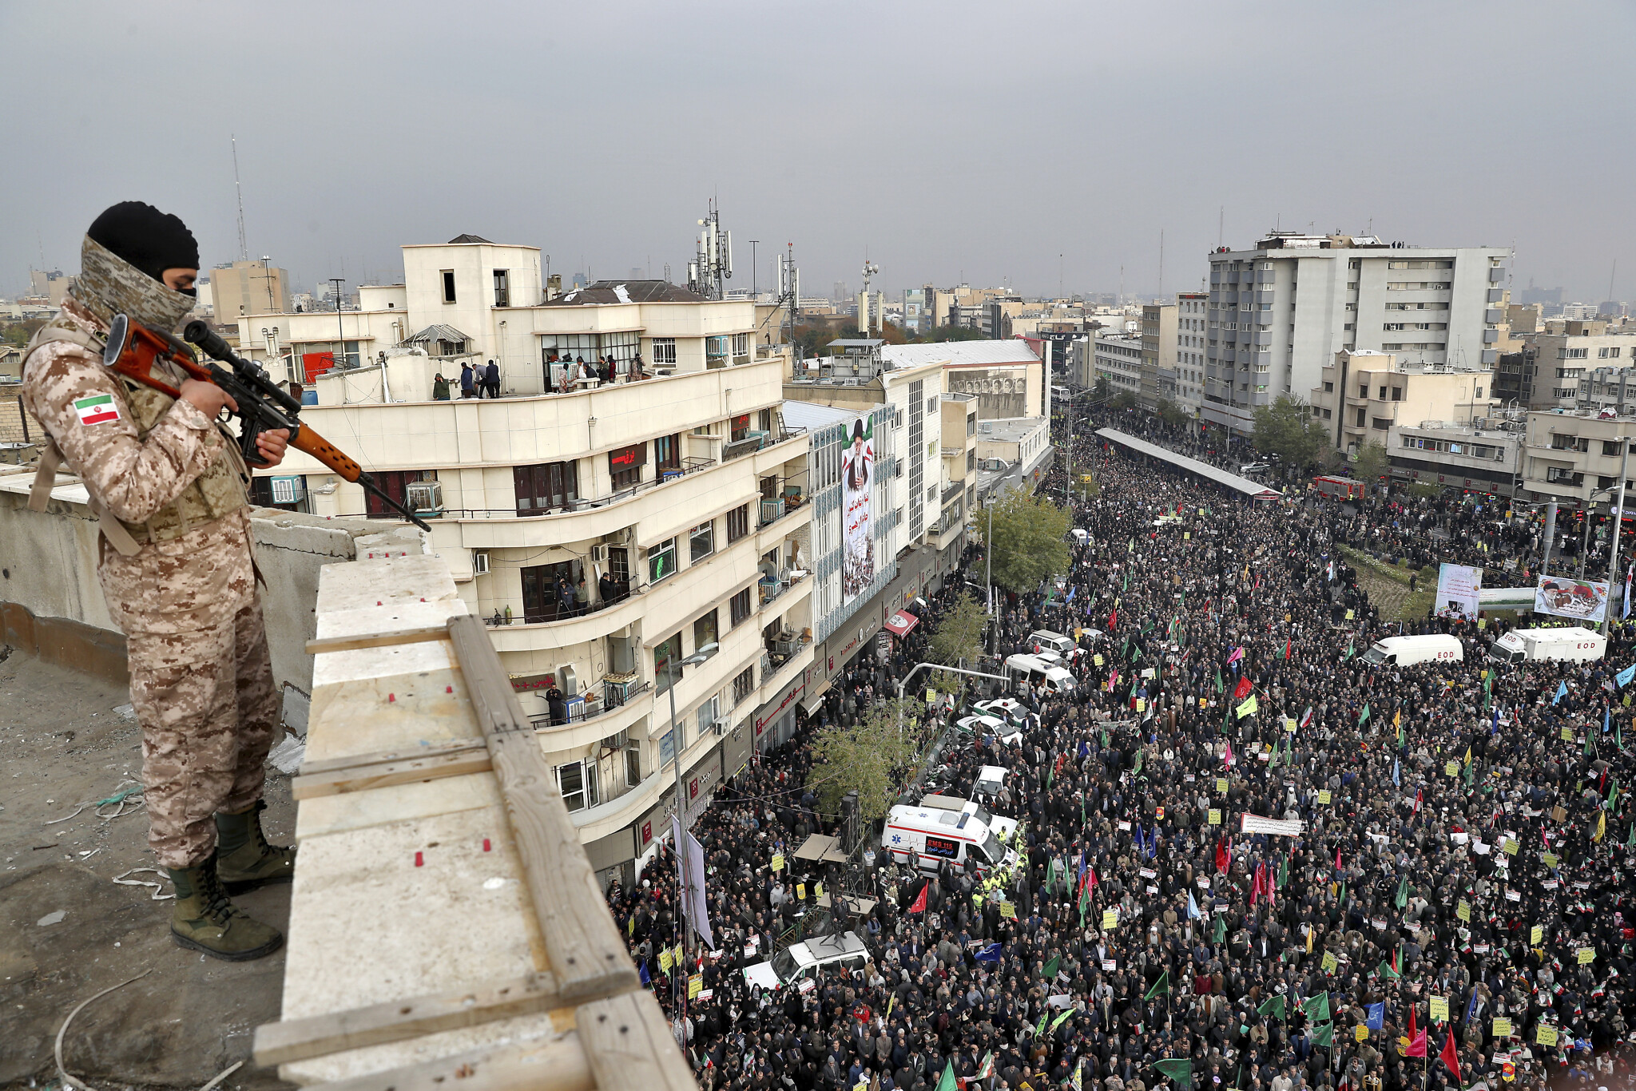
The “Agonizing death” of one of the key figures in the “Islamic Revolutionary Guard Corps” today has a tranquilizing effect on the quickly impoverishing Iranian society, whom only 2 months ago were slaughtered by their reactionary, borderline-fascist regime; leaving more than 1,000 people dead and 9,000 incarcerated.
It is important to note that despite the stand-off between Iran and the US, despite heralds cries about “occupation,” it is Iran and the United States who hold voluntary responsibility for the support and protection of the puppet, antisocial government of Iraq, which under pressure of Iranian advisors had put down mass demonstrations that resulted in the death of 500 people.
We can see that the issue is not as simple as “good/evil” American imperialism confronting the “good/evil” Islamic State. There is a complicated spider web of relations between capitalist countries in the age of imperialism. Using Iran and the US as an example, we can not only see ferocious confrontation but something of a synergy between them (for example the robbing of Iraqi people); while this whole spider web of inter-capitalist relations goes even farther when other imperialist states are included (China, Russia, Saudi Arabia, Turkey and etc.) which makes the analysis of a particular situation even more painstaking.
Without guessing if this escalation will lead to any large scale conflict, it is easy to state the next.
It is certainly clear that this is a prelude to the next Imperialist World War, to which the bourgeoisie has been systematically leading mankind.
Just like the first shots of the Great War “1914-1918” were fired in China, Morocco, Libya, Ethiopia and the Balkans in 1911-1912. Just as the first shots of the WW2 were shot at the Marco Polo Bridge in China and for the second time in Ethiopia in 1935-37, just as back then, the flame of future conflict is slowly starting in Africa, Middle East, and Latin America.
We’ve been told about the inevitability of such wars in Vladimir Lenin’s “Imperialism as the highest stage of capitalism.” The reason is not blood-thirsty capitalists or despotism of lunatic dictators, that start wars between people, but in the essence of capitalism and the system of private ownership.
The system is organized based on reckless competition between capitalists and groups of capitalists and governments under the control of the capitalist class. In certain situations the imperialists have no other way of solving long-lasting problems other than direct conflict i.e. transforming “peaceful” competition into a direct military clash.
That is why all the fairy-tales of bourgeoisie humanists about the ability of modern “civilized” mankind being somehow able to stay out of full-scale military conflicts, bearing death, destruction and woes, are totally absurd. Renouncement of war by capitalists controlling all of the world is equal to the renouncement of competition as a whole since war is the continuation of competition through other very effective (from the capitalists pov) methods.

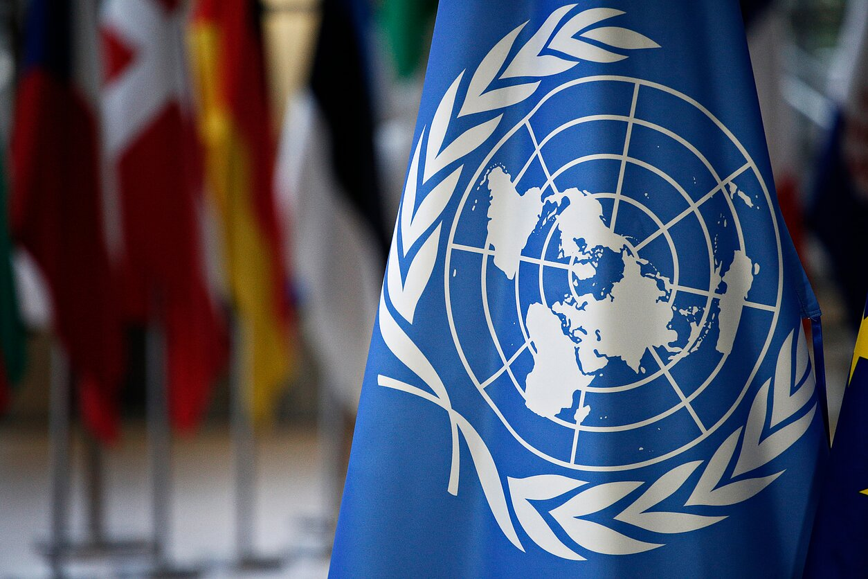
Furthermore, the sole existence and creation of organizations such as the League of Nations and its successor the United Nations, organizations whose sole purpose is to prevent war and conflict between nations proved that these kinds of initiatives made by world capitalists made to allow for “peaceful existence and development” only provide quick breaks between wars. No presidents, secretaries of state or Nobel Peace Prize laureates trying to negotiate amongst each other in the name of peace are really interested in preserving peace. The real purpose of the d’etants is preparation for war, trying to disarm the enemy, strengthen their own positions through maneuvers covered under fake pacifism and therefore delaying the war.

“Peaceful alliances prepare the ground for wars, and in their turn grow out of wars; the one conditions the other, producing alternating forms of peaceful and non-peaceful struggle on one and the same basis of imperialist connections and relations within world economics and world politics” (Lenin, Imperialism as the highest stage of Capitalism)
That is why it is absurd to hope for humanitarianism of capitalists and their puppets i.e. political leaders.
War, with the destruction of extra products and means of production, with the colossal opportunity for enrichment and conquest of new markets, with the upcoming opportunity for militarization of labor (i.e. even farther robbing of the laborers through establishment of a strict slave owner like military discipline,) is a reliable way of increasing profits of certain capitalists, and capitalist groups.
Through this perspective, the images of the horrors of war such as murder and illness of thousands of people become less apparent. Furthermore that in their “full functioning” state all these people attract the attention of the bourgeoisie state as a source of income.
Only the forces, really interested in preserving long-lasting peace between nations are able to stop future imperialist wars. The only such force is obviously the proletariat: who is left to do the dirty job and bear the horrors of war, who is being used as an instrument in a war of capitals, the one who dies on the battlefield; killing and injuring each other, the one who provides the “victory” (and mainly the profit,) to one or the other group of capitalists. Receiving pieces of metal, fake appreciation from the high ranked bourgeois leaders and pennies as a bonus.
Namely these and only these “forces of peace” are able to prevent the future world meat grinder, smoothly diving towards the elimination of the cause of the war – capitalism and the main firebrand – the bourgeois class.

“In reality the question is this; do we let them kill us in the interest of imperialist bourgeoisie, or we will systematically prepare ourselves, and most of the exploited to with the least losses possible capture banks, eliminate bourgeoisie, to eliminate once and for all debt and war.” (Lenin, About the question of the security of the Motherland.)
Unfortunately today this “faction of peace” is too weak, disorganized and ideologically disoriented to do anything.
Furthermore; the capitalists understanding the dangers of such consolidation keep and support the activity of provokers.
Meanwhile

«The character of the war (whether it is reactionary or revolutionary) does not depend on who the attacker was, or in whose country the ‘enemy’ is stationed; it depends on what class is waging the war, and on what politics this war is a continuation of. If the war is a reactionary, imperialist war, that is, if it is being waged by two world groups of the imperialist, rapacious, predatory, reactionary bourgeoisie, then every bourgeoisie (even of the smallest country) becomes a participant in the plunder, and my duty as a representative of the revolutionary proletariat is to prepare for the world proletarian revolution as the only escape from the horrors of a world slaughter. I must argue, not from the point of view of ‘my’ country (for that is the argument of a wretched, stupid, petty-bourgeois nationalist who does not realise that he is only a plaything in the hands of the imperialist bourgeoisie), but from the point of view of my share in the preparation, in the propaganda, and in the acceleration of the world proletarian revolution” (Lenin, The Proletarian Revolution and the Renegade Kautsky”)
Today we can sadly note the weakness of the ideological and organizational skills of the only force that is able to destroy the cause of imperialist war,
But reality opens eyes of even the most unwilling and strong supporters of capitalism; still to this day they can for the time being hide from the poverty and havoc of the world, but in the future they won’t be able to hide and find sanctuary in their cozy houses from the sky falling, total mobilization and the bloody meat grinder.
Looking at the situation happening in the Middle East and Africa, where all sorts of imperialists, hiding behind noble reasons of fighting with something unconditionally “bad,” start turning on each other, leaving cities in ruins on the way, killing thousands of civilians and threatening to bring the confrontation to a global scale, the average Joe should understand that one day he could end up in the shoes of the Syrians, Iraqis, and Lybians.
The development of capitalism, global recession, and ending the escalated capitalist tensions requires starting new Imperialist wars, which can escalate into a global conflict i.e. the feared WW3, during which the average Joe will end up on the battlefield.
That is why the only solution to the situation in the Middle East, to the obvious fact of an upcoming recession, and the danger of another bourgeois war, which will definitely lead to the destruction of the world, is the battle for organizational and ideological strengthening of the proletariat; as the main force of peace, battle for establishment of socialism as the only means of preventing future wars, which are inevitable in capitalism.

Original article

