On the School Collapse in the UK
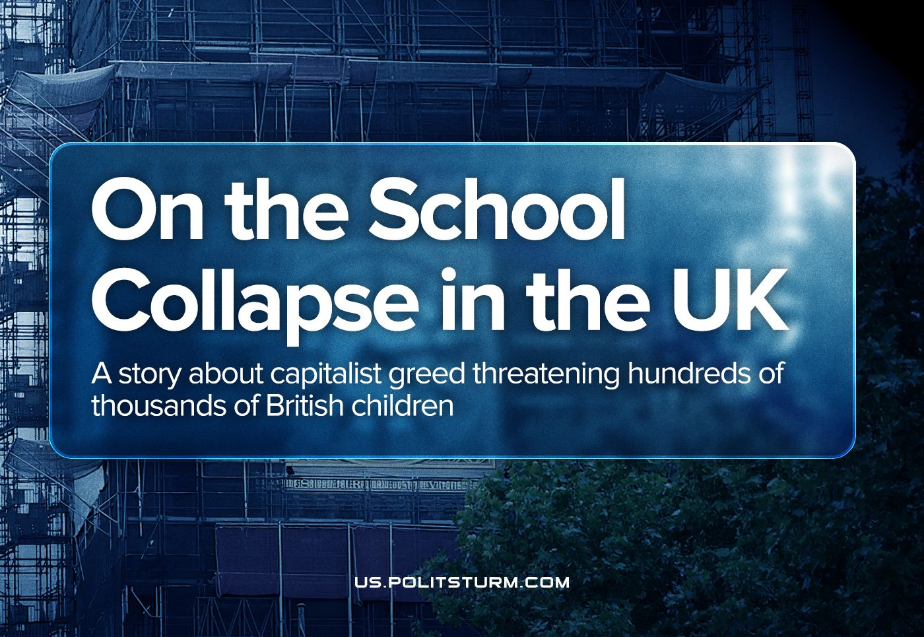

Original article
2023-10-02
12 min read

A silent crisis is unfolding within the United Kingdom. The very structures, meant to shape the future of the nation – its schools – are in danger because of the material they were built of. Reinforced Autoclaved Aerated Concrete (RAAC), an emblem of post-war capitalist cost-cutting, has turned schools into ticking time bombs, as was revealed recently.
An estimated 100,000 students attend the 147 named schools confirmed by the government as having collapse-prone RAAC onsite. Close to one in 10 pupils, are facing a delay to the start of the school term due to this issue. This crisis is not merely an infrastructure failure; it's a testament to a system that prioritizes profits over the well-being of the masses.
We will embark on an odyssey to dissect the intricacies of this crisis, understanding its historical underpinnings and the stark realities of a society ensnared in the clutches of a capitalist agenda. The alienated labour, embodied in the RAAC composes the halls of these decaying schools. As the concrete decays, it is not just the walls and foundations that crumble, but the very future of the country personified in the students.

What is Wrong with Reinforced Autoclaved Aerated Concrete?
Reinforced autoclaved aerated concrete (RAAC) stands as a stark symbol of the capitalist cost-cutting prevalent in the post-war era. It emerged as a lightweight material primarily utilized in flat roofing, floors, and walls during the period spanning from the 1960s to the 1990s.
This cost-efficient substitute to standard concrete boasted swift production and easy installation, factors appealing to the state and corporations that won construction contracts, especially at the time when Public Private Partnerships (PPPs) and private financing was being introduced in the construction of schools. However, its expediency compromised its durability, offering a lifespan of a mere 30 years. RAAC is defined by its bubbly, aerated structure, giving rise to its light-weight, however it also makes it significantly less durable compared to traditional reinforced concrete, rendering it more susceptible to structural failure when exposed to moisture.
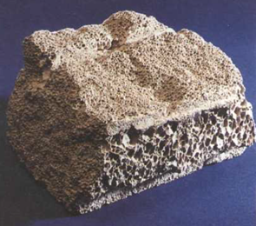
Reinforced Autoclaved Aerated Concrete (RAAC)
The bubbles within the material can facilitate water infiltration, leading to decay, rust, and weakening of any steel rebar reinforcing the RAAC. The material is often coated with substances like bitumen to mitigate these vulnerabilities, but even these protective layers can degrade over time.
This material has been widely used, with tens of thousands of structural panels composed of RAAC already in use, many of which are displaying signs of wear and tear. The Health and Safety Executive has declared that RAAC is now beyond its intended lifespan, warning of its potential to "collapse with little or no notice."
The risks associated with RAAC were first identified as early as 1961, around the time of its initial usage in Britain. The Institution for Structural Engineers pointed out the significant disparities between RAAC and traditional concrete, suggesting that retaining the term "concrete" for these aerated products could be misleading. The material's susceptibility to moisture, resulting in strength reduction, and its sensitivity to polluted air were noted.
The safety concerns escalated in the 1980s and 1990s when roof collapses prompted the demolition of buildings. Reports from the Building Research Establishment in 1996 and subsequent years reiterated the dangers posed by RAAC, recommending regular inspections for aging panels.
Despite widespread awareness of these dangers, the government's responses have been lacklustre. The issue was acknowledged by the state as early as 1994, yet comprehensive action was delayed, allowing the problem to fester as the RAAC continues to decay. The government began monitoring the condition of public sector buildings with potentially compromised RAAC only in 2018.
Schools, which often lack the technical expertise for structural assessment, have faced acute challenges in managing RAAC-laden structures. Guidance on managing RAAC was only substantially updated in 2021 and 2022, indicating a long period of inadequate oversight. Schools Minister Nick Gibb, despite the looming risks, maintained that if RAAC was not in an evidently critical condition, continued usage of the building was considered safe.
This negligence underscores a system driven more by convenience and cost-cutting than by a genuine concern for the welfare of the working-class, especially the future generation whose lives and education is endangered by this structural time bomb.

Why Was RAAC Used?
The expansion of usage of RAAC coincided with the beginning of the rollback of the social-democratic welfare state in the 1970s. The bedrock of the problem lies in the diminishing rate of profit, a reality first discovered by Marx in Capital Vol III. Capital seeks a larger share of the surplus-value created by labour, prompting investments in automation (constant capital) to reduce their labour costs (variable capital) and enhance production efficiency.
This innovation initially grants a competitive edge to the pioneering capitalist, but over time, the rate of profit declines due to the diminished role of variable capital in generating surplus-value. This trend is known as the law of the tendency of the rate of profit to fall.
However, capitalists employ short-term strategies to counter this trend, as discussed in Capital Vol III (Chapter 14). These include intensifying labour, lowering wage rates below their market value as a commodity, engaging in foreign trade with countries having less developed productive capacities, and augmenting stock and finance capital. These reforms implemented in Britain (and globally) successfully embraced these strategies. By suppressing labour movements and curtailing civil and democratic rights, the capitalist state aids the owning classes in intensifying exploitation. Exporting production to countries with inferior productive powers and weaker labour movements further enhances profit rates. Additionally, the growth of finance capital, where money is simply spun into more money through interest, doesn't influence the rate of profit.
The crisis of profitability in the 1970s spurred the introduction of liberal reforms, temporarily boosting capitalists' profit rates at the expense of working-class impoverishment – directly via increased exploitation, or indirectly by robbing them of social services as well as cutting costs on things like building materials. Unemployment and poverty surged, while a small handful of the already richest capitalists witnessed rapid wealth accumulation.
Capitalist ideologues justified this wealth concentration by asserting that prosperity would "trickle down", denying the fundamental contradiction between capital and labour. They exalted market relations as sacred and dismissed any interference with capitalists' holy duty to amass surplus-value, including taxation by the state. The capitalist state was to be stripped of social welfare programs and all other compromises with the working-class and become solely an enforcer of capitalist interests and property rights, funded primarily by taxing workers and increasing the national debt.
As a result, it’s important to realise that this is a systemic phenomenon, not just the decisions of a ruling party. This thesis is evidenced by the fact that the Labour party, after having come to power after Thatcher and the Conservatives, made no effort to reverse the privatisations, deregulations, rollback of the welfare state, or indeed the usage of RAAC. Instead, they were compelled by the capitalists that they serve, to continue and expand these programs.

The Response of British Society and Politicians to the Crisis
In Britain, the response to the crisis of the education infrastructure starkly mirrors the deeply entrenched capitalist values governing the nation. As schools crumble, endangering the lives of students, one would expect an immediate and comprehensive response in any reasonable human society. However, bourgeois society is not a reasonable human society and has created a divide in how this issue is approached.
Society, burdened by the repercussions of austerity measures and influenced by capitalist-controlled media, finds itself trapped in political manoeuvring. The “free” media, which is free to be bought and sold by capitalists, consequently serves the interests of said capitalists, distorting narratives to shift blame from the system that incubates these crises. While the suffering of the working class worsens, the political elite engages in shallow gestures, offering superficial solutions that barely scratch the surface of the problem.
The statistics reveal a damning reality. A staggering 75% of closed or problematic schools are located in regions where Conservative governments, mayors, or city councils hold power. Additionally, 36 problematic schools are situated in constituencies represented by front benchers and ministers of the Conservative government.
Every seventh school on the list of those affected applied for emergency repairs but was denied. The Department for Education mandated schools to check for RAAC in their buildings, revealing a known risk dating back to 2019. However, adequate measures were not taken, and the collapse of the first school this year exposed the tragic inaction.
The Institute for Fiscal Studies reported that it would cost around £5.3 billion annually to address the RAAC related risks in school infrastructure, but the Treasury has only committed around £3 billion. This illustrates a story of cost-cutting and complacency, where necessary public spending on school renovations has been sacrificed for funding private initiatives that failed to deliver the promised benefits.
At the same time, School history researcher Warwick Mansell estimates that the Ministry of Education under the Conservatives offered £1.7 billion a year in grants to private schools and private education. By comparison, the Department for Education only spent around £550 million a year on projects to rebuild England's entire school infrastructure. While, the Prime Minister himself, Rishi Sunak, donated $3 million in 2011 to the US university that his wife graduated from.
Corbyn’s Labour proposed a solution that involves a National Investment Bank with a substantial budget of £25 billion per year for 10 years, far surpassing what has been allocated previously. This likely would have been enough to solve the problem of schools collapsing, however Corbyn was vilified by the entire capitalist class and its media puppets in an unpreceded campaign for this and a return other social-democratic policy. Britain’s position in the imperialist world system and the pressure of the working class are no longer enough for it to maintain a substantial welfare state, and therefore this is now contrary to the interest of the British bourgeoisie. As a result, it is unlikely that Corbyn’s successor, Keir Starmer, will do much to actually fix the problem.
The general elections are less than a year away, and the Conservative party, which has been rocked by scandal after scandal after crisis after crisis, has discredited itself to most people in Britain. As a result, the capitalists will likely look towards the Labour party as their new representatives, as fresh faces who will promise to rectify this and other crises the UK is currently undergoing, while in reality continuing to serve their interests. In the end, the schools, which are already struggling to cope with costs, will likely be mostly left alone with the burden of rectifying their crumbling infrastructure.

Conclusion
In conclusion, the crisis revolving around the crumbling school infrastructure in Britain lays bare the glaring flaws of a system that prioritises profit over the well-being of the working class. The decaying buildings and the endangerment of children's lives serve as a tragic outcome of a society where the relentless pursuit of profits overshadows essential public services, such as education.
Most teachers (as well as working people in general) instinctively know that the government left on its own will do nothing to address the RAAC problem, as well as the many other issues the British education system faces. For example, the lack of funding, increasing class sizes, increased workload and pay cuts for teachers, shortage of new teachers and many others leaving the profession. This is why they have recently gone on strike. However, while victory in these strikes will offer temporary relief, they cannot solve the problem entirely.
To effectively and permanently address this issue as well as the many other crises rocking the UK as well as the world, it is crucial to acknowledge that capitalism is not in fact the end of history, but merely the last phase of man’s barbaric prehistory – class society. We must realise that a better world is not only possible, but the only possible way forwards.
Marxism-Leninism shows the path towards a classless society where the means of production are owned and governed by society as a whole, where all have equal opportunity and obligation to work, each rewarded “from each according to his ability, to each according to his need”, especially so in critical sectors like education.
Sources:
https://www.theguardian.com/uk-news/2023/sep/06/raac-crisis-pupils-at-24-schools-in-england-forced-to-study-remotely
https://www.theguardian.com/education/2023/sep/10/uk-government-did-not-carry-out-detailed-surveys-before-it-bought-free-schools-sites
https://tribunemag.co.uk/2023/09/in-britain-everything-is-crumbling
https://www.theguardian.com/commentisfree/2023/sep/12/tories-children-government-spending-money-building-free-schools
https://www.edinburghnews.scotsman.com/news/opinion/columnists/schools-raac-concrete-crisis-adds-to-feeling-that-everything-is-going-wrong-in-rishi-sunaks-britain-ian-swanson-4288660
https://www.independent.co.uk/news/uk/home-news/rishi-sunak-donation-claremont-mckenna-b2407382.html
https://www.bbc.co.uk/news/education-66669239

Original article

