On the Petro Labor Reform in Colombia
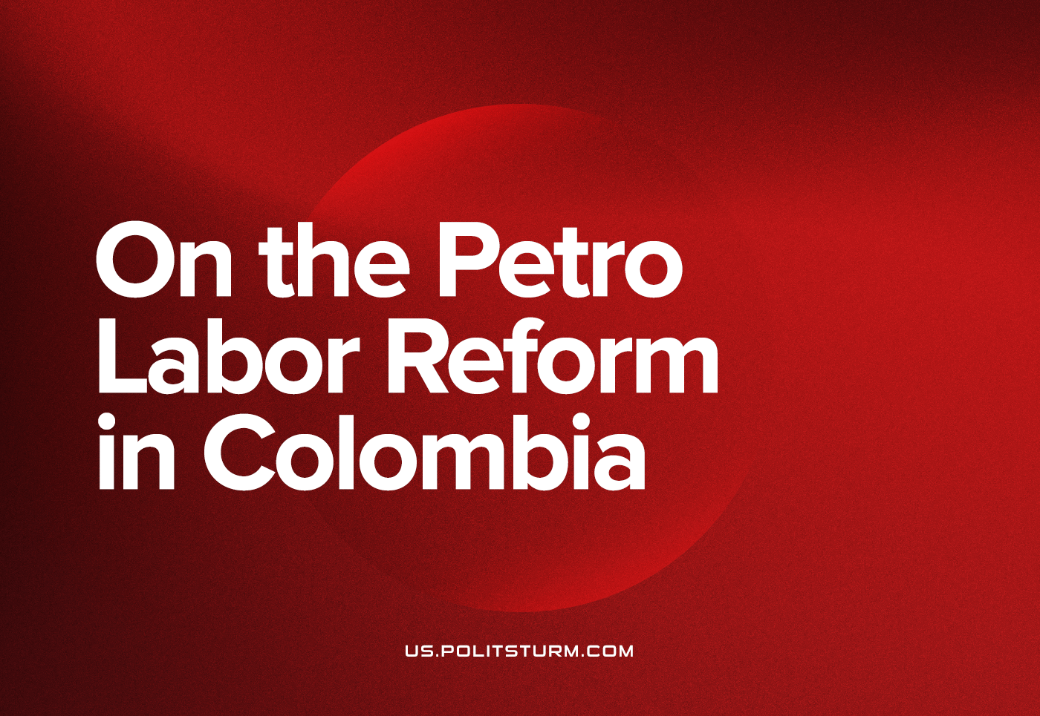

Original article
2023-06-14
13 min read

Continuing our analysis on the social-democrat government of Colombia, we will summarize the labor reform proposed by the Petro administration, which was even planned by a member of the Colombian so-called Communist Party. We previously outlined how the healthcare reform is just an attempt to make the health market functional through state intervention; to address the general lack of basic health services and rampant private corruption. In doing, we revealed the limits the proposed system would find because of the fundamental nature of the market. For the labor reform, there is more at stake for the regime of Capital because the unequal imbursement of labour is the foundation of profit. Without a revolution in the economic basis of society, any state level discussion on labor reveals the position of the current political forces towards capitalism and its failures.

Labor Reform Project
The draft begins to establish some guiding principles for labor law and regulation such as stability, minimum vital remuneration, or freedom of association and collective negotiation, among other international work standards [1, Art. 1]. Then, it limits the temporary contracts only to activities which are occasional, temporary or transitory by their own nature. For the rest, an indefinite-term labor contract is the only legal option. Temporary contracts require precise written indications on the labors and time limits covered and would become indefinite-term after 2 years of renewal, automatic renewal would be made if none of the parts notify their intention to end the contract 30 days before its' termination [1, Art. 4 and 5]. Outsourcing companies should improve the conditions of their employees with the corresponding ones for the contractor's direct employees. Companies couldn't hire trough temporary work enterprises for permanent needs and activities and should hire directly any temporary worker if the contract is extended beyond the legal time limits [1, Art. 12 and 13].
This is particularly relevant since temporary contracts and outsourcing are the most frequent mechanisms by which the Colombian bourgeoisie denies many rights and benefits to the workers outlined in law, such as biannual bonuses, social security, paid vacations and, above all, the possibility of forming a union [2].
Among other important proposals in the draft reform are the improvement of working conditions and legal status of agrarian workers [1, Art. 29-31], domestic cleaners [1, Art. 42] and workers for web delivery platforms (the ministry announced it will be extended to other web platforms after a more detailed research on each sector [3]) [1, Art. 22]. The last of these has been a main focus of discussion on the reform; the enhancement of legal recognition for unionization and strikes, and the recovery and extension of some basic worker rights that had been eliminated since the 90’s as part of the policies of the liberal consensus of the late 80’s. Those parts of the reform need a closer analysis.
Agrarian workers, along with small-scale miners, make up the sector of the proletarian which suffers the absolute lowest conditions of work and the crudest informality - normally being paid under the minimum wage - per day, or by the piece, and under verbal agreement [4, 5]. Where is the fundamental change in living security and rule of law for these workers at the base of the Colombian national economy?
Articles 29 to 31 of the draft reform explicitly establish the improvement of the conditions of agrarian and urban workers, the preference for previously hired personnel for seasonal labor and the responsibility of the employer in guaranteeing the minimum living conditions, repairs and access to public utilities in the accommodation sites for the workers.
For domestic cleaning workers, we can point out that they are often employed under shaky verbal agreements, and even worse that the previous case they are paid by the hour. In some cases, food and accommodation are subtracted from their salary, some are forced to abandon their own families to keep their job and even with its precarious conditions [6]. In their case, the Article 42 mandates written-contract hiring and all of the legal requirements. For that to be accomplished, it proposes the supervision of that regularization process by the International Labor Organization and union representatives.
Delivery riders are an emblematic case of the heightened exploitation in the new labor market, and irresponsibility, cynicism and cruelty of the capitalist class. When delivery and courier apps started to grow their business in Colombia, riders (like in other countries) were not considered employees but instead independent associates hired by the app's users. For the privilege of participation in the platform, they incurred such expenses as a cellphone capable of running the rider app (where constant updates tend to exclude older smart phones and all basic 'flip-phones', thus enforcing a market for medium and high-end devices), the corresponding mobile internet service bills and typically a company uniform and the backpack.
In addition to those non-covered expenses, these companies still pay the riders either by time or by kilometer employed in each travel under certain conditions and only after discounting a commission, that forced the deliverers to adopt risky behaviors to match the delivery time and to remain connected in the app for an unpaid time waiting for the customer to make an order [7]. After some time, the workers of those apps began to organize for legal recognition as employees of the companies that own those apps, for their social security and risk insurance payments and for wage rises and stabilization (because the prices and payments change in function of demand estimations).
In response, many companies engaged in a media campaign against those unionization initiatives aimed at convincing people that the riders didn’t deserve to be considered employees because they don’t commit to a regular schedule, that they are hired by the users for which the company acts only as an intermediary, that unions bankrupt companies (an existing myth already reinforced by liberal propaganda in the press), threatening the precious unicorns of technological innovation and entrepreneurship.
In 2020, the Colombian courts finally acknowledged the right of riders to unionize and formalized their labor relationship with the app owning companies, but not without huge efforts by workers to counteract the campaign against them by exposing their poor conditions and through mass demonstration [8].
Now, when the government proposes to regularize the riders under formal labor contracts (only excluded from the exclusivity clause for them to be able to work for more than one platform), that proposal also considers the possibility of occasional work for those platforms for future regulation, it also establishes the supervision by the Ministry of Labor over labored time, income, tasks, prices and social security payments and the report of that same information to each individual worker [1, Art. 22]. But, their livelihood still retains a precarious 'gig' basis, and foreign 'tech' finance capital continues its penetration into Colombia.
Against all of the reforms, and especially the above points, the Colombian bourgeoisie joined in another media campaign. This time, they must avoid their previous denials that delivery-riders aren't directly employed by the platform; this time, the corporate voices say this is a call for class struggle. This is itself should usually be an idea which the bourgeoisie rejects, but they claim class war is a union invention, coming from their envy and resentment against entrepenuerial altruism and success. They continue their rhetoric by saying:
• that the Colombian economy cannot meet the additional expenses of the companies
• that web delivery companies are so poor, the biggest of them is not even generating profits (but is still expanding in the region and even created its’ own digital financial platform)
• that despite the previous point about the insolvency of the platforms, a delivery-rider makes about 4 times the minimum wage,
• that traditional employment is obsolete, and it's the youth who are no longer interested in work schedules and stability
• that we need more “flexible” labor regulations, to accomodate their innovations
To finish on the abstract of the reform, it contains the proposals regarding workers’ rights, specifically unionization and strikes. Since the 90’s, the domination of a liberal economic consensus has demanded the privatization of state-owned companies, eliminating barriers for international trade (through agreements especially beneficial to the US and in the general to the whole of the developed industrial countries), deregulation of internal markets and finances, and lastly the point that most concerns this article: the elimination of labor rights and regulations.
Within the reform's proposed recovery of those lost rights there are points like the increase of fair firing compensation for the worker making it proportional to seniority [1, Art. 8], the establishment of a written procedure for fair firing with the presence of the concerned employee and union representatives [1, Art. 11], the already mentioned limitations and requirements for outsourcing and temporary hiring, the return of night work bonuses after 6pm (paid at 135% of the normal working hour, in the Uribe government the start time was moved down to 10pm and some years later that line was moved a little back to 9pm) [1, Art. 16].
Further improvements on general rights for the workers in the reform include;
• The limitation of overtime to 2 hours a day or 12 hours a week [1, Art. 19];
• The obligation for employers to allow paid or unpaid licenses for workers to assist or attend elections, home or family emergencies, union commissions, burials of co-workers (for the two last cases the licenses are limited in number to assure the functions of the company), medical appointments, medical emergencies including those caused by hormone cycles, and school obligations for parents [1, Art. 36];
• The responsibility of the employers on the implementation of effective measures against discrimination and barriers for vulnerable groups (women, LGBTQ people, ethnic minorities or disabled people) [1, Art. 37];
• The implementation of fatherhood paid license for both parents (it’s currently only accepted for mothers) starting from 5 weeks and aiming for 12 weeks in 2025 [1, Art. 43];
• The possibility of flexible scheduling by mutual agreement for employees with responsibility over children under 18 years, disabled, severely ill or elder persons [1, Art. 45];
• The protection against firing for union members, persons with health conditions or disabilities, pregnant or newborn parents up to 6 months after birth and persons within 3 years before retirement [1, Art. 7];
• And the progressive reduction of work week from 48 to 42 hours trough 5 or 6 days of between 4 to 9 hours, this is limited to certain conditions depending on the risks of the job, the age of the worker and excludes 36 hour labor week workers from that and most of the bonuses [1, Art. 17].
The reform also establishes some protections against unemployment for workers displaced by automation or 'decarbonization' [1, Art. 32 and 33].
In regards to unions and strikes, the reform establishes some guarantees like the obligation for the employer to allow 2 licensed hours for union members to participate in ordinary assemblies twice a year, establish dialogue and communication spaces between management and unions, access to locations provided by them for the unions to develop their activity, access to financial and workforce information and communication spaces between unions and the rest of the workers including recently hired ones; it also forbids some anti-union behaviors like the creation or support for employer-controlled unions, threatening or bribing the workers to avoid union affiliation, to deteriorate working conditions for union members or strikers, retaliations against workers who declare against the employer either in trials or administrative investigations, to obstruct or to sabotage union meetings or assemblies, to give any advantage for non-unionized workers, to fire a worker because of their union membership, to interfere or intervene with union internal affairs, to deny union licenses without a valid reason, to deny non-confidential or non-reserved information to unions without a valid reason, to defame or spread misinformation about unions, to carry on personnel reductions or outsourcing with anti-union purposes and to fire strikers or workers who took part in any legitimate union activity [1, Art. 47].
It also regulates the acknowledgement of collective agreements between workers and employers [1, Art. 54 and 55] and provides the extension of the agreements to all of the workers of the involved companies when the unions present in that space affiliate at least one fifth of the total employees (even if that affiliation level is reached after the signature of the agreement) [1, Art. 56], when this occurs non-unionized workers must pay an amount equivalent to the membership quota to the bigger union which took part in the collective negotiation in the case they benefit from an extended collective agreement [1, Art. 57]. On this last part, it's important to express some concerns.
Due to the fact that the collected funds are not distributed among all of the present unions, it only favors the biggest one, and generates a risk of preference for certain unions (ie, the pro-management ones) since the capitalists could exclude unions from negotiation and sign more meager agreements with those yellow unions which receive the funds. This situation already happened in the annual minimum wage negotiations, when the bigger union was excluded because they demanded a larger percentage increment than the others [9].
On the subject of strikes, the reform acknowledges them as a fundamental right for the workers [1, Art. 61], provides the condition of guaranteeing a minimum service level for their development in essential services [1, Art. 62] (previously it was illegal for this kind of services), establishes the obligation for both the authorities and the employers to respect them by forbidding the substitution of strikers by external personnel [1, Art. 67]. It limits the criminalization of strikes to those which are not peaceful, those which did not previously notifiy the employer when required, and the already-mentioned cases of unfulfilled minimum satifisfaction of essential services [1, Art. 68].
The context in which this reform is sent to the Congress – in addition to the poor conditions of agrarian workers, small-scale miners, domestic cleaners and gig workers — is that Colombia is one of the most dangerous countries for union activity [10], with one of the longest work weeks [11] while still suffering the same loss of jobs from de-industrialization as other dependent economies.
Within the State, the Executive and Legislative had implemented many anti-labor policies since the 90’s, obeying the liberal consensus which destroyed the welfare-state after the fall of the USSR, while the Judiciary tried to provide a legal background for the legal protection of labor since the beginning of the new millennium, this is not the result of an explicit pro-labor position but of a social liberal tradition inherited from the 1992 Constitution and the signature of ILO recommendations and other international human rights agreements [12]. The reform originates from this social liberal tradition and even abides to previous call from the courts for the effective implementation of constitutional rights, in general the reform goes a very little beyond that perspective of “equilibrium” between labor and capital.
Despite that legalist and conciliatory character, the reform has not only faced the unified opposition leaded by delivery platform owners but recently a former vice-president and minister expressed the intention of many capitalists and petty-bourgeois of expressing their disagreement with the reform by massive layoffs [13] and a report made by some of the “technical” board of the Bank of the Republic telling the same old story of capitalist not being able to afford labor costs and then giving a “technical” justification of the threats expressed earlier [14]. “Technical” analysis of that kind from orthodox economists can only be accepted as technical if we accept that economy is not the subject of social science. Its theories rely on certain “indisputable truths”, the result of class ideology of the same class which promised that unemployment will be reduced by cutting “labor costs” for the last 30 years.

Conclusions
But, why do we criticize an initiative that would improve the situation of many workers and which is so strongly opposed by the bourgeoisie? Why do we keep our distances from a government that has even been praised for its policies by the IMF [15]?
It is not simply because, for communists, critique is a fundamental principle, but because we do not seek the regulation of capitalism. We struggle for a whole new society free from exploitation and under the democratic rule of the working people. We cannot forget that any right or reform in favor of the toiling masses under capitalism is always an incomplete victory, inevitably subject to the needs of Capital to reduce costs to free resources for competition amongst the capitalists and primarily aiming at preserving their class rule by placating those masses and keeping them away from an open struggle.
“For us the issue cannot be the alteration of private property but only its annihilation, not the smoothing over of class antagonisms but the abolition of classes, not the improvement of the existing society but the foundation of a new one.”
K. Marx, Address of the Central Authority to the Communist League, 1850.
Even the so-called communists of the Colombian Communist Party have forgotten their place in the struggle in forming the alliance with Petro which inked this policy. After the mass-killings of the CCP members and leaders and the dissolution of the USSR, this party became insignificant in the struggle even while holding elected office. This brought them into consecutive opportunist alliances with whomever opposed the traditional two parties, the Liberals and Conservatives.
With the Uribe presidency, they met Petro around 2008 in an electoral front called the Democratic Alternative Pole (PDA). At that time, each was hostile to the other because of Petro's attempts to impose a strong rejection of the “armed struggle” [16] as an appeal to the prevailing “Global War Against Terror” propaganda from the U.S. In 2010, the PDA front split after Petro denounced the corruption of Samuel Moreno, the mayor of Colombia's capitol city elected by that party, whom the CCP[17]. Some time after, the CCP was expelled from the PDA [18], returning to erratic alliances in order to retain some electoral significance until they allied again with Petro in 2017 (supportung his presidential campaign the next year) [19], being his movement the biggest founder. As a way to acknowledge the CCP participation in his movement Petro called two of their members for his first cabinet, along with members of the traditional parties and other corrupts, all for the sake of “democratic unity” and peaceful governance.
This is very expressive of their reasons for proposing such a bourgeois legalist reform, while defending it as the most advanced in Colombia's recent history. That’s obviously the more advanced labor law adjustment that could receive any capitalist support, the “reasonable middle path” within the legal misery national big capitals needs to compete with more productive economies and the legal improvements workers could demand to afford an enjoyable life for a decent amount of work.
Marx tells us:
We have seen how the democrats will come to power with the next movement, how they will be compelled to propose more or less socialist measures. It will be asked what measures the workers ought to propose in reply. At the beginning of the movement, of course, the workers cannot yet propose any directly communist measures.
But the following courses of action are possible:
1. Compel the democrats to interfere in as many spheres as possible of the hitherto existing social order, to disturb its regular course and to compromise themselves as well as to concentrate the utmost possible productive forces, means of transport, factories, railways, etc., in the hands of the state.
2. They must carry to the extreme the proposals of the democrats, who in any case will not act in a revolutionary but in a merely reformist manner, and transform them into direct attacks upon private property; thus, for example, if the petty bourgeois propose purchase of the railways and factories, the workers must demand that these railways and factories should be simply confiscated by the state without compensation as being the property of reactionaries. If the democrats propose proportional taxation, the workers must demand progressive taxation; if the democrats themselves put forward a moderately progressive taxation, the workers must insist on a taxation with rates that rise so steeply that big capital will be ruined by it; if the democrats demand the regulation of state debts, the workers must demand state bankruptcy. Thus, the demands of the workers must everywhere be governed by the concessions and measures of the democrats. — K. Marx, ibid.
Then we cannot forget that social-democracy proposes those slightly beneficial reforms not because their goal is to improve the conditions of workers but because they want to reach an “equilibrium” and reconciliation between exploiters and the exploited ones, they want pacific exploitation.
In this reform, we are seeing how pacification can’t be satisfactorily achieved by social democrats under normal conditions, as the right wing of the bourgeoisie will oppose any pro-labor policy unless it buys them time against an imminent revolution, and that’s not the Colombian case. In any other situation they will keep proposing “labor-cost reductions” either by saying that it’s required for “technical” reasons, and otherwise enforcing their will through violence from both their state and their fascist squads. This all happens while our day to day needs compel us to struggle for higher wages, for more time out of monotonous and tiresome employment to address the mounting social issues at home and seek our personal goals for the development of our human capacities, to eliminate overproduction and restore the regular environmental conditions that support our life, and to transform work from a dehumanizing and meaningless activity into an expression of social-wide solidarity which reflects and enhances our talents. We must openly declare the failures of social-democratic proposals which expose the limits of the capitalist “democracy”; its class dictatorial nature.
Sources:
[1] https://www.mintrabajo.gov.co/documents/20147/0/Proyecto_Reforma_Laboral_Congreso_removed+%281%29.pdf
[2] https://ail.ens.org.co/informe-especial/nuevo-decreto-583-tercerizacion-laboral-colombia-gran-retroceso/
[3] https://www.elespectador.com/economia/reforma-laboral-mas-de-700-plataformas-digitales-serian-reguladas-en-colombia/
[4] https://ail.ens.org.co/opinion/mas-precariedad-laboral-para-el-sector-agropecuario/
[5] https://ail.ens.org.co/derecho-laboral/la-formalizacion-laboral-pequena-mediana-mineria-tambien-parte-del-debate/
[6] https://ail.ens.org.co/informe-especial/historias-tras-las-cortinas-cifras-y-testimonios-sobre-el-trabajo-domestico-en-colombia/
[7] https://ail.ens.org.co/opinion/lo-que-no-le-cuenta-rappi-a-los-colombianos/
[8] https://www.solidaritycenter.org/colombia-gig-economy-workers-wage-country-wide-protest-for-rights/
[9] https://cut.org.co/central-unitria-de-trabajadores-excluida-por-el-gobierno-de-negociacion-sobre-salario-minimo/
[10] https://www.bbc.com/mundo/noticias/2013/05/130430_colombia_sindicalismo_peligros_aw
[11] https://www.businessinsider.com/ranking-countries-with-longer-workweeks-than-the-us-2019-8#1-colombia-has-a-477-hour-workweek-19
[12] https://www.ilo.org/wcmsp5/groups/public/---americas/---ro-lima/---sro-lima/documents/publication/wcms_866312.pdf
[13] https://www.elespectador.com/politica/congresistas-rechazan-advertencias-de-vargas-lleras-sobre-despidos-masivos-si-se-aprueba-la-reforma-laboral/
[14] https://www.nhregister.com/news/world/article/banco-de-colombia-cuestiona-la-reforma-laboral-de-18090840.php
[15] https://forbes.co/2023/03/24/economia-y-finanzas/fmi-elogia-reformas-sociales-de-petro-y-solidez-de-la-economia-colombiana

Original article

