On The False Anti-Imperialism
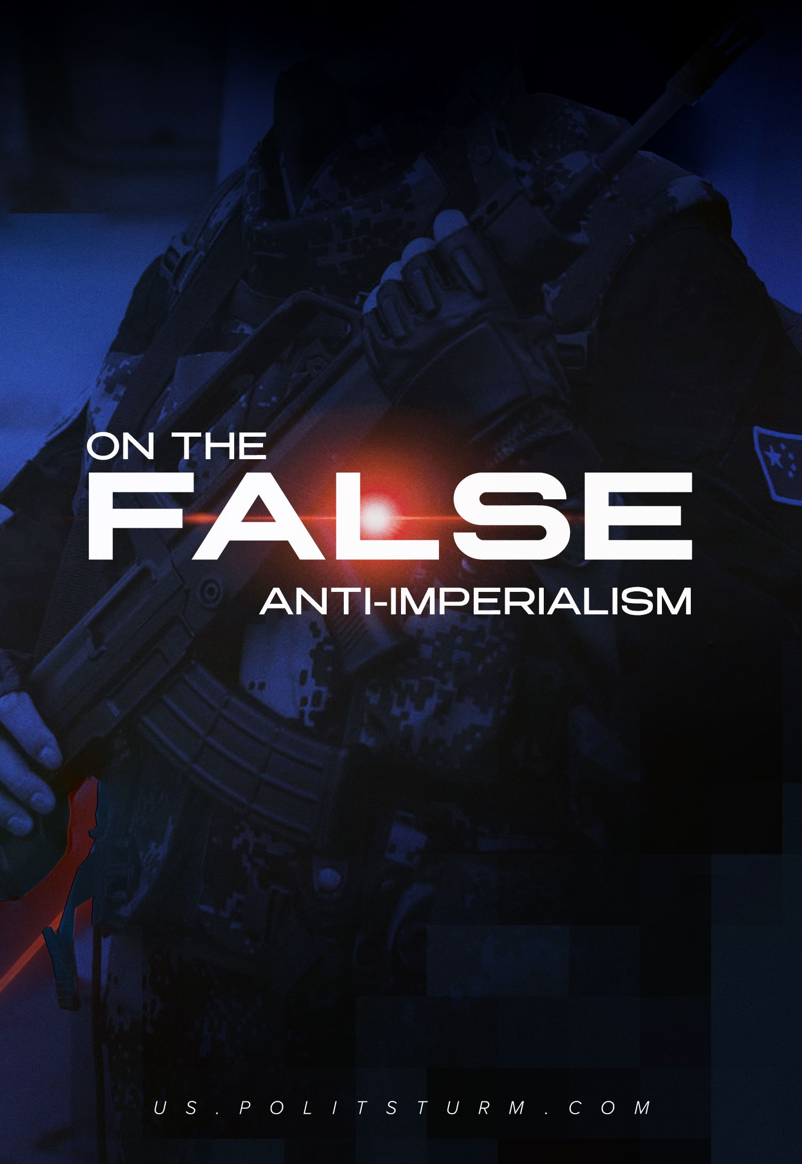

Original article
2023-11-04
44 min read

On The False Anti-Imperialism
Recently, a number of bourgeois states have increasingly begun to use the term “anti-imperialism”, such as China, Russia, Latin American countries and some pseudo-socialist states. They claim to be on the side of “resistance” to the West, or more precisely, to the imperialist policies pursued by the Western powers.
However, their “anti-imperialism” has nothing in common with genuine communist anti-imperialism, since these countries use such rhetoric to justify their own expansionist policies aimed to redistribute the world market.
Having rejected the economic essence of imperialism which is monopoly capitalism, they simplified and reduced imperialism to only an aggressive foreign policy. By presenting themselves as victims of Western pressure, these and other countries justify their own aggressive foreign policy, which still has the same imperialist features as it is shaped by the same imperialist capitalism.

1. Who uses anti-imperialist rhetoric?

1.1 PRC
China has repeatedly stated that it stands for anti-imperialism. Chinese leader Xi Jinping actively speaks about opposition to American hegemony in his propaganda. Theses about the “anti-imperialism” of China are combined with promotion of the “socialist” character of modern China.
"We comprehensively promote the diplomacy of a major power with Chinese characteristics, contribute to building a community with a common destiny for mankind, and resolutely defend impartiality and justice in international relations, advocate and practice true multilateralism, and take a clear stance against hegemonism and the policy of brute force," Xi Jinping said. [1].
The 2021 “Resolution of the CPC Central Committee on the Major Achievements and Historical Experience of the Party over the Past Century” places special emphasis on the fight against unipolarity:
“The Party promoted the development of a multipolar world and the democratization of international relations and pushed economic globalization in a direction toward common prosperity. China took an unequivocal stand against hegemonism and power politics” [2].
The market-oriented reforms which were carried out from 1979 until the end of the 20th century turned China into a strong capitalist power with its own interests in the world market. The CPC encouraged a policy of foreign direct investment, using cheap labour as the main advantage of the country.
Economic growth was followed by deterioration of working conditions and the further cheapening of Chinese workers' labour. Direct foreign investment also led to the creation of giant companies: 20 years ago only two Chinese companies were in the “Global Fortune 500” list, 10 years later there were already 22, and now there are more than a hundred Chinese enterprises. In addition, there are three Chinese companies that are among the top five largest multinational companies in the world.
Chinese capitalists, having increased their capital and strengthened themselves, through the "communist" party that they controlled and the Chinese state, eventually switched to direct foreign investment themselves. China has begun to carve out its own share of the world market: today the volume of exported Chinese capital exceeds imported capital.
According to Visual Capitalist, China's share in the global gross domestic product (GDP) accounts for $18.3 trillion, out of a total world GDP of more than $100 trillion. To compare, the US's GDP for the same year was $25 trillion. Over the past 20 years, China has significantly increased its foreign investment: in 2022, there were almost no countries left where China has no investments.
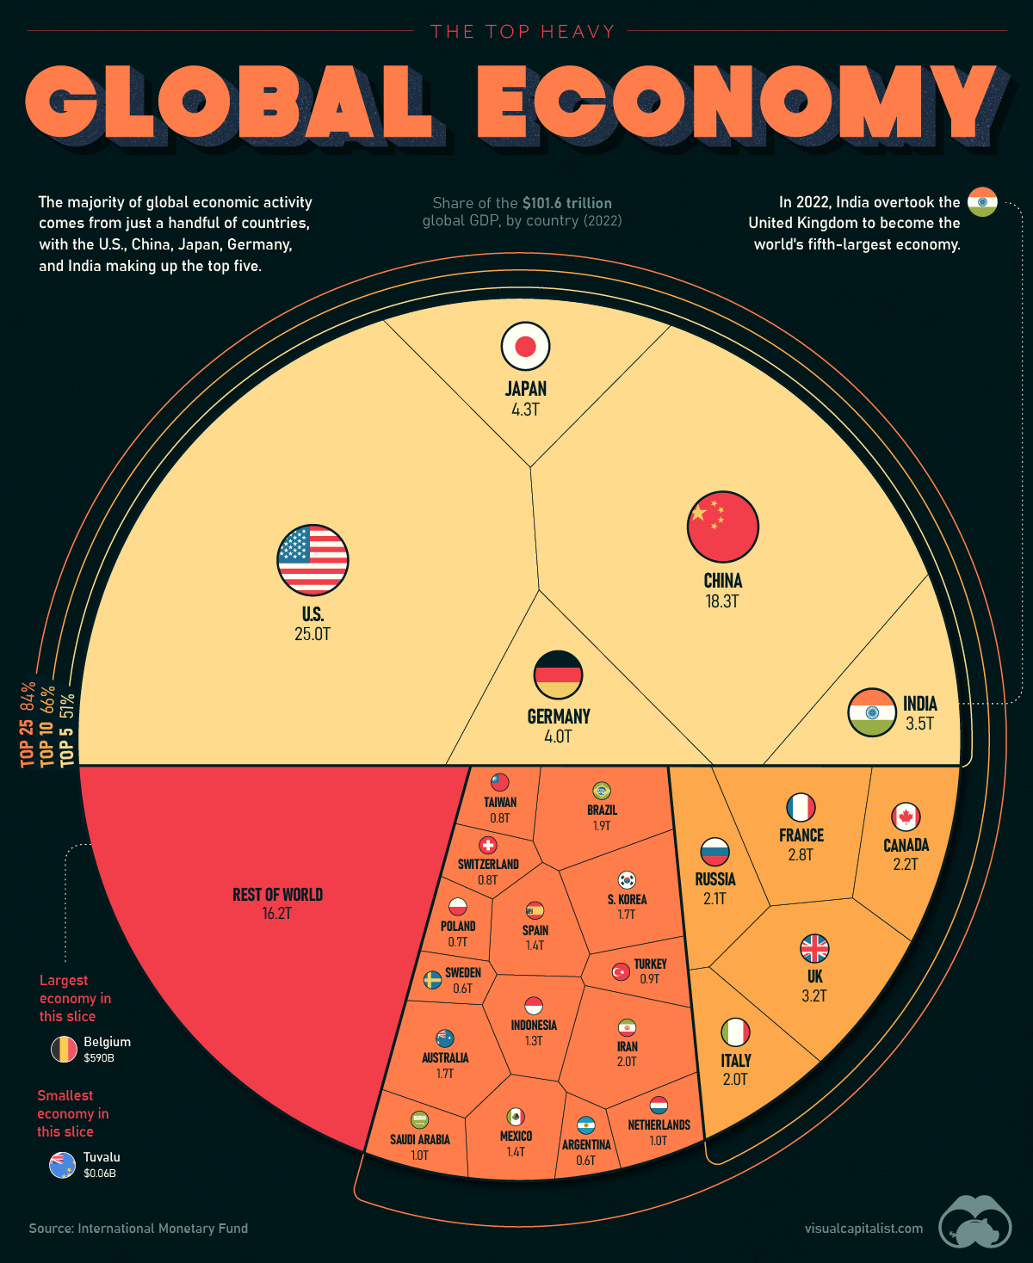
The largest recipients of Chinese investments over the last 17 years are countries such as the USA, Australia, Great Britain, as well as Brazil, Switzerland, Canada and Germany [3]. According to recent studies, the most economically dependent countries on China are Singapore, Taiwan, Vietnam, South Korea and Malaysia [4].
Having created “special economic zones” and joined the WTO, the next step in the economic expansion of Chinese capital was the Belt and Road Initiative, which connects China to Europe via land and sea routes. By penetrating other markets, Chinese capital exploits local labour. Every year, China's economy is growing and looking for new ways to continue expanding. The Belt and Road enslaves the countries of Asia and Africa, and the numerous loans that China issues to many countries make them economically and politically dependent on it.
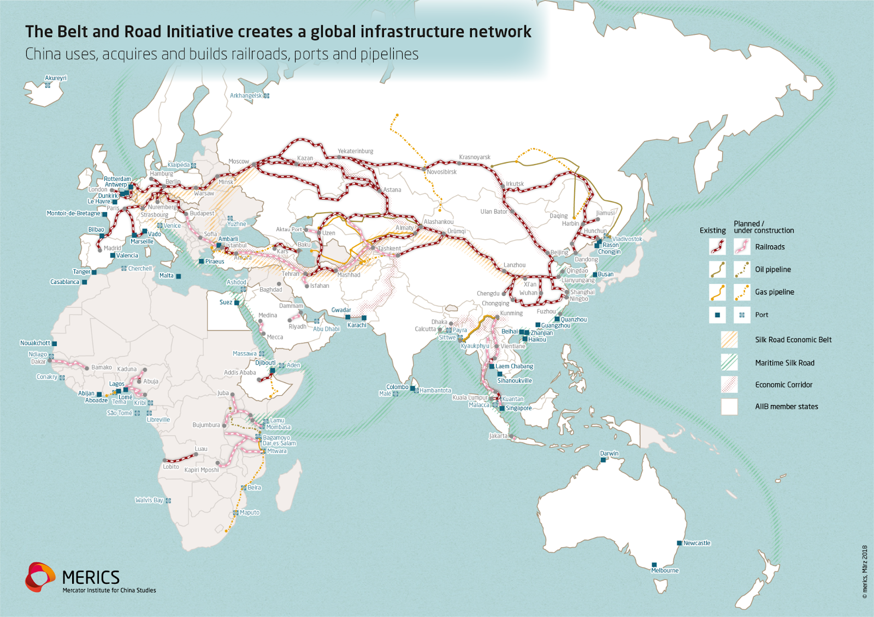
Map of “Belt and road” initiative
In one of our materials, we already revealed how China is building factories and power plants in Kazakhstan, transporting gas and crude oil back home; using the country as a raw material appendage. African countries have also been the object of China's expansion: the number of Chinese investor companies in Africa increased by 108% from 2013 to 2016, indicating a significant increase in the presence of Chinese capital on the continent.
At the same time, the CPC covers up its lending, with honeyed words about noble assistance to states that are lagging behind. However, if we examine the situation in Montenegro and Sri Lanka for example, China’s lending to countries is revealed to not be noble at all.
It is expected that in the near future China will demand that Montenegro hand over the port of Bar to it as well as taking a 93% completed highway for the duration of 100 years as a concession for its debt. Sri Lanka has already faced a similar situation, where, as part of fulfilling its debt obligations, it has already leased the deep-water port of Hambantota to China for 99 years, repaying only ⅛ of its debt.
Facing opposition from American capital in carrying out its economic expansion, China is building up an appropriate policy.
Firstly, China is seeking to enter into an alliance with countries which will make confrontation with the United States and its allies easier.
Secondly, China is creating a belt of countries dependent on it, increasing the total economic and political power of Chinese imperialism.
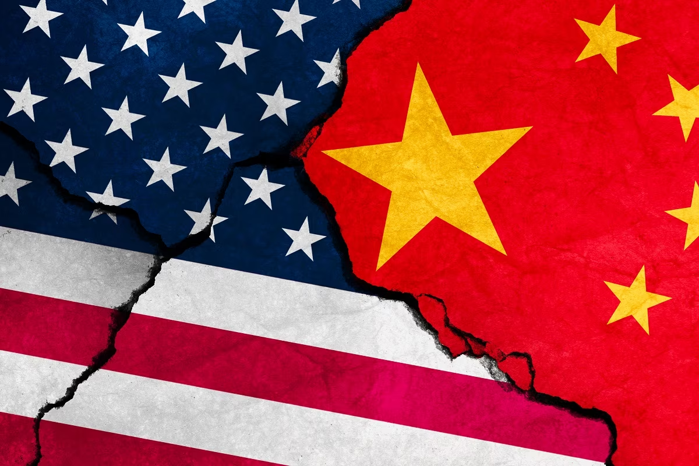
In this case, pseudo-anti-imperialist rhetoric becomes one of the most convenient tools of Chinese propaganda. By opposing American and European hegemony and imperialism, China is winning over weak capitalist countries that are under pressure from Western powers or under the influence of Western capital.
Under the slogans of building a multipolar world in which American dominance will end, China is putting together an alliance of powers that fall under the influence of China and compete against Western capital. The instrument for creating such an alliance — or “belt of dependent countries” — was BRICS. Five states - Brazil, Russia, India, China, South Africa, three of which - Brazil, Russia and South Africa - are under great economic influence from China.
“All BRICS countries are important emerging markets, major developing countries and constructive forces representing the direction of world development,” said Chinese Foreign Minister Wang Yi [5].
He noted: “China is willing to work closely with Russia and other BRICS countries to help make BRICS cooperation more substantial, strong and broad-based, and to protect the common interests of developing countries.”
The leadership of the PRC, in words declaring itself to be communist and claiming to adhere to the teachings of Marxism in its policies, quite naturally found an explanation for its own imperialist policy using the rhetoric of anti-imperialism.
Having blamed the United States as the sole source of world problems, China is trying to convince the population of weak countries that they are fighting against American and any other hegemony, supposedly in order to restore a fair world order. But this only conceals Chinese plans to expand its share of the world market and increase the number of countries dependent on it.

1.2 Russia
Manipulation of the class consciousness of working people in Russia and its “friendly” countries is carried out in exactly the same manner as in China: by creating the image of an enemy who holds the whole world hostage, and building the image of the Russian Federation too as an “anti-imperialist” and “anti-colonial” force.
“Power over the world is exactly what the so-called West has at stake in its game. But this game is, of course, dangerous, bloody and, I would say, dirty,” says Vladimir Putin [6].
Western powers, according to Russian authorities, have always been engaged in the oppression of other countries. This serves as an unspoken justification for Russia's own expansion. Russian propaganda is trying to make it seem like Russia is supposedly defending not only itself, but also other countries that are oppressed by Western powers. Russian authorities are calling for change, a fairer world and “multipolarity” so that each state can benefit from mutual economic activity.
The propaganda particularly emphasizes that the imperialists, represented by the United States and the EU countries, are in confrontation with Russia and its allies, the latter of whom are simply anti-imperialists who want a “just world.” In this context, it is useful to consider the joint statement of Vladimir Putin and Chinese President Xi Jinping dated February 4, 2022, published in Beijing [7]. Russia and China are calling for a new world order, which the “world community” needs, and the special operation in Ukraine is considered by the President of the Russian Federation as the basis of this honest multipolar world [8].
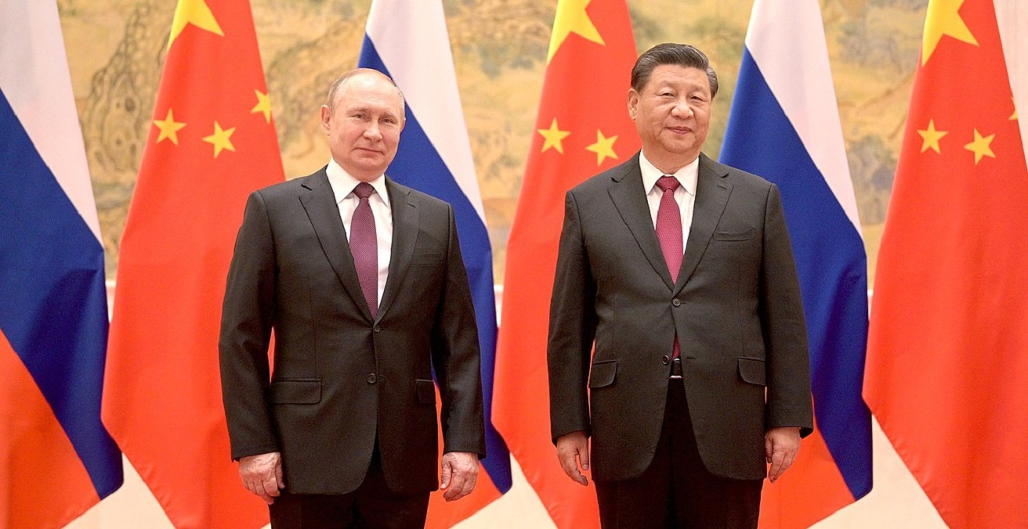
Vladimir Putin and Xi Jinping, source: International Affairs
But in reality, Russia, just like China, wants to dictate its own terms to other states and bring more countries under its influence. In particular, the CIS countries, some countries of Africa and Latin America fall under the Russian influence.
The expansion of Russian capital historically began with the Commonwealth of Independent States (CIS). Although direct investment in the CIS does not account for the majority of Russian investment, Russian companies have long been established in these countries.
Since the 2010s Russia has been particularly active in its expansion in Africa. First of all, Russian capital was attracted by the resource wealth of the “dark continent”: 35–40% of all the minerals on Earth are located in Africa, and this is extremely attractive for Russian capital [9].
“Mutual trade turnover with African countries is growing every year, which at the end of last year reached almost $18 billion. This is far from the limit” said Vladimir Putin in his speech at the interparliamentary conference “Russia – Africa in a multipolar world” [10].
In addition, Russia views Africa also as a sales market. In 2022, about 22% of Russian supplies to the African market were oil and petroleum products, and the key companies in oil and gas projects in African countries are Lukoil, Gazprom and Rosneft [11].
The largest Russian corporations are intensively increasing their influence in African countries: Rosatom is building a nuclear power plant in Egypt, Alrosa is participating in joint ventures for diamond mining in Angola and Zimbabwe, Rusal is working in Guinea. Russian specialists participate in geological research on the basis of intergovernmental agreements in Equatorial Guinea, Angola and a number of other states [12].
The African market is not yet very popular among Russian banks, but a number of Russian banks still have their own divisions in Africa: VTB, Renaissance Capital and Renaissance Credit. Vnesheconombank is also conducting projects and activities in Africa [13].
Russian imports include food products and agricultural raw materials (64%), manganese concentrates and mineral products, textiles. The composition of Russian exports includes cereals, weapons and military equipment, petroleum products (these three categories account for 70% of the total export volume), vehicles and equipment, food and ferrous metals [14].
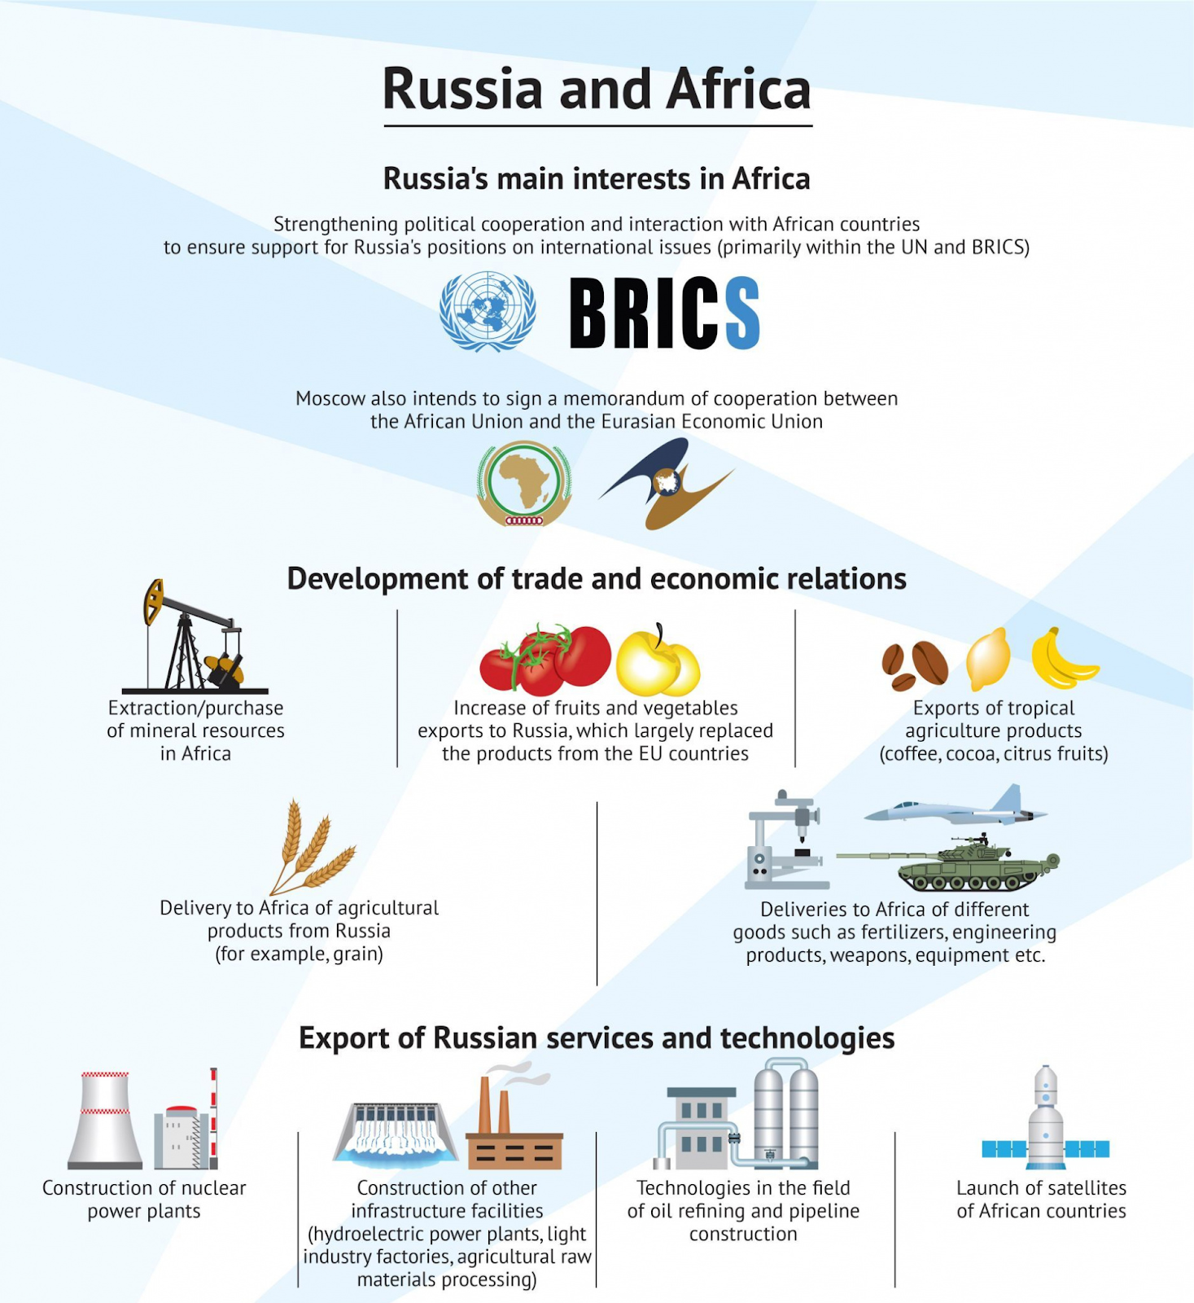
Source: ValdaiClub
According to estimates by the Stockholm International Peace Research Institute (SIPRI), Russia ranks first in arms supplies to Africa. The largest buyers are Algeria, Egypt, Angola, Sudan, Uganda and Ethiopia. According to JSC Rosoboronexport data, in 2021 the volume of contracts approached 2.5 billion euros.
Russia wants to make as many countries dependent on it as possible, so for Africa, the Russian authorities are offering all sorts of deals that will push African countries into dependency. To differentiate its expansion in Africa from that of Western capital, the Russian leadership uses anti-imperialist rhetoric, as well as statements about assistance to underdeveloped countries.
But at the same time, Wagner PMC has been operating in Africa for a long time, specifically in the Central African Republic (CAR), Libya, Mali and Sudan, each of which has extremely strained relations with the West [15]. In exchange for diplomatic support and concessions in resources, PMC Wagner Group provided military assistance to the governments of these countries in defence against insurgents.
Through its military force, the Russian Federation gradually carried out the economic subjugation of Africa. In 2018, about a thousand mercenaries were deployed to protect the government of the CAR. In exchange, subsidiaries of the PMC Wagner Group received unlimited logging rights in the country and control over the profitable Ndassima gold mine.
Another example is Sudan. Since 2017, PMC Wagner Group has trained Sudanese military personnel, protected mineral resources and suppressed dissent against the government of President Omar al-Bashir in exchange for gold exports to Russia.
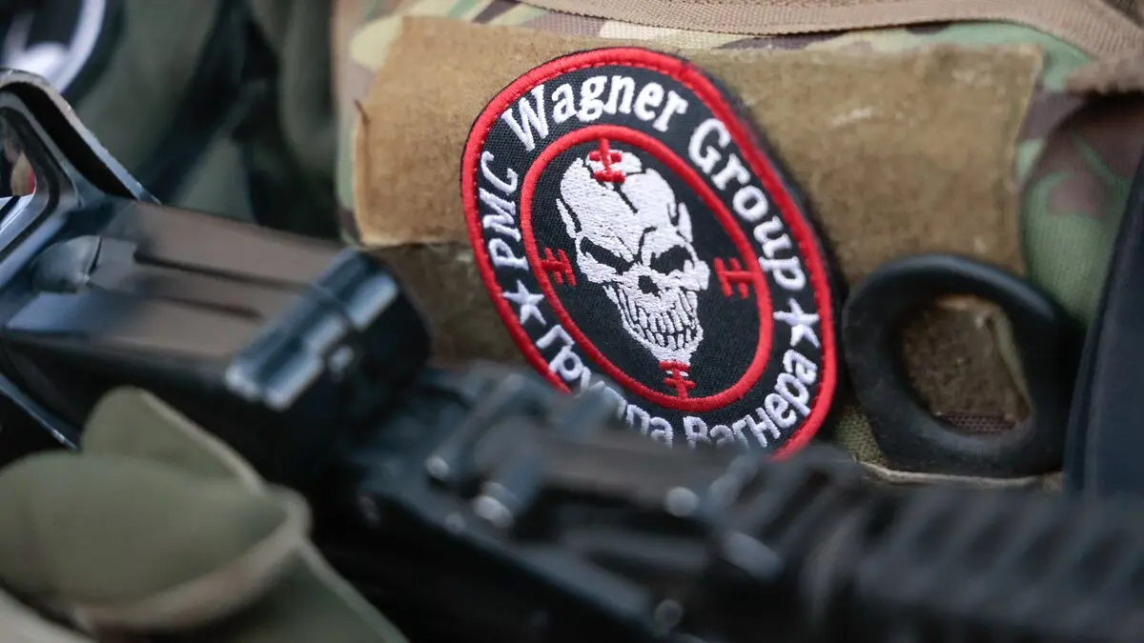
Wagner's involvement in Africa was accompanied by the brutal treatment of local populations and contributed to general instability in the region. In Libya, Wagner Group troops, who fought alongside the Libyan National Army during the 2019 Tripoli campaign, were accused of committing extrajudicial killings and planting landmines in civilian areas [16].
In any case, before the death of Prigozhin, the CAR army worked closely with Wagner, and the local population was afraid to speak directly about the atrocities and violence committed by PMCs in their country. With impunity, they arbitrarily detained, tortured, kidnapped and executed without trial.
The Russian government has so far kept itself distant from Wagner PMC, pretending that it is not involved in its activities, saying things like “it is a question for the sovereign governments of African countries whether Wagner group will or will not be present on their territory” [17].
To win over African countries, the Russian government organizes summits and forums, idealizing the relationship between Russia and Africa and creating the appearance of close cooperation. On July 27 and 28, 2023, the Russia-Africa summit was held in St. Petersburg and, within its framework, the Russian-African economic and humanitarian forum.
Its goal was to strengthen “comprehensive and equal cooperation” between Moscow and African countries “in all dimensions” including: politics, security, economics, scientific, technical and humanitarian causes.
“For our country, the African continent has never been a subject of mercantile interest, for the use of labor and raw materials, which cannot be said about the United States and European countries,” said Chairman of the State Duma Vyacheslav Volodin [18].
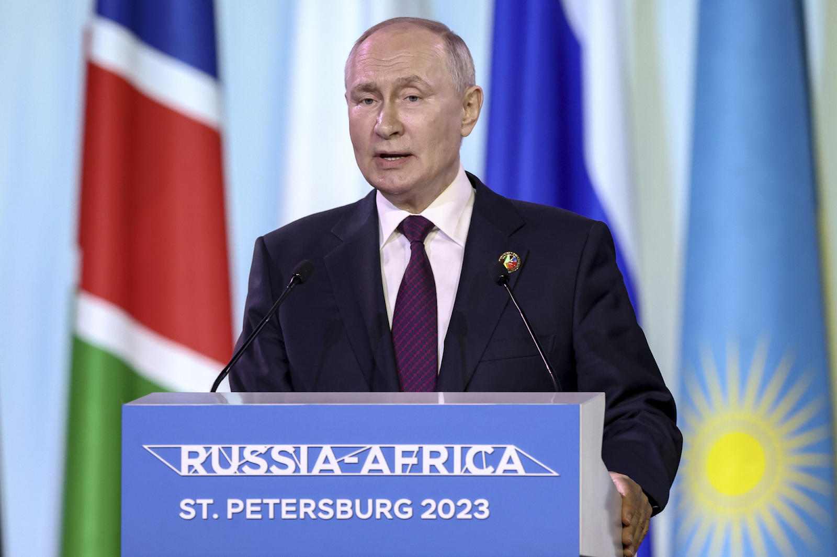
Russian President Vladimir Putin at the Russia-Africa summit in St. Petersburg
The Russian President Putin generously promises African countries to get rid of the colonial past, assuring that “Russia and African countries are resisting the neocolonial ideology imposed from outside” [19]. In fact, Russia is carrying out aggressive economic and political expansion in Africa, and the dominance of Russian capital is essentially no different from the dominance of Western or Chinese capital there: countries are used as markets, resources and raw materials appendices, and places for capital investment.
Latin American countries are another region in which Russian capital is expanding its influence. For a long time, until 2022, these countries remained without much attention, but now they have become attractive to Russia. It must be said that Latin American countries have been under serious influence and pressure from the United States, and in recent years from China too, so Russia doesn’t have as many chances there. Nevertheless, the Russian Federation is trying to extract any possible profit.
Cuba, which is economically isolated, shows a special inclination towards Russian capital. The Russian Federation constantly expresses its political support for it and declares special relations with Cuba [20]. “Freedom Island” reciprocates.
At the same time, all these speeches cover up the true significance of Cuba for the Russian authorities: Cuba is primarily of interest as a market for sales and investment of capital.
In Cuba, for example, UAZ cars are being assembled and other Russian-made cars are sold. Recently, about 2,500 KamAZ vehicles were delivered to Cuba [21]. Russian corporations are planning to create a service center for their repair and maintenance.
There are also projects for the construction of a solar power plant, reconstruction of light industry enterprises, organization of production of building materials, flour, juices, alcoholic beverages, processing of soybean cake and sugar cane, which is especially important for the Cuban economy — all this in exchange for supplies of mineral fertilizers from Russia [22].
Rosneft and Zarubezhneft expanded their activities in Cuba [23]. They are implementing a joint project on the Cuban shelf in the Gulf of Mexico, already agreeing on production sharing. In addition, they received rights to the Boca de Jaruco oilfields in order to increase their oil output.
The Russian company “Industrial Engineering”, under a contract with the Cuban Acinox Comercial, is implementing a project to modernize the largest metallurgical plant on the island — named after Jose Marti.
The major energy project, worth €1.2 billion, includes the construction of four new power units with a capacity of 200 MW each: three at the East Havana Thermal Power Plant and one at the Maximo Gomez Thermal Power Plant.
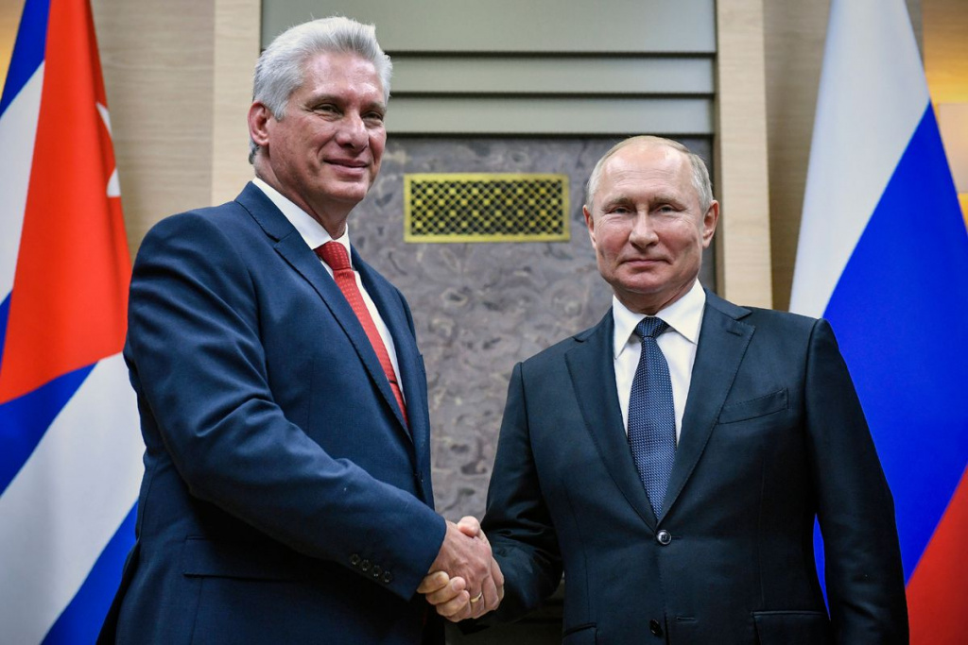
Miguel Diaz-Canel and Vladimir Putin
The total trade turnover between Russia and Cuba at the end of 2022 has tripled.
In addition, the Russian Federation is pursuing a more open aggressive policy, participating in various armed conflicts. They are presented by state propaganda as an act of “restoring justice,” but in essence they are the implementation of purely cynical economic and political goals.
For example, Russia’s intervention in the Georgian-Ossetian conflict had several reasons, both political and economic. The official reason was proclaimed to be selfless assistance to South Ossetia in separating from Georgia.
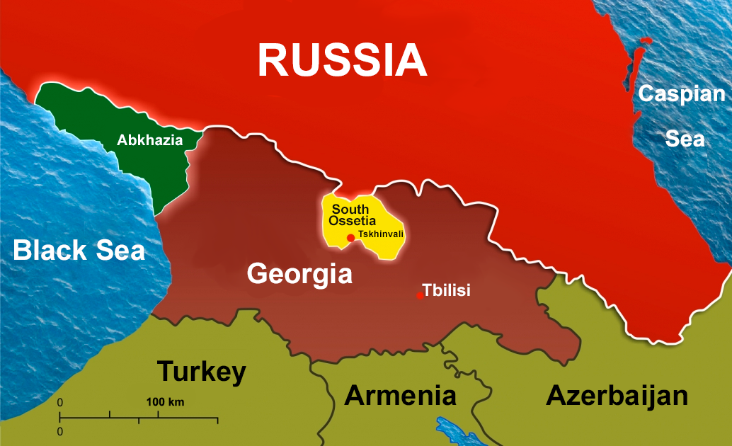
Maintaining territories beyond its control on Georgian territory met the interests of Russian elites in expansion in the Caucasus and keeping Georgia from joining the North Atlantic Treaty Organization, with which Georgia began cooperation in 1992.
There were also purely economic reasons. First of all, the opportunity to supply gas to South Ossetia, which turned out to be an ideal place for Russian expansion: to this day, investments in the development of South Ossetia exceed 1 billion rubles. At the same time, Russia invests more than 7 billion rubles of financial assistance every year directly into the budget of South Ossetia itself, while the total budget of South Ossetia was 8.7 billion rubles for 2023 [24].
Russia has been practically the only foreign trade partner of South Ossetia since August 2008. At the end of 2022, REC group companies supported Russian exports to the republic for a total amount of more than $20.6 million [25].
Just like South Ossetia, Ukraine is not apathetic to Russian capital. There are a number of political and economic reasons behind the “special military operation”. In one of our previous publications, we already touched upon the issue of the true interests of Russian capital in Ukraine.
The largest number of Russian investments among the CIS countries was invested in Ukraine — about $17 billion. Russian capital in 2001–2006. controlled more than 90% of the design capacity of Ukrainian oil refining, 85% of oil supplies and 70% of the retail market, but the Western bourgeoisie increased its influence and constantly sought to stand in the way of Russian capitalists.
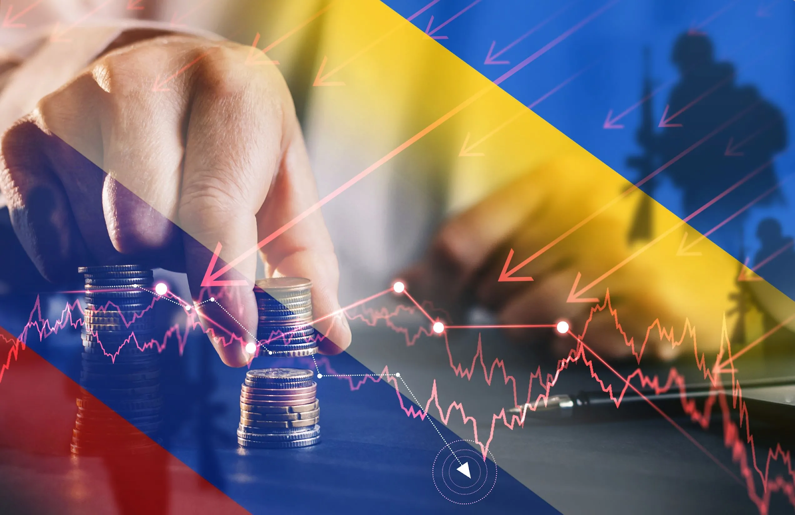
There was a competitive struggle between Russian and Ukrainian metallurgical corporations over markets for semi-finished products (slabs and square billets), which are used for production of rolled metal in the target markets of the USA, Europe and China.
In addition, the country became a donor of migrant labour to the countries of Central and Eastern Europe as well as the Russian Federation after the migration crisis in Europe in 2014 and the reduction of migration flows from Asia and Africa.
Ukraine has become a competitor in agriculture. The Russian and Ukrainian agro-industrial complexes are fighting for markets to sell their products (e.g. EU, China, Egypt, Gulf countries).
Accordingly, the production capacities and resources of Ukraine are capable of significantly strengthening the wealth of the Russian bourgeoisie, increasing its ability to export raw materials, and eliminating a direct competitor.
The main goal of the Russian Federation in Ukraine is to protect and expand its sphere of influence in order to prevent the final absorption of its market and resources by “the West”. This is also why there is a need to have some kind of “buffer zone”, thanks to which the state border is conditionally moved away.
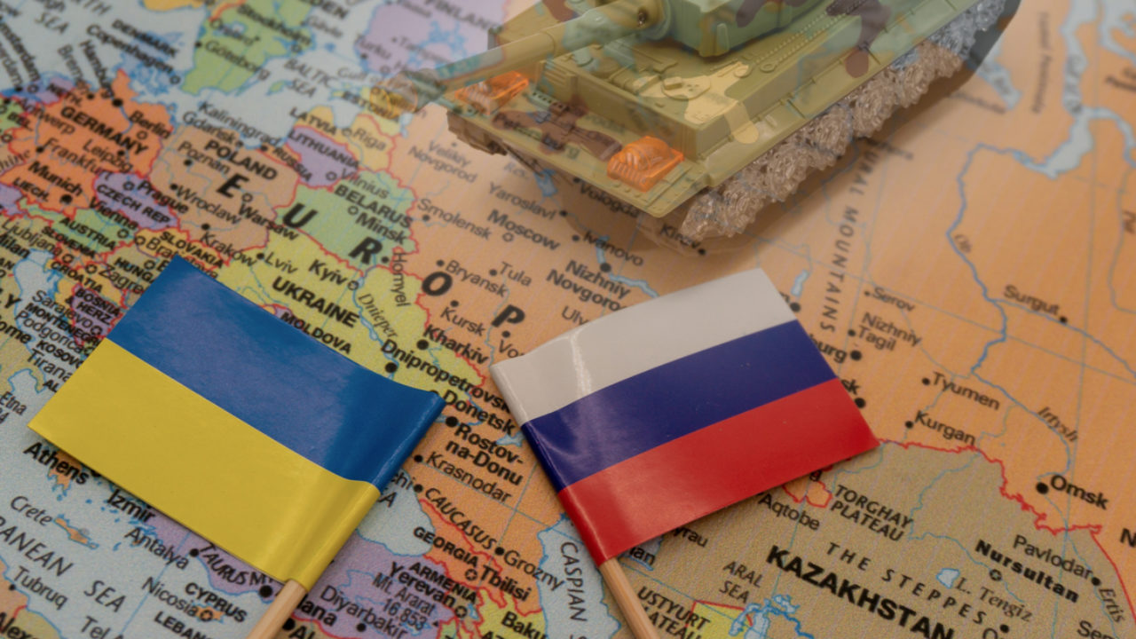
In such zones, one can create puppet regimes, place military bases, thereby expanding one's zone of influence, and in the event of a military conflict, transfer military operations there. In this regard, control over the Crimean Peninsula, Zmein Island, and such large ports as Odessa, Sevastopol, Nikolaev and Mariupol is strategically important for the control of the Black Sea.
But the authorities in Russia continue to insist that its policies in general - and in Ukraine in particular - are aimed at fighting imperialism. Putin is trying his best to convince other countries that Russia is fighting for justice, which will prevail as soon as a multipolar world order comes under the leadership of Russia and China [26].
“We are confident that the new, multipolar world order, the contours of which have already been outlined, will be more fair and democratic. And there is no doubt that Africa, along with Asia, the Middle East, and Latin America, will take its rightful place in it, and will finally free itself from the heavy legacy of colonialism and neocolonialism, rejecting its modern practices” [10].
Pseudo-anti-imperialism plays a significant role in the speech of bourgeois politicians and is a key justification for conflicts and expansion. In contrast to the current situation in the world, where “America and European countries are to blame for everything,” a different picture of the world is painted, in which “every country could claim it's place under the sun with the support of China and Russia.”
China and Russia say that together they are defending the world from American imperialism. They speak with one voice about a multipolar world, but they themselves export their capital to other countries, make them dependent and absorb their resources. The imaginary benefit that dependent countries receive cannot be compared with the profit that Russian and Chinese capital derives from their dependency. By speaking about the destruction of imperialism and the creation of a new world, they only cover up their own interests, which are exactly the same as all other capitalist countries.
The concept of a “multipolar world order” only serves to benefit the imperialist interests of Russia and China. The struggle to replace the “unipolar” world with a “multipolar” one covers up the struggle of several imperialist powers for dominance in the world. Under the conditions of capitalism, the peaceful coexistence of several strong imperialist powers is impossible: a new world conflict over the redistribution of world markets is inevitably brewing.
In addition to China and Russia, there are a number of countries that actively use pseudo-anti-imperialist rhetoric. These are Latin American countries and pseudo-socialist countries that have experienced the invasion and economic pressure of capitalist monopolies.

1.3 Venezuela
The President of Venezuela is actively using the rhetoric of anti-imperialism to deceive Venezuelan workers, distorting the essence of his policies.
“A year ago we talked about the aggressive intentions of the United States against Venezuela. We were refuted, and today all the media confirmed this information. The people of Venezuela will never surrender to North American imperialism,” the Venezuelan Foreign Ministry quotes Maduro speech [27].
With statements about opposition to American imperialism, the Venezuelan elite obscures the fact that the country is subjugated by other imperialist countries: namely China and Russia. Russia today controls more than 70% of the oil produced in Venezuela, while simultaneously acting as its creditor: over the past 10 years, Russia has issued loans to Venezuela totaling $17 billion [28].
In parallel with this, Venezuela’s debt dependence on China is also growing: in 2007, the country borrowed $50 billion from China in exchange for oil supplies and is still paying off its debt [29]. Even after the 2019 US sanctions, Venezuela continued to supply oil to China. Russia and China are the main arms suppliers to Venezuela. During the reign of Chavez, 66% of weapons and military equipment were supplied from Russia, but after his death, China became the main supplier [31].
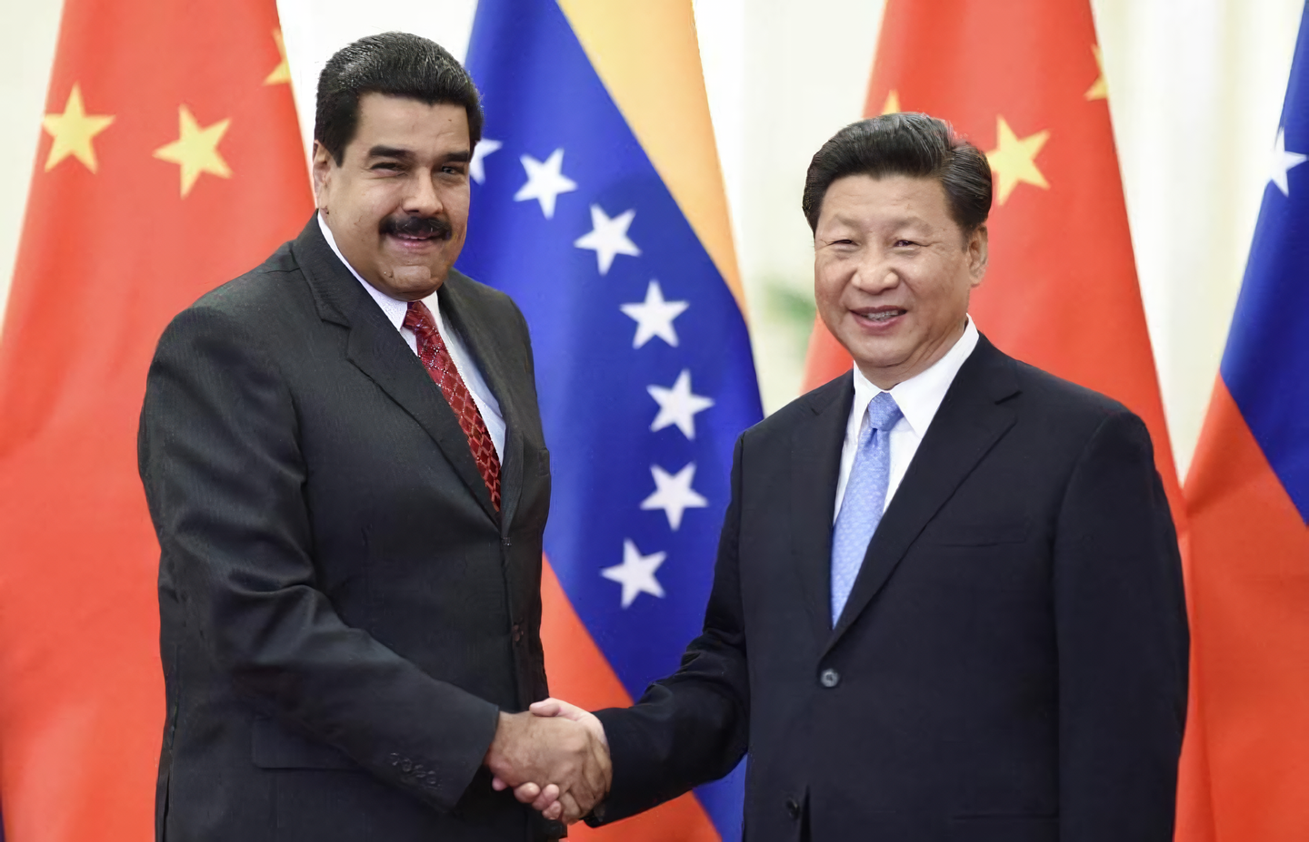
Venezuelan President Nicolas Maduro and Xi Jinping
The anti-imperialist agenda, even in this “socialist” country, turns into another falsehood necessary for the Chavist bourgeoisie: with its help, it covers up the consequences of an orientation toward Russian-Chinese imperialism.
The political consequence of this is the unconditional political support of China and the Russian Federation. Maduro supports Russia in carrying out the Special Military Operation, condemns sanctions against Russia, and supports China on the Taiwan issue. At the same time, he promotes a narrative beneficial for the Russian Federation and China about the unity of Latin America with the “big brothers” Xi and Putin, and proposes to create a political bloc for these countries' allies in the region.

1.4 Cuba
Condemning American hegemony and American hawks, Cuban President Miguel Diaz-Canel declares “Cuba’s revolutionary orientation, the country’s commitment to the struggle for “friendship of peoples” and assistance in the struggle of the peoples of all oppressed countries against imperialism” [32]. The Cuban leadership calls the United States nothing less than the “Yankee empire” that manipulates most of the world [33].
In general, the pseudo-anti-imperialist rhetoric of Cuba is no different from that in Russia or China and uses the same set of clichés. But behind them lies the same subordination of Cuba to Russian and Chinese imperialism, the pursuit of policies in their interests.
We have already talked about how the Cuban leadership allowed Russian monopolies into its market. At the same time, Chinese corporations did not stand idly by. The Chinese oil company Sinopec has long been present on the island, participating in the development of oil fields. Another Chinese corporation, Great Wall Drilling, a subsidiary of the China National Petroleum Corporation, has made the Cuban oil industry dependent on the supply of its drilling rigs.
In 2021, Cuba signed an energy cooperation agreement with China as part of the “One Belt One Road” program. Thus, Chinese capital received opportunities to invest in the energy sector of the Cuban economy.
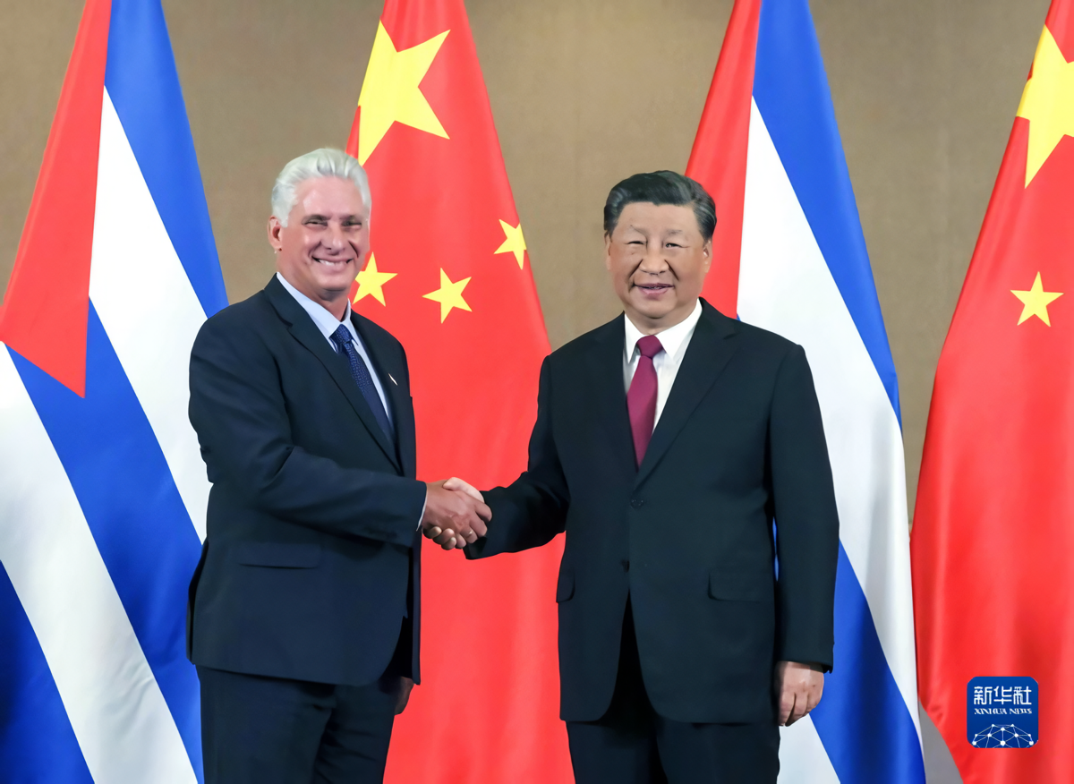
Miguel Diaz-Canel and Xi Jinping
Cuban “revolutionaries” pushed the country into the same debt dependence on China as Montenegro, Sri Lanka or other similar countries. The inevitable build-up of debt to China will ultimately lead to a loss of control over infrastructure and raw materials. The Cuban leadership, which so ardently criticises imperialism in words, doomed the country to be absorbed by the Chinese bourgeoisie in order to maintain their control. This outcome is now inevitable, since Cuba already faces the problem of non-payment of its debt to Chinese companies and the state.
Cuban “anti-imperialism” actually obscures the economic subjugation of Cuba by China and Russia. Finding itself in their economic network, Cuba is forced to follow them at the political level.
Cuba does not vote on resolutions clearly directed against the Russian Federation at the UN. Although maintaining a cautious position on the issue of the conflict in Ukraine, at the last meeting with Putin in November 2022, Diaz-Canel unequivocally supported the foreign policy of the Russian bourgeoisie, welcoming Russia’s efforts to preserve a “multipolar regime” in the world. Cuba, clearly supporting the leadership of the Russian Federation, condemned the US sanctions policy. During Nancy Pelosi's visit to Taiwan in the summer of 2022, Cuba's ambassador to China expressed his "steadfast and unequivocal" support for the "one China" principle, condemning the US provocation.
1.5 Other Latin American countries
Some other countries in the Latin American region also do not hesitate to use supposedly anti-imperialist messages in their rhetoric.
The President of Colombia, Gustavo Petro, addresses all complaints related to problems in the country and region to the United States. He blames the country for the destruction of almost all the world's economies, and blames capitalism for the destruction of the environment: “capitalism has created Frankenstein: the climate crisis” [35].
“You are only interested in my country to spray poisons on our jungles, to take our men to jail and isolate our women,” Gustavo Petro said in a speech to the UN General Assembly. The President argues that change is needed, and South America should become the force for unification [36].
The President of Bolivia also criticizes capitalist countries on many points, including social injustice, war profiteering and the illegal drug trade [37].
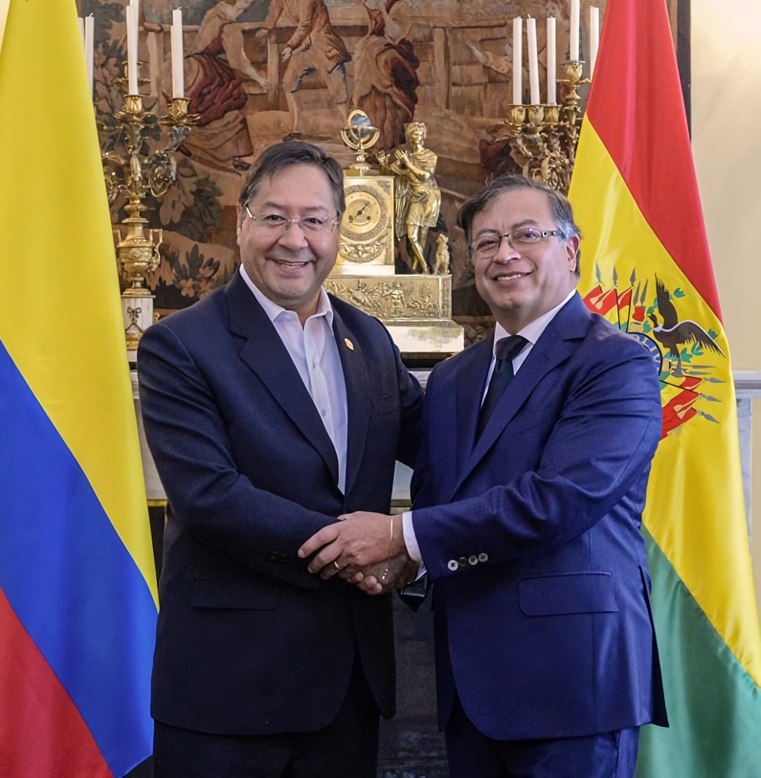
President of Bolivia, Luis Arce (left) and President of Colombia, Gustavo Petro (right)
However, the “anti-imperialism” of Latin American countries is filled with the same falsehood as the “anti-imperialism” of the PRC or the Russian Federation. Recognizing exclusively the United States as the center of imperialism, these countries often become dependent on China, causing them to present it as a better alternative. In essence, China uses the same methods as America: enslaves countries and spreads its expansion in every possible way.

1.6 DPRK
Kim Jong-un uses anti-imperialist rhetoric to justify the increasing militarization of North Korea.
“The DPRK’s hydrogen bomb test is an act of self-defense against the threat of atomic war created by the US-led imperialists” [38].
At the same time, the political position of the DPRK is focused on the imperialist bloc of Russia and China. Continuing to condemn imperialism, the DPRK clearly sides with the Russian Federation in the issue of the Ukrainian conflict:
“Warm combat greetings to the army and people of Russia, who boldly embarked on the sacred struggle for the implementation of international justice, the defense of world peace against the violence and tyranny of the imperialists” [39].
At the same time, North Korea is commercially and politically dependent on China. Even the market transformation of the DPRK is not happening without the participation of the latter. By becoming dependent on China, the PRC becomes part of the Chinese belt of dependent countries and an economic appendage of China.
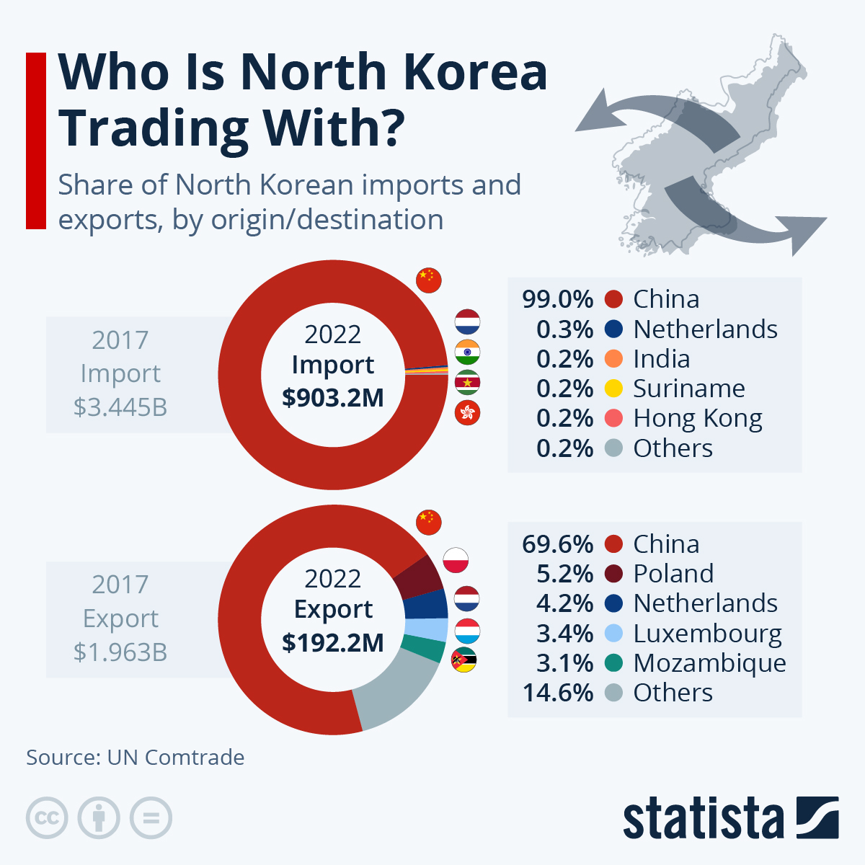
Having made the DPRK dependent on food and oil supplies, which allow the North Korean leadership to maintain stable prices for rice and fuel, China acquires North Korean raw materials, primarily anthracite and seafood. At the same time, North Korea supplies labour to China.
Transport, construction business, agriculture, processing of agricultural products and manufacturing of industrial goods - all these are included in the projects for the development of free economic zones created by agreement between the PRC and the DPRK. Using these zones, North Korea attracts Chinese investment, while giving Chinese businesses control over these zones. So North Korea finds itself in complete economic dependence on China, the consequence of which is, among other things, full political support of Beijing on the most important issues of Chinese politics.

2. What kind of anti-imperialism do we need?
Thus, all countries that today take a supposedly anti-imperialist position are in fact pursuing policies that benefit large monopolies. All the feigned “anti-imperialism” of the PRC, Russia and the countries dependent on them turns into economic and political subordination of weaker capitalist powers to Russian and Chinese capital. Under the guise of fighting imperialism, corporations seize sales markets and areas for capital investments, while dependent governments justify their subordination to large imperialist states.
This is not surprising, since in this era of imperialism, when all countries in the world are now capitalist states, it is impossible to talk about any anti-imperialism.
Genuine anti-imperialism is not only a fight against the United States and Western powers. It is a struggle against capitalism in general, against every manifestation of imperialism in all countries and forms. The reasons for the oppression of some countries and their population by others do not lie in “Western hegemony,” as US rivals are trying to present.
The reasons for this are in the capitalist system itself, that has reached its highest stage - imperialism, where oppression of weaker states by stronger ones is law. The capitalists of those states declaring their commitment to “anti-imperialism” are not drawing workers into the struggle against imperialism. By deceiving their population with long-winded statements about “multipolarity” and the fight against “hegemony,” capitalists lure their people into the struggle between the interests of monopolies.
There are no non-imperialist countries in the modern world. Imperialism is a state of capitalism, and all countries today are precisely capitalist, in all of them private ownership of the means of production and the exploitation of labour prevail.
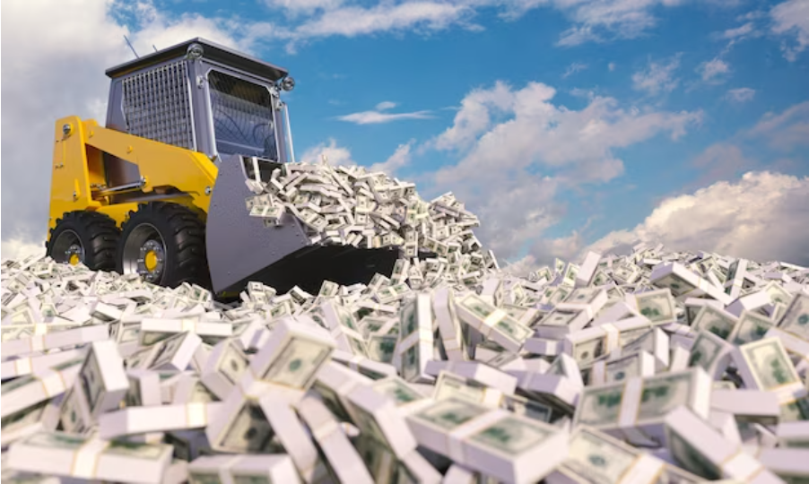
Vladimir Lenin in his work “Imperialism as the Highest Stage of Capitalism” defines imperialism as a monopolistic stage of capitalism providing its five characteristic features:
— the concentration of production and capital has developed to such a high stage that it has created monopolies which play a decisive role in economic life;
— the merging of bank capital with industrial capital, and the creation, on the basis of this “finance capital”, of a financial oligarchy;
— the export of capital as distinguished from the export of commodities acquires exceptional importance;
— the formation of international monopolist capitalist associations which share the world among themselves;
— the territorial division of the whole world among the biggest capitalist powers is completed [43].
For Lenin, there are no ‘simply capitalist’ and imperialist countries; he does not distinguish groups of conventionally “good” and “bad” capitalist powers. In the era of imperialism, every capitalist power is an imperialist country, since imperialism is the state of the entire capitalist system as a whole, and not of its individual representatives.
“Imperialism is the export of capital to the sources of raw materials, the frenzied struggle for monopolist possession of these sources, the struggle for a re-division of the already divided world, a struggle waged with particular fury by new financial groups and Powers seeking a ‘place in the sun’ against the old groups and Powers, which cling tenaciously to what they have seized. This frenzied struggle among the various groups of capitalists is notable in that it includes as an inevitable element imperialist war, wars for the annexation of foreign territory.” [44].
This is exactly the picture that we see now: capitalist countries, including those that hide behind the rhetoric of an allegedly “anti-imperialist” orientation, are fighting for markets and areas to export capital. In this struggle, they subordinate economically weak capitalist countries to each other.

The propaganda of the opposing blocs finds convenient propaganda formulas to embellish this cruel and unprincipled struggle. While the major Western powers talk about the struggle of the “democratic world” against dictatorships, Russia and China present their expansion as an anti-imperialist struggle aimed at “liberating” the world from American hegemony. However, the result of the victory of either side still turns out to be the preservation of the capitalist order, the exploitation of workers, the oppression and subjugation of weak countries by strong ones.
Capitalist states, by definition, cannot fight against imperialism as a system. The destruction of imperialism is possible only with the destruction of capitalism as such, and this is contrary to the interests of transnational corporations around the world. To break free from US pressure, to deprive the Western powers of their markets and influence in order to become hegemons in their own right - this is the real goal of those capitalist powers that loudly declare their “anti-imperialist” orientation.
Genuine anti-imperialism is the fight against the economic system that gives rise to imperialism.
Since imperialism is the highest stage of capitalist development, it cannot be destroyed otherwise than through the elimination of the capitalist system as such.
Putting an end to imperialist expansion and aggression is possible only through the destruction of the class that carries it out and the very economic conditions of its existence.
Genuine anti-imperialism thus includes:
— destruction of the bourgeois state and the establishment of the dictatorship of the proletariat;
— liquidation of capitalist productive relations and building socialism;
— the international coordination of all countries' workers with each other and also with truly socialist states in the struggle against imperialism for the victory of the world proletarian revolution.
Without this, anti-imperialism is unthinkable. It cannot look any other way, since imperialism is not just an aggressive foreign policy of expansionism. Imperialism is the state of modern capitalism, which is characterised by the dominance of the financial oligarchy and monopolies.
It is their interests that provoke aggressive takeovers of markets and armed conflicts, suppression and oppression of peoples. The hypocritical attempts of bourgeois officials in Cuba or Venezuela to pretend that their countries are being resubordinated to non-American transnational corporations are not anti-imperialism.
A historical example of genuine anti-imperialism is provided by the experience of the Bolsheviks and the Soviet Union, a socialist state of workers and peasants. Soviet anti-imperialism was built on the recognition of the inextricable connection between imperialism and capitalism, the proclamation of the need for the struggle of all countries workers to abolish capitalist exploitation, establish a workers' republic and build socialism.
Having carried out a revolution, the proletariat in Russia established Soviet power. Having got rid of the domination of capitalists in its country and having taken the country out of the imperialist war, Soviet Russia waged a struggle against the imperialism of other capitalist powers. The vanguard of the international movement of workers was the Third, Communist International – the Comintern.
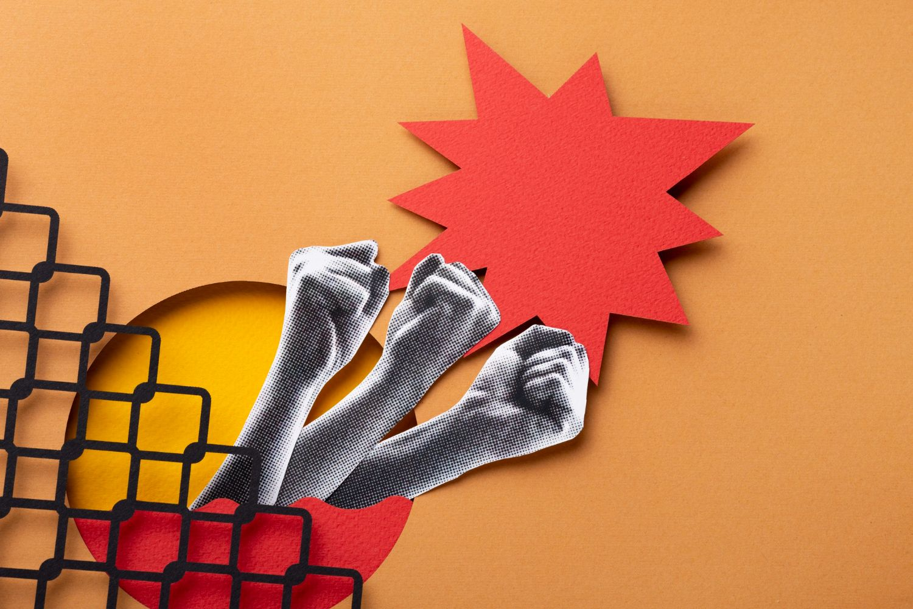
In the wake of the revolutionary upsurge that followed the First World War, an organisation arose that proclaimed the worldwide struggle against the domination of capital and the creation of an international union of peoples of the socialist type as its goal.
“The proletariat has to establish real order —communist order. It must break the rule of capital, make wars impossible, abolish the frontiers between states, transform the whole world into a community where all work for the common good, and realize the freedom and brotherhood of peoples”. [Source]
Statutes of the communist international proclaimed the goal of the struggle “for the overthrow of the international bourgeoisie and for the creation of an international Soviet republic” [45]. At the same time, Manifesto of the Communist International to the proletariat of the entire world pointed to the true path of liberation of small nations from oppression by major capitalist powers.
It indicated that free existence can only be achieved by a “proletarian revolution, which will liberate the productive forces of all countries from the constraint of the national State, unite the peoples in closest economic collaboration on the basis of a common economic plan, and afford even the smallest and weakest people the opportunity of conducting their national cultural affairs freely and independently, without detriment to the unified and centralized European and world economy" [46].
Not the re-subordination of weak countries from one hegemon to another, covered up by slogans about multipolarity, but their full liberation from the oppression by national and international capital. This struggle can only be waged by the working class, led by the Communist Party.
The Soviet Union and the Comintern fully supported revolutionary movements in other countries, both financially and by directing the policies of local communists. Communist parties of different countries were members of the Communist International, guided by its principles and directives, coordinated their policies with the USSR and waged a common struggle against capitalist governments. The Soviet state supported the Chinese revolutionary movement, the Spanish Republic during the Spanish Civil War, Bulgarian, German, Polish, Yugoslav and other communists.
After World War II, a new rise in the national liberation movement began in colonial countries. With the support of the USSR, new communist parties were created, work was carried out to create revolutionary trade unions that involved the working class in the struggle for liberation from colonialism. The USSR made a huge contribution to the destruction of the international system of colonialism, supporting numerous local revolutionary liberation movements.
At the VII World Congress of the Comintern, G. Dimitrov pointed out the necessary conditions for the victory of the proletariat, noting the importance of uniting all the workers of the world in this struggle [47]:
“Only by struggling hand in hand with the proletariat of the imperialist countries can the colonial peoples and oppressed national minorities achieve their freedom. The sole road to victory for the proletarian revolution in the imperialist countries lies through the revolutionary alliance of the working class of the imperialist countries with the national-liberation movement in the colonies and dependent countries, because, as Marx taught us, "no nation can be free if it oppresses other nations”
After the creation of the world socialist system, the Soviet Union maintained close economic relations with socialist countries. But unlike imperialist states, they were not exploitative in nature. The countries of the Eastern Bloc were united within the framework of the Council for Mutual Economic Assistance, with the help of which economic cooperation between socialist countries as well as scientific, technological and trade exchanges were built.
Thus, true anti-imperialism can be found only in the joint struggle of all countries' workers against the capitalist system itself, which is what gives rise to imperialism, the hegemony of the “major powers,” and the oppression of weak countries and small nations.
Genuine anti-imperialism is a struggle against capitalism for the power of the working class, the socialist system and world revolution.
Sources
- Xi Jinping spoke out against hegemony and brute force politics — dated October 16, 2022.
- Full Text: Resolution of the CPC Central Committee on the Major Achievements and Historical Experience of the Party over the Past Century — dated November 16, 2021.
- From fish in Sweden to college in Vanuatu: Where and how much China is investing — dated October 13, 2022.
- China Dependency Index: Which countries are most impacted by China's economy? — dated August 7, 2016
- China is ready to protect the interests of developing countries, Wang Yi said — dated July 24, 2023.
- “The future world order is being formed before our eyes”: what Vladimir Putin said at the meeting of the Valdai International Discussion Club — dated October 27, 2022.

- Joint Statement of the Russian Federation and the People’s Republic of China on the International Relations Entering a New Era and the Global Sustainable Development — dated February 4, 2022.
- Putin: the special operation in Ukraine marked the beginning of the destruction of the “American world order” — dated July 7, 2022.
- Markets of Opportunity: The Future of Exporting to Asia, Africa and Latin America — dated February 6, 2023

- Putin announced that Russia had written off the debts of African countries amounting to more than $20 billion — dated March 20, 2023.
- Russia and Africa: a new stage of big energy — dated March 19, 2023

- Russia - Africa: an opportunity that must be seized — dated June 16, 2023.
- Promsvyazbank is going to develop its business in Africa — dated August 15, 2016.
- History of relations between the USSR and Russia with African countries — dated January 23, 2023.
- What Is Russia's Wagner Group Doing in Africa? — dated May 23, 2023
- CAR: Russian Wagner Group harassing and intimidating civilians - UN experts — dated October 27, 2021
- Zakharova called the sovereign right of African countries their decision to cooperate with the Wagner PMC — dated June 28, 2023.
- Speech by Vyacheslav Volodin at the plenary session “Russia - Africa in a multipolar world” — dated March 20, 2023.

- International Parliamentary Conference “Russia - Africa in a Multipolar World” — dated March 20, 2023
- Putin to the Prime Minister of Cuba: We in Russia have a special relationship with the Island of Freedom — dated June 14, 2023.
- The long-awaited return of Lada to Cuba — dated February 12, 2018.
- Ombudsman Titov: Russian investors are ready to develop about thirty new production projects in Cuba — dated May 19, 2023.

- Rosneft and Cuba are working on projects to improve the efficiency of mature fields — dated October 2, 2019.

- The Cabinet of Ministers of South Ossetia approved the draft budget for 2023 in the amount of more than 8.7 billion rubles — dated November 25, 2022.
- The Russian export center and South Ossetia agreed to strengthen trade relations between the two countries — dated May 30, 2023.
- Putin said that the era of attempts to build a unipolar world has already passed — dated January 27, 2021.
- Maduro said the people of Venezuela will never surrender to "North American imperialism" — dated July 18, 2018

- The United States announced the transfer of 70% of oil produced in Venezuela to Russian control — dated January 7, 2020.
- Reuters learned about China’s shipment of Venezuelan oil to pay off the Chavez-era debt — dated August 26, 2022.
- Venezuela confirmed the lifting of US sanctions on the work of oil workers in the country — dated May 18, 2022.
- Under President Maduro, China has surpassed the Russian Federation in arms supplies to Venezuela — dated May 18, 2022.
- Diaz-Canel: history can only be changed by peoples — dated January 13, 2016.
- The President of Cuba called the “Yankee Empire” the common enemy of Moscow and Havana — dated November 22, 2022.
- US eases restrictions on Cuba — May 17, 2022

- President Gustavo Petro blames capitalism for climate crisis — dated July 17, 2023
- Colombian President Gustavo Petro Calls for an End to the War on Drugs in Historic UN Address — dated September 20, 2022
- UN: Bolivia Asks for Peace and Blames Capitalism for Conflicts — dated September 20, 2022
- Kim Jong-un justified the nuclear test by the need for protection from the United States — dated January 10, 2016.
- Kim Jong-un said that the people of the Russian Federation have embarked on a “sacred struggle for peace and against tyranny” — dated May 9, 2023.
- About the XXII International Meeting of Communist and Workers' Parties — dated November 1, 2022
- News from the Solidnet meeting. Speech by a representative of the RCWP — dated October 29, 2022
- On the ideological–political confrontation at the 22nd International Meeting of Communist and Workers’ Parties and the “trick” about the “anti-Russian” and “pro-Russian” sentiment — dated October 27, 2022.

- V.I. Lenin. Imperialism, the Highest Stage of Capitalism. Lenin’s Selected Works, Volume 1, p. 265

- J.V. Stalin: “Foundations of Leninism”, Works, Vol. 6, Foreign Languages Publishing House, Moscow 1954, p. 75
- Statutes of the Communist International adopted at the second Comintern congress.
- Manifesto of the Communist International to the proletariat of the entire world.
- Georgi Dimitrov. The Fascist Offensive and the Tasks of the Communist International in the Struggle of the Working Class against Fascism — Main Report delivered at the Seventh World Congress of the Communist International

Original article

