On the Dissolution of the "European Communist Initiative"
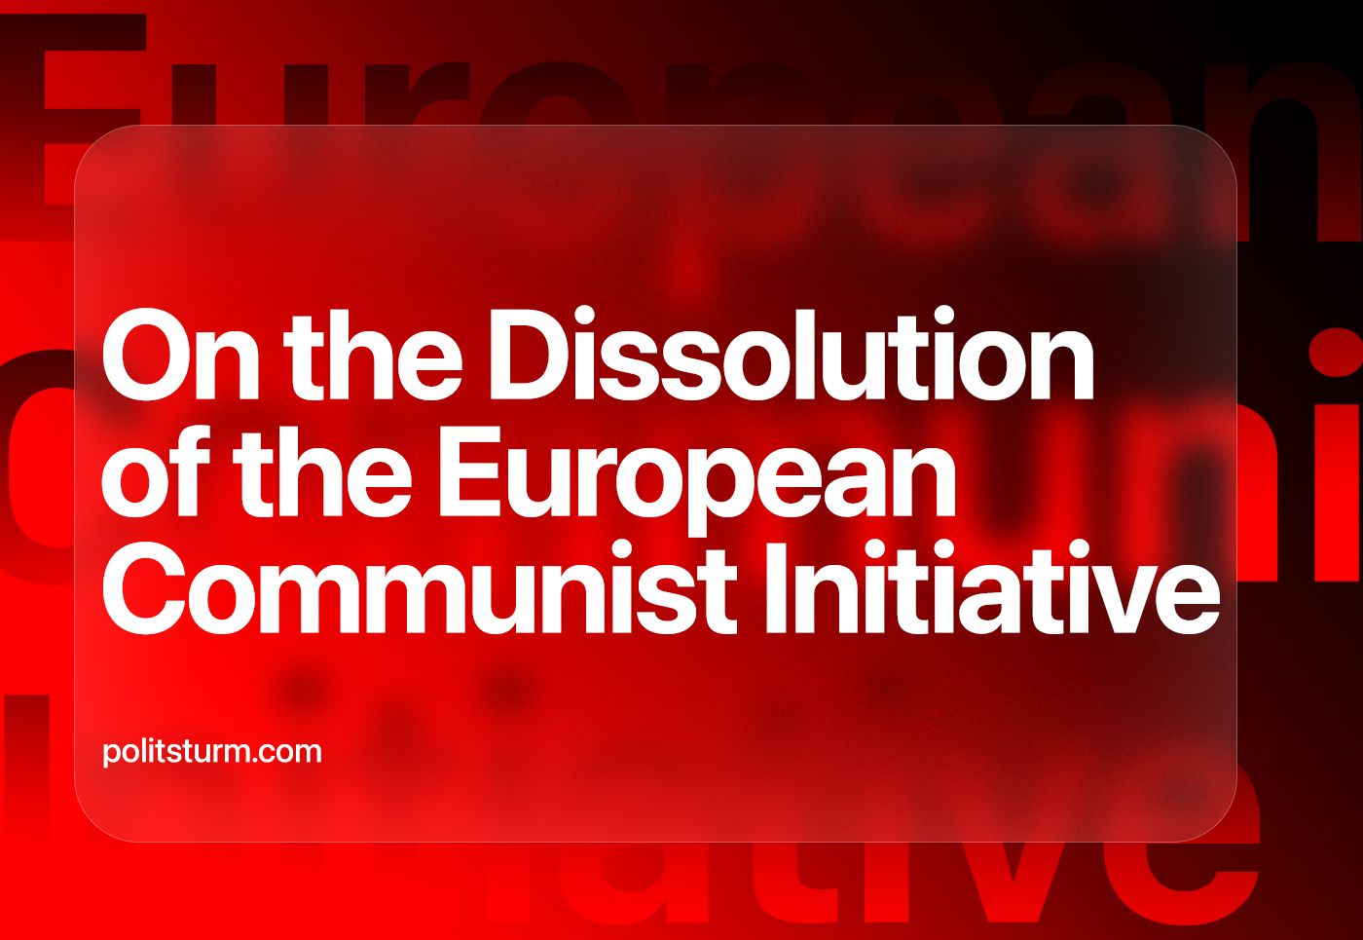

Original article
2023-09-22
9 min read

On September 11th, 2023, the ECI secretariat published a statement “On The Termination Of The Activity Of The European Communist Initiative”. The ECI was created in the fall of 2013 on the initiative and with the active participation of the Communist Party of Greece (KKE).
In the Founding Declaration of the Initiative, its goal was described as “to contribute to the research and study of issues concerning Europe, particularly concerning the EU, the political line which is drawn up in its framework and has an impact on the lives of the workers, as well as to assist the elaboration of joint positions of the parties and the coordination of their solidarity and their other activities".
The real goal was broader: KKE representatives repeatedly characterized the Initiative as a form of regional cooperation and coordination of the activities of communist and workers' parties in Europe, as “a step forward in coordinating the struggle of the communist movement”, as an attempt to form a “Marxist-Leninist pole” and to reorganize the international communist movement.
In his opening speech at the founding meeting of the ECI on October 1st, 2013, a Politburo member of the Central Committee of the KKE Marinos stated: “Our INITIATIVE serves the unity of the communist movement in Europe and the strengthening of the struggle of the communist parties for the rights of the working class, the popular strata, the youth... All parties, with their disposition, responsibly and persistently, will support this attempt, which will give impetus to the struggle of the communist movement in Europe, with a positive impact in the international communist movement”.
For many communists, especially in Russia and post-Soviet countries, the very information about the existence of such a structure over the past ten years may come as a surprise. What organizations did it consist of and what activities did it carry out?
In "Participating parties” on the Initiative’s website, in addition to the KKE itself, one can find a variety of organizations. Among the 32 members of the ECI, only a few are actual Marxist-Leninist communist parties.
The overwhelming majority of participants on the “Initiative” have turned out to be either half-dead organizations that have not shown any activity for many years (like the “Party of Bulgarian Communists”, “Unified Communist Party of Georgia”, “Socialist Party of Latvia”, etc.), or opportunist groups who stand on social-chauvinist positions (“Hungarian Workers’ Party”, “Communist Party (Italy)”, “Russian Communist Workers’ Party”, “New Communist Party of Yugoslavia”, etc.).
The press release from the ECI secretariat states that one of the reasons for the impossibility of continuing the work of the Initiative was “the important ideological and political differences that have arisen over time and which have been aggravated since the outbreak of the war being waged between the USA-NATO-EU and capitalist Russia”.
If one looks at the ECI website, one will notice that, in fact, the sections of the site, with a few exceptions, have practically not been updated for five or more years. Over the past two years, the Initiative's activities, with rare exceptions, have consisted of secretariat statements on current events and memorable dates.
The ECI was barely coping with its tasks. The study of issues concerning the European Union and the unification of the communist movement were implemented only as a formality. Moreover: the “Initiative” legitimized many opportunist, revisionist organizations. Ultimately, instead of revitalizing, reviving and developing the communist movement in Europe, it contributed to maintaining the status quo, i.e. a state of crisis in the international communist movement.
A good example is found in the collection of organizations that represented Russia and other post-Soviet countries in the ECI: “Russian Communist Workers Party”, Belarusian “For the Union and the Communist Party of the Union”, “Communist Party of the Soviet Union”, “Unified Communist Party of Georgia”.
All these revisionist organizations (neither in activities nor size taking on the position corresponding to a “party”) over the years took part in numerous conferences, congresses and discussions under the auspices of the ECI. After February 2022, they supported the imperialist actions of the Russian Federation under the slogans of the fight against American hegemony and “fascism for export”.
These organizations were in the ECI for almost a decade. With the exception of the RCWP – a micro-organization that acts as a mouthpiece for social-chauvinism in its ongoing debate with the KKE – the status and functioning of these organizations remain unclear: their activities are expressed in support of the Russian government, giving numerous statements in support of the CPRF and the RCWP, as well as creating the appearance of a majority when staging signatures under various international statements of these organizations.‌‌‌‌The presence within the ECI of such supposed “organizations” as “Communist Party of the Soviet Union" completely discredited the "Initiative" as a serious political association. How can we even talk about “parties of the Soviet Union” when the USSR itself has not existed for more than 30 years?
Undoubtedly, such organizations are not a unique feature of the post-Soviet communist movement. Similar dead structures can be found in most European countries. What remains incomprehensible is the uncritical attitude towards them and similar organizations on the part of the KKE – the main organizer of the Initiative – which did not express criticism of this situation during these years and did not take measures to fix it. This is all the more incomprehensible since, for example, in 2016, the Greek communists themselves wrote about the need to attract new communist organizations to the “Initiative” and fight against opportunists, apathy and passivity:
“These forms... are not free from the influence of the class enemy and the many years of delays of many communist parties in developing a modern revolutionary strategy at the national and international levels.
Our Party must continue its efforts within the framework of the International Communist Review and the European Communist Initiative, work towards their stabilization and expansion by attracting new communist forces, and get rid of the forces influenced by the bourgeoisie and opportunism that create obstacles, and, if necessary, transform these forms and replace them with others...”
By attracting the organizations mentioned above and other similar structures to the “Initiative”, the Greek communists did not make the work easier but complicated the fight against opportunists in particular countries, creating difficulties for their own struggle as well. The RCWP, the HWP, the NCPY and others openly oppose the position of the KKE on the issue of Ukraine, they denounce the Greek communists as “revisionists”, “defenders of the United States” and support the so-called “World Anti-imperialist Platform” right up to joining it. The "Platform", in turn, publishes materials of a slanderous nature against the Communist Party of Greece itself.
The “European Communist Initiative”, which ceased to exist almost exactly 10 years after its creation, could not become neither “communist” (since there were almost no actual communists there) nor “initiative” and could not change the crisis situation in the European communist movement. It would be difficult to expect a different outcome from the numerous pseudo-communist parties: they did not carry out work in their countries, and at the international level, confusion and vacillation manifested themselves in even more contrast.
In this regard, the accusations of social-hauvinists that the Communist Party of Greece seeks to “dictate its will” appear ridiculous.
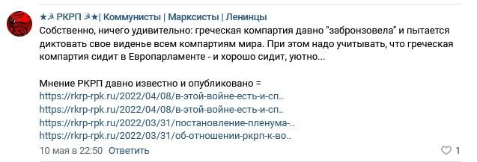
A comment made by RCWP official group in VKontakte: "...the Greek Communist Party has long been “bronzed” and is trying to dictate its vision to all the communist parties of the world. At the same time, we must take into account that the Greek Communist Party sits in the European Parliament – and sits well, comfortably..."
In our opinion, these accusations have no basis. On the contrary, if the Greek communists can be accused of anything it is of an excessive passivity and caution, of an unfounded hope for the possibility of a “left turn” within opportunist organizations without straightforward criticism of these organizations and the situation that has developed in them.
The “Initiative” would not have suffered the fate of another dead structure, a source for meaningless statements that do nothing, if it had really been an initiative, if it had practically acted to unite European communists. If this work had been successfully carried out across 10 years, then today the social chauvinists would not be so strong, and international imperialism would be opposed by a strong bloc of communist organizations.
Perhaps Marxist-Leninists could be lenient about the “first attempt to create a Marxist-Leninist pole”, but the capitalists won’t grant the communists multiple attempts. On the contrary; they energetically organize themselves. The bourgeoisie sees the weaknesses of the communists, it is active and does not forgive mistakes.
The past few years have brought about an onslaught of reactionary forces around the world. As before, capitalists are actively interfering in communist movements around the world (the latest events in Venezuela are a vivid example of this), trying to subjugate the communists, reduce them to the role of extras, and strangle Marxist-Leninist theory, replacing it with false “anti-imperialism”.
At the “Meeting of the Communist and Workers' Parties” in Havana last October, social-chauvinists openly attacked the Marxist-Leninist parties, threatening the creation of their own international organization, forcing compromises on the most important issues of our time and obstructing the development of the international communist movement.
One can speak endlessly on the crisis situation, but only decisive actions can lead to its resolution. The unification of real communists and international assistance for the revival of the communist movement is not only possible, but vitally necessary. Under the present conditions, our organization stands for:
- establishing stable and regular contacts between actual communists of different countries;
- establishing joint work in the field of theory and practice;
- development of a unified theoretical platform.
Politsturm is already doing this work with a number of foreign communist organizations. We call on our readers to join our ranks in the joint struggle for the revival of the communist movement in Russia and throughout the world.

Support and join us.

Original article

