On the Decline of US Infrastructure
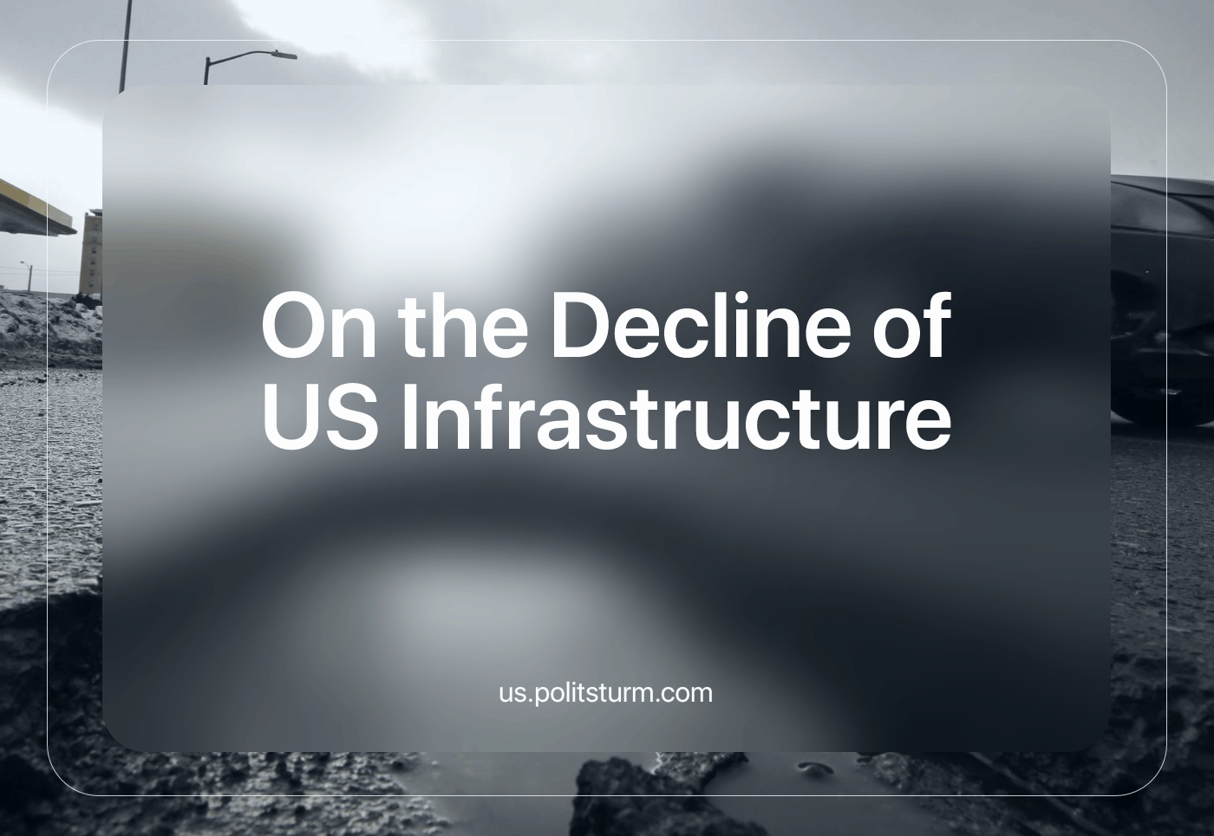

Original article
2024-05-04
8 min read

A few weeks ago, Baltimore experienced a tragic event, the collapse of the Francis Scott Key Bridge. The incident was caused by an accident in which a 32,000-ton container ship collided with the nearly half-century-old steel arch span, creating a vivid visual representation of the crumbling infrastructure of the United States. As ageing bridges and critical infrastructure reach the end of their useful lives, the safety and reliability of the foundations of the U.S. economy have been called into question.
The CFR (Council on Foreign Relations), an American think tank, found the following conclusions according to experts in the field of infrastructure: “Economists say that delays and rising maintenance costs are holding economic performance back, and civil engineers warn that structurally deficient bridges and antiquated water infrastructure pose safety risks.” Accurate estimates of infrastructure deficiencies run into the hundreds of billions of dollars.
A study by Inrix, a transportation analytics firm, estimated the cost of traffic congestion at more than $87 billion in 2018. Other deficiencies, such as flight delays, cost the American economy an estimated $33 billion in 2019, according to the Federal Aviation Industries. The systematic underfunding of America's infrastructure has had the effect of hampering business profits, which is a cruel irony given that building infrastructure is not profitable for businesses.
The profitability of infrastructure in the United States is a net loss of -4.18%. It is almost impossible for companies to build infrastructure without government contracts. This results in underfunded infrastructure projects due to low investment as the profit motive prohibits investment in any real capacity. However, the government itself is not stepping in to save the sinking ship of infrastructure.
Why should the government not invest in infrastructure? Because the economy under capitalism is not determined by the will of the people, but by unconscious forces. All capitalists are forced by market competition to maximize their profits. If they don't, they will lose and be ruined. Since it's no longer profitable for them to invest directly, the task falls to the government. The government, being run by and for the capitalists, represents the interests of capital. However, the many capitals compete with each other, and the degree of class discipline the government shows depends on many factors, including the strength of the organized proletariat, the strength of competing imperialists, as well as subjective factors.
These markets of competing interests and corporations create uneven development through heavy investment in profitable industries and markets that create uneven distribution by selling to the highest bidder, not the person with the greatest need. You can imagine that this uneven foundation does not allow for the planning of the economy, such as large infrastructure projects. On the other hand, national planning, which is the foundation of all sustainable, well-maintained infrastructure, invests directly in what is socially necessary without the chaos of the markets, creating a stable foundation for sustainable infrastructure.
The United States government does the bare minimum to provide services to the public. It gives contracts for some construction projects, with healthy subsidies and tax breaks for the contracted firms.
However, these construction projects by contracting companies are notorious for their carelessness and incompetence. In 2020, the Edenville Dam in Michigan collapsed due to the profitable negligence of the capitalist owners. The “owners” deliberately didn't improve the dam as engineers had suggested as early as 2010 in order to save money. The neglect of maintenance for higher profits caused a flood that destroyed 2,500 homes and businesses and caused an estimated $200 million in damage. In one monumental moment, the lives of thousands of people were ruined. In a matter of seconds, their entire livelihood was wiped out because of corporate greed.
More recently, in February 2024, a hangar at the Boise Airport collapsed due to a suspected unstable structure. Three workers working to upgrade the hangar were killed. “While the collapse is still being investigated, multiple workers noticed problems with the structure before it collapsed, including bending beams, snapped cables, and structural issues, according to Boise Police Department records.” The testimony confirms the same story that American infrastructure is so terrible that even repairing the damage is dangerous.
Our opponents, the liberals, and even the capitalists themselves recognize that the situation is dire. U.S. President Joe Biden has said in the past about the corrosion of the infrastructure, “Across this country, people have been struck and they — and they’ve been struck by all the changes that are needed. They’re stuck. They’re angry. They’re sickened by the broken water and sewer systems — polluted water from the faucets, raw sewage in their backyards.”
The Bipartisan Infrastructure Act failed to follow through on these statements, and the investments it encouraged did not make up for decades of underfunding. The underfunding has been cited by the American Society of Civil Engineers (ASCE) in 2021 as an “'infrastructure investment gap' of nearly $2.6 trillion this decade that, if unaddressed, could cost the United States $10 trillion in lost gross domestic product (GDP) by 2039.”.
These engineers are pointing out the clear and consistent lack of infrastructure, not hiding the systemic problem. Engineers whose labor relations prevent them from performing such useful tasks, even though the problem is obvious even to the capitalists themselves. Engineers are limited by their class position, they have no social ownership (and consequently no say) over the means of production, in this case, the crumbling infrastructure. Under capitalism, only the capitalist has a say in how, when, where and what is produced, regardless of the consequences of that choice for the majority of people. The clash of productive relations in capitalism has, in this case, created a system of productive forces (the workers, engineers, and the available tools and machinery needed to maintain and expand the infrastructure) that are prevented from doing so.
The systemic problem of infrastructure within capitalist society highlights the inherent contradictions of this system. The basis of these contradictions is the anarchic nature of production and the conflicts arising from labor relations and productive forces. As a result, the current system of production is characterized by inefficiency and cruelty. The obvious flaws of capitalist production have severely hampered human society. The problem is clear, but the solution is not. We should ask ourselves how to plan an efficient, pragmatic economy.
“How should planning be organized? There, capital is spontaneously distributed according to profit. If we were to develop branches of the economy depending on their profitability, we would have been able to develop only flour milling, production of toys (they are expensive and yield a higher profit), and textiles, but we would not have had heavy industry. Heavy industry requires great investment and is unprofitable at the beginning. The departure from heavy industry is what Rykov and his followers proposed. We overturned the law of development of the capitalist economy, put it on its head, or, to be more accurate, on its feet. We began with the development of heavy industry and machine building. Without the planned economy, nothing would occur.” - Conversations with Stalin on Questions of Political Economy
Shifting production to the benefit of society rather than profit was a success, as Stalin had predicted. The socialist mode of production had higher growth rates comparable to the U.S. in the same period between 1928 and 1965. According to The Record of Soviet Economic Growth, “Concerning national product and national product per capita, show USSR’s rates of increase that are substantially greater than the U.S. rates: e.g., 4.6 or 4.8 percent per year for USSR national product per capita against 1.2-2.3 percent per year… for the United States.”
Unlike its capitalist counterpart, the Soviet Union grew faster by investing in heavy industry and infrastructure, as well as the educational and cultural development of its workers. It created industrial giants such as the Magnitogorsk Blast Furnace (MMK), the largest blast furnace in the world at the time it was commissioned in 1930. Nearly 100 years later, the furnace is still in operation, a testament to craftsmanship and superior planning. Such a feat would not be possible in today's capitalist system. To build socialism, we need a communist party to lead the workers toward that goal, but no such party exists in the United States. We are working to build such a party. Join us in the struggle for a better future.
Sources:
1, 2, 3, 4, 5, 6, 7, 8, 9

Original article

