On the Death of the British Queen
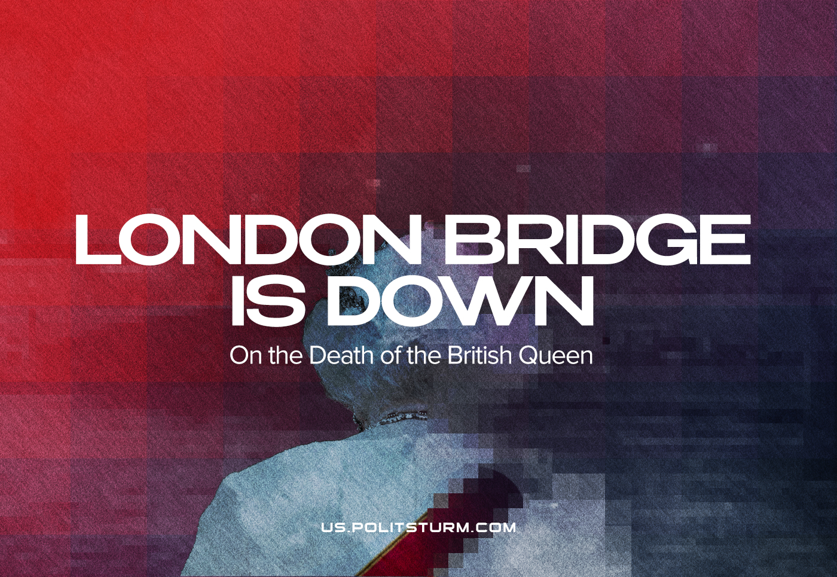

Original article
2022-09-09
8 min read

At around noon on the 8th of September 2022, the UK’s Parliament was informed mid-debate on the news that Queen Elizabeth II had fallen gravely ill. The media all day kept their eyes screwed to her Scottish retreat, Balmoral, for any news on the Queen’s situation. At 18:30 GMT, Buckingham Palace confirmed that Britain’s longest-reigning monarch had passed.
Even before her death, an allegedly “secret” plan was revealed, with so much attention and details, that were put in commemorating another pillar of the British state and memorializing her life. Taking care to skirt around the atrocities committed by the British imperialists “for Queen and Country” and her role and attitude therewith, “loyal” media keep spreading tearful messages.
We will take a look at the deeds of the not-so-decorative British monarch.
The capitalists of Britain needed a strong state (to protect their home market and to enforce private property rights and colonialism), so they had the monarchy overthrown in the XVII century, tamed it and made it work in the interests of the capitalists.
Error loading image
While no one believes in the divine right of kings anymore, the monarchy was turned into a cornerstone of the British national identity.
This is reflected in Britain’s unwritten constitution, where the monarch plays an integral role in the running of the country (e.g. opening parliament, and giving royal assent). Essentially the monarch’s role was relegated to an icon of class conciliation: whether one is a worker or a capitalist, rich or poor, “we are all subjects of His/Her Majesty”. An example of the success of this policy is the RMT union cancelling planned industrial action to pay respects to the dead monarch.
The capitalists turn everything into a commodity and the monarchy is no exception. The royal family were turned into a brand, which according to some estimates can be valued at £91 billion, with the now-deceased Queen Elizabeth II’s personal brand worth an additional £35 billion. This is all, of course, fictitious capital, however, it demonstrates the value of the family to the capitalists.
Just like celebrities, every major and minor occasion in the life of this family is apparently worthy of news and serves as an opportunity to sell trinkets and memorabilia and distraction for the country.
And the resources diverted to these inbred feudal relics is nothing to sneeze at. They were estimated to cost the British taxpayer £202 million per year (excluding their property income – which is about ~£50 million from the duchies of Lancaster and Cornwall alone). This would be an unacceptable number ordinarily, but especially now, while much of the country struggles to afford basic necessities and put food on the table, they are expected to look up to and be grateful for the “sacrifices” that “dear queen” has made for the country by living a life of parasitism, decadence and opulence.
The history of this monarchy reveals that the royals are not “above” the struggle between classes like the bourgeoisie claims. The Queen’s uncle, Edward VIII, the Duke of Windsor and King before his abdication, was a known Nazi sympathiser. More damning, family footage unearthed in the tightly-sealed Royal Archives recently of the Queen as a child depicts her making fascist salutes along with her family. The monarchy is interwoven in the fabric of class society.
Moreover, an analysis of its history leaves no doubt that the Crown is not a paternal institution that cares for its subjects but is consistently used as justification for the bourgeoisie’s attacks against the proletariat.
In the 1980s, for example, Elizabeth II was well into her reign when Britain’s working class faced the Thatcherite assault on trade unions and labour laws that stripped them of much of their power: beggaring the proletariat to such an extent that only recently have the workers consolidated enough power to begin fighting back against the capitalist class once more.
Error loading image
Indeed, one can see that from the very outset of the Queen’s reign, the monarchy was used as a tool for British imperialism not just against British workers but against those subjugated in her name in the colonies. The year Elizabeth ascended to the throne, 1952, Britain was waging a brutal counter-revolutionary campaign against the workers and peasants of Malaysia in which captured Communists and innocent civilians were beheaded among other atrocities as part of a policy of terror. That same year, the anti-colonial Mau Mau Uprising in Kenya started, leading to the unleashing of reaction against Kenyans. Forced migration, massacres, concentration camps and torture were the punishments that awaited Kenyans that were fighting for their freedom.
Under her reign, Irish Catholics in Northern Ireland were treated as second-class citizens leading to The Troubles as Irishmen and Irishwomen fought a liberation struggle. From the Suez Crisis to the overthrow of Iran’s Mossadegh to protect Britain’s oil monopoly in the country, to the war in Iraq and Afghanistan, the most vile atrocities were committed “for the Queen and Country”. It is evidently clear that rather than being above the “vulgar” class struggle between the capitalists and the proletariat, the monarchy is heavily involved in the class struggle against the working classes; for all these crimes were committed under her “benevolent and dutiful” reign.
This is not, however, unknown to the broad masses. Despite the bourgeoisie’s best attempts, the monarchy is not a sacrosanct institution to the workers of Britain. Although the bourgeois media will wax lyrical about the special bond between Britons and the deceased monarch, the workers are not always so easily duped.
The British monarchy’s popularity is dependent on the wider political trends. Following the aforementioned smashing of Britain’s trade unions and the managed decline of many industrial towns, republican sentiment began to grow within the country in the 1990s due to numerous scandals involving the Royal Family and the extreme wealth of the monarchy alienated the workers who at the time were getting poorer and poorer. Similarly, there is a waning support for this archaic form of government presently, although the support from the capitalist media would seem to show otherwise.
Day by day, the struggle of the proletariat awakens them to the nature of their exploitation; in May 2012 support for the monarchy was 80% according to a poll, since then the popularity of Britain’s monarchy has slowly been decreasing, reaching a historic low of 53% in July of 2021 following successive scandals connected with abusing and racism in the royal family.
Since then, its popularity has grown a small amount but this is most likely due to the Platinum Jubilee marking her becoming Britain’s longest-reigning monarch and it is most likely to resume its trend once the shock of Elizabeth’s death wears off. With the current global crisis that is acutely affecting the people of the United Kingdom, it is likely that the monarchy can not maintain its popularity going into the winter.
While human society is divided into classes, there can be no “above class” appraisals, they must be evaluated from the standpoint of a certain class. And from the standpoint of the bourgeoisie, Queen Elizabeth II was exemplary in performing her duties. She has acted as a rallying figure for the capitalists of Britain to delude the workers into subservience and to fight for the “national interest” (i.e., the predatory interests of the British propertied classes). By fooling much of the working class of the country into accepting her warmly as some kind of grandmotherly figure, she has performed the duty assigned to her station by the ruling class over 300 years ago.
It will remain to be seen whether her son and successor, now called King Charles III, will be able to match his mother’s “successful” legacy, or whether the growth of democratic forces, the workers and the communist movement will finally bring about an end to this ossified feudal vestige of an institution. The newly-crowned King already expressed his concern about the ongoing cost-of-living crisis in the UK back in May, in an address given atop a golden jewel-adorned throne, demonstrating the utter hypocrisy in the mouthed concern of the ruling class and the royal family. The British king, who shares his name as Charles I, was executed by revolutionaries 400 years ago. Who knows, perhaps King Charles III will follow the fate of his four-century-old predecessor.

Original article

