On the Current State of the Communist Movement in Britain
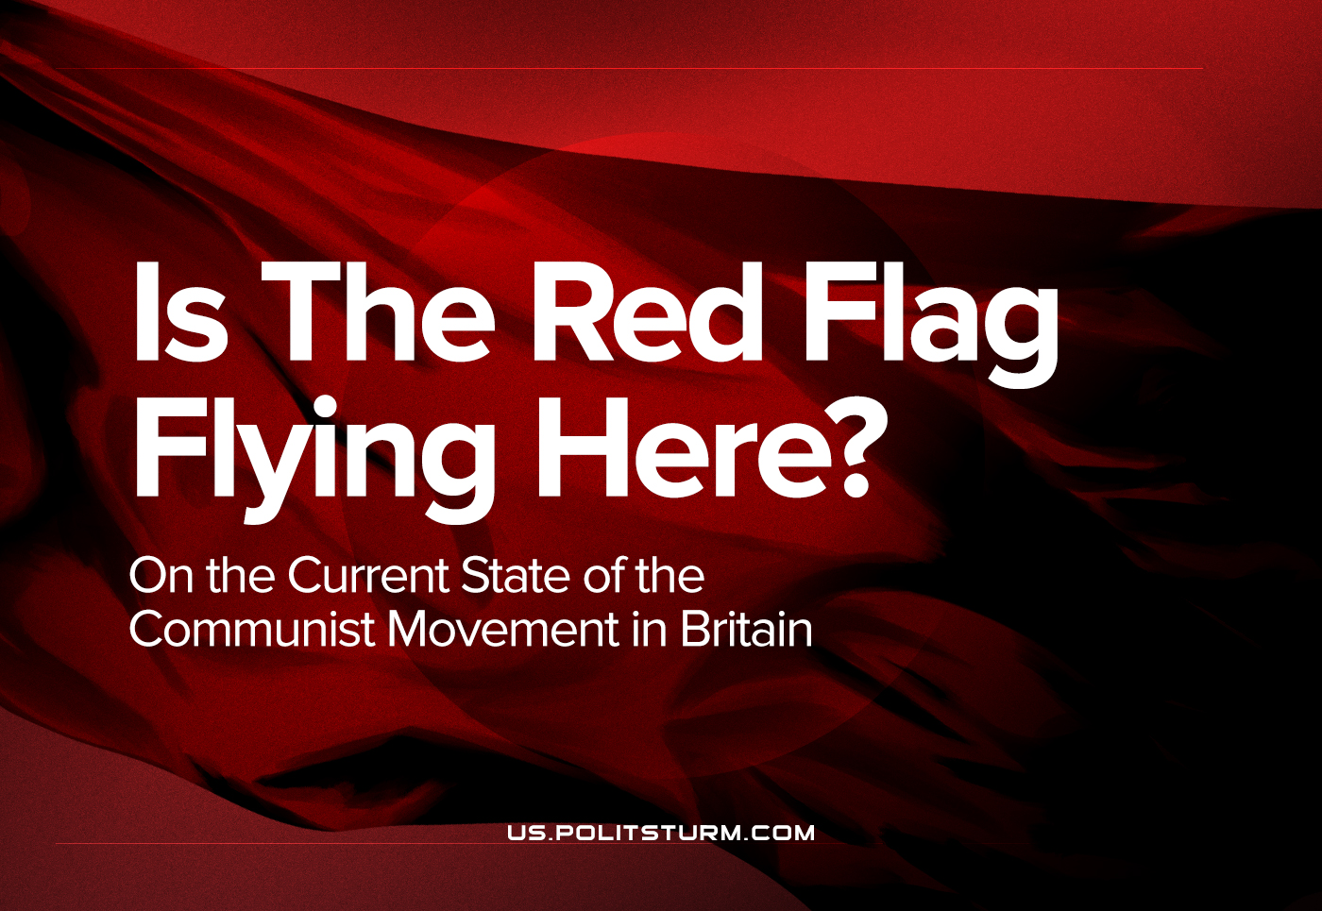

Original article
2022-06-30
32 min read

The Communist movement throughout the West is at a historic nadir; worker’s parties in the imperialist countries have either embraced bourgeois electoralism, reformism or have outright dissolved. Of particular note is the state of the communists in the United Kingdom. It was ‘in Englands green and pleasant land’ (Blake, 1804) where the Industrial Revolution and its ‘dark satanic mills’ (Blake, 1804) were born, where modern industrial capitalism took root, and consequently was the most developed for the majority of the nineteenth and a good part of the twentieth centuries. It was Britain in which the proletarians first became the largest group in class society and ushered in a new epoch in human history.
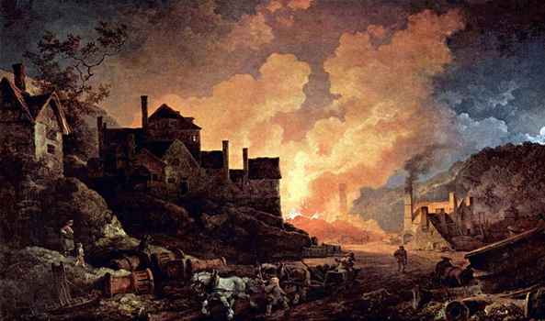
It was in Great Britain that Marx and Engels first began researching and formulating in earnest their ideas of scientific socialism, later called Marxism, for Britain was the perfect petri-dish to uncover the laws of wages, trade and production in capitalist society and its effects on the proletariat.
In the land where capitalism was most developed, it also stands to reason that it was where the workers’ movement was most mature; indeed, it was. The British labour movement had a head start compared to the rest of the world and as such trade unions played a massive role in British society up until as recently as the 1980s. But where there are capitalists and workers there is also class struggle: with the proletariat being the most mature there so too was the bourgeoisie and all its weapons and tactics to prevent a dictatorship of the proletariat being established.
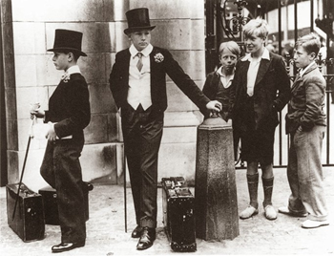
As such British communists had an uphill battle fighting off the Conservatives (who traditionally represented the aristocracy), the Liberals (who had the support of the middle-class) and the Labour Party which was formed by Fabians, socialists and trade unions and became the party that the working-class lent its support too despite very quickly revealing its labour-aristocratic, reformist and imperialist nature. However, the Communist Party of Great Britain maintained its support in several regions: areas of London, factory and mining towns in the Midlands, Wales, the North and famously the industrial port city of Glasgow with the last being a significant centre of Communist agitation.
This brief picture of British history is just an outline and does not cover the entirety of it, this is simply to put into context just how severe the situation British communists find themselves in. The movement has been seemingly cursed with endemic factionalism, splitting and even abusing cases. So, this will focus on some of the largest (or perhaps most notorious) groups in the UK at present.

The Communist Party of Britain
The first shall be the successor of the original Communist Party of Great Britain: The Communist Party of Britain (CPB). The original party throughout the twentieth century gradually lost its influence among the workers and trade unions due to the post-war boom that stabilised global capitalism. By the 60s and 70s the party was struggling to overcome factionalism between the pro-Soviet faction which maintained the prevalent orthodoxy and the reformist Eurocommunist tendency which was becoming popular within Western European Communist Parties. The Party then suffered irreparable harm with the implementation of reactionary policies by Thatcher which decimated British industry and trade unions (which was an important source of support for the Party) and the dissolution of the Soviet Union which disheartened most members and led to its liquidation. There were those that refused to give up however, and reconstituted the party, although up to now they have had nothing to show for their work. Faced with irrelevancy and obscurity the party has reached out to form electoral alliances with other left-wing groups, (even forming alliances with Trotskyite parties!); in fact, in 2017 the Party announced that it would not field candidates and endorsed the “radical” social-democrat: Jeremy Corbyn, who was gaining popularity as leader of the Labour Party.
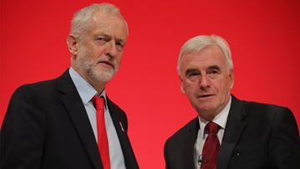
Corbyn’s appeal with voters and especially the youth reinvigorated left-wing politics in the UK after decades of anti-people policies under Thatcher, Major and Blair. After 2008 these policies were exacerbated by austerity measures which drove thousands of the working masses into poverty and despair. This situation led many to look for alternatives, which Corbyn’s fiery anti-austerity rhetoric and soft anti-imperialism fulfilled. However, this utopian belief in a Labour government ending austerity and ushering socialism in Britain was idyllic nonsense.
As the leader of the Labour Party, Corbyn was no revolutionary. Whilst certainly he was the most radical Opposition leader in decades, his party was still at its core a reformist and social-democratic one. From the 90s until the end of the 2000s the Labour Party did not end its policies and reverse deindustrialisation, it cemented it. From its inception the Labour Party has been and is: an imperialist and anti-proletarian party created to ensure the proletariat never seizes power. Corbyn alas was defeated at several general elections over the issue of Brexit and unceremoniously ousted by party members in an internal coup. The left was incensed at what they considered the betrayal of the Blairites and malicious attacks on Corbyn by the bourgeois media. It also laid bare the failure of the CPB’s policy.
As of 2022, the Party boasts that it is growing in membership, however upon closer inspection the party’s membership has remained stagnant with an increase in the membership of the Young Communist League (the party’s youth wing). This is most likely due to disillusioned students leaving the Labour Party (which has returned to openly being a centre-left bourgeois party under Keir Starmer) and joining a group they perceive to be more radical. It is doubtful that the CPB can maintain this growth, it has yet to reach out to the working masses in a meaningful way and continues to believe that it may win elections by growing support and allying electorally with other parties: a complete contradiction of Leninist teachings.
Its programme, the British Road to Socialism does not inspire any confidence in its ability to win support amongst the working class. Whilst it has a fairly mature understanding of political economy and Britain’s position in global imperialism, many vague references to ‘popular democratic and anti-monopoly alliances’ (CPB, 2020), ‘a Left-Wing Programme’ (CPB, 2020) and ‘electing a Left government’ (CPB, 2020) as well as its website advocating for what is essentially a Popular Front bringing in together a left government elected ‘on a parliamentary majority of Labour, socialist, communist and progressive MPs.’ (CPB, 2022).
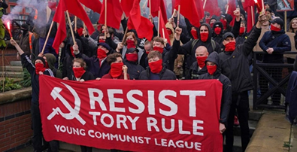
It’s worth noticing, that ‘The British Road to Socialism’ was written more than 50 years ago as a program of actions for the British communists of the CPGB in the middle of the 20th century. It should be reviewed critically in connection with the modern state of capitalism and international communist movement. Being just one of the representatives of split and disorganized communist movement in Britain, CPB acts opportunistically, as the problems of the communists’ low popularity aren’t in their low election statistics.
Participation in the capitalist elections isn’t a problem, however. We want to remind, that this question was researched by Lenin in his well-known ‘Left-Wing Communism: An Infantile Disorder’, which was dedicated to the analysis of the tactics of the British communists as well. Lenin warned them not to make left-wing mistakes and called for participation in the Parliament elections.
But it was a question of tactics, and tactics can always change. The main thing is that Lenin’s work was dedicated not to a small group, but to the newly-created CPGB – a Comintern member, uniting the majority of the British communists in its ranks. Such actions, as taking part in those elections, should be performed by the communists, united in one organization in a nation-wide scale. There is no such organization today, and this means that CPB isn’t helping the communists to fix this problem; it maintains the status-quo, which all the conscious communists should fight against. It makes itself a “fan-group” of the left-wing in the Labour party.
As such advocating for a united electoral ticket to win power in Britain is the height of folly as it undermines the revolutionary potential of the working class into supporting a coalition that contains imperialists and labour aristocrats that have no intention of establishing a dictatorship of the proletariat. These political stances, therefore, reveal its thoroughly parliamentary slant.
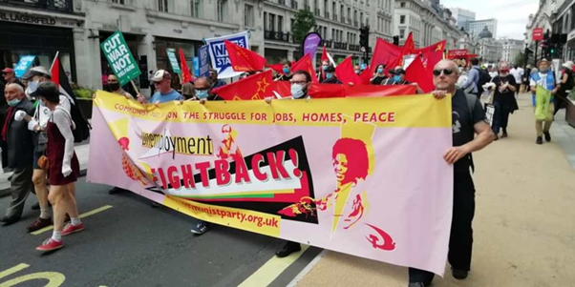
The Communist Party of Britain, thus, is not a revolutionary vanguard of the working class like the Bolsheviks: it is an external, radical pressure group of the Labour Party. A final thing to note on the CPB’s programme is that the dictatorship of the proletariat is mentioned but once throughout the entire text, an omission that demonstrates that it is not a Marxist-Leninist organisation.

“Socialist Workers Party”
Trotskyists aren’t part of the communist movement. Throughout history they wanted to create “their own” communist movement, but always ended up being a few sectarian groups, ready to denounce any of their principles for a bit of attention and recruits in their few ranks. Besides that, they helped the capitalists greatly with their fierce attacks against the USSR and the socialist countries. It’s no wonder that the Labour party, which had not accepted the communists to join them, greeted Trotskyists in their ranks in 1970s. The dissolution of the world socialist system, led by the Communist parties, seemed to be proving Trotskyist schemes. However, not even that fact allowed Trotskyists to gain a great influence.
But under the mask of “non-communists” Trotskyists try to replace the communist movement and the vanguard-party concept with their amorphous federation of different “platforms”, “currents” and “tendencies”, and to replace the time-tested Marxist-Leninist theory with the petty-bourgeois amalgamations of their unfortunate theoreticians like Trotsky and some modern ones, like Tony Cliff or Ted Grant. That’s why it’s necessary to pay some attention to one of their “parties” – the so-called “Socialist Workers Party”.
A Trotskyite party, it, like most Trotskyite groups were particularly popular amongst students and being incredibly active like the others on university campuses. It, however is particularly infamous for a sexual assault scandal that tore the party apart between 2013-2014. At the time the SWP was one of the most prominent socialist parties in Britain; its influence was disproportionately large due to its front organisations that united many disparate groups under a common banner, the most notable being the Stop the War Coalition created in the aftermath of NATO’s imperialist war in Iraq, the organisation was at the helm of one of Britain’s largest mass demonstrations in her entire history, with an estimated two million taking to the streets of London protesting the war.
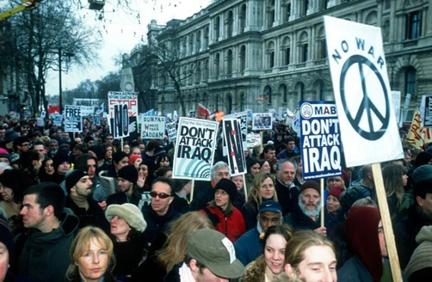
The SWP is but one of numerous Trotskyite groups that have existed in Britain, where they are particularly prominent. Trotskyism grew rapidly after the global protest movements of 1968, with Militant becoming a force on the British left through their entryist tactics aimed at recruiting Labour Party members. Their influence reached its peak in the 1980s when Militant had three MPs in Parliament and control of the Liverpool city council. The SWP similarly has its origins from the 60s protest movement being known as the International Socialists at the time. It became the most enduring of the plethora of Trotskyist parties in the UK. Its founder, Tony Cliff, cemented its unique position in the Trotskyite milieu by rejecting the orthodox Trotskyist line that the Soviet Union was a “degenerated worker’s state”, instead claiming that it and the Eastern Bloc states were “bureaucratic state capitalist” (this position clearly marks them as enemies of the Marxist-Leninist theory and the history of the communist movement).
As mentioned before, the SWP is heavily involved in protest movements and other agitational work, it does this as a means to attract new recruits into its organisation. With the many fronts and organisations that it organises as well as its presence on university campuses, the party has been able to gather thousands most of whom are unaware of who organises these demonstrations and no doubt is a fertile recruiting ground for the SWP; even at protests not organised by them, a stall of theirs will surely be there to proselytise. However, their tactic of building their party by recruiting from all these different movements that are linked to their myriad of fronts have led it to odd alliances in the past, most notably with the Respect Party of George Galloway (more on him later).
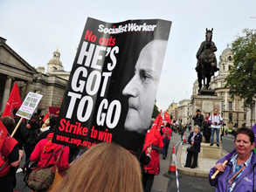
The alliance with the Respect Party was an odd one as it attempted to bring together Trotskyists, socialists, greens and the Muslim community in Britain. The party was formed in the aftermath of the imperialist wars in Iraq and Afghanistan and attracted many working-class Muslim voters away from the Labour Party. The SWP, attempting to attract more members following the success of the Stop the War Coalition, formed an unofficial alliance with the group.
After just three years, tensions between the SWP members in the Respect party and the Muslim members came to a head with the SWP members leaving this unofficial coalition. This is a deficit within Trotskyite parties noticed back in 1924 with Trotskyism being described as ‘the theory that revolutionaries and opportunists can co-exist and form groups and coteries within a single party.’ As Lenin noted (and Trotsky frequently aimed to undermine) only a party held together by iron discipline, developing and adapting Marxist theory to the local conditions in which it operates and committed to the establishment of the dictatorship of the proletariat can succeed in uniting the most progressive and class-conscious sections of the working masses.
This appeal to discipline however, has been used to hypocritically justify gross abuse of power within the SWP. By the early 2010s the party had grown to have an estimated seven to eight thousand members, most likely galvanised by the Great Recession and the austerity implemented against the working class in its aftermath. In 2010, a nineteen-year-old woman known as “Comrade W” accused the now notorious “Comrade Delta” (a high-ranking member of the SWP) of sexually assaulting her, and he stepped down as National Secretary while remaining a member of the party’s central committee. The party was told of the allegations at its conference in 2011. There, the allegation was downplayed and eventually swept under the rug. This attempt failed and the more the Central Committee tried to stifle dissent, the bigger the backlash by party members was. Eventually this led to a major rupture in the SWP with around a thousand members leaving in disgust at the behaviour of the party’s leadership.
The SWP then, like other Trotskyist parties, should not be considered legitimate communist parties. Their theoretical and tactical positions deviate highly from Marxist-Leninist positions, to the detriment of the workers they desire to lead. But what is Trotskyism? As elaborated in Trotskyism or Leninism? it is based on three premises:
- The ‘theory of “permanent” (uninterrupted) revolution’
- The ‘distrust of the Bolshevik Party principle, of the monolithic character of the Party, of its hostility towards opportunist elements.’
- A ‘distrust of Bolshevism’
Marxist-Leninists have opposed Trotskyism vehemently as a deviationist movement. For this opposition Trotskyist parties frequently slander Bolsheviks for not accepting Trotsky’s deviationist dogma as holy writ, creating factions within the CPSU in the 1920s (ignoring the monolithic nature of the Party) in an attempt to seize control of state power to implement their policies. This continues to the present day, the SWP frequently attacks other communist groups as “Stalinist” for not accepting their ideas thus continuing the second and third premises which defines Trotskyism.

Revolutionary Communist Group/Fight Racism, Fight Imperialism
The RCG/FRFI (Fight Racism, Fight Imperialism) – another Trotskyist group – has had accusations of assault and attempts at covering it up as well. However, to criticise this would be flogging a dead horse, the RCG’s shortcomings as a self-proclaimed revolutionary organisation have deeper roots. Founded in the early 1970s out of the Revolutionary Opposition faction of the International Socialists (another Trotskyist party and forerunner of the SWP), the RCG gradually moved from a “traditional” Trotskyist line of denigrating everything related to the USSR, being one of the few groups in the UK that argued that the dissolution of the Eastern Bloc and the USSR represented a victory for imperialism.
The group has been at the forefront of a number of anti-imperialist protest groups, for instance during the Troubles, it supported: the Prisoners Aid Committee; Sinn Féin; the Troops Out Movement (TOM), and focusing particularly on support for Irish republican prisoners held in British prisons. During the intensification of resistance to Apartheid in South Africa they formed the City of London Anti-Apartheid Group. Its recent anti-imperialist adventures are in support of Cuba via the Rock Around the Blockade (a group founded by the RCG to defend the Cuban Revolution) as well as support for Palestine.
However, beyond the almost constant picketing and demonstrations the RCG has not become a force of proletarian politics. In the almost five decades of its existence (fifty years just to be clear!) the RCG has little to show for itself beyond its long-running newspaper: Fight Racism, Fight Imperialism! Whilst it has been one of the more successful groups in Britain, having survived until today whilst others have dissolved or just faded into obscurity, it seems that the group has never moved beyond petty protests and endless publications on its website and magazine.
This shows a clear tactical weakness, an incapacity in the RCG since instead of using its support base as the foundation for expansion and deepening its links to the working class of Britain; it seems that the RCG is content in remaining immobile, in the same position it has held since the late twentieth century. The question of tactics in a party that adheres to Leninism is one of paramount importance that has occupied Marxist-Leninist parties since their inception following the October Revolution. To assume that the party must maintain and dogmatically uphold the same tactics despite the ebbs and upswings that naturally occur as the revolutionary situation changes, is the hallmark of ultra-leftism.
Whilst the RCG is not an ultra-leftist group, the fact that its tactics are limited to protests and picketing lays bare its tactical and strategic deficiencies; as such despite it being in existence for half a century it has not earned the support of the working-class as it has done nothing to appeal to the masses and demonstrate any capacity to lead them to throw off the yoke of the bourgeoisie.
Since the 70s, Britain has been rocked by: the smashing of its unions; deindustrialisation; neoliberal fiscal policies; depreciating wages; the 2008 global recession; increasing exploitation; Brexit; food and housing insecurity; the COVID-19 pandemic and resulting supply-chain issues and inflation. All of these events could be of immeasurable service as evidence of capitalism being unable to resolve its own internal contradictions and that the workers have nothing to gain from it. Yet it continues to agitate primarily on anti-imperialist issues which alienates the working-class if it is not linked to domestic concerns, the results of which can be clearly seen. As such, taking into account the context, it can be firmly stated that the RCG is not an up-and-coming threat to the bourgeoisie; that its claim that it is ‘committed to building a revolutionary socialist movement in Britain’ (RCG, 2018) can be disregarded as it is still building a Marxist-Leninist party fifty years after its inception with no results.
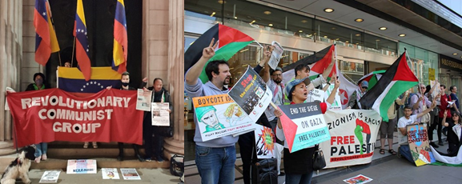

Red Fightback
The most recent addition to the British left-milieu is Red Fightback, a Maoist group that takes inspiration from the Black Panthers. Formed sometime in 2018, Red Fightback is growing as an organisation, supported by slick and well-composed articles and other forms of media. The group eschews the traditional form of spreading class-awareness in the UK (selling newspapers and protesting) and has embraced more modern methods of communication and propagation. Moreover, their current tactic for gaining support among the working class is via weekend stalls and foodbanks where drinks and food are handed out to those that need it, encouraging personal relationships between the area’s branch and local residents. This innovative way of forging links with the working masses is novel in Britain (though it may not appear so to communists where this is the norm), creating a grassroots movement genuinely rooted in the communities in which it aims to serve. In Red Fightback’s own words: ‘Rather than only appearing in a community whenever there is a protest and then leaving again, not to be seen until the next protest, we need to forge solid connections with the people of our communities, offering advice and support and creating organisations to challenge the horrors of capitalism that we are experiencing.’ (Red Fightback, 2018)
This strategy is complemented by its prominent use of media and the internet. The group is incredibly internet-savvy, which can most likely be attributed to its youthful membership, no doubt influenced by the collapse of the Corbynite faction of the Labour Party (the group formed just after) to start an organisation that aims to deliver on its revolutionary credentials. Thus, the language and actions of this group stands out from backdrop of older organisations which are heavily tied to the legacy of the 20th century communist movement. In comparison to the other communist parties discussed, Red Fightback appears to be a breath of fresh air: it fights the idea that the Labour Party is able to build socialism as well as criticising the older communist groups for their chauvinistic behaviour as well as having a clearly mature understanding of the state of British capitalism and its position in the imperialist chain. But whilst Red Fightback seems to be trying to make inroads in working class communities, it cannot be said exactly where this would lead.
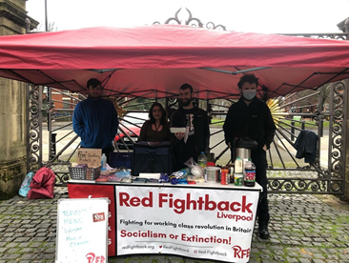
As Maoists, however, it is necessary to be cautious regarding the effect they will have on the wider Communist movement due to the ultra-leftist positions taken up by many that believe that Mao Zedong contributed positively to the struggle against imperialism; these positions can be gleaned from the texts they publish. The group warns of the impending climate crisis and imperialist conflict that daily grows closer. But, it has little to say beyond polemics against the British state and the NATO bloc, thereby not demonstrating much difference in positions with most self-described communist groups in Britain. Whilst undoubtedly communists must struggle against their governments, as ‘the struggle of the proletariat with the bourgeoisie is at first a national struggle. The proletariat of each country must, of course, first of all, settle matters with its own bourgeoisie.’ This however does not mean that communists must support the governments that are the victims of Western imperialism. Many leftists confuse anti-imperialism with unconditional support for a government (more on that later), especially if it is deemed to be a socialist one (often without analysing the class and political dynamics of that society): Red Fightback is no different.
An example of this is its apologia for North Korean revisionism or more prominently its solidarity with the “Bolivarian Revolution”. Whilst Venezuela is still unconquerable by US imperialism, due to its petty-bourgeois origins it has fallen victim to the other imperialists, including PRC and the Russian Federation. This has been recently proven correct by mounting allegations by the Venezuelan Communist Party, which at one point did support Chavez, that it is now fighting against government persecution after attempting to push through the complete nationalisation of the economy for the benefit of the Venezuelan proletariat. Red Fightback proclaims solidarity with Maduro but not with their Venezuelan comrades.

Communist Party of Great Britain (Marxist-Leninist)
The last that shall be discussed is the Communist Party of Great Britain (Marxist-Leninist). The CPGB-ML calls itself rather orthodox Marxist-Leninist party. However, it has some peculiar positions regarding imperialism, China and Russia. The party has lent its support to numerous anti-imperialist struggles but also has voiced sympathy for Russia and China despite Russia being a capitalist nation ruled by oligarchs with desires to maintain its sphere of influence in her “near-abroad” in the name of anti-American imperialism.
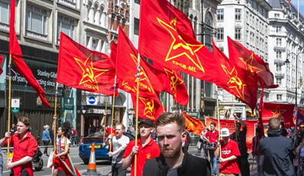
This is a pattern that emerges regarding many countries, the CPGB-ML supports any nation that they believe is an enemy of American imperialism no matter the situation or reactionary nature of the state; the party supports China wholeheartedly and speaks warmly of the People’s Republic despite admitting (albeit obliquely) that it has restored capitalism. Its position is similar to Iran which is officially an Islamic Republic which imposes religious law on its populace and whose state is run by clerics. These countries are hailed by the CPGB-ML due to the fact that they are the enemies of American imperialism. Here reveals a theoretical deficit within the CPGB-ML, they view American imperialism as a force so overwhelming and so reactionary that any force opposing it is considered progressive.
This is a vulgar interpretation of Lenin’s theory of imperialism in the period of monopolistic finance-capital. Lenin never supported one imperialism over another, indeed he criticised that as revisionism that distorts Marxism and diverts the revolutionary drive of the proletariat as the parties of the Second International did during the First World War when they threw in with their respective bourgeoisie and sent young working-class boys to be slaughtered. Lenin constantly called on the working-class of Germany, France and Britain to unite and end the war. It was this call that led to the Revolution in Germany in 1918, to the French Army’s mutiny and to Red Clydeside in Glasgow; as a consequence, forcing the imperialists to end their war to re-divide the world. As Britain’s Prime Minister at the time, Lloyd George stated: ‘our real danger now is not Germans, but Bolshevism.’
For a Marxist-Leninist there are no good or bad imperialisms, to flirt with the idea that one nation’s imperialism can be progressive is deeply misguided, for it was not just Lenin that stood steadfast against all imperialisms but Stalin too. On the eve of the Second World War and after numerous attempts to form an anti-fascist alliance; recognising that Nazi Germany and Mussolini’s Italy were particularly dangerous especially to the still isolated Soviet Union, Stalin chose to ensure at least temporary security when it became apparent that an inter-imperialist war was imminent.
During the early years of the war the Comintern maintained its principled opposition to all imperialist ambitions, calling for the proletarians of France, Great Britain, Germany and Italy to start a revolution and bring an end to the war by refusing to carry it on. The CPGB-ML’s position therefore is a distortion of Leninist teachings which state that imperialism is the foremost enemy of all that wish to see socialism and as such whilst every principled Marxist must be vehemently opposed to imperialism, that does not mean that Marxists should support every reactionary class that fights against the imperialists of one’s own nation and any alliance with the bourgeoisie must be temporary and limited; never a long-term strategy outside of, colonial, semi-colonial and dependent nations:
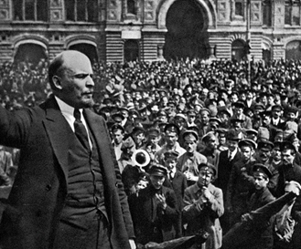
‘Imperialism is as much our “mortal” enemy as is capitalism. That is so. No Marxist will forget, however, that capitalism is progressive compared with feudalism, and that imperialism is progressive compared with pre-monopoly capitalism. Hence, it is not every struggle against imperialism that we should support. We will not support a struggle of the reactionary classes against imperialism; we will not support an uprising of the reactionary classes against imperialism and capitalism.’ (Lenin, 1916)
Whilst the party is relatively young as a group (being formed in 2004 from a split like most British communist organisations), it has seemed to have gained the confidence to start operating as a nation-wide party through a front called the Workers Party of Britain. Formed in the aftermath of Corbyn’s and the Labour left’s defeat, the WPB was formed by members of the CPGB-ML to attract discontented former Labour supporters and winning over pro-Brexit workers who the WPB believes lent their support temporarily to the Conservatives who pledged to get Britain to leave the EU. As such, it has advertised itself as ‘patriotic, Pro-Brexit, economically radical and socially conservative’ (Galloway, 2021), refusing to indulge in “culture wars.”
The WPB is led by George Galloway, a former Labour MP and notorious firebrand that has tried over the years to form a new socialist movement in Britain through various alliances (such as the Respect Party). Achieving limited success in those endeavours, it seems that he has thrown in with the CPGB-ML and the WPB, attempting to win a seat in Parliament during the Batley and Spen by-election on 1 July 2021. Despite coming in third, Galloway and the WPB caused enough fear in the bourgeois media that he could tap in to some discontent in the community and gain a platform, indeed, his results are nothing to laugh at, winning 21.9% of the vote whilst both the Labour and Tory vote-share decreased by 7.4% and 1.6% respectively.
This can be attributed to Galloway’s appeal among Muslim voters, having won in Bradford earlier in the decade based on his vocal pro-Palestinian views (it is also speculated that Galloway has converted to Islam but has never expressed any public confirmation of this, although he has married several Muslim women over the years). It cannot be said at this time if the Batley and Spen by-election was anything more than a fluke or touched upon an emerging current in British politics: it remains to be seen if the WPB will be a force on the British left.
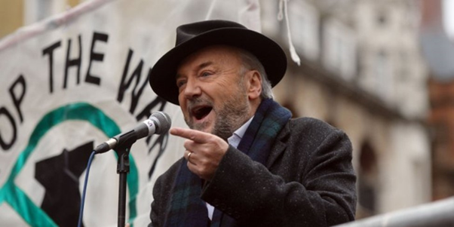
It is not an absurd proposition though, Galloway and the WPB/CPGB-ML has presumably implicit support from the Russian government. Galloway hosts a political talk show on RT called the Mother of All Talk Shows (MOATS) which broadens his profile across Britain and must be seen as an tool in propagating the anti-establishment views of the party under the auspices of a broadcaster alleged to be a Kremlin mouthpiece. This is not mere speculation, frequent guests on MOATS (especially since the beginning of the COVID-19 pandemic) are Ranjeet Brar (a doctor and medical expert) who criticises government health policy and Joti Brar (vice-chairwoman of the CPGB-ML and deputy head of the WPB), both of whom are children of Harpal Brar, founder and chairman of the CPGB-ML from its inception until 2018. Thus, it is clear that the CPGB-ML/WPB is tightly linked to Russia in some shape or form, explaining their docile words about the Russian state and their support of Putin and the Russian bourgeoisie’s imperialist aspirations.
This article was meant to be but a brief introduction to the state of the communist movement in Britain. Despite the brevity in content, it still took five thousand, two hundred and seventy-nine words to cover just five groups. Extrapolate this and apply it the myriad of reading groups, leagues, organisations and aspirational parties that have existed up and down the country and it becomes clear that communists in Britain have a Sisyphean struggle ahead of them if they want to win over the working masses of Great Britain (a lot of whom are some of the poorest in Western Europe) (High Pay Centre, 2017).
However, this crisis can be resolved. There is a working-class upswing in the country, wages began to rise before inflation started depressing them, union membership is beginning to rise again after a historic low whilst poverty and proletarianization is accelerating.
What Britain needs is a communist movement that avoids the mistakes of all the other groups that fight for the proletariat, a Leninist party that does not run for election numbers in order to survive as a part of the political system, party that is disciplined and instils confidence in the working-class of its ability to lead and conduct the struggle, a party that does not cosy up to imperialist powers in the name of anti-Americanism. A party that is democratic, disciplined and rooted in the working-class of the UK, that has a correct understanding of Marxist-Leninist theory and tactics can ensure victory and break one of the crucial links in the global imperialist chain.

References
Blake, W., 1804. And did those feet in ancient time. s.l.:s.n.
CPB, 2020. Britain’s Road to Socialism: Programme of the Communist Party. [Online]
Available at: https://yclbritain.files.wordpress.com/2020/06/britains_road_to_socialism.pdf
[Accessed 6 January 2022].
CPB, 2022. Communist Party of Britain. [Online]
Available at: https://www.communistparty.org.uk/what-we-stand-for/
[Accessed 18 January 2022].
Galloway, G., 2021. The newly woke Labour Party hates its voters too much – it’s right to fear they will pick me instead. [Online]
Available at: https://www.rt.com/op-ed/524154-galloway-labour-voters-by-election/
[Accessed 12 January 2022].
Lenin, V., 1916. A Caricature of Marxism and Imperialist Economism. s.l.:s.n.
Lenin, V., 1917. The State and Revolution. s.l.:s.n.
RCG, 2018. Introduction to the RCG and our politics – SECTION ONE: Who are the RCG?. [Online]
Available at: https://www.revolutionarycommunist.org/marxism/introductory-education-programme?start=1
[Accessed 17 January 2022].
Red Fightback, 2018. A Class Analysis of the Current Material Conditions in Britain and Our Strategy for Revolution. [Online]
Available at: https://redfightback.org/a-class-analysis-of-the-current-material-conditions-in-britain-and-our-strategy-for-revolution/
[Accessed 17 January 2022].
High Pay Centre, 2017. The Poorest Regions in the UK are the Poorest in North-West Europe. [Online] Available at: https://mailchi.mp/highpaycentre/new-research-uks-poorest-regions-are-the-poorest-in-north-west-europe?e=646b379b9b

Original article

