On The Blockade Of Artsakh
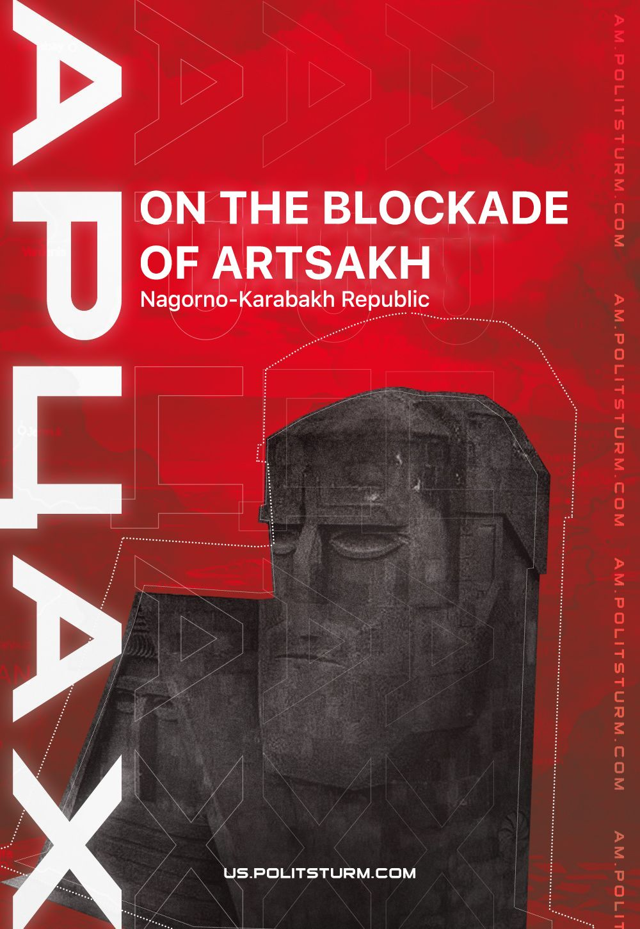

Original article
2023-09-21
11 min read

Preface
Yesterday Azerbaijan managed to achieve victory over the 30 years' problem of Karabakh. What events preceded this? We publish a series of materials from our comrades from PS Armenia, in which they reviewed the events of the last year, starting with the blockade of Karabakh. This material was published in February 2023.
In 2020 Azerbaijan managed to secure its border with Armenia, cutting the majority of Artsakh communications. The blockade of the unrecognized Nagorno-Karabakh Republic (Artsakh), organized by the Azerbaijani authorities, has been going on since December 12, 2022, until it resulted in Azerbaijani ‘anti-terrorist operation’ on September 19, 2023 – Politsturm International.
The Stepanakert-Goris-Berdzor (Lachin) corridor, which was the only route connecting Artsakh with Armenia, remained completely closed by the Azerbaijani side allegedly "for environmental reasons". As a result, 1,100 people, including 270 children, were cut off from their homes.
In addition to the blockade of the Goris-Stepanakert highway, Baku has blocked the gas supply of the republic. 120,000 residents currently live in the unrecognized Nagorno-Karabakh Republic, receiving the bulk of goods, including food and basic necessities, along the above-mentioned road from Armenia.
Azerbaijan continues to bring people there, allegedly environmentalists, on buses that provoke Russian peacekeepers with nationalistic gestures and shouts.
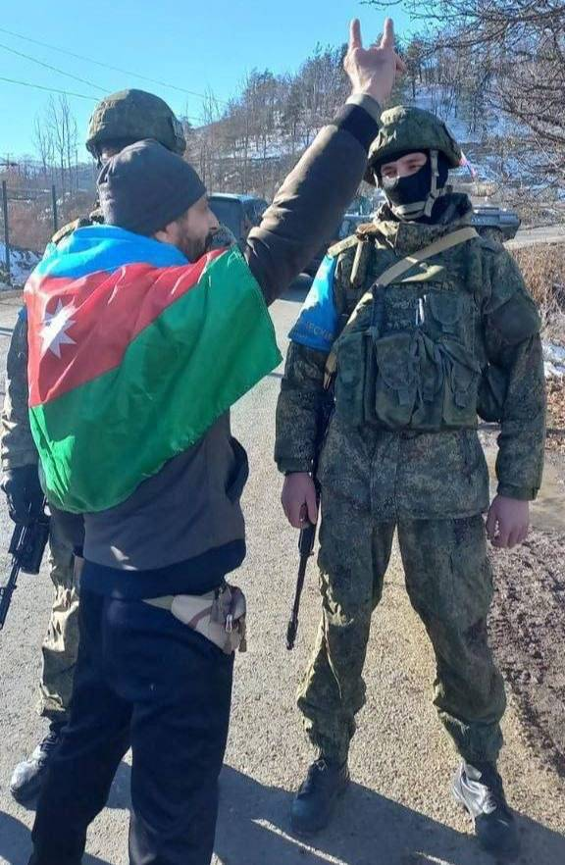
One of the "eco-activists" shows the sign of the "Gray Wolves" - a Turkish nationalist organization.
The actions of the Azerbaijani authorities posed a threat to the food and humanitarian crisis in Artsakh. In addition, the current situation violates the trilateral statement of November 9th, 2020, according to which the Lachin corridor is under the control of Russian peacekeepers, and Azerbaijan guarantees the safety of traffic along it.
The confrontation actually left the Armenians of Karabakh alone, forcing them to become economical and start distributing food and fuel by stamps.
It is obvious that Baku will squeeze the Armenians of Nagorno-Karabakh out of the region at any opportunity. This refers to the issue of the creation of cultural autonomy for the Armenians of Artsakh within Azerbaijan, in the creation of which the supporters of Artsakh's being part of Azerbaijan believe, or maybe pretend to believe.
We see the solution to this conflict only in the recognition of the right of the people of Artsakh to self-determination. However, as long as the power in Azerbaijan belongs to the representatives of the oligarchy, the right of the people of Artsakh to self-determination will not be recognized in any form.

What is the Aliyev regime trying to achieve by the blockade of Artsakh?
Most likely, the blockade will not be lifted in the near future, at least until the Aliyev regime achieves its goal of persuading the Armenian authorities to unblock transport communications and sign a peace treaty as soon as possible on conditions favorable to the ruling class of Azerbaijan.
For this, Azerbaijan launched the 2020 war, and the beneficiary is primarily Turkish capital, which gets access to sales markets and raw materials.
The words of the so-called Azerbaijani ‘environmentalists’, who express concern about the export of resources from the region, can also be taken quite seriously. If you read between the lines of the pretentious statements of the ‘environmentalists’, they broadcast the indignation of the ruling class of Azerbaijan because of the export of minerals from the territory of Nagorno-Karabakh to the Republic of Armenia.
Unsupported element
The Azerbaijani ruling class considers the territory of Artsakh, which for almost 30 years they did not control and did not have access to, their own. After all, the Aliyev clan considers itself the winners in the 2020 war. However, they won the war, but there was a small piece of territory that they do not control and from which the oligarchs from Armenia export resources.
Unsupported element
Capitalists from Azerbaijan want to exploit the subsoil of Artsakh. The latter cannot calmly survive the fact that someone else is profiting by exploiting the resources of the region. And the "Azerbaijani environmentalists" who blocked the Lachin corridor are either useful idiots, or are directly used by the ruling class of Azerbaijan to achieve their selfish goals.
In addition, the British “Anglo Asian Mining Company” claims the mines of Artsakh, which Azerbaijani "environmentalists" are so concerned about. It was to her that the Azerbaijani authorities, in exchange for $3 billion, handed over a number of mines, including the Kashen copper-molybdenum mine owned by the Armenian company Base Metal, located in the Martakert district of Artsakh.

Who is to blame?
It is also obvious that the ruling class of Armenia is also to blame for the current situation, which for 30 years has done nothing to resolve the conflict or to create conditions conducive to ensuring the security of the Armenians of Artsakh. The Armenian bourgeoisie had enough other worries – it was necessary to enrich itself by impoverishing its own population.
However, the Azerbaijani bourgeoisie was busy with the same thing. It was just luckier with resources and an ally without which it would not have been able to wage war so effectively and with such a high degree of intensity.
The Armenian bourgeoisie is not ready and is not able to solve this national issue. The ruling classes have done everything possible to pit the two peoples against each other.
The Armenian bourgeoisie and the state, which generally protects its interests, found themselves in such a situation that, on the one hand, the existence of an independent Artsakh does not allow them to fully benefit from unblocking transport communications and opening borders with Turkey, and, on the other hand, they also cannot openly and definitively merge Artsakh, since the population will not understand this.
However, it is significant that the ruling class as a whole theoretically considers it possible to abandon the idea of an independent Artsakh.
In fact, we fully admit their willingness to abandon the unrecognized Republic for the sake of profit in the event of the opening of borders with Turkey and the unblocking of transport communications.
In this case, Armenia will turn into a sphere of influence of Turkish capital, as Georgia and Azerbaijan are now. And this is a natural outcome of the path that our country chose in 1991. This path was imposed on us by anti-communist forces who needed "independence" for personal enrichment.
It is noteworthy that the same anti-communist forces used the Karabakh movement to destroy socialism and withdraw the Republic from the Union.
Socialism was destroyed, capitalist relations were established in the country presenting these processes as the revival of the national state and the return of the Nagorno-Karabakh Autonomous Region "unfairly transferred" by the Bolsheviks to the Azerbaijan SSR.
A small group of oligarchs became the beneficiaries of the destruction of socialism, and the results of the Karabakh movement were reset by the ruling class of Armenia 30 years later.
In the current situation, all those involved in the establishment of a corrupt oligarchic system in Armenia are collectively to blame. The war of 2020 was lost not only because of the actions of Nikol Pashinyan and his team, but also because of the political and economic system that developed over 30 years. And Nikol Pashinyan himself is a consequence of this system. Thanks to the actions of the previous authorities and the degradation of society, it became possible for such an insignificant populist as Pashinyan to come to power.
As a result, it can be stated that the Karabakh movement was necessary for nationalist circles and the emerging class of large owners to come to power and destroy socialism. The task was completed, therefore, in case of the loss of Artsakh as the Armenian bourgeoisie will be more than able to compensate for this with the benefit of the opening of borders.
Against this background, the reproaches of the Armenian nationalists against the Communists look ridiculous. Yes, the Bolsheviks had to make a difficult and contradictory decision in resolving the Karabakh issue. But it was resolved without blood and on a compromise basis.
The Armenians of Nagorno-Karabakh had their own autonomous region, their own status, etc. The most important thing is that no one killed each other, and the Armenians of the Republic and the Armenians of the NKAR lived in the same country and had the opportunity to create and develop.
The above does not mean that Artsakh should be transferred to Azerbaijan. Not in any case, as this would lead to ethnic cleansing of the Armenians of Karabakh. The entry of the NKAR into the Azerbaijani SSR, which in turn was part of the USSR, is not the same as the presence of the Armenians of Nagorno-Karabakh in bourgeois Azerbaijan.
Of course, the decision of the Caucasian Bureau of the Central Committee of the CPSU(b) of 1921 on the transfer of the Armenian-populated Nagorno-Karabakh to the Azerbaijani SSR is controversial, however, it is better than being in a state of permanent threat of destruction.
We wrote in more detail about the reasons for the transfer of Nagorno-Karabakh to the Azerbaijani SSR in the article "The Nagorno-Karabakh conflict: the Legacy of Soviet power?".
The conflict was not caused by the Bolsheviks. Nationalists on both sides and figures of the First Armenian Republic and the Azerbaijan Democratic Republic, created in 1918, are to blame for its beginning and tightening.
The nationalist governments of the above-mentioned republics, which were unwilling or unable to agree, played a big role in fomenting the interethnic conflict.
The Communists got republics after the nationalists, and they had to resolve interethnic conflicts that happened through the fault of the latter. The Communists sought to resolve and did resolve interethnic conflicts and territorial disputes, even if not in the way they wanted. The Soviet system itself allowed these disputes to be resolved at the negotiating table.
What do we have now? A small piece of land remained from the Republic of Artsakh, blocked from the rest of the world, whose borders are much smaller than the administrative borders of the NKAR, and the population is under threat of ethnic cleansing.
In any case, the Bolsheviks tried to resolve the Karabakh issue. We admit that it was possible to solve this national issue better. However, the unambiguously "bad" solution to the Karabakh issue implemented by the Bolsheviks, is a hundredfold better than what the nationalists offer us.
Nationalists, and in general capitalists from Armenia and Azerbaijan, propose to solve certain national issues by completely destroying one of the parties to the conflict.
Such an approach will not solve any national conflict, but will only aggravate the situation even more.
Thousands of people have died on both sides, which further contributes to mutual hatred, and the nationalist propaganda of the two states only intensifies national enmity and dehumanization of the opposite side of the conflict.
Ordinary hard workers suffer from the conflict, children from poor families on both sides die in this war.
The bourgeois governments of the two Transcaucasian republics do not want and will not be able to stop this slaughter, nor will the intervention of the great powers (USA, France, Russia), as many hope in Armenia, lead to the end of the conflict.
In order to end the enmity between Armenia and Azerbaijan, it is necessary that the workers of these countries finally acquire political subjectivity and be able to seize power in their states. They should do it together and together, forgetting about old grievances and nationalist prejudices.
They – workers – must understand that they have nothing to share, their main enemy is the class enemy. Workers should finally understand that first of all people are dying because of the actions of their elites, who are ready to sacrifice their people for profit.
The workers of the two countries, having removed the bourgeoisie class from the management of the state apparatus and having established a new socio-economic system in Transcaucasia instead of capitalism, will be able to agree on a compromise basis. Yes, it will not be easy and the old nationalist prejudices will make themselves felt for a long time. But at least under socialism we have more chances to overcome national enmity and establish peace in the region.

Original article

