On the Arrest of Boris Kagarlitsky
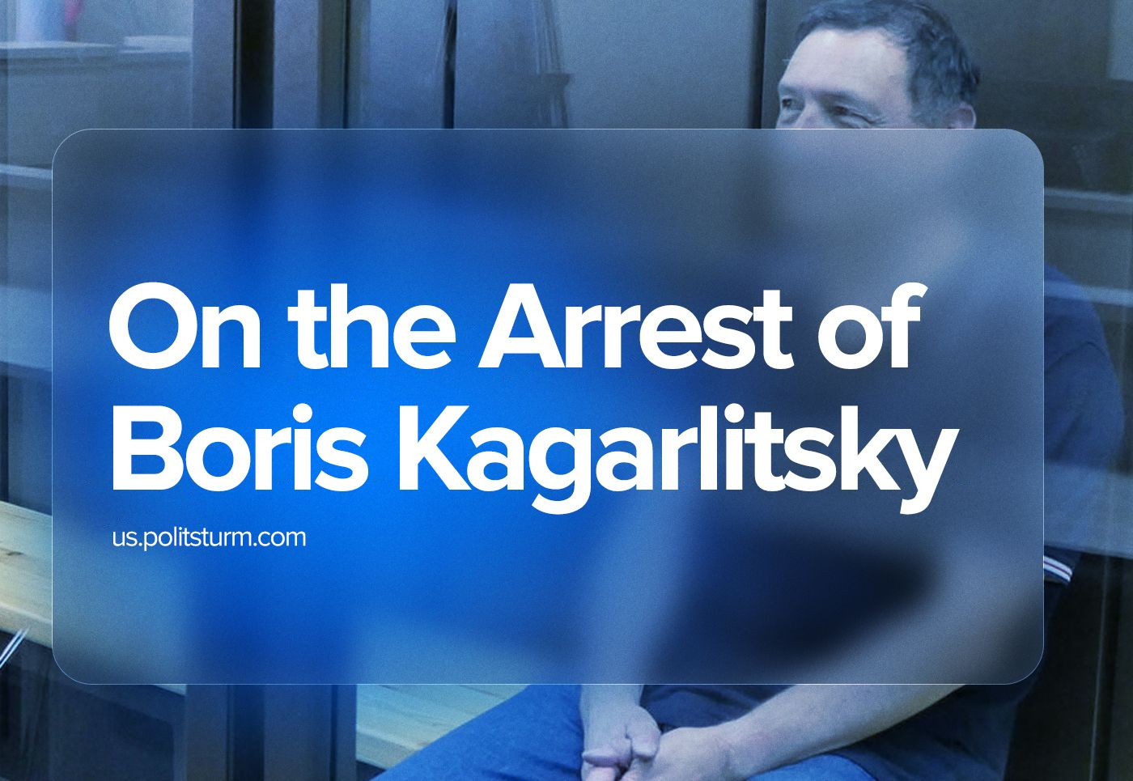

Original article
2023-08-04
5 min read

On July 25, Russian left-wing sociologist who adheres to social-democratic views, named Boris Kagarlitsky, was arrested.
I. In recent years, Kagarlitsky did not pose any danger to the government and paid more attention to the media space, attending various conferences and his “Rabkor” resource. Since being listed as a "foreign agent" in Russian “Foreign Agents Registry” May 2022, his media capabilities have been severely curtailed.
As communists, we view this event as yet another act of government intimidation and oppose bourgeois repression and attempts to restrict political activity. The Russian government is methodically clearing the media space of potential opposition and is rapidly curtailing the remnants of bourgeois-democratic rights against the backdrop of the consequences of the Wagner PMC rebellion, preparations for the presidential elections in 2024, the situation in the ‘Special Military Operation’ zone in Ukraine, as well as a possible second wave of mobilization. The capitalists seek to intimidate both the left and the "angry" right camp.
II. The reaction from the Communist Party of the Russian Federation, as the largest formally leftist organization in the country, to the arrest of Kagarlitsky is virtually absent, although back in 2021, in his address to President Putin, party leader Gennady Zyuganov mentioned Kagarlitsky among those groundlessly detained during the elections to the State Duma. Deputy from the faction of the Communist Party of the Russian Federation, Russian general Sobolev declared: “We now have a counteroffensive of the Armed Forces of Ukraine, large-scale reforms of the draft system – these topics are much more important. Although in the case of Kagarlitsky, probably, we also need to understand carefully”. Other social-chauvinist media personalities supported the arrest and once again sided with the government.
Condemning the actions of the ruling group of the bourgeoisie and repressions, including those against the Social Democrats, we are extremely critical of the flow of laudatory tirades and inappropriate comments about Kagarlitsky, and especially the ideas that he broadcast, from some people and organizations.
Russian Trotskyists from “Organization of Communists-Internationalists” (aligned with “International Marxist Tendency”) claim: “Whole generations of young communists of post-Soviet Russia grew up on his books and articles” ."In 2022 Boris took a consistent anti-war stance"— broad-left blogger Vasily Sadonin writes.
Indeed, representatives of various political currents, including liberals, sided against Russia's ‘Special Military Operation’. However, back in 2014, Kagarlitsky himself willingly supported LDNR. His certain materials are very similar to the current narratives of the Russian government regarding Ukraine:
“The failure of the economic policy pursued by the Ukrainian state predetermined its collapse with the same inevitability as its cultural policy... This state no longer exists and will never exist. The "cold" civil war began here long before the first shots were fired. And the economic crisis with subsequent political upheavals predetermined its transition to the “hot” phase”.
Sadonin continues:
"However, the main thing, I think, is that Boris provided a platform for POLITICAL DISCUSSION ... Perhaps, on the contrary, the arrest of Kagarlitsky will serve as an additional impetus for gathering a broad all-democratic coalition".
Here Kagarlitsky consistently showed himself not as a conscious communist (which he never was), but as a social democrat: of all the “leftists”, he turned out to be a person convenient for the widest possible audience, since he communicated with both the left and the right, had close contacts with liberals and, in general, always behaved as streamlined as possible.
The idea that the scheme of making money on streams and increasing the audience through guests, used by Kagarlitsky and working since the time of Dmitry “Goblin” Puchkov, was in fact some kind of secret plan for the development of “political discussion”, only shows, using the example of Sadonin, the isolation of left-wing bloggers from practical work and their misunderstanding of the difficulties of real organizational building.
Moreover, Kagarlitsky himself had rather modest experience in building an organization: the broad left-wing Socialist Party and the Labor Party, in which he took part in the 90s, were soon liquidated. The Left Front, which he joined in the mid-2000s, also failed.
It is not surprising, therefore, that the support for Kagarlitsky expressed even the far-right camp represented by the “Angry Patriots Club”, one of whose active members was also recently arrested:
“Solidarity with Kagarlitsky! … Despite the differences in political positions, we consider the case politically motivated in the same way as the case against Igor Ivanovich Strelkov”.
It would be difficult to expect such attention to any consistent communist.
Finally, it is worth noting that the streams of pompous words, that do not correspond to either the current situation or the organizational capabilities of their authors, are addressed to the most moderate social democrat, who promoted world-systems analysis as a replacement of the Marxist theory, for decades. He made a considerable contribution to the revision of the Marxist theory and ideological degradation of the Russian left.
But Kagarlitsky also spread anti-communist propaganda during the Soviet era. At the turn of the 1970-1980s. Kagarlitsky was arrested for participating in the activities of the "Circle of Young Socialists", distributing such materials as:
- the works of Solzhenitsyn, a well-known anti-communist;
- the “Posev” magazine, published by CIA-funded Nazi-collaborators from “The National Alliance of Russian Solidarists”;
- the leaflets of the Polish anti-communist trade union "Solidarność".
III. On the example of Kagarlitsky's arrest, we see the desire of the Russian government to maximally clean up the media space from those who disagree with its policies. Against the backdrop of growing problems of a social and political nature, the capitalists are taking all measures to strengthen their positions.
In condemning such measures, the communists must remember the importance of the strictest observance of all security measures and to keep the work of building a communist party. We are already doing this work. Join us.

Original article

