On Strikewave in USA: Labor on the Rise?
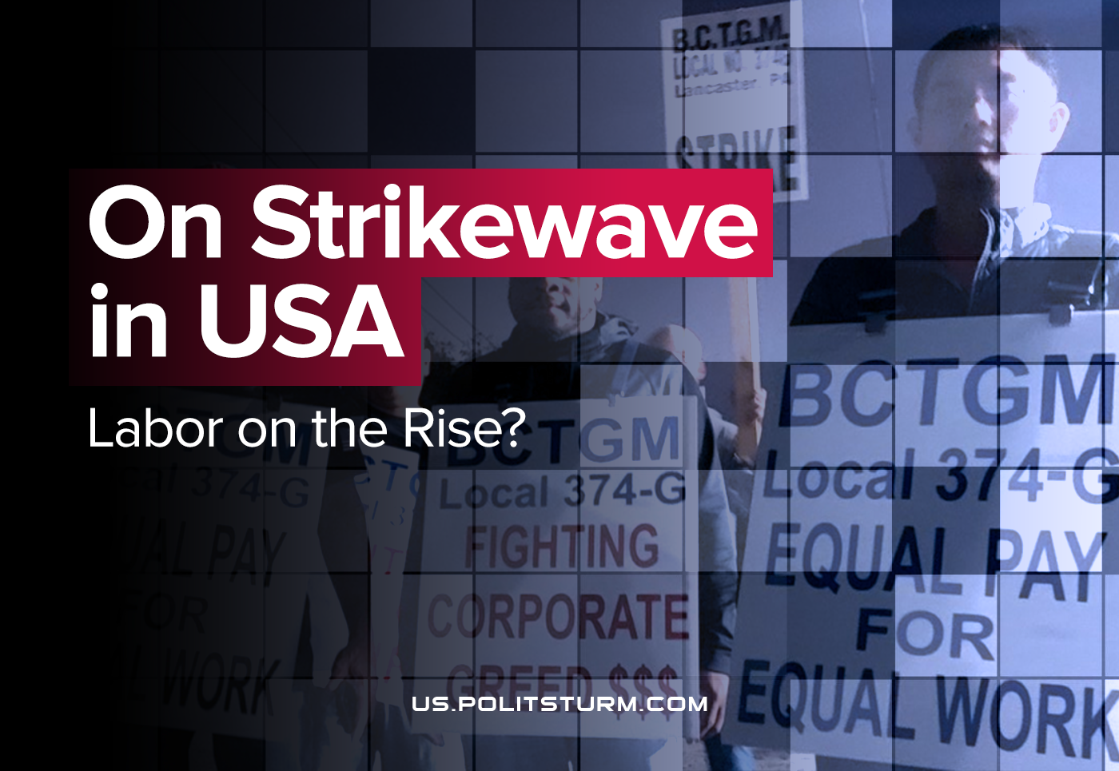

Original article
2021-10-13
6 min read

Latest news from the American labour movement shows worker’s strikes ringing out across numerous industries, involving tens of thousands of organized labourers in stoppages of varying intensity and organizational basis amidst a general increase in labour activism. This wave was anticipated due to the looming deadlines on critical votes and upcoming reviews of contracts with union bodies, like 10,000 John Deere workers are currently doing, many of which have the potential to develop into stoppages.
Year 2020 was noted by the National Labor Review Board for a record low number of strikes, reaching only 27,000 workers; but other sources have revealed over 1300 strikes in that time when one considers those which remained ‘illegal’ or simply unrecognised. Since 2020, we have not seen so many of these strikes, but we do continue to see hundreds of grassroots organised strikes each below 1000 active workers, totaling in the thousands of workers. Either way, these small numbers fall far below those which had spiked to 400,000 in 2018 and in 2019 there was 10 stoppages by at least 20,000 workers each – the largest recognised striking numbers in the US since the early 90’s. This all reveals a developing trend.
Error loading image
Now, new and high-profile labour activities like the unionization of major American media outlets, including the New York Times technician stoppage in August, but especially the stoppages by hundreds of entertainment workers with the industry’s union IATSE, have propelled a media buzz around the idea of a developing strike-wave in the U.S. through the latter half of 2021.
Cornell’s labour tracker records 139 labour actions in the US with less than 100 participants. However, the potential number of workers who are poised to go on strike through various presently extends into the hundreds of thousands.
Preliminary work stoppage records for this year, collected by the U.S. Bureau of Labor Statistics, confirm the view of an increasing trend in the average number of days of stopped work for this year in perspective with the past 4 years.
Overall, the view of a strikewave in Autumn of 2021 includes various different forms of a labour organisation; while the significant strikes of four Kellogg cereal production plants, for example, are organised through official actions of four N.L.R.B.-recognised locals, while organised workers at Instacart have called for a boycott over degrading conditions and the company’s suppression of ameliorative grassroots labour activity. 60,000 film and television workers plan to strike soon, as well as 24,000 Kaiser Permanente health workers. With the varying forms of labour organising also manifests different goals and strategies for satisfying the particular goals of each organized effort.
Error loading image
Spontaneity reigns, as the ‘trade union consciousness’ which Lenin described over 100 years ago limits the horizons to which these activities can aspire. Our malnourished American labour movement is finding new forward momentum, and in this stage only blindly rushes ahead to catch up with conditions which degrade at a hopelessly faster rate.
Some communists have echoed the call for a so-called October General Strike, hoping to feed into (or, off of) the rising labour confidence. But this is a pointless affectation of an ultra-left tendency in the face of real developments, while the real activities of organized workers remain disconnected and the unorganised masses remain disinterested with something so unrealistically aspirational in its outline and completely ephemeral in its real organisational basis.
And while we see the growing number of strikes as a positive sign of increasing class struggle in the United States, we shouldn’t look at it as a cure for all the problems. As history showed us many times before, without the leadership of the Communist Party, the trade union movement does not have the coordination to concentrate a substantial attack of labour capable enough to tackle the capitalist ruling class and will inevitably end in either open defeat by the capitalists or slowly turning into a part of the bourgeois state, like it happened with AFL and, later, CIO.
The irreplaceable opportunity of the current labour situation in the US is that with millions of workers no longer receiving unemployment payments and the retirement of an aging workforce, labour is in an advantageous position to make demands.
So where are we now towards Communist Party leadership? The only ones in the American Left that are really active in labour are the Democrat’s own in-house opportunists, the DSA. While their forces have matured over the past 5 years, they represent an absolutely regressive trend. Even the CPUSA follows this lead, the lead of the Democrats, while other groups simply have little labour presence at all. Hoping to increase the potential of labour activism, the CPUSA has fallen directly into the bourgeois political trap of liberal coalition. So, we have no good Communist Party.
This means that the first task for all the class-conscious workers is to create such a party. To really change the situation and improve life in the country, all conscious working people need to start studying Marxism-Leninism as soon as possible, making communist agitation, explaining the position of the communists, organizing like-minded people and protecting the real interests of the workers. Only such work will lead to the creation of a vanguard communist party and will contribute to a real change in the situation in the country.
Politsturm calls on all conscientious comrades from the US to join their forces and organize. If you are interested in communist work in our ranks, message us at politsturm.inter@gmail.com or in our social networks.

Original article

