On The Farmers’ Strike In the Netherlands
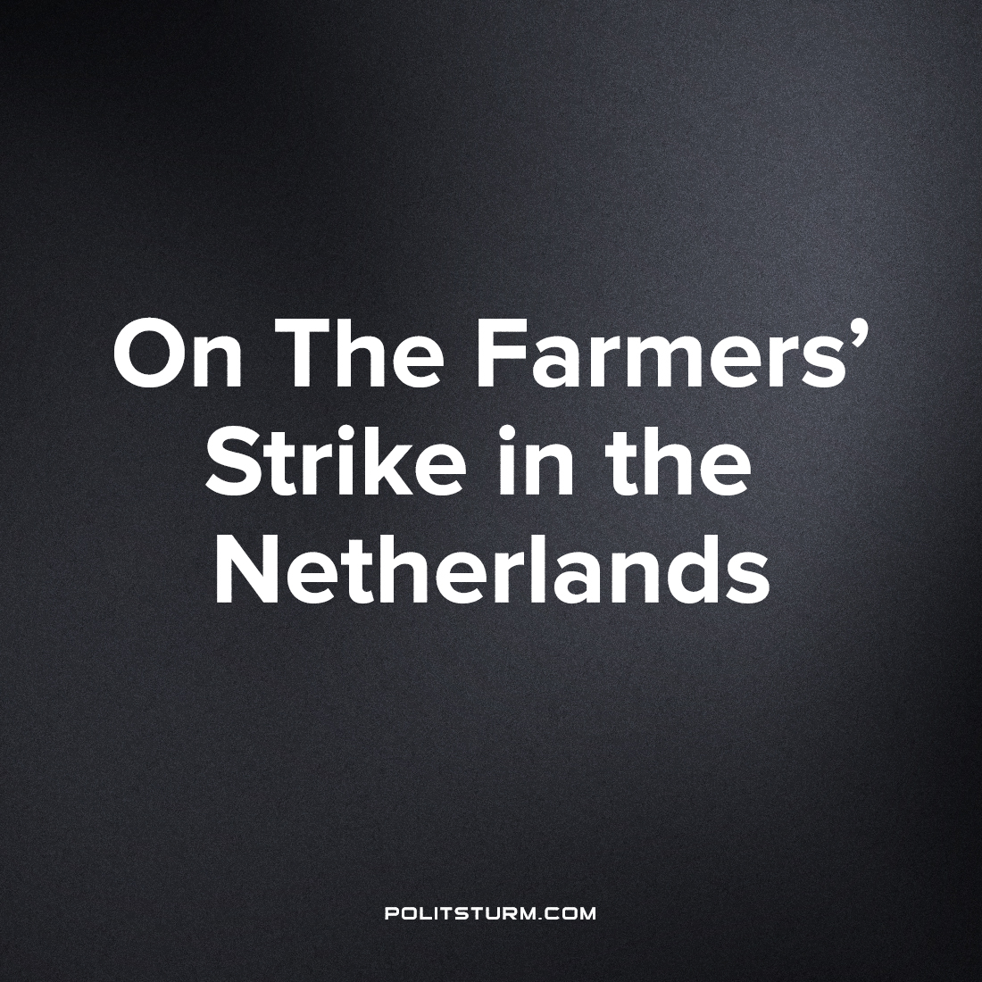

Original article
2022-07-19
2 min read

Since mid-June 2022, mass protests and strikes among farmers have swept through the Netherlands. Around 40,000 farmers are participating in the protests. In the last few weeks, confrontations between the demonstrators and the police have become violent.
Farmers began their mass protests when the Dutch government demanded that they reduce their activity in order to meet new climate goals. These demands, however, were not accompanied by any offers of financial support or substitute employment opportunities from the government.
In June 2022, the Dutch government resolved to reduce emissions of nitrogen oxides by 50% by 2030. In order to reach this goal, farmers must significantly reduce the amount of fertilizer they use and the amount of livestock they raise. Official government statements have recommended that farmers reduce the number of cattle on their farms, move to other regions, or entirely close down their businesses. The Dutch government itself even admitted that the new climate policy will force around 30% of farmers in the country to close their farms permanently.
Already in June 2022, tens of thousands of Dutch farmers declared a strike. In protest against the government’s new climate policies, they began blocking streets and highways with trucks, tractors, and hay bales. In the last few weeks, farmers have blocked both food deliveries to supermarkets and public transportation to the Amsterdam airport. Fisherman have joined the strike in solidarity with the farmers, blocking ports around the islands Terschelling and Vlieland, and refusing to sell their products to stores. Residents of the Netherlands have begun complaining on social media about the shortage of groceries in stores caused by the farmers’ strike.
In a time period of only a few weeks, Dutch farmers have managed to stop traffic and food deliveries in large parts of the Netherlands.
Police shoot at farmers
On Tuesday, 5 July, local police shot at a group of farmers protesting in Friesland. One of the demonstrators shot at by the police was a 16-year old farmer’s son, who quickly became a symbol of the growing protests. According to the local police report, the 16-year old was said to have attempted to drive his tractor at the police, who fired at his tractor in response. The police reported that the tractor was shot three times, but no person was injured.
The 16-year old was arrested and detained but released on the next day, when a group of around one hundred farmers with 40 tractors gathered in front of the police station to demand the boy’s release.
New Policies Increase Concentration in Agriculture
The demand to reduce agricultural activity will primarily hurt smaller farmers, who need a certain production level in order to be profitable. Forcing these smaller farmers to scale back their activities will likely reduce their profits, such that they are no longer able to live on the proceeds of their production. Larger-scale farmers, on the other hand, can easily divide their farms into smaller units and thus more easily meet the government’s new regulations.
In this way, the proposed law favors the concentration of land in the Netherlands. It also demonstrates that climate politics under capitalism do not lead to a more sustainable society, but instead allow the rich to become even richer.
Source: https://riktpunkt.nu/2022/07/bondestrejk-skarps-i-nederlanderna-polisen-skjuter-mot-demonstranter/

Original article

