Ohio Disasters: What's Happening in the State?
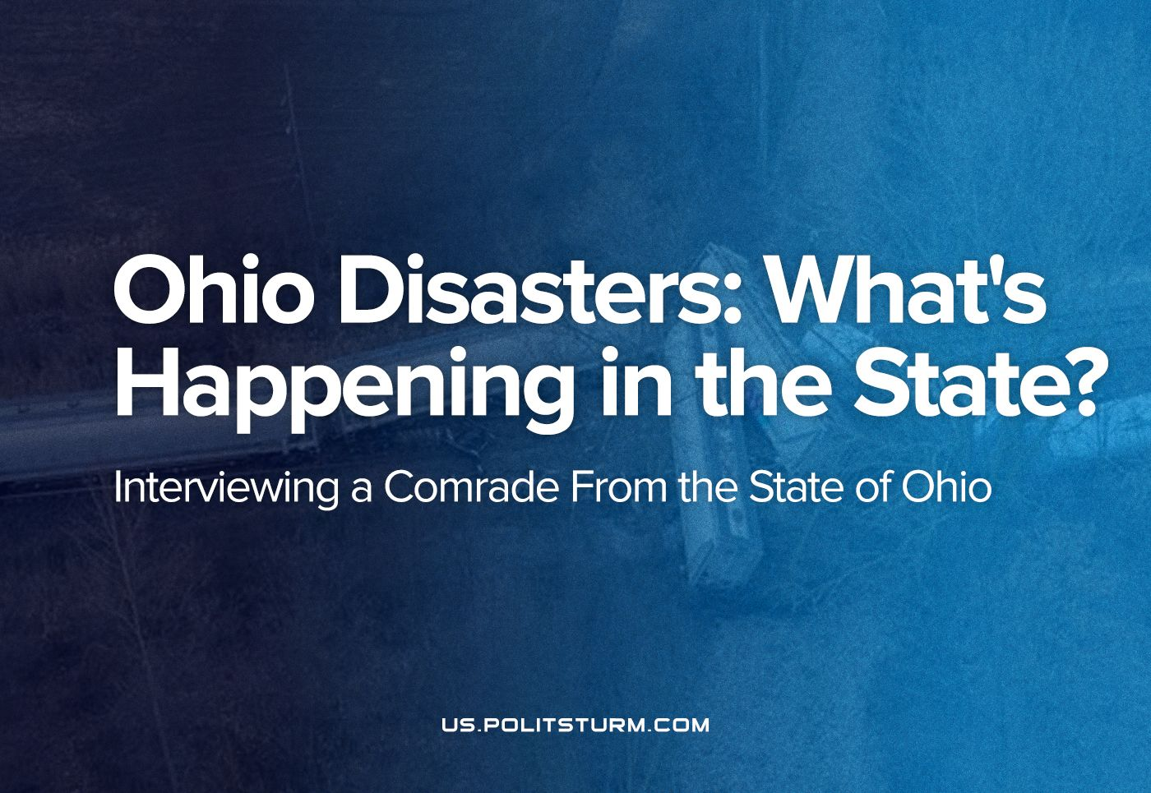

Original article
2023-03-16
9 min read

Over the past few weeks, Ohio has been hit by a series of industrial disasters. We interviewed one of our supporters from this state about the chemical train disaster and the environmental situation in the state as a whole.
Q: A month ago it became known about the environmental disaster in Ohio. How would you describe the situation in the state at that time? What immediate consequences of the accident have you experienced? How can you characterize the state of the environment at that time? Were your acquaintances affected?
A: Ohio citizens have been quite environmentally conscious for decades, this not only is the case for Democrats, the Green Party and others on the Left, but also the conservative farmers that care for their agriculture and livestock. We have fought for years to preserve our environment from corporate pollution, mass use of pesticides used in the agribusinesses, and to prevent shale gas fracking. Overtime, these capitalist lobbies used our State Government legislators to favor the corporate will and profit motivations over the people's desires. This was largely based upon more Republicans being elected into office (campaign-funded by these very corporate lobbies) and by a little known corporate board called ALEC (the American Legislative Exchange Council) that actually drafts policies for not only our date of Ohio, but for all of the 50 US states.
The South-Western region of the state, where I live, hasn't been immediately impacted by the toxic chemicals, so far, however, some of these chemicals did make it into a tributary of the Ohio River, which is very concerning.
The environment is being 'privatized' literally and environmental regulations are being thrown into the trash can, especially now, due to our November 2022 elections where a majority of Republican legislators were voted in (under a 'religious' platform). Since then, these Conservatives have been completely destroying our rights, environmental policies and giving the top capitalists everything they could dream of. They even voted to privatize our State Parks and State Lands to be fracked for shale gas. Communities cannot even object. Further they overturned a previous state ban on the overuse of pesticides.
However, no one that I personally know was affectedby the toxic train derailment.
Q: How did the state and federal governments respond to the disaster? Did they provide tangible help?
A: Both the State and Federal Government bodies were quite inept in their response and this verges on criminal neglect.Although the derailment was known immediately on February 3, the response was to "burn off" the chemicals, rather than to contain them and dispose of them appropriately and by rapid response. Rather than burn already volatile toxic chemicals, and create more exotic toxic chemicals in a combustion reaction, the protocol should have been to immediately blanket the affected area with foam absorbents which would sponge up the waste.
Nevertheless, this would have been very costly for the capitalists to do, so they burned their 'accident' to not cut into their profits.
The Republican Governor of Ohio, Mike De Wine (whose campaign was in part funded by the Norfolk-Southern Railway train company) claims that everything possible was done to minimize the disaster. The so-called Environmental Protection Agency (EPA) claimed that there was no evidence that toxic chemicals were in the community and it was safe for residents to return to their homes. Later, it was found that the Norfolk Southern train company paid a private laboratory for the necessary chemical testing - the tests were not performed by the EPA itself. It’s worth noticing: few know that the EPA outsourced the testing of chemicals to private labs over 30 years ago. The EPA itself does no testing now.
The Environmental Protection Agency (EPA) has become increasingly reliant on contractors. Contract obligations have increased from $600 million in 1986 to approximately $1.4 billion in 1992. Currently, the agency has about 700 active contracts serving nearly all program areas, including information systems development, pesticide testing, and Superfund site clean-up.
In light of the above facts, the EPA is not policing corporate responsibility, rather it serves as a cover for corporate neglect, by allocating its responsibility to private labs for testing – testing paid by the corporations, that the EPA should be policing.
Biden did tell Governor De Wine that the Federal Government would grant the State all the help he requested for the toxic disaster, and that Governor De Wine only had to declare a 'State of Emergency'. But Governor De Wine wouldn't return Biden's call. This was widely publicized, yet the Governor gave no explanation.
Error loading image
Our State Senator Sherrod Brown (a Democrat) has been trying to intervene for the East Palestine citizen's rights in this matter and demands financial compensation from all parties contributing to the disaster. Senator Brown explained that the Norfolk-Southern train company was negotiating with the citizens to give each family $1000 if they waived their rights to sue the company. Senator Brown demanded that the citizens to not sign any waivers nor take any money in this regard.
The East Palestine community is not receiving any acceptable justice for the damages inflicted upon them. There was a health clinic set up, but the testing was only for treating rashes or breathing problems and blood tests for toxicity or metabolic problems were not performed. A few rashes were treated. Many lost their farm animals, chickens, livestock, dogs, etc, but as far as is known, have not been compensated. Their contaminated local water supply has not been remediated, and at first they were suppliedwith bottled water, not tankers of water to bathe etc. These were the known chemicals released into their ground water system.
Q: Subsequently, it became known about several more accidents in Ohio and in neighboring states. What, in your opinion, is connected with such a series of industrial disasters?
A: The industrial disasters are directly the result of deregulation of health and safety laws that were established about 50 years ago, on both the Federal and State levels. At that time, the Democrats and Progressives pushed for such legislation at the mass objections of the political Conservatives, Libertarians, and Republican Party.
As a result,the capitalists began to finance candidates they could use for the deregulation of these health, safety and environmental policies.
Overtime, the more Left leaning legislators were also replaced with corporate Democrats as was seen during Bill Clinton's era. Thus, deregulation of such policies started, slowly at first, but over the next 30 years,very few of such health,safety and sound environmental policies remain. The capitalists won over the people's will.
Q: It is known that the major American media tried not to mention the disaster in the news. Can you confirm this?
A: The US media publicized this disaster non-stop over this entire month. However, there's much deflection over some serious questions and has only turned into a Republican versus Democrat pointing of fingers. But I will say, that the Left does blame corporate greed and the Norfolk rail company. Still, less is said about the deregulation in the media, and certainly no media is blaming the capitalist system itself.
Q: The disaster was sometimes linked to the Soviet Chernobyl NPP catastrophe. As stated in one of the tweets, "Why don't HBO make a film about this?". The capitalist media always try to hide this and other "capitalism moments". Why, do you think, this is the case?
A: I personally cannot equate the East Palestine toxic disaster to Chernobyl, since the latter has a much more serious and lasting consequence. Accidents can always happen no matter how ideal a system may be, material failure or human errors will always exist, even in a Marxist system. However, given the lack of concern that capitalists have other than profit motives & a governing system which serves their interests, such 'accidents' are in fact more related to negligence, & the people pay the ultimate price especially with lasting health problems which were avoidable.
Again, the media didn't hide this disaster, but it was how It was politicized as a “GOP versus Democrat” issue which deflected from the root cause.
Q: Is it possible for the American government to make real environment-friendly policies?
A: The US Government is merely part of the capitalist system,thus policy is dictated by corporate interests and profit seeking motives. It is true at one time that citizen's will had some impact in helping shape policies, but that seemed to have been discarded overtime. Our policies are drafted by corporate boards like ALEC, thus there is no political will to restore what was lost.
Unless the people themselves can control our policies, destiny,and system over the capitalists dominion, there will be no safe or healthy environment. Only liberation of the working class from the greed of capitalism can put a truly environmentally friendly and humane system into the people's hands.

Original article

