NYPD Officers At Protests Covering Badge Numbers
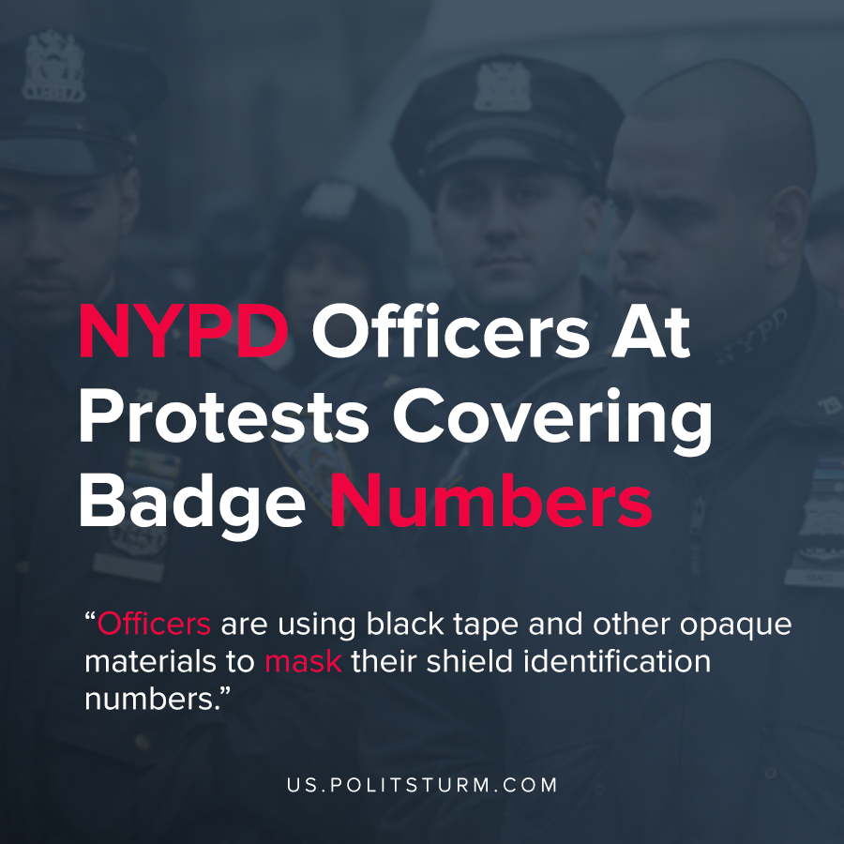

Original article
2020-06-04
1 min read

A letter sent from the National Lawyers Guild states that New York City Police officers are using black tape and other opaque materials to mask their shield identification numbers. This measure makes it impossible to identify these police officers and any police misconduct they perpetrate.
The National Lawyers Guild demanded that the New York Police department take immediate action to ensure that all uniformed police leave their shield numbers visible at all times.
This demand comes as a wave of protests sweep the United States following the death of George Floyd by Minneapolis police.
New York police commissioner Shea publicly stated that the black bands covering police officer identification numbers are “mourning bands” to commemorate the 27 police officers that have died as a result of COVID-19.
In the midst of the economic crisis and the growth and aggravation of the class struggle, the police officers are using great force to suppress public demonstrations. While the commissioner will use charades to mask their true intentions, the class interests are the driving force behind their actions. The police organizations will take all available measures to “protect their own”, as defenders of the interests of the bourgeoisie and this obfuscation of identification demonstrates this fact.

Sources: 1 , 2

Original article

