NYPD Buys Police Robots
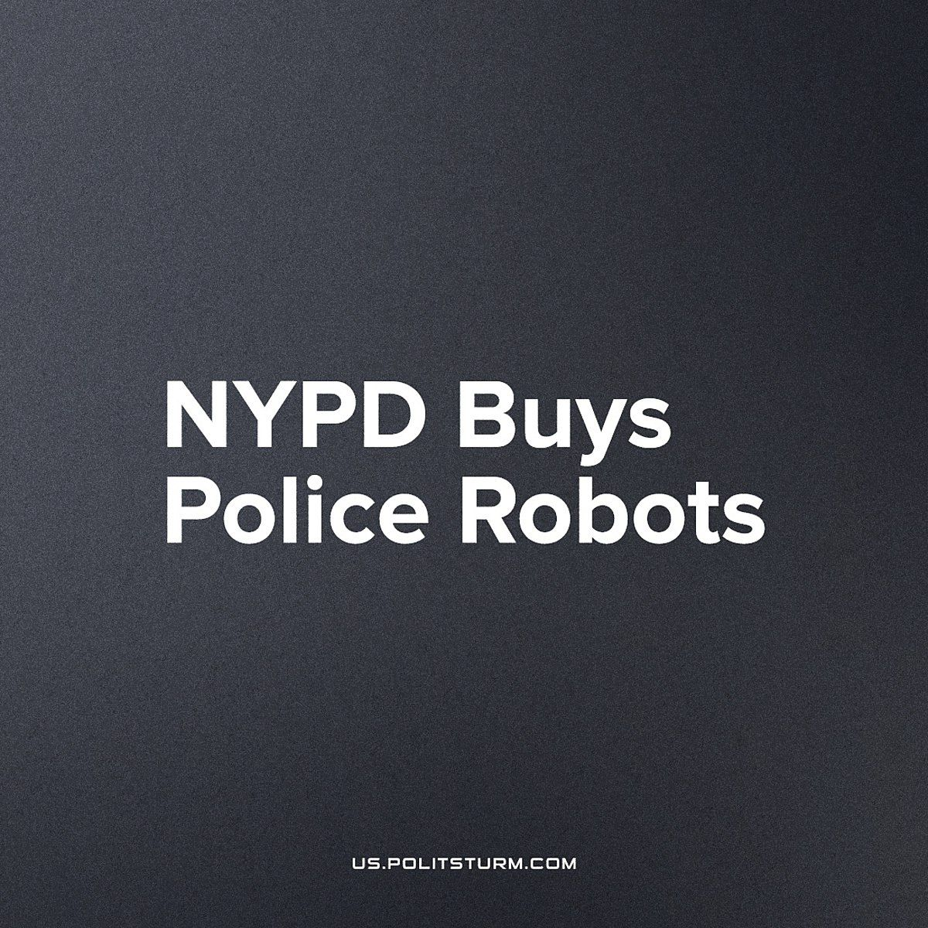

Original article
2023-04-15
3 min read

New York Police Department (NYPD) has acquired three new robotic police assistants. They include the reintroduction of a robot dog (which first debuted 2 and a half years ago but was retired following public pressure), a GPS tracker for stolen cars and a security robot for the New York subway.
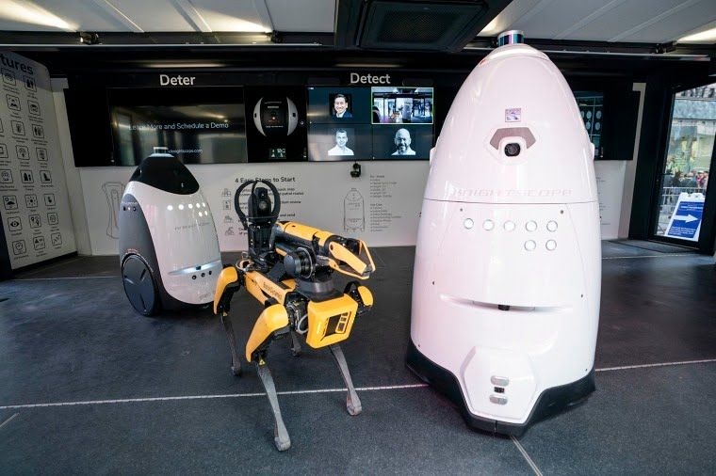
The NYPD enjoys annual funding of $10.9 billion (which is more than most country’s militaries) and has leased these new additions to their arsenal with $750,000 raised from “civil forfeiture”. This is money taken from people when they are arrested, who must then file a lawsuit if they want their money back (which is not feasible for most normal working people). As a result, in the vast majority of cases the police keep the seized money as part of a very lucrative and legal form of theft.
The current robot police fleet is so small, they obviously aren't a practical address to the tasks of such a huge city as New York. It resembles more of a display set, likely for donors and policymakers to imagine futuristic public service. But really it's clear that this is just the start of a worrying trend.
Other countries too are seeing the utility of these novel tools, like the Australian military which has just begun it's trials into the use of versatile robot 'dogs'. South Korea (all the way back in 2018), Singapore, and numerous American cities have begun to employ them as platforms for surveillance, recording facial data and more with it's host of sensors. This data can be sold by the state to tech monopolies, who are again fattened up and their toys brought into general use by such eye-catching tax-funded contracts as robotic police dogs.
Remote-controlled robots have been used by the armed wing of the state for over 100 years, including the Soviet 'teletank' which was equipped with automatic weapons and flamethrowers during World War Two. However, under the current fascizing development of the capitalist state, these tools are used more and more, not against standing armies and trenches, but against the civilians of America and in the American imperialist wars.
In 2016, Dallas police used a negotiation with a shooter to send in a bomb-disposal robot - armed with a bomb, which detonated and killed the suspect. Now, such an ad-hoc use for robots as tools to kill is being comprehensively replaced by the private corporate tech industry in its partnership with the state. These robots will be able to perform a wider array of tasks than ever before - replacing many of the problematic human elements from the state's armed apparatus.
Capitalists (in a psychology fundamental to their class' role in production) imagine a manufactured replacement for the living, thinking human being, who is capable of disobeying orders and struggling for their own independent interest, with machines to enforce their rule, reflecting their own inhumanity and fear of the human masses.
Much to the dismay of the capitalist-imperialists, capitalism will never outgrow it’s need for the working-class. Robots require operation, manufacture, maintenance, repair, recharging, programming etc. all of which is done by workers; on the contrary it is the workers that have outgrown their need for capitalism.
These robotic police assistants represent the bourgeoisie’s forlorn hope that, with the assistance of robotics and artificial intelligence, they can suppress the flaws of their social system. However, these are ills which are fundamental to capitalism; it is not technological advancement that determines the economic system, but the economic system that determines technological advancement. The robotic fruits of workers’ alienated labour are being used to reinforce the dictatorship of capital over them. Instead, robots could and should be used to automate the most tedious and dangerous work as well as phenomenally increase labour productivity. Under capitalism, they are not used to their real potential, and only under socialism will their full use not lead to unemployment and poverty (which restricts their application today) but to make the workday ever-shorter, and allow more meaningful and engaging human labor.
Sources: 1, 2

Original article

