Global Nuclear Stockpiles Are on the Rise
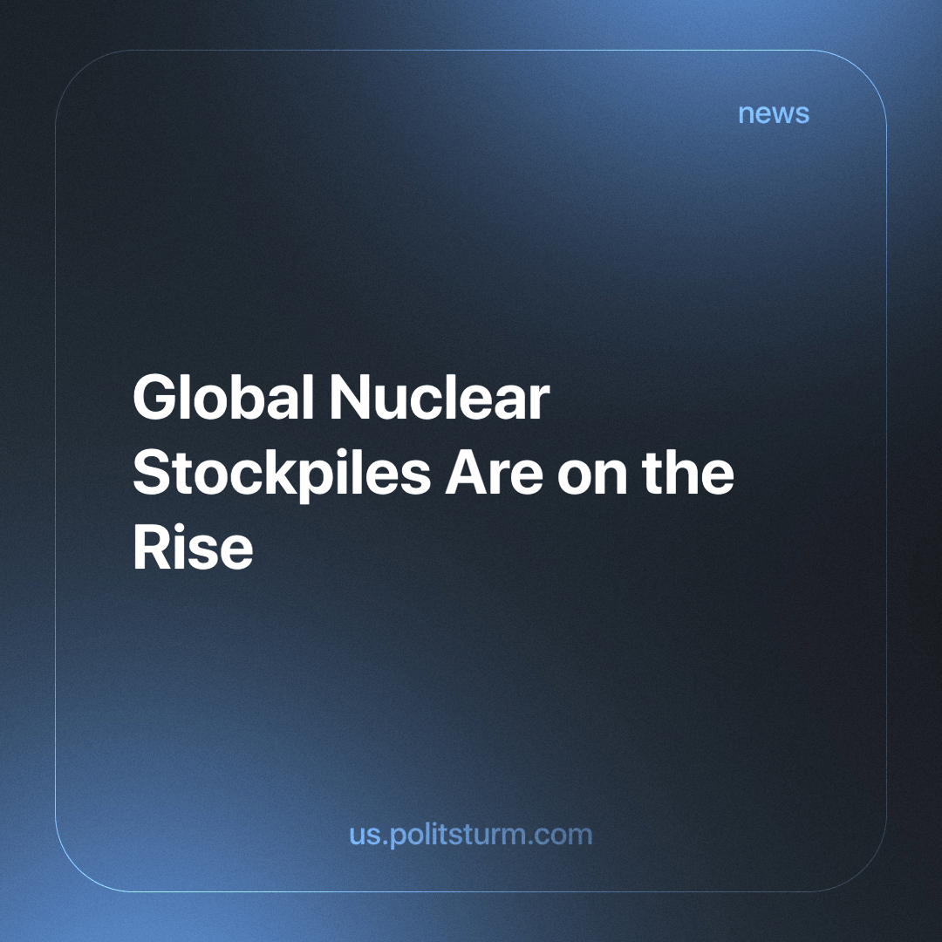

Original article
2023-12-15
3 min read

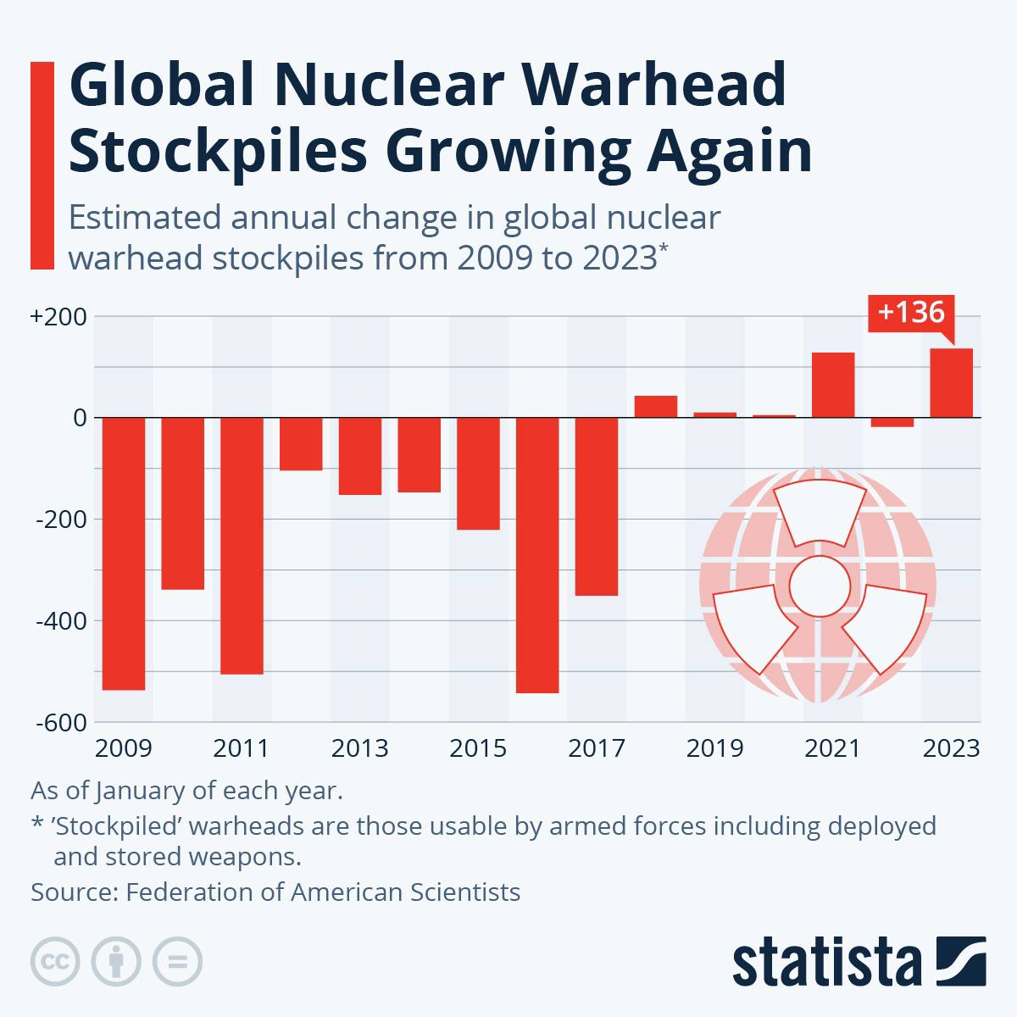
Since 2018, there has been a tendency for the gradual return to the build-up of nuclear weapons.
It is worth noting right away that in this area we can only judge from official sources, which are collected from countries actively hostile to each other, and there may be discrepancies in the finer details. But the trend itself is important to us.
In February 2023, Russia withdrew from the arms deterrence treaty, and in October it withdrew from the treaty on the prohibition of nuclear tests. Even more recently, Russia withdrew from the treaty limiting the testing and production of nuclear weapons, which was ratified in November 2023 by Russian President Putin. [1] This is likely to limit the collection of such information in the future from one of the largest nuclear countries. Both the United States and Russia are implementing broad and costly programs to replace and modernize their nuclear warheads, their missile platforms, aircraft and underwater delivery systems, as well as the production facilities for such weapons. [2]

Nuclear Priorities
In 2021, the nuclear-armed countries collectively spent more than $82 billion on their nuclear weapons programs, with the United States accounting for $44.2 billion of these expenditures, China 11.7 billion, and Russia 8.6 billion. [3]
Meanwhile, for reference, the UN World Food Program is struggling to raise 6.6 billion dollars with an outstretched hand to help 42 million hungry people in Syria, Yemen, Congo, Sudan, Pakistan and dozens of other countries. [4]
Although there are significantly fewer nuclear warheads now than at the height of the Cold War, the nuclear states will not give up these weapons. The theory of deterrence, according to which a country retains nuclear weapons to deter (the imperialist ambitions) of other nuclear states, underlies the logic of preserving nuclear capabilities. This means that when someone increases the arsenal of nuclear weapons, the other is “obliged” to respond with similar actions.
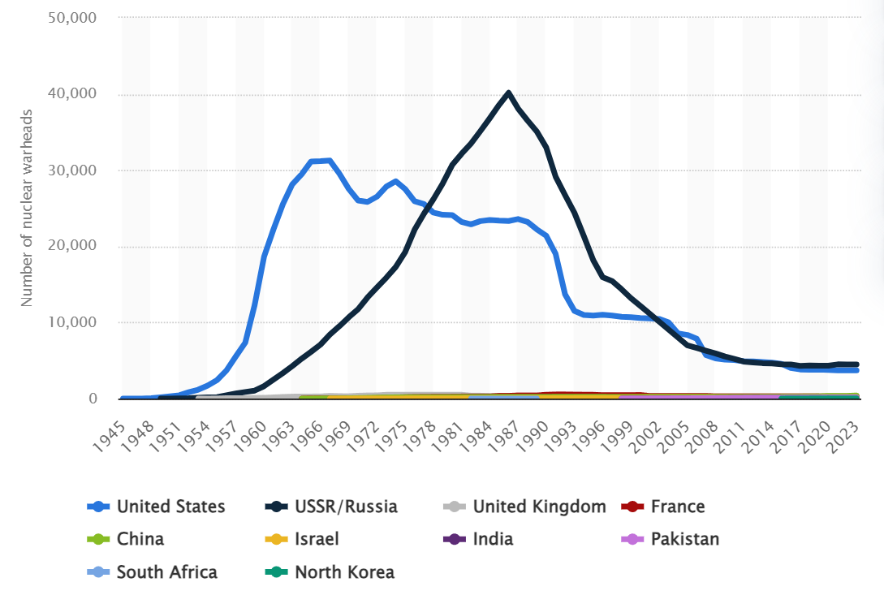
Estimated number of nuclear warheads per country in each year from 1945 to 2023
But these are all theories, what is the situation in practice?
Deterrence works as follows today: after Russia started its so-called “Special Military Operation” in February 2022, various government officials immediately hinted that any intervention by external forces would be met with a devastating response. Similarly, in Israel's war against Hamas, the US did not forget to hint to other countries and organizations that any military support would mean the involvement of the US armed forces.
The United States currently has no intentions of deploying regular ground troops to Israel; however, it has dispatched two aircraft carrier groups to the Eastern Mediterranean and bolstered its aviation group. On October 7, the commencement of the conflict, President Joe Biden cautioned other nations that might seek to exploit "this situation." [5]
Thus, non-nuclear powers are therefore theoretically deprived of the chance to successfully participate in the conflict for their own benefit.
What follows from the latest example of a direct conflict between a nuclear state and a non-nuclear one?
- This is a manifestation of a characteristic feature of the true goal of deterring the proliferation of nuclear weapons - so that all other (non-nuclear) capitalist predators do not flock to the feast and the pendulum does not swing in the opposite direction.
- It is quite convenient for a still strictly limited number of nuclear countries to solve their “problems”, and protect their market share and profits from the encroachments of other imperialists.
- The only way for other imperialists to participate, without provoking a nuclear conflict is indirect participation - the supply of everything necessary to counteract, namely money, weapons and supplies. As experience shows us, with the proper amount of allocated funds, this can be quite enough to deter others and protect their own interests.
Nuclear weapons are simply a tool in the hands of the bourgeoisie, the possession of which grants them near impunity to carry out their imperialist war for the conquest of territory, markets and labour. The abandonment of nuclear weapons under capitalism is impossible, and moreover, with the collapse of the socialist camp, measures to contain the nuclear potential, and avert nuclear war are no longer being imposed on the bourgeoisie. It is important for workers to understand that it is not their lives that are protected behind the nuclear shield, but the imperialist ambitions of their bourgeoisie, which is only restrained by other nuclear countries.
Will there be a nuclear war in the near future? A separate and very detailed article was published by Politsturm on this topic, we recommend you read it.
Sources: 1, 2, 3, 4, 5

Original article

