NLRB Calls For New Amazon Unionization Vote
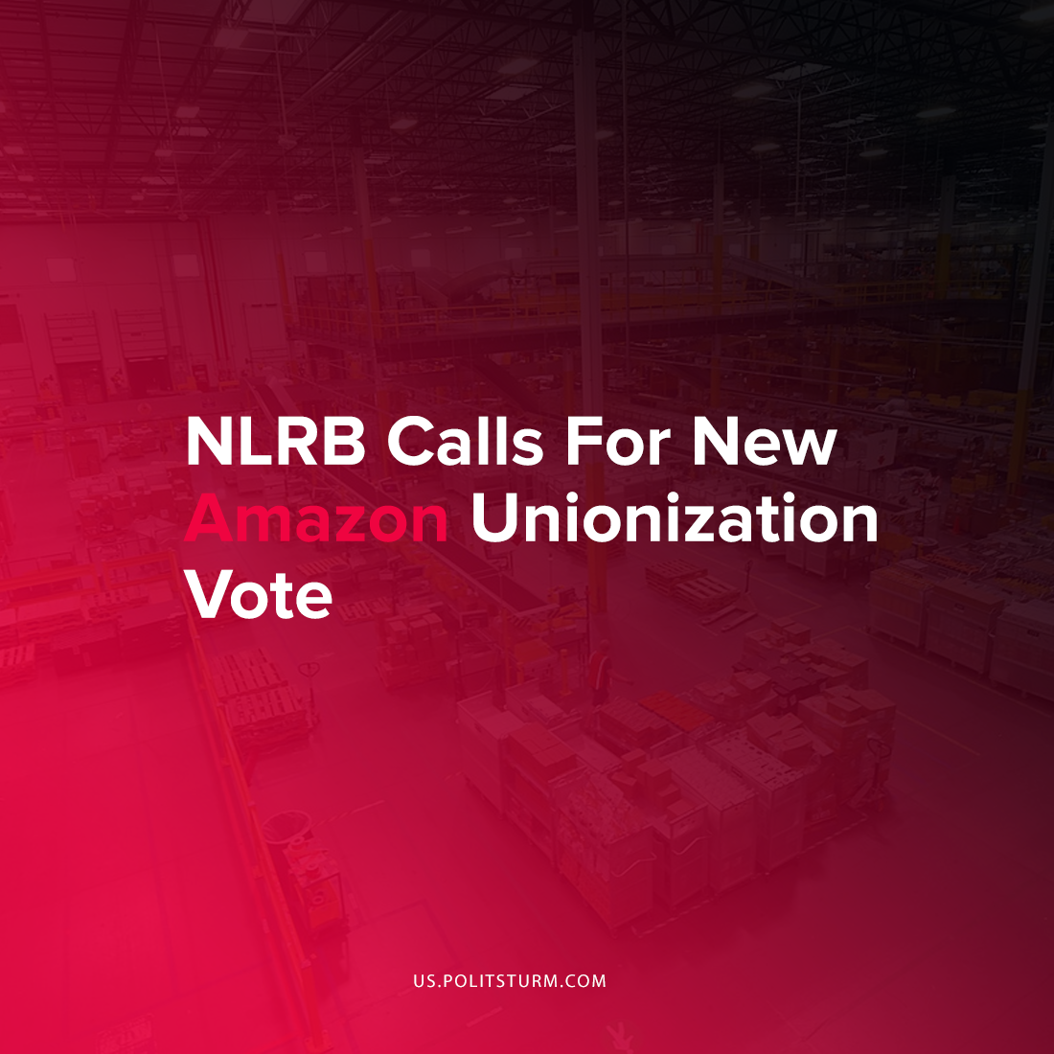

Original article
2021-12-03
1 min read

On November 29th, 2021 the National Labor Relations Board granted Amazon workers at the Bessemer, Alabama fulfillment center a new union election. In the initial union vote 1,798 workers votes against the union while 738 were in favor of unionization. Following the results, the Retail, Wholesale and Department Store Union objected to the results.
The objections were made on the grounds that Amazon’s conduct interfered with the integrity of the election results. For e­xample, Amazon installed a mailbox onsite surrounded by a tent with a sign that displayed Amazon’s anti-union campaign slogan “speak for yourself”.
Also, leading up to and throughout the election Amazon actively polled or interrogated employees with respect to their support for the union. Workers were directed to pick up the “Vote No” paraphernalia in plain view of the anti-union campaign owners, hired consultants and human resources managers. It was determined that Amazon “tried to discern their support for or against the Union based on whether they picked up the paraphernalia”.
The National Labor Relations Board sided with the unions objections and ordered that a new election will be conducted.
Amazon’s tactics to subvert the formation of a worker’s union is an example of the modern class struggle between employers and employees. Amazon used its enormous resources to conduct a campaign against unionization and engaged in conduct that was egregious to the extent that the original results were nullified. However, even if the workers are able to successfully unionize this is not sufficient to end the exploitation of workers. It is necessary for workers to learn and apply Marxist-Leninist theory against the exploiting capitalist class.
Source: 1

Original article

