New Tariff Law Spurs Trade War
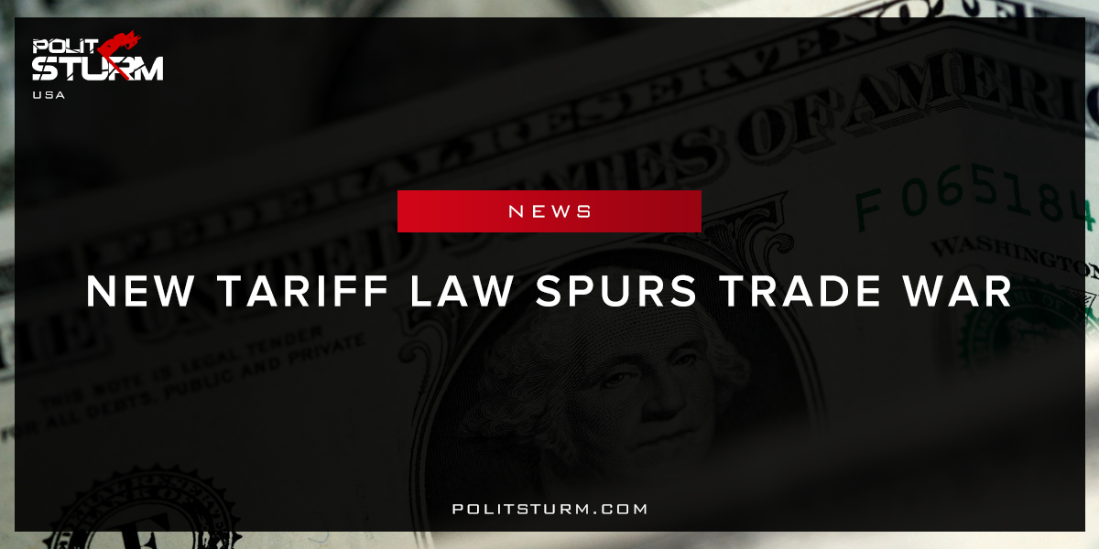

Original article
2017-12-30
2 min read

U.S. companies are bringing new trade lawsuits against their foreign competitors with a scope and frequency not seen in more than 15 years, government documents show, as a wave of new complaints builds under President Trump.
A Washington Post analysis of Commerce Department data found 23 new trade disputes initiated since January, making 2017 the busiest year for tariff cases since 2001. The new cases target trade between the U.S. and 29 counties, the most in any year since 2001.
The cases include fights over Korean washing machines, Spanish olives, Chinese aluminum foil, Vietnamese tool chests, Argentine biodiesel and Canadian jetliners. The U.S. trade warriors include financially strapped solar panel manufacturers, downsizing Rust Belt steel plants and declining California olive farms.
Several requests came from companies that are under foreign ownership. And in a shift from previous years, some profitable corporations are asking the government to place new restrictions on their foreign rivals, taking advantage of a recent change in federal law.
Politsturm: The increase in trade disputes derived from the Department of Commerce report is the result of capitalist competition. The recent change in federal law was the passages of the American Manufacturing Competitiveness Act of 2016. This law simplified the process by which manufacturers could submit claims for tax breaks. This law creates a process by which American manufacturers can get this tax break if they are forced to import foreign commodities while manufacturing their own commodities.The law was intended to make commodities manufactured domestically relatively cheaper than their foreign counterparts. From the viewpoint of the American industrial capitalist this is clearly advantageous. Of course, this bill was sold to the public as though it would “create jobs” for American workers and was packaged as a “win-win” situation for everyone involved.
The truth of the matter is that this law was intended to support the capitalist class, not the working class. The national bourgeoisie will be able to increase their profits and simultaneously lower their tax burden with their ability to waive certain tariffs. Following the logic that this situation entails, there will be a decrease in tax revenues directly attributable to the tariff reduction. Rather than “creating jobs”, this increased competition will certainly lead to either increased taxes or a reduction in services for the American working class. The insanity of the capitalist economic system enriches the parasites of the bourgeois class and impoverishes the mass of people. Not only will this act lead to domestic instability, but international instability as well. Foreign producers of finished commodities will experience more fierce competition in the American market and will likely retaliate with their own national legislation to respond to this situation. When a bourgeois politician says that a law will “spur innovation, create jobs, and invest in our communities” this is synonymous to serving the bourgeoisie wholeheartedly.

Original article

