New Rule Attacks Farm Worker Wages
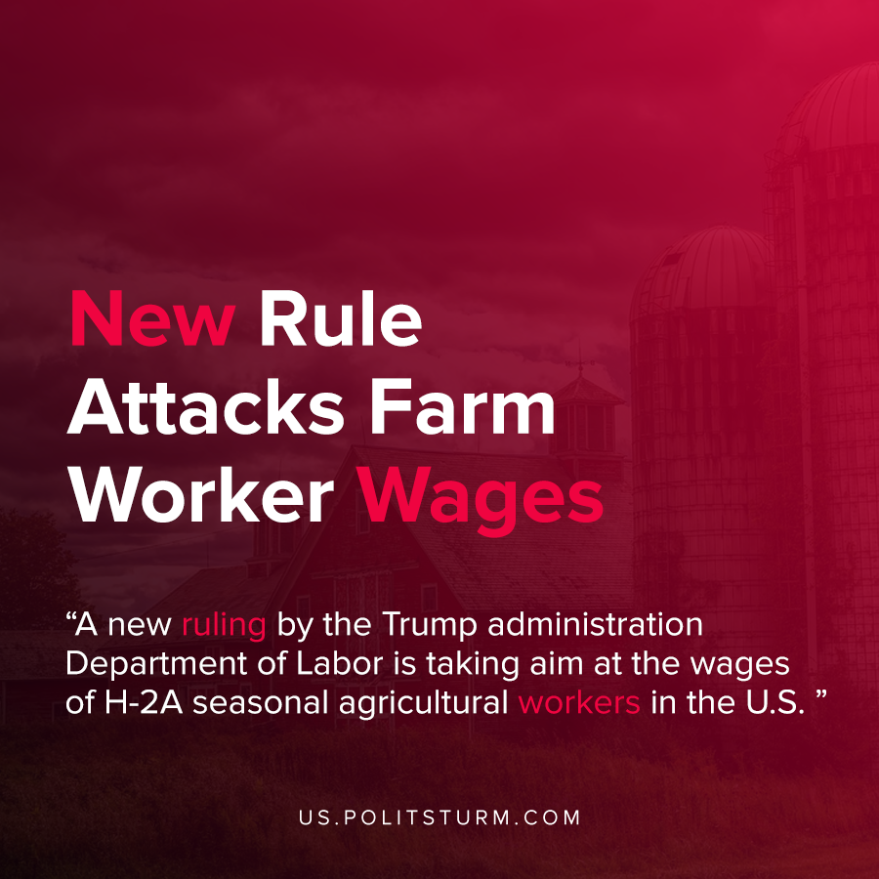

Original article
2020-11-12
1 min read

A new ruling by the Trump administration Department of Labor is taking aim at the wages of H-2A seasonal agricultural workers in the U.S. The Department of Labor sets a lower threshold for H-2A worker wages through an Adverse Effect Wage Rate.
To prevent employers from applying for H-2A visas for non-immigrant laborers to undercut domestic laborers in the labor market, surveys are conducted to determine the comparable rate.
Under the pretext of helping employers due to the “unpredictability and volatility” of the wage data, the data is no longer collected. This wage rate has been rising steadily in recent years. Furthermore, the Adverse Effect Wage Rate is being frozen at its current levels for the next two years.
This action is obviously to the benefit to the employers and to the detriment of the workers.
The Trump administration and the capitalists are well aware that the Adverse Effect Wage Rate has been steadily rising due to a labor shortage.
In a letter to Congress, the Agricultural Workforce Commission said, “Over the last five years the national average AEWR has increased by 17% while revenues for fruits and nuts have only increased 3%, and revenues for vegetables and melons have not increased at all”.
In order to maximize profits and increase the ratio of unpaid to paid labor, the capitalists drive down wages whenever possible. While the capitalists extol the virtues of the free market and limited government they have no problems using the law as their instrument against the working class.
Sources: 1 , 2 , 3

Original article

