New Proposed Ruling Targets U.S Farm Workers
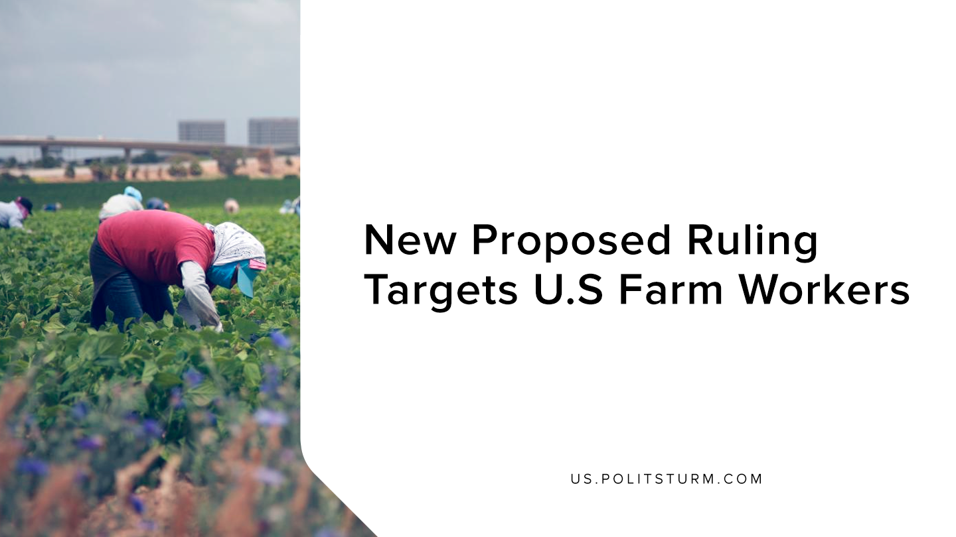

Original article
2019-09-30
1 min read

New changes to the regulatory framework protecting agricultural workers in the United States would have a negative impact on farm workers. The H2-A visa allows for employers to hire nonimmigrant labor under certain conditions.
There are two conditions required in order for employers to utilize the H2-A visa. First, there must not be a sufficient quantity of U.S workers who are “able,willing, and qualified” to perform that type of labor. Secondly, the employment of these laborers must not have an adverse impact on the wages and working conditions of similarly employed workers in the United States.
In words, the rule says that it is protecting American workers and is only used to fill jobs where employers cannot find domestic workers. However, in actuality the law is used to pay nonimmigrant laborers low wages and house them in unsuitable conditions, to profit the employers.
The Department of Labor under the Trump administration is changing the laws to make it easier for employers to exploit non-immigrant laborers. In order to obtain the visa workers often pay exorbitant fees, and receive low wages and poor accommodations.
While the Trump administration demagogically claims to support the workers of this country, this is another example of the Trump administration supporting the capitalist class. The changes to the law make it easier for employers to utilize and exploit non-immigrant labor while at the same time undermining the program’s current “prevailing wage guarantees”, at the behest of the capitalist class.
Sources: 1, 2, 3

Original article

