Nestle Shutters Bottled Water Businesses in North America
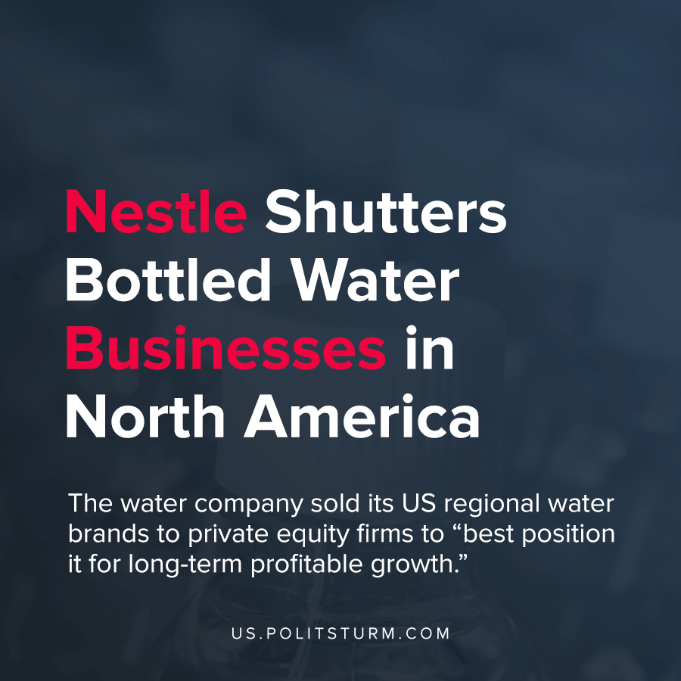

Original article
2021-04-03
1 min read

Following previous announcements of the sale of Canadian water-businesses, food-conglomerate Nestlé will further shutter it’s U.S. water businesses and properties to the private-equity partnership of One Rock Capital Partners and investment firm Metropoulos & Co.
Nestlé’s North American water businesses include 27 production facilities and employ more than 7,000 people, now managed by the conglomerate slated to become America’s largest water company.
This sale has made 4.3 billion dollars for Nestlé through the sale of its many different companies and of the debt that is owed to those companies, as well as the operation of the associated wells.
Sold companies include Poland Springs brand bottled-water, which draws from 10 wells in the state of Maine that are bottled in three plants in the state, Deer Park, mainly drawn from and bottled in Pennsylvania, as well as the brands Arrowhead, Ozarka, Zephyrhills, Splash, Pure Life and the distribution company ReadyRefresh.
The withdrawal of the Swiss-based monopoly from the American water-supply industry signals an ominous future for access to water for working-class Americans. This sale should be seen in the context of the rising U.S. sales of bottled-water, recently out-selling soda.
Local community organizations, including in Fryeburg, Maine, are concerned that the change in corporate operators of the many U.S. wells will result in a decline in safety and contamination standards as the new owners cut costs to meet their professed goal of increased profitability.
Source 1, 2

Original article

