Nestle Closing Eight Distribution Centers
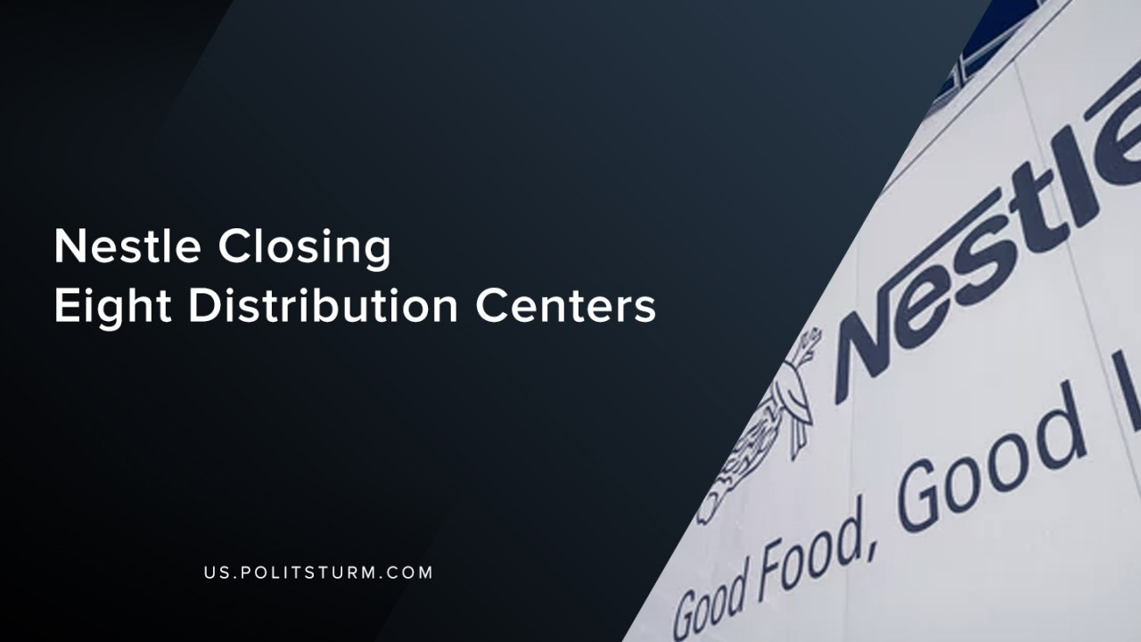

Original article
2019-09-12
1 min read

A press release from May 07, 2019 announced that Nestle would be closing eight company-owned frozen distribution centers and frozen inventory transfer points. The move comes after the company announced it was ending its frozen Direct-Store-Delivery network for its pizza and ice cream businesses and will be moving to a warehouse model.
“As we continue to focus on driving long-term profitable growth, leveraging a simpler route to market unlocks resources we can use to fuel our efforts in demand generation, such as product innovation and brand building”, stated Steve Presley the Chairman and CEO of Nestle USA.
The CEO went on to talk about the impact that the closures would impact the employees who were affected.
“Treating them with respect through this process is a top priority for us, and we are committed to doing all we can to provide them information, resources and support.”
The capitalist class, in order to maximize “long-term profitable growth”, is laying off its employees in order to reduce the labor costs in the supply chain of pizza and ice cream delivery. The capitalists in words say they support the workers who create value, but in deeds serve the interests of the shareholders.
The capitalist system is predicated upon the maximization of profits and the appropriation of unpaid labor from the working class. While in a planned, socialist economy a reduction of labor would benefit the working class, under the capitalist mode of production it leads to unemployment for the workers and “profitable growth” for the capitalists.
Source: 1

Original article

