Nearly 15 Million Americans Lose Health Insurance
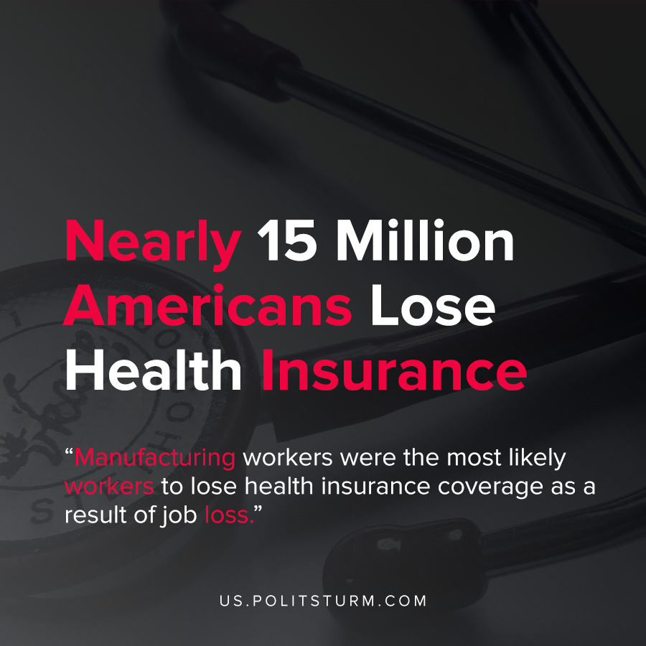

Original article
2021-01-09
1 min read

According to a report by the Commonwealth Fund, nearly 15 million Americans have lost health insurance as a result of job loss. As of June 2020, nearly 7.7 million workers lost jobs with employer-sponsored health insurance in addition to 6.9 million dependents.
“We estimate that, of these newly unemployed workers, 7.7 million lost jobs with ESI (employer- sponsored insurance), and these job losers had 6.9 million dependents who were covered by ESI. As a result, 14.6 million individuals in total either lost a job with ESI or were the covered dependent of a job loser with ESI), said the report.
Manufacturing workers were the most likely workers to lose health insurance coverage as a result of job loss.
During capitalist crises, workers lose their jobs as businesses either curtail operations or shut-down. During the coronavirus pandemic and the simultaneous economic crisis, millions of American workers lost their jobs and their health insurance coverage was subsequently affected.
In favor of the capitalist class, health insurance is predominantly associated with a worker’s employment. As such, when workers lose their jobs they can lose coverage for themselves and their loved ones. The capitalist class benefits from the desperation of the working class who are dependent on their employment, with no guarantees of a job being available.

Source: 1

Original article

