Navalny is Dead: What Did He Represent for Russia?
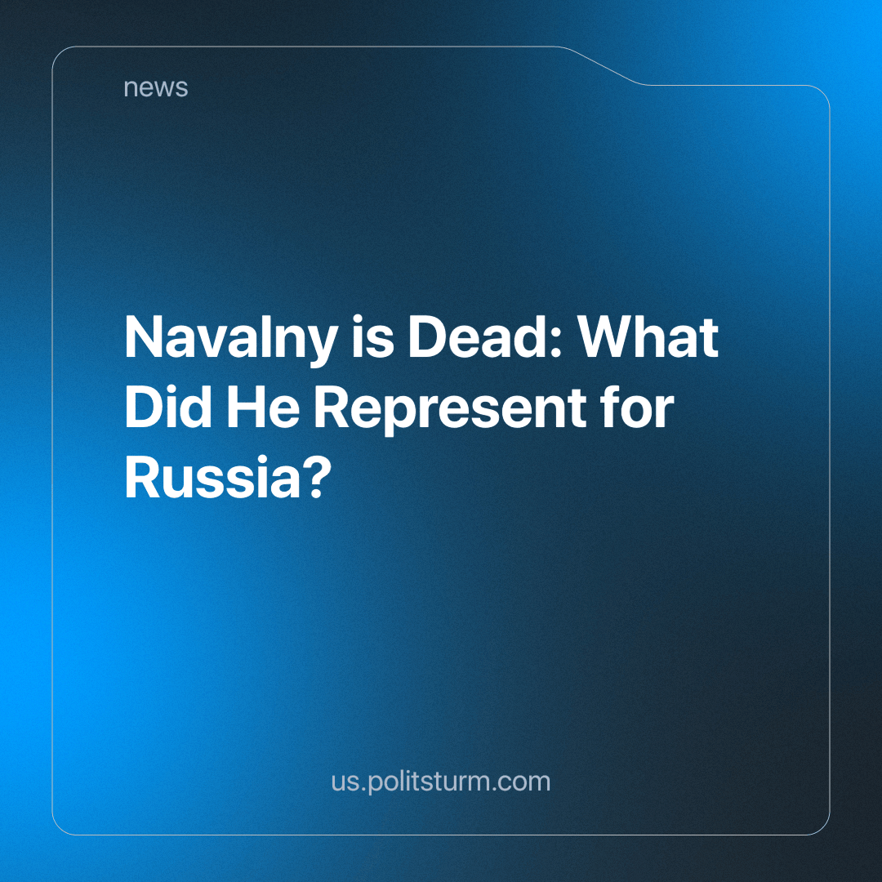

Original article
2024-02-19
2 min read

The death of Alexey Navalny, the representative of the Russian liberal movement, caused a big spectacle in the Western media. Almost every government publisher paints him as a "voice of truth". But what kind of truth? And why do the countries hostile to the Russian bourgeoisie suddenly start heaping praise onto the now-deceased liberal politician?
Navalny has had many encounters with the Russian government on the grounds of undermining the image of Putin among the citizens. How did he do that? Navalny's ideas consist of blaming the current ruling elite and promoting free market ideology. He said that the unemployment, and poverty of the masses could be resolved by placing him in the presidential position and somehow this would eliminate corruption and increase the welfare of the Russian proletariat.
Why did he used to say so? This free-market apologist had a multitude of so-called "Navalny centres" in various Russian cities; he had his own organization, widespread election campaign and media resources. Saying that ordinary people's donations covered all the expenses would be a funny explanation; the sums are beyond that scale. Therefore, Navalny, as the liberal and bourgeois politician he is, had been receiving the money from his benefactors. He represented the interests of the oppositional camp of Russian capitalists and the Western foes.
"But at the same time, Marxists are waging the most determined struggle against reformists who, directly or indirectly, limit the aspirations and activities of the working class to reforms. <...> Therefore, reformism, even when it is quite sincere, turns into an instrument of bourgeois corruption and the exhaustion of the workers. The experience of all countries shows that, trusting the reformists, the workers have always been fooled", - Vladimir Lenin, complete works volume №24: "Marxism and Reformism".
The work Navalny and his allies were doing wasn't beneficial to the working class, and instead was directly harmful. The Bolsheviks and modern communists don't rely on the belief that if we replace one politician with another - if we support another group of slaveowners instead of the current one - while preserving the essential foundation of capitalism (the exploitation of man by man) we can guarantee a "better" society. A better and lawful society for who? Those who don't understand the true class nature of liberal and chauvinistic ideas will be incessantly fooled and manipulated by those who understand them and benefit from the mighty and benevolent facade they've built. The proletariat either follows communism and fights for its real economic freedom, for the establishment of a socialistic labour system or continues to follow the bourgeoise's stooges, falling into their web of false promises and breathing the smell of the lord's flower garden, never seeing it behind the brick wall.
Sources:
https://www.theguardian.com/world/2024/feb/16/russian-activist-and-putin-critic-alexei-navalny-dies-in-prison
https://2018.navalny.com/platform/

Original article

