Italy's Nationwide Transport Strike
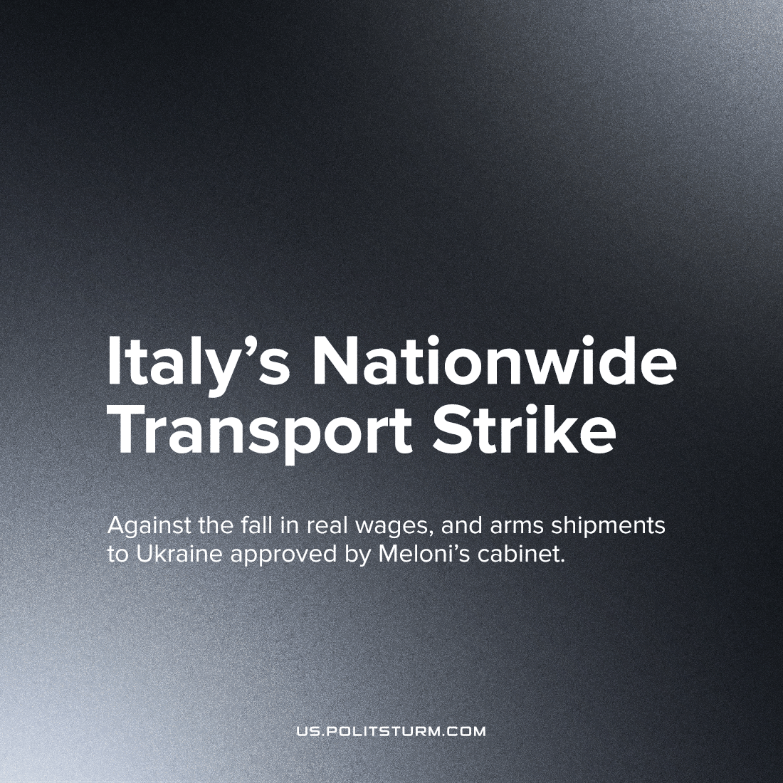

Original article
2022-12-10
2 min read

On the 2nd of December, metro, bus and air company workers waged their strike in Rome, Milan, Neapolis, Venezia, Bolonia Florenzia, Piza, Palermo, Trieste and other cities in Italy. Organized by large unions, a national strike in the transportation sector led to significant interruption in the public and private transport throughout the country.
Generally, workers' demand increased wages following inflation and a minimum wage of no less than 12 euros per hour. Strike participants also opposed the new decree by the Italian government approving arms supplies to Ukraine starting the 1st of December. According to this decree, the supplies for AFU will continue throughout 2023, without the need for approval from parliament for every shipment.
"Wages - Up, Guns - Down!" chanted one participant in summation of their goals.
In addition to the requested terms, protesters criticized low government spending on education and healthcare. Many participants protested against the recent Italian state decision to close hundreds of educational institutions and cut thousands of jobs. Outraged by this action, educators, together with medics, are planning to join the national strike in the coming weeks. Another general strike has been called for December 12th-16th by unions including CGIL and UIL.
Error loading image
The situation in Italy shows again that bourgeois-democratic states are constantly strive to thrifty on the basic needs of their citizens and, at the same time, spend public funds lavishly on the most profitable sectors of weapons production and sales. Under capitalism, the living situation of the working people can only worsen over the long term. Particular concessions won by workers through strikes can not lead to qualitative changes in living and working conditions but only to short-term relief before the next crisis. Fascisation of the state only makes the futility of this position obvious; workers cannot win a life for themselves under such a protectorate state of the capitalist class. The working class can only break free of the endless cycle of crises by tearing apart the dictatorship of capital and transitioning to the rule of the working majority.
Sources: 1, 2, 3, 4

Original article

