Musk Retreats from Politics After Becoming a Liability
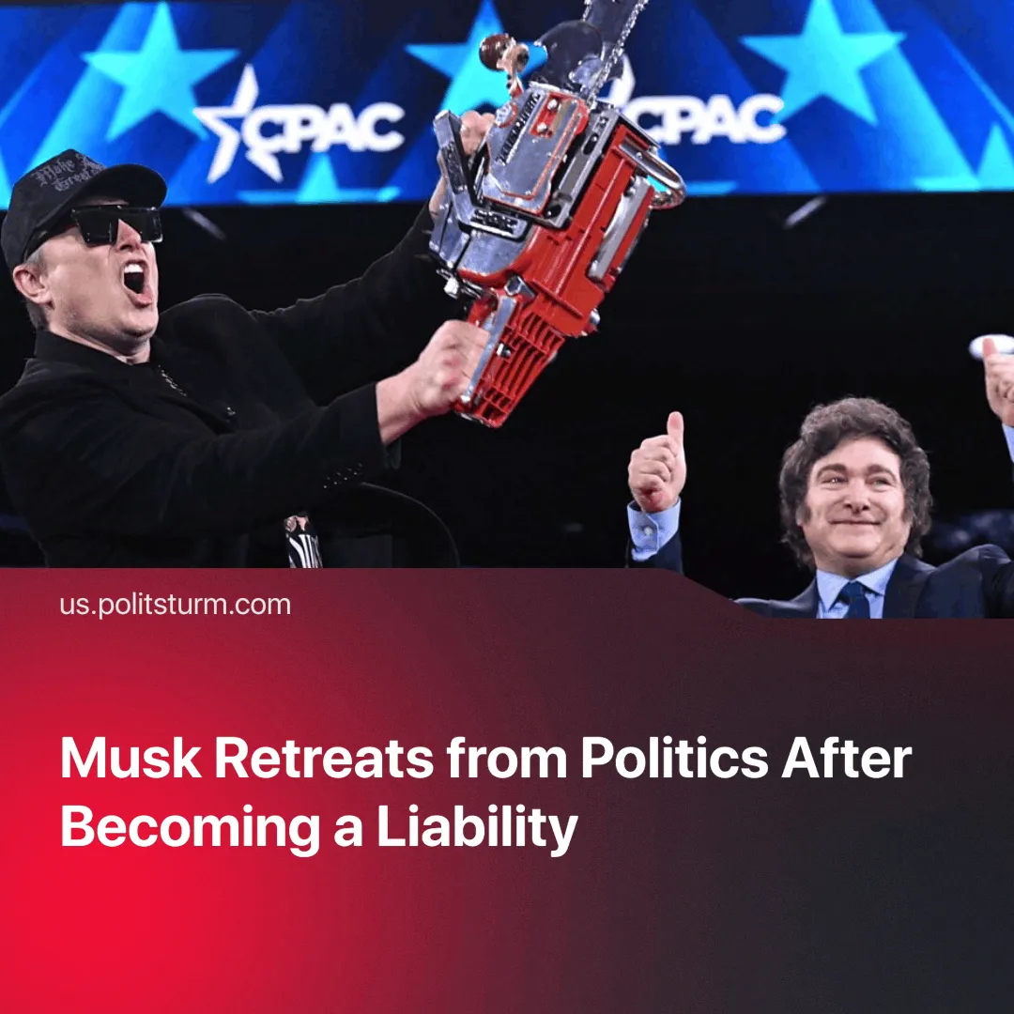

Original article
2025-06-03
2 min read

The richest person in the world, Elon Musk, is stepping away from public politics after his unpopularity and political failures became a burden to the ruling class.
Details. Musk has resigned from the Trump administration’s “Department of Government Efficiency” (DOGE), citing a return to business after a string of high-profile failures.
► Musk's approval has collapsed. Just 34% approved of his actions, while 57% disapprove, and 55% say he wields “too much influence” in Washington.
► Musk lost the 2025 Wisconsin Supreme Court election. His candidate, Republican Brad Schimel, was beaten by Libertarian Susan Crawford by 10%. He spent over $25m through his political action committee and made controversial $1m donations to 2 voters, which led to formal bribery accusations.
► Tesla's sales in the European Union fell by 49% in April compared to the same month last year, while the total number of electric cars sold increased by 28%. Tesla's declining sales are linked to backlash, protests, and boycotts resulting from Musk’s political views.
Context. Musk’s habit of deliberately provocative behaviour has seriously damaged his public image. His Nazi-style salute during Trump’s inauguration speech drew widespread outrage and support from far-right groups.
► He received at least $38 billion in government support over the past two decades. Starlink alone secured roughly $900 million in federal funding, and Musk’s DOGE appointment formalised his state-backed role. In 2022, referencing these subsidies, even Trump mocked Musk at an Alaska rally, calling him a “bullshit artist” and warning he could make him “drop to your knees and beg” for more.
► After Musk purchased Twitter for $44 billion and renamed it X, he became a key figure in the culture war. He changed the algorithm to promote his own tweets and began attacking “woke” values, pushing right-wing populism and conspiracy theories.
► The billionaire became a constant source of embarrassment for the Republican Party because of his ineffectiveness at DOGE and various public scandals.
► Mainstream media began to portray Elon Musk as “the real president”. His impact on U.S. political processes has been widely discussed in traditional and social media. Trump rejected these claims, calling them “another hoax” invented by his political opponents.
Important to know. As the wealthiest capitalist in the world, Musk was given an uncontested influence in the capitalist stage, but the broader capitalist class, and ultimately himself, determined that his conduct and image was no longer compatible with their collective interests.
► Despite this. Musk was useful to the ruling class as a scapegoat — his outsider image helped justify deregulation and public sector cuts under the guise of “efficiency” and “innovation”. Once that function was exhausted, and his behaviour and image became a liability, he willingly stepped aside.
► The ruling class prefers tech billionaires acting like Bill Gates, who quietly reinforce capitalist legitimacy through philanthropy and policy influence, rather than disrupt it through spectacle. Musk's future role will likely be confined to financing technical contributions, where he is most profitable and least visible.

Original article

