Elon Musk Spreads Claims that UK Labour MPs Facilitated Child Grooming
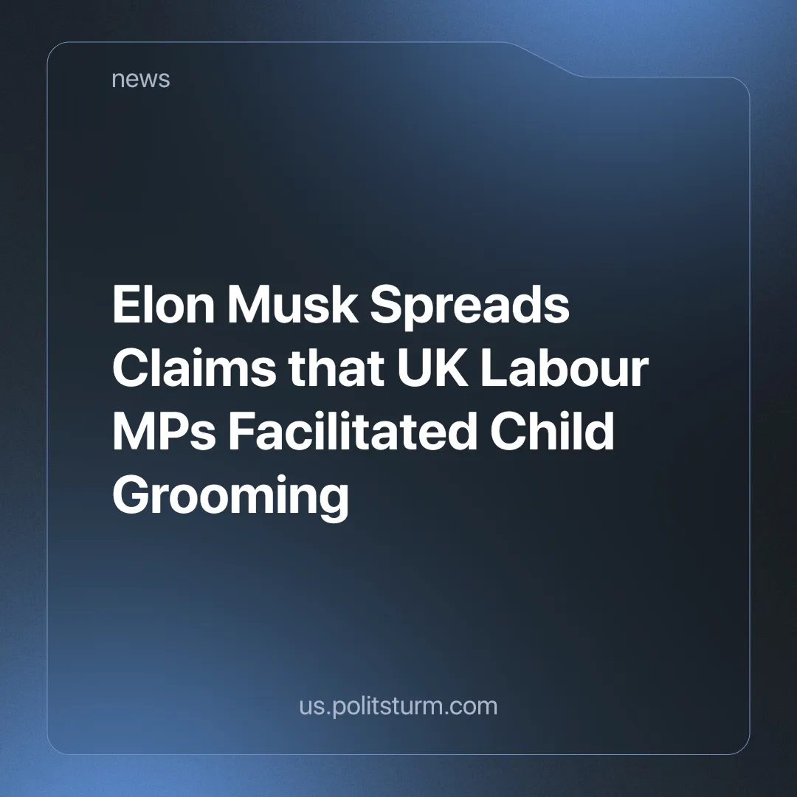

Original article
2025-01-20
4 min read

Multi-billionaire and the richest man on the planet, Elon Musk, has shared online claims that former Labour Prime Minister Gordon Brown ordered British police not to prosecute rape gangs [1].
He went on to accuse Brown of committing "an unforgivable crime against the British people" and that he "sold those little girls for votes" [2].
Professor Alexis Jay, the former chair of a national inquiry into child sexual abuse, has called for the full implementation of the reforms she set out in her 2022 report. Her group, Act on IICSA, has called on the government to set out a clear timetable for adopting all the measures set out by the Independent Inquiry into Child Sexual Abuse (IICSA) [3].
The group published a report in 2014 detailing how at least 1,400 underage girls, some as young as 11, were abused in the South Yorkshire town between 1997 and 2013, mostly by men of Pakistani heritage [4].
After Safeguarding Minister Jess Phillips rejected calls for the government to investigate child sexual exploitation in Oldham, Elon said she should be jailed and called her an "apologist for rape genocide".
Phillips wrote a letter explaining why she had asked Oldham Council to carry out its own inquiry rather than accepting the request for a government-led inquiry, pointing out that the local authority had already begun to set up its own inquiry.
There is a serious problem of child sexual abuse in the UK and the government is failing to deal with it effectively. However, billionaires like Elon Musk are not really interested in solving this problem either.
This is exemplified by Musk's hypocrisy. He has used his own platform, X, to express support for the notorious UK far-right figure, Tommy Robinson, as the "solution" who we have written about before [5]. Tommy's far-right organisation, the English Defence League (EDL), has numerous members who had been convicted of child sexual abuse, yet the EDL, far from condemning them, demonstrated in favour of their release from prison [6].
Elon has also expressed his support for another far-right figure, Andrew Tate, in setting up a new party in the UK [7]. Despite the fact that Tate himself has been accused and is under investigation for sex trafficking and rape (including of minors) both in Romania and in the UK [8].
Capitalism is incapable of dealing effectively with cases of child sexual abuse.
Firstly, the primary role of the police is to protect private property and existing class relations. Although the police, along with the welfare state, can be used to some extent to "maintain order", the self-interest of the capitalist class in seeking ever-greater profits leads it to cannibalise welfare institutions and even its own instruments of oppression.
Secondly, these political figures opportunistically use cases of sexual abuse for their own political interests. Statistics show that perpetrators of child sexual abuse in Britain are roughly proportionally distributed by ethnicity, there is no ethnicity that is more 'prone' to commit such acts [9]. Yet Elon supports the EDL, which solely focuses on rapes perpetrated by Muslim men (and not the numerous such crimes committed by their own ranks), calling it a ‘Rape Jihad’.
Thirdly, a proper investigation of these crimes would reveal that many of those within or with links to the capitalist class are perpetrators of these crimes. For example, the aforementioned EDL, Andrew Tate, or the notorious sex trafficker Jeffrey Epstein, who infamously invited many of the richest capitalists to a private island where he trafficked and raped children [10].
The very nature of capitalism creates the conditions for sexual abuse. It requires a class of dispossessed people who must either live by selling their own labour or starve. Despite various protective laws, this fundamental feature of capitalism makes it not only possible but easy for capitalists to abuse their power.
Given all this, we see that Elon Musk is not really interested in helping rape victims. To understand then, why he is sharing such claims, we must analyse the current international situation. The world is divided into different capitalist blocs, whilst the EU and the US have had mostly friendly relations for many years, their competing capitalist interests increasingly put them at odds.
The British capitalists, too weak to be an independent force, are forced to ally and subordinate themselves to one of these blocs. The current Labour government is generally more EU-aligned, and Elon hopes to move the country, closer to the American bloc instead by launching a smear campaign against the Labour Party and by supporting far-right figures that expound on his interest. He is doing similar in Germany where he supported the far-right and Eurosceptic AfD party [11].
Only under socialism can the truth of these matters come to light, when capitalists can no longer use their wealth to escape punishment and are eradicated as a class. Therefore nor will they be able to use that wealth to abuse children or selectively target different demographics, and sow discord between races, nations or individuals for their own interests.
Under socialism, where the means of production are socially owned and society is organised on the basis of cooperation and development rather than competition, it will then be in the best interests of society to deal effectively with this issue by fully punishing those who commit these crimes, as well as understanding the root causes of them and preventing them from happening again.
Politsturm advocates and works towards the creation of genuine communist parties that can work to lead the working class to socialism. If you want to contribute to this goal, consider joining.
Sources:
[1] BBC — Brown: No foundation to Musk child grooming claims — 07/01/2025
[2] Twitter — Gordon Brown sold those little girls for votes — 06/01/2025
[3] BBC — Child sex abuse victims 'let down' by government says inquiry chair — 20/10/2023
[4] BBC — Rotherham child abuse: What was the Jay Report? — 26/08/2024
[5] Al Jazeera — Who is Tommy Robinson and why is Elon Musk throwing his weight behind him? — 03/01/2025
[6] Hope not Hate — Tommy Robinson is a hypocrite when it comes to opposing child sexual exploitation — 11/01/2022
[7] Timeline — "He Is Not Wrong": Elon Musk Responds To Andrew Tate's New Political Party — 10/01/2025
[8] NY Times — What to Know About the Accusations Against Andrew Tate — 20/12/2024
[9] CSA Centre — Child sexual abuse in 2022/23: Trends in official data — February 2024
[10] The Guardian — Jeffrey Epstein details close relationship with Trump in newly released tapes — 01/11/2024
[11] CNN — Musk urges Germans to vote for AfD in latest involvement in European politics — 9/01/2025

Original article

