Most Young Adults Live With Parents Since Great Depression
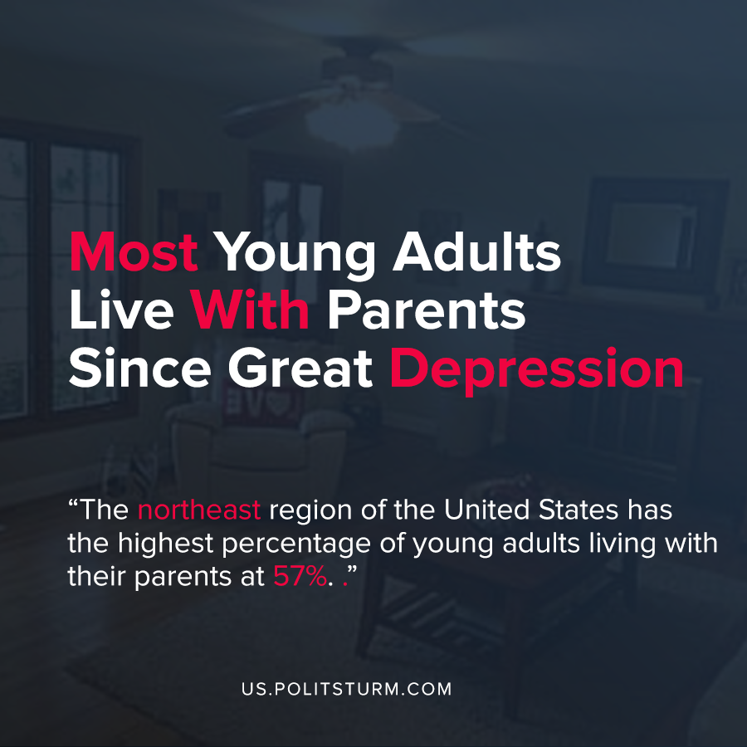

Original article
2020-09-18
1 min read

New research by the Pew Research Center suggests that the majority of young adults in the U.S. are living with their parents for the first time since the Great Depression. The share of young adults who live with their parents increased from 47% to 52% between February and July 2020.
Key reasons for the increase were cited as closures of college campuses due to the coronavirus epidemic, and the large increase in unemployment and various other financial reasons. Of those young adults who live with their parents, 88% live in their parent’s home.
The northeast region of the United States has the highest percentage of young adults living with their parents at 57%.
The economic instability and disruption brought about by the most recent crisis of overproduction and concurrent coronavirus pandemic played no small part in the increase in young adults living with their parents.
Unlike under a planned, socialist economy which guarantees housing and employment to the working class, the capitalist system has systemic crises of overproduction which disrupt the livelihoods and opportunities of the workers.
The entire capitalist system is subordinated to the profit of the capitalist class who ruthlessly exploit the workers and benefit from mass unemployment through the reserve army of labor. Only through the dictatorship of the proletariat is it possible to provide adequate housing and employment to all workers, as opposed to the burdens imposed by the capitalist system on U.S. families.
Source: 1

Original article

