More Americans Working Multiple Jobs
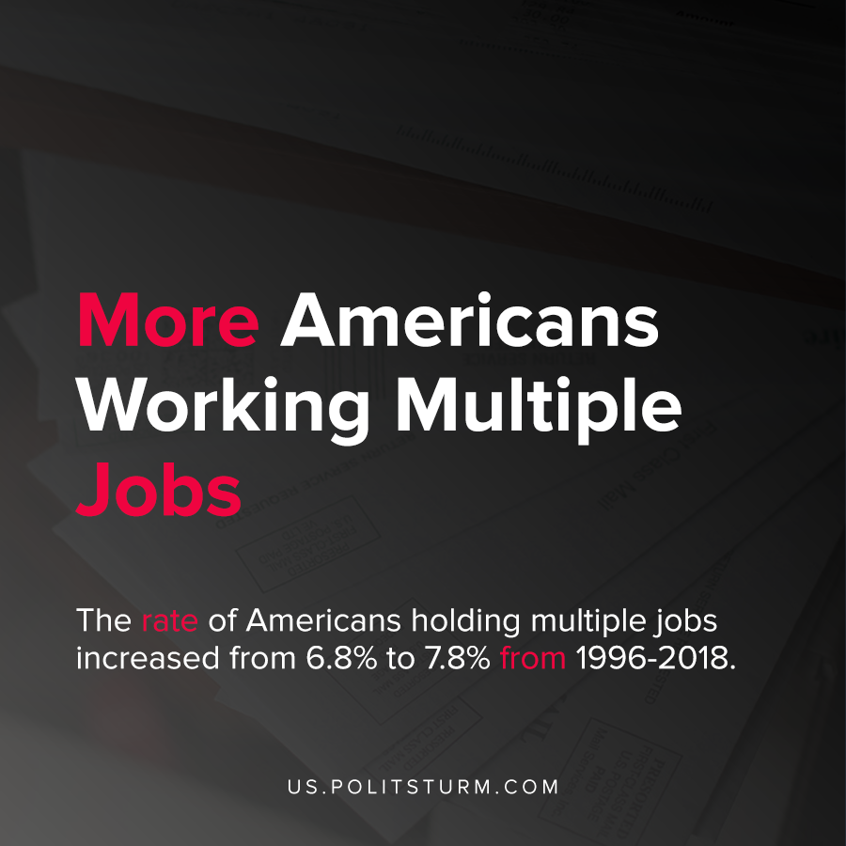

Original article
2021-02-20
1 min read

According to new data by the U.S. Census, the percentage of Americans who have second jobs has been on a long-term increasing trend. The rate of Americans holding multiple jobs increased from 6.8% to 7.8% from 1996-2018.
The large percentage of these workers who work second jobs primarily were employed in food service, retail, healthcare and social assistance. The number of Americans working a second job is also noted to be pro-cyclical, plunging during crises and increasing afterwards.
The wages derived from second jobs make up 28% of those workers earnings and thus form a substantial part of their earnings. Workers with lower wages are more likely to work multiple jobs than higher earners.
“Multiple jobholders earn less. Individuals with full-quarter jobs who are multiple jobholders earned an average $9,770 from their primary job in the first quarter of 2018 and an average $3,780 from all secondary jobs during that same quarter for a total of $13,550 from all jobs.”
Under the capitalist economic system, the tendency is for capital to maximize profits and the needs of the private owners of the means of production. Workers who are unable get by on just one income go to the labor market and work more hours.
It is possible to raise the quality of life for the workers, but not under capitalism. Capitalism presents the worker with precarious employment, and over time more Americans cannot rely on just one job. Socialism, by contrast, guarantees employment and eliminates the exploitation of workers that is foundational to capitalism and the anarchy of the market.

Source: 1 , 2

Original article

