Grandson of Molotov Criticized the Communist Party of the Russian Federation
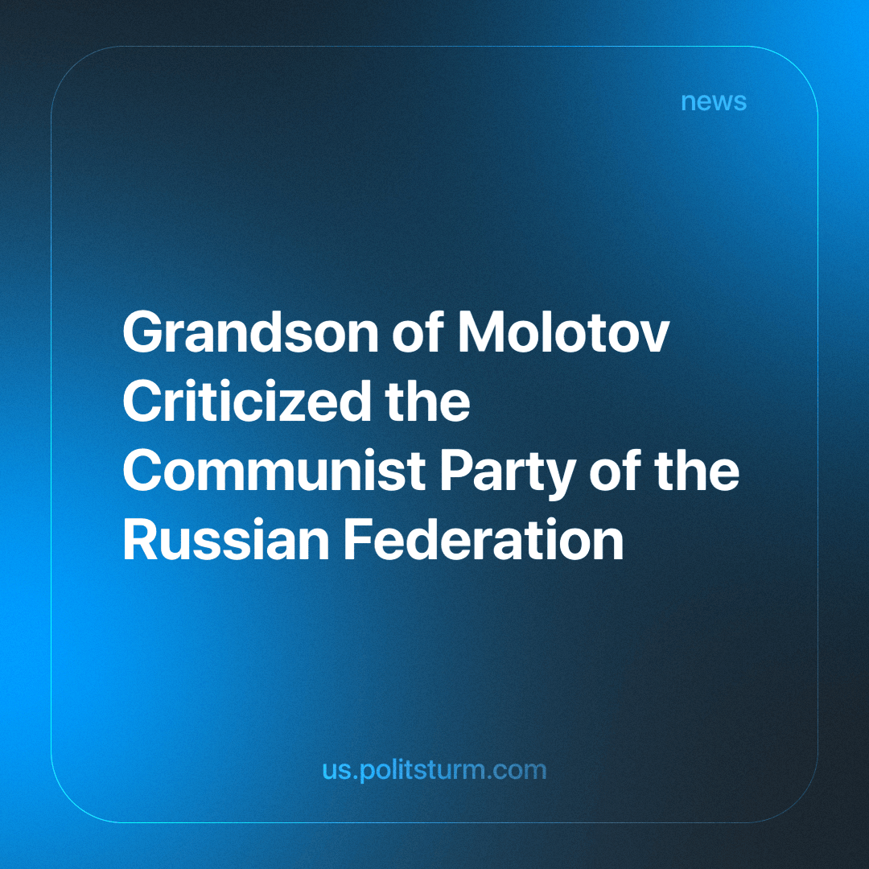

Original article
2024-03-21
1 min read

In the State Duma of the Russian Federation, Vyacheslav Nikonov, a member of United Russia and the grandson of People's Commissar for Foreign Affairs Vyacheslav Molotov, stated that the program of the Communist Party of the Russian Federation lacks any use of Marxism-Leninism, and the party itself, along with its members, has transformed into "statists.”
Nikonov pointed out that the statements of the Communist Party of the Russian Federation do not align with their actions; the party has seemingly abandoned atheism, the dictatorship of the proletariat, and the world revolution, instead aligning itself with those who defend the state. Recently going as far as to support Putin's re-election.
It remains unclear what prompted Mr Nikonov to make such revelations and disclosures. Perhaps he aimed to underscore the inconsistency of communist ideals or simply intended to disparage a political rival.
The ideological struggle among defenders of capitalism sometimes transcends the boundaries of bourgeois logic, leading to accusations against the "communist" party for not adhering strictly enough to communist principles.
These incidents serve as a reminder that the threat of communism, declared "defeated" by the bourgeoisie in 1991, remains relevant, unsettling capitalists and prompting them to launch tirades against opposing political groups.
As crises and social contradictions intensify, hysteria mounts in the search for the red menace, prompting attacks even against advocates of "red" capitalism.
We appreciate Nikonov for exposing the opportunists who hide behind communist rhetoric and for articulating genuine communist principles to a broad audience. Russian workers truly do require a Marxist-Leninist party that genuinely represents their economic aspirations.
Source: Country Capital - “You don’t want a revolution!”: Molotov’s grandson blasted the communists in the State Duma” from January 31, 2024

Original article

