Model Predicts 200,000 U.S. COVID Deaths
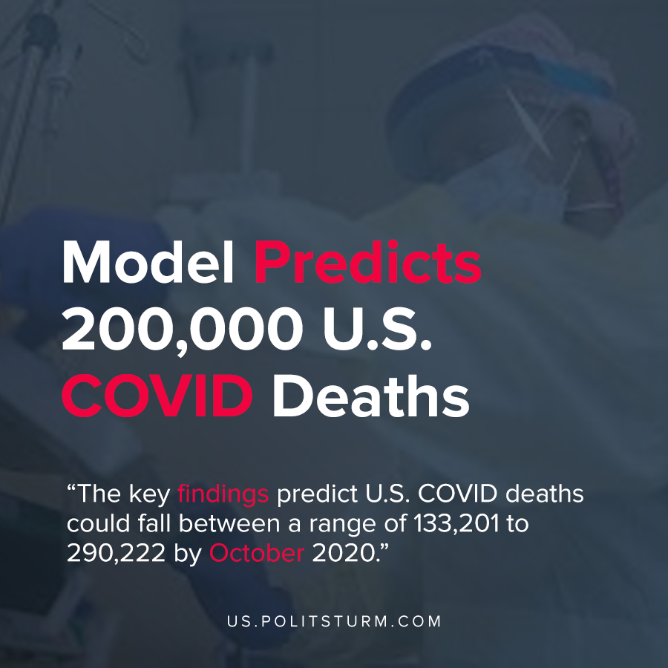

Original article
2020-06-18
1 min read

Due to active exposure caused due to current protests and the poor reaction of the state when the pandemic actively developed, the rate of COVID infections had skyrocketed. A new release from the IHME predicts U.S. COVID deaths could fall between a range of 133,201 to 290,222 by October 2020.
As we can see, the capitalist system was unable to handle the social pressures presented before it. This is due to capitalism at its core possessing no incentive to spend extra money in the interest of the employed.
Due to this, any response will occur once it begins to severely affect society as no action would be done to prevent COVID 19 going to the USA since it would risk the competitive opportunity.
The main goal of capitalism is obtaining maximum profits from its labour and hence it is a structural problem that cannot be fixed and must be removed by the next progressive change that socialism provides.
By 1936, Stalin’s constitution guaranteed free healthcare to every Soviet citizen. Today, we long possess all of these resources to swiftly guarantee these permanent victories for the working class. Such a perspective means that while current protests are good, to achieve great success we need a revolution and build a strong communist party.
Sources: 1 , 2

Original article

