Minimum Wage Workers Cannot Afford Rent Anywhere in US
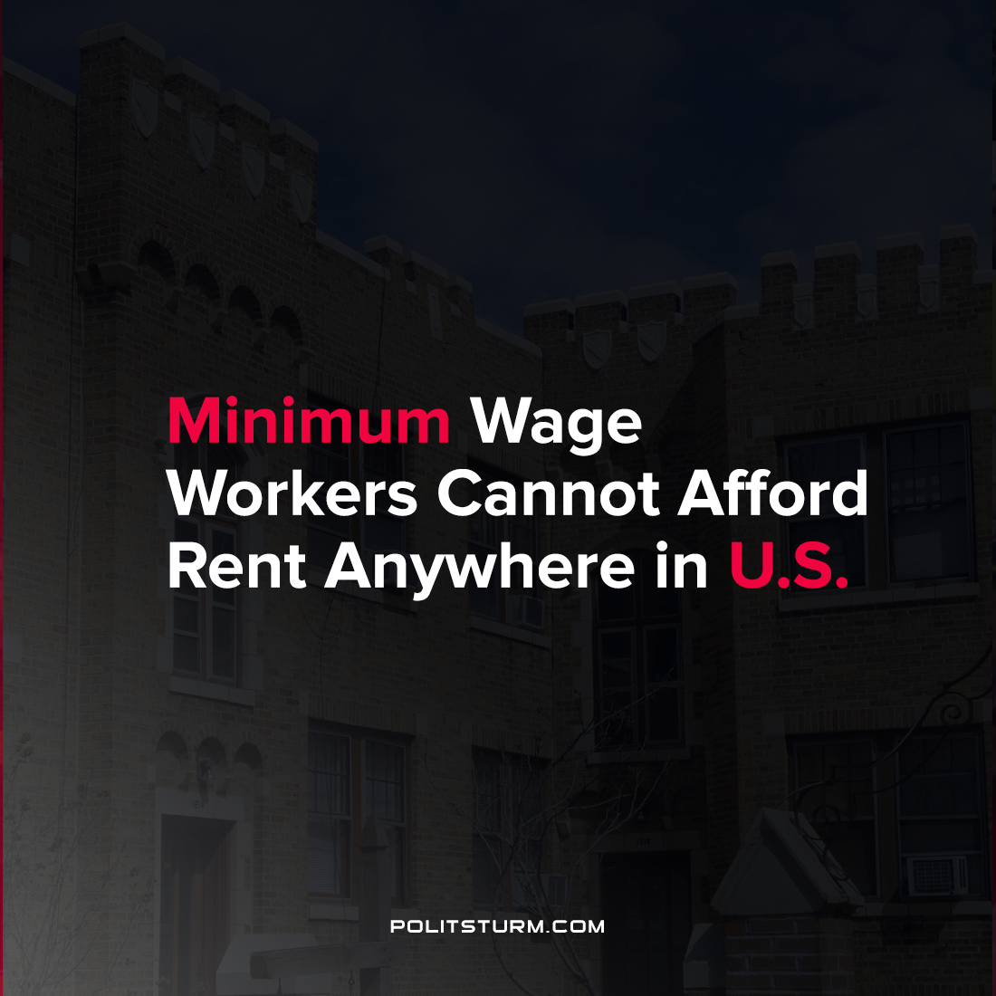

Original article
2021-08-06
1 min read

A new report by the National Low Income Housing Coalition examined the affordability of rental housing for workers who are earning the minimum wage. In no state in the United States is a minimum-wage worker able to obtain a two bedroom apartment at prevailing market rates when working a 40-hour workweek.
In order to afford a two-bedroom apartment in 2021 the hourly wage that a worker would need to earn in California is $39.03. The median asking rent for multifamily buildings constructed between July 2018 and June 2019 was $1,620 per month which greatly exceeds the amount of monthly income low-wage workers receive.
“Most new rental housing in the private market is built for high-income renters, in order
to turn a profit after paying high development costs”, the report states. It is also implied that an insufficient supply of affordable housing exists as landlords do not supply housing at affordable levels without government subsidies.
The maximization of profit by the private owners of housing by individuals and entities such as real estate investment trusts drives the price of housing beyond what low-wage workers can afford. These workers are burdened with high housing costs while a small group of oligarchs reap private benefits from such a situation. While the government can play a limited role in subsidizing housing, the capitalist economic system will never be able eliminate unaffordable housing as the capitalists benefit from low-wage labor and the landlords benefit from “market rents” which yield a profit.
Source: 1

Original article

