Millions Lose Insurance Coverage During Pandemic
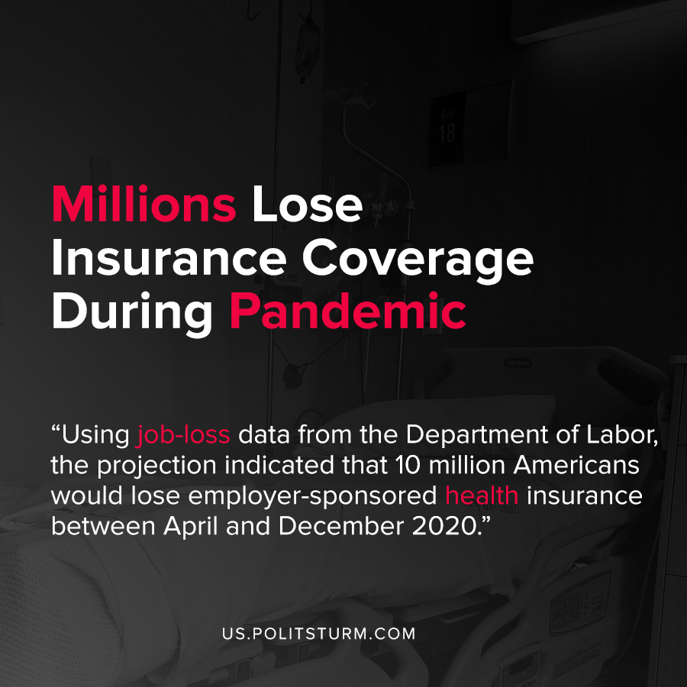

Original article
2020-10-03
1 min read

Research by the Robert Wood Johnson Foundation examined how health insurance coverage would be impacted in the U.S. by the concurrent economic crisis and pandemic. Using job-loss data from the Department of Labor, the projection indicated that 10 million Americans would lose employer-sponsored health insurance between April and December 2020.
Job loss will cause millions of Americans to either switch to a household members insurance coverage, enroll in Medicaid, buy insurance coverage through the marketplace or lose coverage entirely.
As the coronavirus pandemic continues to infect millions of Americans, millions of Americans will simultaneously lose their health insurance coverage.
The capitalist economic system subordinates societal production to the profit motive, including the insurance and health care sectors. Due to the association between employment and health insurance, during economic crises workers here can potentially lose their insurance along with their livelihood.
Under a planned economic system, the health care of the workers would not be subordinated to the profiteering of a small class of oligarchs. By contrast, capitalism does not guarantee or secure workers healthcare, even during an epidemic.
Source: 1

Original article

