Multi-Millionaire to Buy British Political Magazine ‘The Spectator’
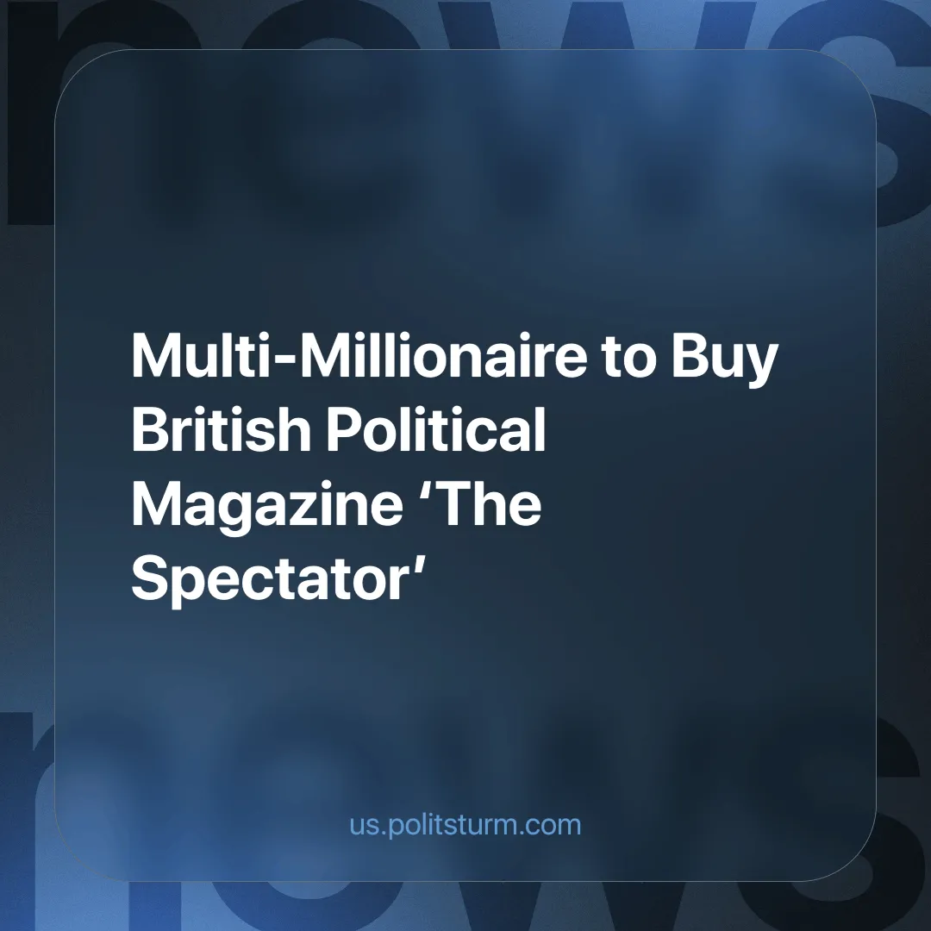

Original article
2024-08-08
3 min read

Sir Paul Marshall, already a shareholder of GB News (although he stepped down from the board earlier this year) and co-founder of the $66.6 billion global hedge fund Marshall Wace, is closing in on a deal to buy the British news magazine ‘The Spectator’, which covers politics, culture and current affairs. Marshall has a net worth estimated at £630 million. The auction also includes the Daily and Sunday Telegraph newspapers.
This transaction would separate The Spectator from the Telegraph newspapers, which are considered to be more "right-wing" (although this only means they are more open in their defence of capital and reaction) and are also looking for new owners.
If Paul Marshall were to buy The Spectator, it wouldn't mean that he couldn't or wouldn't buy The Telegraph, although there seems to be some doubt that he will take part in the newspaper auction.
A number of other bidders were interested in The Spectator, including the infamous billionaire Rupert Murdoch, owner of The Times and The Sun, and hundreds of other local, national and international publishers around the world [1].
These media assets were to be bought and controlled by RedBird IMI, a company controlled by Abu Dhabi [2], but negotiations broke down when the UK government intervened, as the ownership of national newspapers is blocked from receiving funds from foreign governments.
In the UK, three companies control 90% of the national newspaper market [3]. This is not an anomaly, nor is it the worst example of the phenomenon. In the United States, just six companies (sometimes referred to as the Big Six) control 90% of all media in the country [4].
The working class has the illusion that there is a wide range of different sources of information. But in reality, the vast majority are concentrated in the hands of a few powerful capitalists, and the information they choose to broadcast reflects their interests.
The media is manipulated and used to promote the interests of the exploiting class as a whole by suppressing critical revolutionary content or promoting the specific interests of whichever capitalist owns that specific media company.
They can suppress media that is in favour of rival capitalist countries, such as pro-Russian or pro-Chinese content, or suppress and slander social democrats and left-wingers that advocate for the workers to have a greater share of the social wealth, while still maintaining the current system. For example, we can look at what happened to MP Jeremy Corbyn, who was scorned and ridiculed in more than 50% of news stories about him during his election campaign as head of the Labour Party [5].
Thus Lenin wrote (in Draft Resolution On Freedom Of The Press):
“For the bourgeoisie, freedom of the press meant freedom for the rich to publish and for the capitalists to control the newspapers, a practice which in all countries, including even the freest, produced a corrupt press.”
In many cases it is used to set the working masses against each other, to divide and confuse them. This can be done by dividing the country into different electoral bases (with parties that all agree on the most fundamental questions), or by setting the working class of one country against the working class of another. This insidious form of manipulation is much harder to detect than overt media control and can be very dangerous for workers' movements.
It is important to note that, while classes exist, there is no such thing as "unbiased" media. The media will always defend the interests of a specific class. Alleged "neutrality" generally means that a specific media is content with whatever the mainstream view is; mainstream media is owned by capitalists and therefore reflects the views and interests of the capitalist class. Not to mention the meticulous use of language they use to lead the reader to a desired conclusion.
For example, the BBC has been criticised by its staff for putting more emphasis on humanising Israeli victims, rather than Palestinians [6]. Another example is The Telegraph's coverage of the collateral damage that striking workers may cause, attempting to blame the overworked nurses for delays in the treatment of cancer patients, rather than the crumbling National Health Service and the capitalist system that is responsible for both the degradation of the service and the inflation making the pay of its employees inadequate to live on [7].
In a capitalist system, the media will almost always defend the interests of the ruling class. That is why news sources must be socially owned by all workers and thereby defend the interests of the working class. The workers' long-term class interests lie in the end of exploitation; the end of a system designed to produce profit for a tiny minority of people while the vast majority suffer. They must do this by building socialism; which is a system where all means of production are owned in common, all are free to work the social-owned means of production, and as a result, the fruits of collective labour can be distributed “from each according to his/her ability, to each according to his/her work”.
Join Politsturm to help provide workers around the world with a single united political and theoretical that will serve as the foundation for a future communist party.
Sources: 1/2/3/4/5/6/7

Original article

