The Resurgence of Militarization in Europe
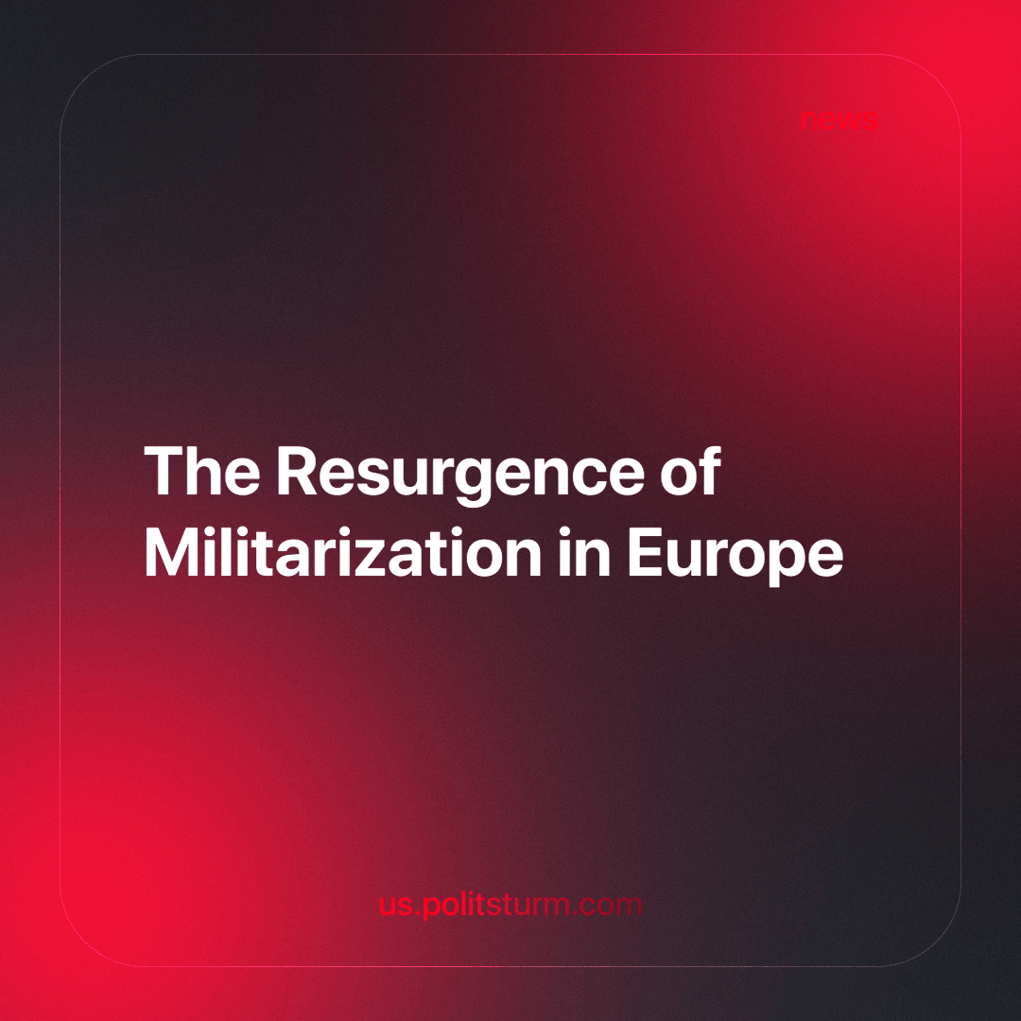

Original article
2023-12-24
2 min read

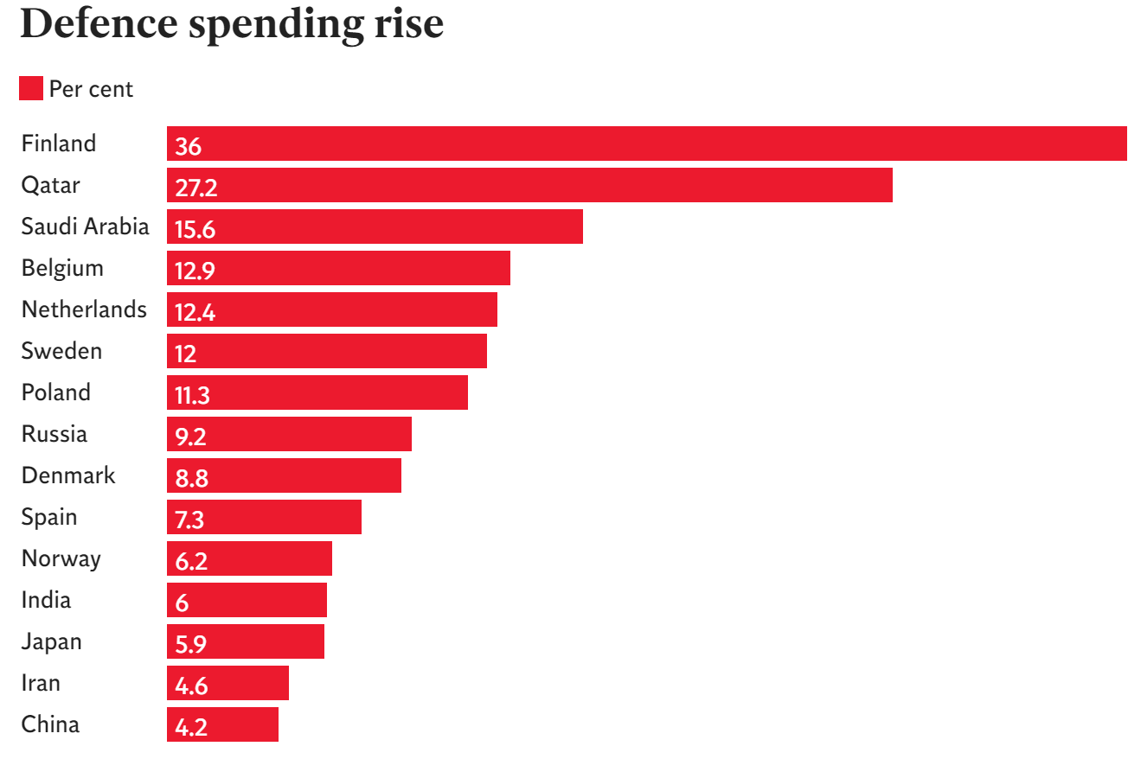
source: https://www.independent.co.uk/news/world/military-spending-finland-cold-war-b2325728.html
In the decades following the conclusion of the Cold War, Western nations saw reductions in defense budgets, delays in procurement decisions, and a slowdown in military industry production. However, a significant shift occurred after February 2022.
By April 2023, MDBA, a pan-European missile manufacturer's British division, secured a contract worth £1.9 billion ($2.4 billion) for supplying air defense systems to Poland. In June, the French company Safran sold tactical drones to the Greek army, and in July, BAE Systems, a British defense company, signed a deal to replenish artillery shells for the British army.
During the same month, Rheinmetall, the largest German manufacturer of military equipment, obtained contracts from the German government. These included a contract for ammunition supply worth up to €4 billion and another contract for €1.9 billion, involving the delivery of over 3 thousand airborne vehicles to Germany and the Netherlands. Rheinmetall's CEO, Armin Papperger, expressed enthusiasm, declaring it as the company's best year in terms of orders in history.
On August 1, Rheinmetall completed the acquisition of Expal, a Spanish ammunition manufacturer. By August 10, the company reported a 12% increase in military equipment sales for the first half of the year compared to 2022. It anticipates an overall growth of 20-30% for the year. Notably, the company received an order from the Ukrainian army for drone supply, leading to the establishment of a new factory in Hungary due to the high number of orders.
Industry analysts predict growing order portfolios as European countries modernize their armed forces. European governments, expecting an increasingly threatening security situation, contributed to a 13% rise in military budgets last year, surpassing other regions of the world. The growth is particularly evident in countries geographically close to Russia, with notable increases in Finland, Lithuania, Sweden, and Poland. Even Germany, the largest economy in Europe, shifted its traditionally restrained stance on military spending, committing to raise defense spending from 1.4% to 2% of GDP and establishing a "special fund" of €100 billion ($110 billion).
What do capitalists expect when they invest money in something? They expect profits. The situation with the military industry is the same as with all other industries - profits will be made even at the cost of kilotons of human blood. In the 20th century, the militarization of Europe has already demonstrated this with two World Wars. Will we be able to avoid a bloodbath this time? Capitalist contradictions are once again growing more acute, which is reflected in the increased frequency of conflicts in different parts of the world, so the answer seems to be rather negative. War is after all an inevitability of capitalism, especially so in its imperialist phase. What remains for us is the struggle against the bourgeoisie, which everywhere cannot find money for its ordinary citizens, but willingly finds money for military budgets, and subsidies for megacorporations. If the working class does not win, it will once again become cattle, sent to slaughter and be slaughtered in the name of profit for 1% of the population, as they struggle against each other once again for the re-division of the world.
Source: 1

Original article

