Migrants in Russia Deprived of Education
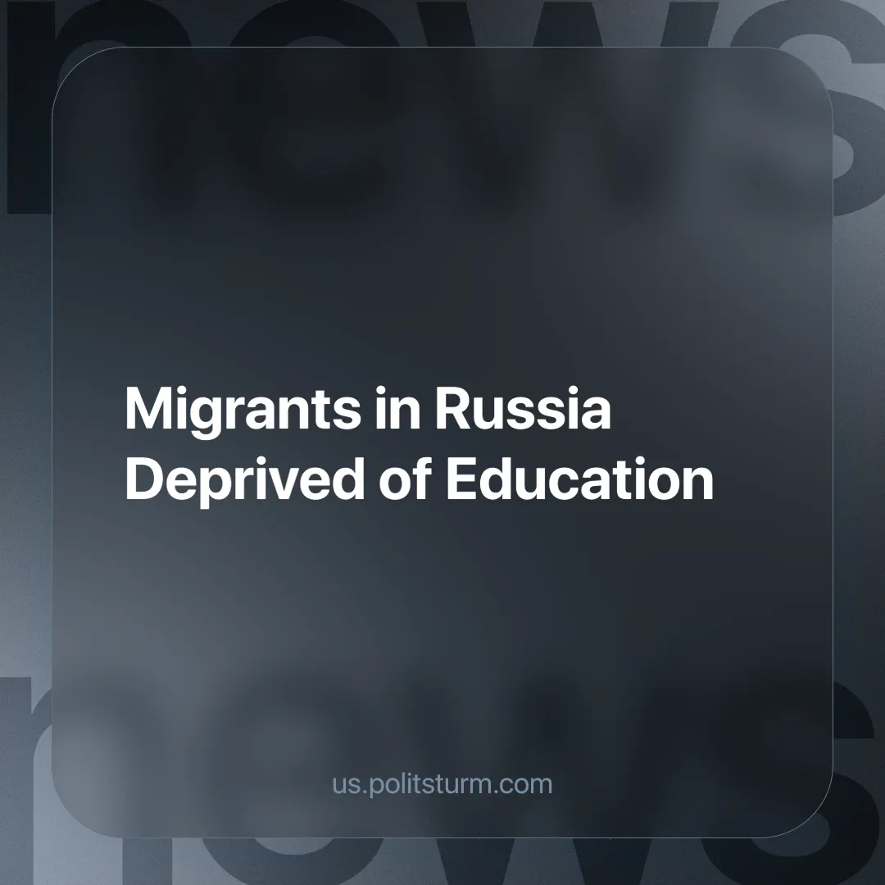

Original article
2025-01-31
5 min read

"The State Duma unanimously approved in the first reading a bill that provides for mandatory Russian language tests for migrant children when they are admitted to schools," writes RBC [1].
The bill clarifies that immigrant children who do not pass the test will not be allowed to study. Guaranteeing the “accessibility and quality” of education, the deputies suggest that parents contact schools when their child improves their language skills.
They emphasize that the number of attempts is unlimited. However, experts note that this will further complicate the socialization of children of other nationalities. After the test was introduced, statistics showed that only 58% of children passed the test successfully, 23% had learning difficulties, and about 18% did not know Russian at all.
"Forbidding children with poor language skills from entering schools is direct discrimination," says Sofya Ismailova, coordinator of the Access to Education project of the Citizens' Assistance Committee (listed in the Ministry of Justice's register of foreign agents). According to her, the adoption of the bill will not solve the problem of the low level of Russian language skills. Ismailova noted that so far there is no state program in Russia for adapting and learning Russian for children of foreign citizens. The only way to learn Russian if it is not spoken in the family is to pay tutors," RBC [1].
How does this improve access to education? Migrants who do not have the opportunity to receive a quality education will work illegally and will not be protected from the economic machinations of their employers. In addition, the second part of Article 78 of Federal Law No. 273 "On Education in the Russian Federation" states that all foreign citizens already have "equal rights with citizens of the Russian Federation to receive preschool, primary, basic and secondary general education... on a generally accessible and free basis".
In other words, instead of state-sponsored free Russian language education for migrants, to which they are entitled, paid private education is imposed. Furthermore, the number of students in schools is deliberately reduced, and these schools are “optimized” by the authorities (i.e. by artificially reducing their number, thus worsening their availability).
Surveys show that the longer migrants stay in the Russian Federation, the less they want to return home [2]. What is the reason for this? CIS citizens immigrate to Russia: Tajikistan, Uzbekistan, Kazakhstan, etc. The ruling class of these countries is economically dependent on the Russian Federation, China, France, the USA, etc.
The big imperialists lend money to small countries, finance infrastructure, and transport routes, establish their own companies in those countries, and invest heavily in the companies of the local bourgeoisie which uses every means for mutually beneficial cooperation. For example, selling local labor cheaply to foreign companies. The declining standard of living and its quality push the workers to emigrate in search of a better life and higher wages.
As in any capitalist state, the ruling class shifts all economic problems onto the workers. As a result, people rush to countries with a higher standard of living where labor can be paid more. This is evident from the experience of the EU: as the economic crisis intensified in 2022 compared to 2021, the influx of immigrants increased by 117% (2.7 million people) [3].
In the United States, the situation is even clearer. Experts point out that from 2021 to 2024, 8 million people migrated to the U.S., 60% of them "without legal authorization". According to an analysis by the New York Times, in 2023, 15.2% of the population was foreign-born, mostly from neighboring states. This is a new record after 1890 when it was 14.8% [4].
"For Mexican illegals in the United States deportation to their home country is a nightmare. Many of them came to the United States as children, and all they know about Mexico is that life is very bad there. So bad that their parents did everything to leave.
Therefore, when migration officials inform adult migrants of their deportation, they practically say goodbye to life – in February, for example, an illegal immigrant preferred to commit suicide rather than return to his historic homeland” [5].
Once in another country, migrants are forced to take all kinds of jobs as cheap labor. Will they have difficulties in finding a job? In Russia, companies employ migrants in the following industries [6]: construction (builders, roofers, plasterers), industry (installers, loaders, carpenters), transportation (conductors, couriers, drivers), etc.
Unexpectedly, migrants are even necessary for the Russian state to maintain its population [7]. According to Rosstat (Federal State Statistics Service) estimates for 2022, the population loss amounted to 533 thousand people. By the beginning of 2023, there were 146.65 million people in Russia.
"Until 2100, the growth of the number of migrants in Russia must range from 390 thousand to 1.1 million annually, so that the population does not decrease", – the assessment of experts of the Vishnevsky Institute of Demography at the National Research University Higher School of Economics [7].
"According to the Ministry of Internal Affairs, we have 7 million migrants, according to our estimates 8-9 million. That is over 10% of the country's working population. If they were removed, many sectors would simply collapse... Therefore, it will not be possible to simply remove them from the economy," said Vadim Kozhenov, Chairman of the Federation of Migrants of the Russian Federation [2].
From the above, it is clear that migrants are cheap labor, which is why they are a sought-after category of workers for businessmen. Capitalists use their labor, which does not require high or even average wages, medical examinations, or additional bonuses. Providing education for migrants is seen as an additional cost for businesses, one they typically avoid.
The capitalist state will always try to limit the rights of the "new citizens", by creating additional difficulties for immigrating workers. But what are these people guilty of?
For business, migrants are guilty of being in limbo, forced to sell their labor to survive, and unable to legally defend themselves. Most are deprived of even the basic rights that "legally protected" working Russians have.
Therefore, taking advantage of the unprotected position of immigrants, entrepreneurs reduce wages and cut social benefits for native workers. Historical experience confirms that this is what awaits every worker over time. This will be the case as long as there is a division of society into classes of exploited and exploiters.
Migrants, like many workers, are deprived of legal and social protection in a bourgeois state, despite constitutional provisions declaring that "All people shall be equal before the law and court" – Article 19, paragraph 1 of the Constitution of the Russian Federation.
Sources:
[1] rbc.ru — “State Duma approves ban on admitting migrants who don't speak Russian to schools” – December 10, 2024.
[2] kp.ru — “Will Russia's Economy Collapse If Migrants Are Removed?” – December 10, 2021.
[3] Eurostat — “Migration and migrant population statistics”, March 2024.
[4] interfax.ru — “NYT Reports Record High Immigration to US Under Biden” – December 11, 2024
[5] lenta.ru — “Two Homelands, No Home How Mexicans Deported from the US Live” – April 3, 2017.
[6] nark.ru — “The most in-demand professions of labor migrants in the Central Asia – Russian Federation corridor have been named” November 24, 2021.
[7] rbc.ru — “Demographers named the number of migrants needed to stabilize Russia's population” – April 13, 2023.

Original article

