Microsoft vs. Sony: On Transnational Capital
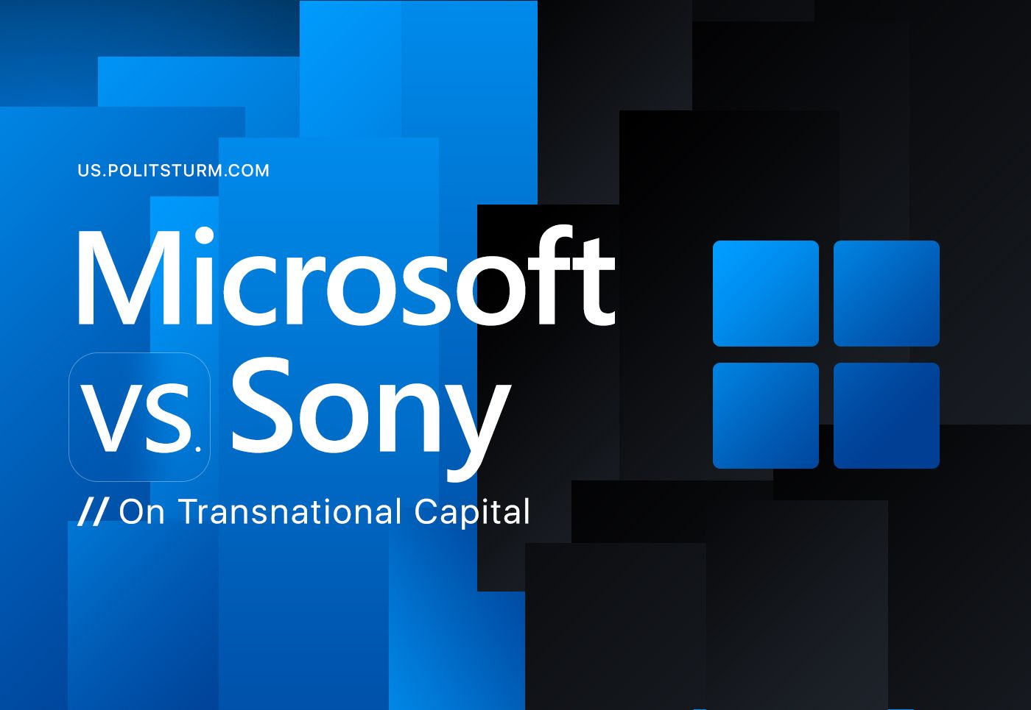

Original article
2023-04-14
14 min read

In January of 2022 Microsoft announced its readiness to acquire Blizzard. The news was instantly picked up and spread by the world media, the amount of the transaction was estimated at $ 68.7 billion. Its significance was declared as "the largest acquisition of Microsoft in history", "the largest deal in the video games industry", "the largest deal in the field of technology up to this date".
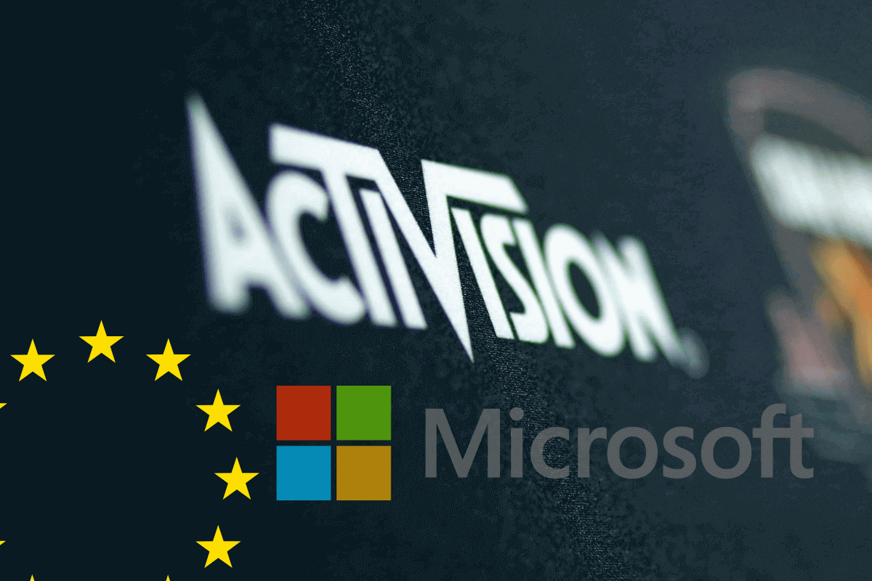
It was indicated that the deal would significantly expand Microsoft's already significant video game business and the organization would become the third largest by revenue gaming company in the world after Chinese Tencent and Japanese Sony.
What is the reason for such a high excitement around this transaction, what socio-economic processes formalize it and what is their significance?

About Microsoft
Microsoft began to gain popularity in the mid-1970s, initially developing software for the then-new personal computers and later developing and producing computers themselves and operating systems for them. Since 1987, the company has expanded and acquired other companies and this process of absorption contributed to its growth and, accordingly, the growth of the respective markets' monopolization.
To date, according to the open source data, the company has completely absorbed almost a hundred other companies engaged in software development, programming, design programs, gamepads, video games, provider services and Internet software, data exchange programs and music web services, encryption software, digital TV services, travel business, the development and production of mobile phones (Nokia was absorbed in 2013). In short, Microsoft is a huge corporation with tremendous assets and influence in the world.
Since 2001, Microsoft has been actively present in the video game industry selling its own Xbox game console, which soon took its place among the best-selling game consoles in the world.
Since 2014, the company has also acquired a number of video game development firms. In 2014, Microsoft acquired the Mojang studio for $ 2.5 billion – the developers of Minecraft – and since then, according to rough estimates, the franchise has brought Microsoft more than $ 2.7 billion. In 2020 Microsoft bought ZeniMax Media Inc. for $ 7.5 billion including the well-known Bethesda Softworks game publisher.
The gaming industry currently occupies one of the key places in the digital economy entertainment market due to the very high income level growth rates. In 2022, the video game market in the United States alone was estimated at $97.67 billion US dollars, setting a new industry record for all time.
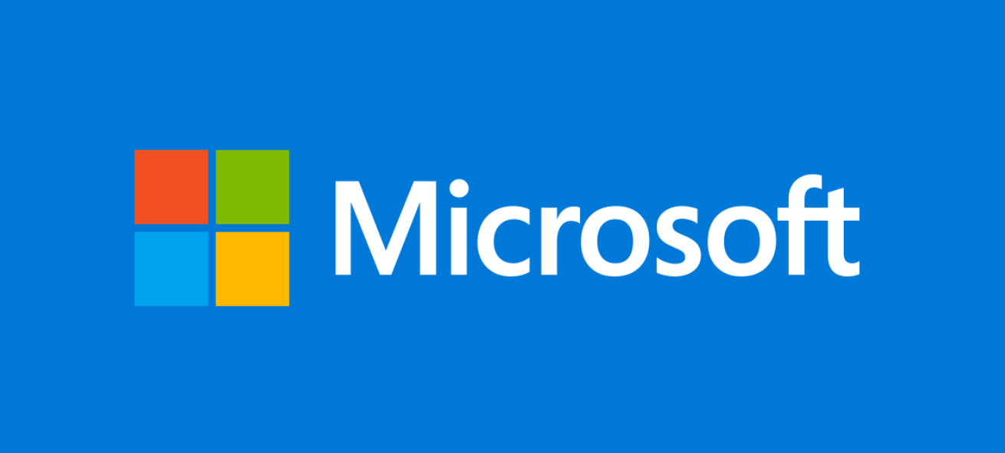
Thus, Microsoft today is a global technology giant worth more than $2 trillion and is one of the largest players in the field of information technology in the world market and, in particular, computer games.

About Blizzard
Blizzard Entertainment, founded in 1991, develops and publishes video games. Fame and success came to the company in 1995, after the release of such game franchises as Warcraft, Starcraft, Diablo and a number of other popular games. In 2008, the company expanded by merging with the French game holding Vivendi Games, while changing its name to Activision Blizzard and becoming one of the largest in the field of computer games and entertainment.
In 2014, Activision Blizzard was the fifth largest by revenue gaming company in the world with total assets of $14.746 billion US dollars and total capital estimated at $7.513 billion US dollars. In 2017, Blizzard became the third in the Fortune Global 500 ranking of the world's 500 largest gaming companies.
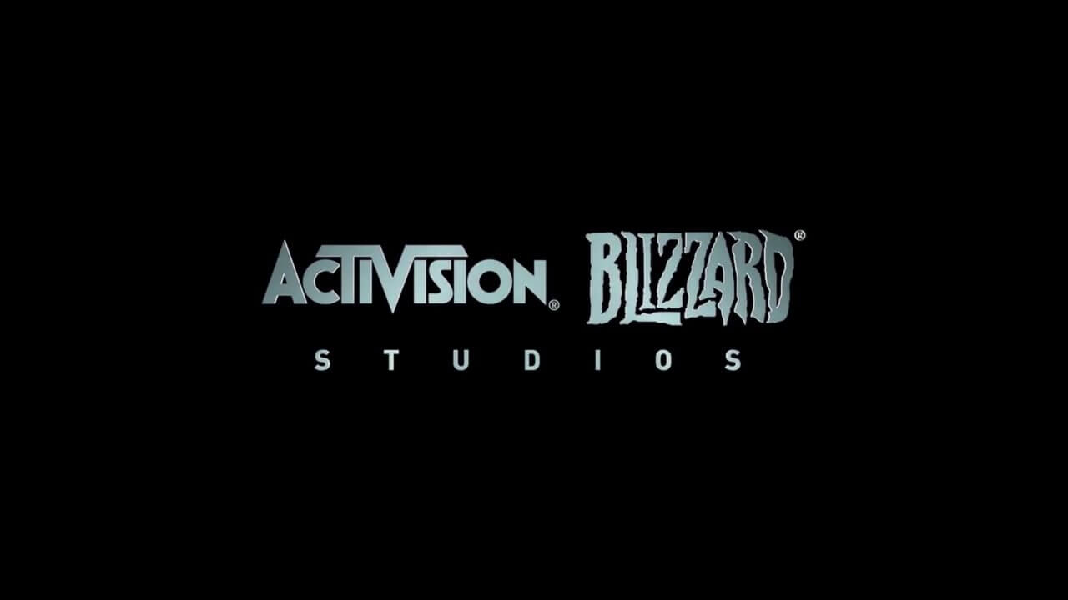
Given such a company history and Microsoft's pursuit to expand its influence including in the virtual entertainment market, the interest of the latter to Blizzard is quite understandable. According to some analysts, this deal significantly accelerates the recent years changes observed in this market sector including game streaming, which will lead to the emergence of even larger gaming empires.

Who Are the Competitors?
Being currently one of the largest monopolists in the IT and the gaming market, Microsoft is still not the only player in the industry.
According to the results of the financial reports analysis, Sony was in the lead among the gaming giants in 2021 with $24.87 billion in revenue and a net profit of $2.63 billion. Microsoft was in second place with $16.28 billion in revenue and no net profit data, Nintendo was in third place with $15.3 billion in revenue and $5.4 billion net profit.
Microsoft itself names among its competitors on the video games market such companies as Japanese Sony and Nintendo (according to Microsoft, Sony's share in the global gaming market reaches 70%), as well as the Chinese giant Tencent.
The Chinese company Tencent, despite the fact that its activities are almost entirely concentrated in mainland China, actively invests in foreign companies and has several dozen subsidiaries focused on software development, online advertising, development of online games, mobile games and other things. In addition, Tencent has its shares in other media companies, including the Activision Blizzard (5%). As of 2022, Tencent was the most profitable among Chinese mobile game developers.
Amid news on the acquisition of Activision Blizzard by Microsoft, competitors felt the threat of losing their advantages, which, of course, in a capitalist economy implies primarily the risk of financial losses.
Thus, Tencent shares fell by 2.75% on the day of the announcement of the deal.
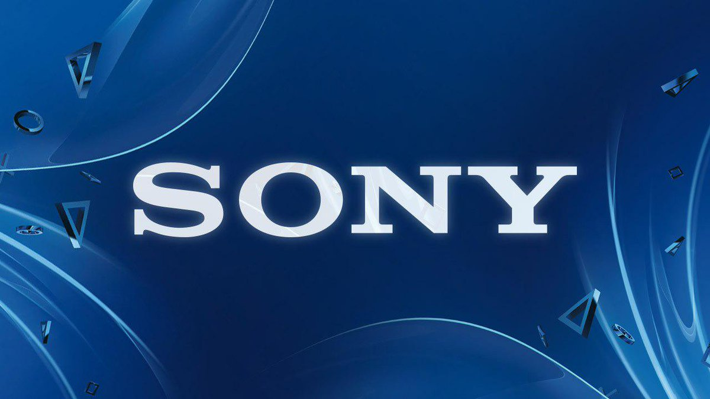
Sony shares fell by 10% amid concerns that Microsoft could outpace it (according to analysts, Sony lost about $10 billion in market capitalization overnight).
Sony has a special reason to be wary of this deal. The fact is that since 2003, Activision Blizzard has published the very successful Call of Duty game franchise, which is also released on PlayStation game consoles owned by Sony. And after the acquisition of Blizzard by Microsoft, control of the release passes to Microsoft and there is a possibility that the game will cease to be released on Sony consoles at all or will have temporary exclusivity for PC and Xbox. Of course, this will provide Microsoft with an increase in profits, and Sony's profits will decrease accordingly.
However, this is not the only way Microsoft can worsen Sony's position in this aspect. Thus, in the documents submitted by Sony to the UK Competition and Market Authority (CMA), it is indicated that after the closing of the transaction, Microsoft may undertake the following:
- Increase the price of games in the series;
- Remove games from other subscription services to leave them available only in Game Pass;
- Purposefully release "buggy" versions on PlayStation to make people switch to Xbox;
- Ignore special PlayStation features (e.g. DualSense tactile feedback);
- Prohibit or degrade multiplayer game modes in the PlayStation version;
In general, Sony has plenty of reasons to worry. Recently, there has also been a deterioration in the situation of Nintendo stock prices which have already fallen by 6.9% from the previous indicator and the decline is likely to continue. According to analysts, Nintendo should introduce the next generation of its Switch game console in the near future in order to compete with Xbox (Microsoft's game console) and PlayStation (Sony's game console).
In short, key market players are extremely concerned about this deal, which will significantly change the balance of power far from in their favor.

Consumable Resources of the Market
However, despite the past year after Microsoft announced its readiness to purchase Blizzard, the deal is still in limbo and cannot be closed due to ongoing litigation.
During this time, Microsoft reportedly lost a significant percentage of its capitalization against the background of the unfinished transaction and the fall in the value of shares, and the net profit of the IT giant for the first half of the 2022-2023 financial year decreased by 13.5 percent. In general, analysts note that over the past year after the announcement of the deal with Blizzard, the company has lost 22% of its capitalization, which is approximately $ 480 billion.
Under these conditions, Microsoft needs to show investors the preservation of financial stability, one of the guarantees of which is, among other things, the dismissal of employees in order to reduce monetary costs.
In this regard, since the fall of last year, Microsoft began mass layoffs, and in February 2023, the company officially announced the largest reduction in its history, laying off more than 11 thousand people in order to reduce operating costs. The opinion is expressed that this step and the public statement about it is an extremely indicative gesture for investors: "we are cutting costs, and you will receive your dividends".
However, mass layoffs, numbering tens of thousands of employees, have happened in the company before due to issues of falling profits during economic crises and the takeover of other companies (for example, Nokia in 2013).
And Microsoft is not at all outside of the general trends here.
So, if we talk about the main participants of the event in question and the company's competitors, then we can recall that, for example, Nintendo laid off more than 100 employees in 2021, closing its office in the USA. Earlier, in 2014, the company dismissed 320 employees from the European office with the official wording of the reason: "adaptation to a rapidly changing business environment."
Activision Blizzard laid off about 800 people in 2018, which was 8% of the staff, while layoffs occurred amid reports of record high revenues of the company (revenue for 2018 amounted to $7.5 billion dollars), exceeding last year's figures. It was noted that the management still expressed dissatisfaction with such results, and the president of the company indicated in an open letter that the number of staff did not meet the needs of the corporation.
Sony laid off 16,000 people in 2008, 10,000 thousand in 2010, about 5,000 employees in 2014, and dozens of employees of European and American offices were laid off in 2019. The reasons for the layoffs were the consequences of the global financial crisis and "the need to prepare the company for subsequent growth." In 2019, as noted, journalists who talked with third-party developers suggested that the company's reshuffle may be related to internal corporate struggles.
In the summer of 2022, the gaming company Tencent laid off 5,500 employees after announcing a quarterly drop in the company's profits, which was explained by the deepening consumer crisis due to the downturn in the real estate market and the introduction of special anti-coronavirus restrictions. In an attempt to maintain its profits, as noted, Tencent has closed some of its branches engaged in e-commerce and news gathering.
The development dynamics of capitalist monopolies is invariably associated with mass layoffs of employees accompanying the transformation of companies, or with the aim of surviving financial crises generated by the capitalist economy. The meaning of these layoffs is the same – reducing costs and increasing profits, which make up the income of the management staff of companies, contributing to their further growth and the maintenance of competitive advantages.
In these conditions of economic instability and uncertainty, the value of the deal between Microsoft and Blizzard increased many times, exacerbating the struggle between the main competitors.

New Level of Capital Monopolization
Following the announcement of Microsoft's purchase of Blizzard, civil activists and administrative resources calling for the compliance with laws and market rules in the capitalist economy were "roused up".
A group of gamers filed an antitrust lawsuit, stating that they are seeking a court decision prohibiting companies from making deals, since the merger will give Microsoft enough influence "to exclude competitors, limit product output, reduce consumer choice, raise prices and further suppress competition."
The US Federal Trade Commission called for blocking the deal, expressing confidence that it would strengthen Microsoft in the fight against competitors and allow price manipulation.
At the same time, according to Bloomberg citing its sources, the December lawsuit from the US Federal Trade Commission against Microsoft arrived much earlier than expected, as the agency wanted to get ahead of the company's potential agreement with the European Commission.
The European Commission (as the highest executive authority of the European Union) acts here as a body that monitors compliance with anti-monopoly legislation and the possibility of abuse of a dominant position in the market. Actually, the involvement of the European Union in the deal speaks about the scale of the possible consequences of this acquisition and the influence of its participants on the political and economic situation in the world.
The British Competition and Markets Authority (CMA) also joined the case, whose investigation previously showed that the proposed acquisition could lead to higher prices, reduced choice or reduced innovation for British gamers.
The Brazilian antitrust regulator (CADE), on the contrary, approved the purchase of Activision Blizzard by Microsoft, expressing confidence that there is no problem in the loss of the Call of Duty series from PlayStation consoles. At the same time, some owners of Sony devices may abandon the franchise, switch to other games and platforms or to Xbox or PC for this exact shooter.
The "dear partners" in the market did not stand aside either: as journalists found out, representatives of Sony announced the inadmissibility of the Microsoft and Activision Blizzard deal, writing about it on the website of the UK Competition and Markets Authority. As an argument, representatives of the Japanese company pointed out the likelihood of the company losing the ability to produce games of the popular game franchise, which will lead to a decrease in their competitiveness.
On the contrary, according to reports the Chinese giant Tencent expressed a positive opinion about the deal during a survey by China's anti-monopoly services. It is understandable, because in the case of a satisfactory decision regarding the acquisition of Blizzard, this creates a certain precedent and makes such expensive transactions “legal". Given the resources of Tencent, there is no doubt that the Chinese will be the first to rush to "shopping" after the deal closes.
Microsoft, in turn, requested a court hearing in order to protect its deal.
A Microsoft representative told Reuters that its "... commitment to provide long-term 100% equal access to Sony, Steam, NVIDIA and other companies preserves the benefits of the deal for gamers and developers and increases competition in the market."
Currently, pre-trial hearings have been held in the case and a decision has not yet been made. However, according to Reuters, the European Commission still intends to approve Microsoft's acquisition of Activision Blizzard, as Microsoft has pledged not to obstruct other companies.
So, what do we see as a result? Seemly a simple purchase of one company by another the matter of which concerns only the release of video games.
However, for no reason at all, the US Federal Commission, European bureaucrats, the British Competition and Markets Authority, as well as the Brazilian and Chinese anti-monopoly services are suddenly involved in the case. It would not be an exaggeration to say that almost the whole world is embroiled in a dispute over this deal, which is called "the largest in history."
One thing is hidden behind all of this: a clash of real transnational titans is taking place before our eyes. Modern capitalism has achieved an even higher, truly global nature of competition, and with it, a worldwide level of market monopolization in favor of several multinational corporations. It is their struggle among themselves that determines global processes these days.

What about Politics?
It should be noted that increasing interest shown by political actors in the field of the information technology business, which undoubtedly reflects the observed fusion of global media corporations, as representatives of business, with politics in mutual interests, of course.
Not so long ago, businessman Elon Musk bought the Twitter network for $ 44 billion. It is believed that there is something more behind this than "just" business interests, since having gained control of Twitter, Elon Musk first of all launched a vote on the return of Trump's account, giving him the opportunity to broadcast his ideas to the widest audience as a result.
Numerous opportunities are also provided to political circles by huge databases on users and their interests which are one way or another collected by IT giants and representing, as it seems, a high value for manipulations not only of a financial but of a political nature as well.
In 2018, a "scandal" leaked to the media about data of users of the social network owned by businessman M. Zuckerberg being transferred to Cambridge Analytica - a company providing political consulting services. Also the British channel published a recording of conversations with the company's managers, from which it can be concluded that its employees resort to bribes to discredit political figures.
In 2020, the then U.S. President D. Trump signed executive orders that prohibited American citizens from "having any dealings with Chinese companies ByteDance and Tencent which own TikTok and the Wechat messenger," justifying these measures by saying that the networks could be used by Chinese "communists" for disinformation and propaganda campaigns.

In Russia, in December 2022, it became known that a high-ranking official close to the Kremlin, ex-head of the Audit Chamber Alexei Kudrin, accepted Yandex's offer to become a corporate development adviser, thus practically becoming the head of the largest Russian IT company, which gives the authorities the opportunity to increase control over the digital space.
Actually, large financial capital has long been firmly connected with politics. Even in the very conclusion of the discussed transaction there is an involvement of global political forces represented by anti-monopoly services and regulators. There is no doubt that the main or significant negotiations between the parties to the deal are taking place "behind the scenes", with the involvement of various politicians. There is also no doubt that the influence on the policy of such a giant as Microsoft will only increase if the deal ends successfully.
Everything that has been said – both on the processes taking place in the industry, and specifically about the situation around the Microsoft and Activision Blizzard deal – indicates that we are not just talking about another business deal. We are talking about the intensification of competition between transnational capital caused by an unprecedented consolidation of capital. The outcome of this competition will be of great importance for politics.

What is This All About?
The development of capitalism takes place according to long-established patterns that have received their most complete description in Marxism.
Any "fair business", no matter how it starts, in its development is inevitably driven by the endless pursuit of profit and the need to participate in the competition for this profit.
The best opportunities for both making a profit and increasing competitiveness are provided by the maximum expansion of the business, its expansion horizontally and vertically, the absorption of weaker competitors and the establishment of ties in legal and political structures. Do not think that the Microsoft and Blizzard case does not apply to politics — we have already noted which political forces are involved in concluding this deal.
At the same time, in the development of business structures, attention is not paid at all to the main locomotive of their development - hired workers. Ordinary workers, who ensure the success of all corporations, are under capitalism nothing more than ordinary labor, necessary only insofar as it is possible to squeeze out of it the maximum saleable result of labor at the minimum cost of these results.
In case of any problems related to the real or potential threat of loss of profit, workers replenish the ranks of the unemployed.
Growing, yesterday's small companies turn into huge structures seeking to monopolize the production of their product, or a variety of products, which allows to achieve increase in profits by influencing pricing policies, less and less considering the quality of the product.
Due to the active development of digital information technologies in the modern world, the development and competition of monopolistic companies operating in this area is of particular importance for humanity.
Expanding and turning into giant multinational corporations, they, however, remain subject to the same laws of capitalist development and competition – both external struggle with other similar companies and internal struggle, because within business structures competition for receiving more tidbits never stops.
The maximum opportunities for competition are provided by the spike of business structures with political structures. Regarding the field of information technology, this is an extremely important component since it allows companies to accumulate information about millions and billions of users and exploit it for manipulative purposes both directly in the interests of increasing profits and in the interests of mutually beneficial promotion of political elites.
Thus, in its development, the competition of transnational giants sooner or later inevitably passes to the level of political competition, which has immeasurably greater opportunities for influence, but at the same time drawing into this process such political objects as countries and peoples inhabiting them.
What can be considered the pinnacle of competition, reaching the political level?
The answer has been known to mankind for a long time — war. "War is simply the continuation of politics by other" (namely violent) "means". And whose interests are mutually defended by politicians in the conditions of capitalism? That's right — the interests of big capital.
And now let's turn around and see where it all starts. Quite right — with private ownership of the means of production and fair market competition — the foundations of the capitalist economy. The kind of "hype" that now reigns around a potential deal between Microsoft and Blizzard Entertainment is just a very bright flash of the fierce, irreconcilable struggle that is going on among large and largest multinational corporations among themselves.
And so far, this struggle is unfolding at the hearings of the antimonopoly services. But the noise that accompanies it clearly speaks of fierce competition for the market. Competition, which is getting closer to developing into an open armed struggle for the redistribution of the world market by force.
Sources:
“Sources report that Microsoft will receive EU approval in the case of the acquisition of Activision” from March 4, 2023.
“How the gaming industry has become a new battleground for large tech companies” from January 25, 2022
“Microsoft announced the purchase of Activision Blizzard for $ 68.7 billion” from January 18, 2022.
“Activision Blizzard takeover - a good deal for Microsoft” from January 21, 2022

Original article

