Microchip Arms Race: World Imperialists Jostle over the Future of Advanced Computer Production
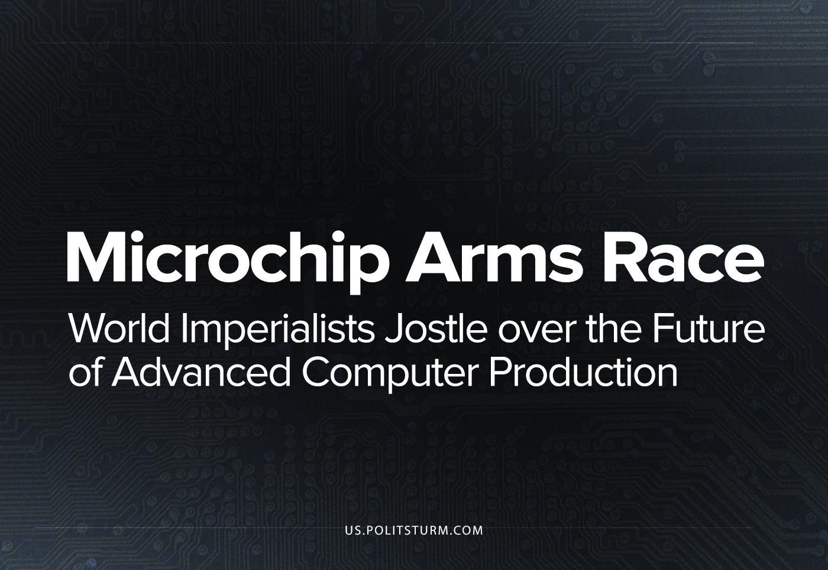

Original article
2023-07-24
16 min read

Last year, as a part of an ongoing American policy of ‘decoupling’ from, and obstructing the monopoly growth of, their biggest national competitor and economic trade partner, the administration of President Biden announced a ban on the export of advanced microchips to China. These are defined as less than 18 nanometre transistors, as well as related software and equipment from US companies, and foreign ones which use U.S. equipment [1]. This comes at a time when the Taiwanese microchip monopoly TSMC has spent $40 billion constructing a two new production facility in the U.S. state of Arizona, a novel venture for the U.S. which has seen decades of decline in its domestic manufacturing industry [2].
Two months previously, Biden signed the CHIPS (“Creating Helpful Incentives to Produce Semiconductors”) Act, which outlined the spending of $280 billion (including $39 billion in subsidies as well as large tax cuts for chip-producing monopolies) to boost domestic American design and manufacture of microchips [3]. In January 2023, the Netherlands and Japan (two countries intricately involved in the global semiconductor supply chain) announced they would be also restricting the export of chip related equipment to China [4], with the Netherlands more recently in late June also announcing further restrictions limiting the export even more of their crucial DUV lithography machinery which is crucial for the manufacture of microchips [5]. The EU and Japan have announced micro-chip acts of their own, with the EU outlining the investment of €43 billion ($46 billion) [6], while Japan invests ¥369 billion ($2.8 billion) [7] towards domestic chip manufacture.
In May 2023, China increased its response with a ban on U.S. chipmaker Micron, citing national security concerns [8, having announced a $143 billion investment package for its domestic chip design and manufacture industry. Even more recently, in July 2023, China has announced restrictions in the form of license requirements on the export of gallium and germanium, two metals vital for the manufacture of gallium nitride (GaN) transistors used certain advanced military radars [9].
At ‘the end of history’, when the tendrils of the world market reach across the entire globe and unites it in one imperialist world economy, why are these countries attempting to boost their own chip manufacturing capabilities at the expense of their competitors? In order to examine this, it is necessary to briefly outline what microchips are and why they are so instrumental in modern society.
Microchips (also known as semi-conductor chips) are a set of electronic circuits involving large numbers of transistors printed on a piece of semiconductive material (normally silicon). Transistors can amplify or switch an electrical signal and are used to make logic gates which are the physical element that facilitates the basic binary computations within a computer that it depends on to function; from complicated calculations to the colour of each pixel on the screen you are reading this on.
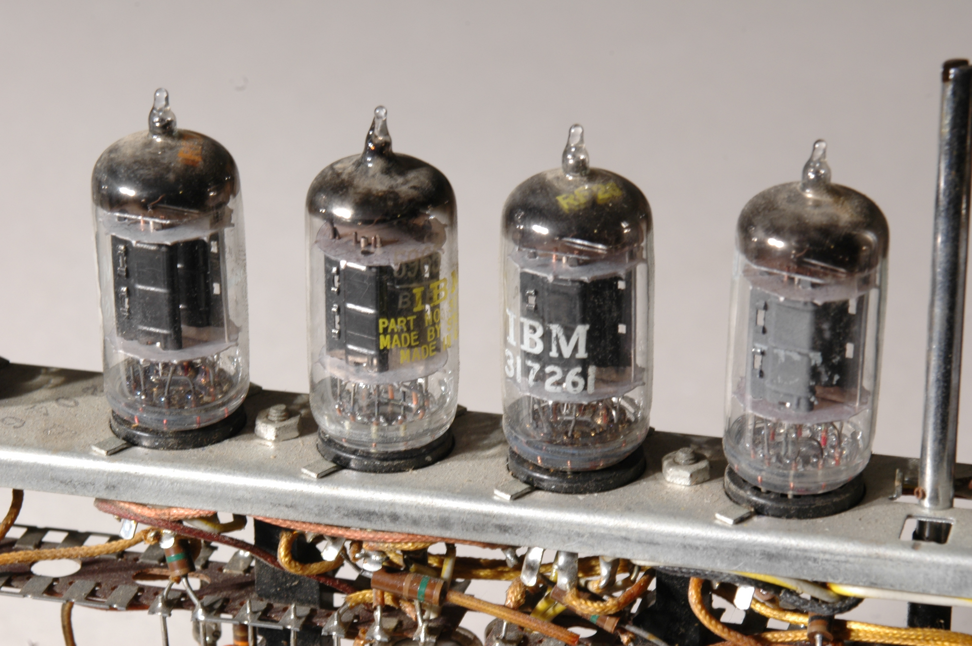
The first computers used vacuum tubes, a few centimetres in length, for this function. Consequently, computers far less powerful than modern ones needed to be the size of rooms. Today, the most advanced modern transistors are measured in single digit nanometres. This incredible and continuous miniaturisation of transistors is what allows more of them to be packed within a single microchip, leading to the size of computers to decrease, while their speed increases. This rapid and ongoing process means that a 5- or 10-year-old model of chip will be qualitatively worse than a modern one, a desirable factor for a commodity in the eyes of a capitalist enterprise.
In the modern world, virtually everything has been digitised, meaning that microchips are integral to nearly all modern large-scale industrial production processes, research and development as well as many important end-products such as cars, smartphones, supercomputers and the most advanced military weapons. The need for semiconductive microchips will only increase in the future.
Initially (with microchips being a US invention), the entire production process was located within the U.S., from design to manufacturing and final assembly. However, in the 1970s, these firms relocated their manufacture and assembly primarily to Taiwan, Japan, Hong Kong, and South Korea in an effort to reduce labour costs. While most advanced countries can manufacture older chips on their own, the production process of the most advanced semi-conductor chips is a very global process, but which resides mainly in a few advanced production centres of certain nations. The monopoly on the software to design the advanced chips as well as the designs is held by U.S. companies. The machinery required to produce them is produced by ASML in the Netherlands, but this is dependent on components made only in the USA, while the foundries that use this machinery to produce said microchips are located mainly in Taiwan using semi-conductive wafers from Japan.
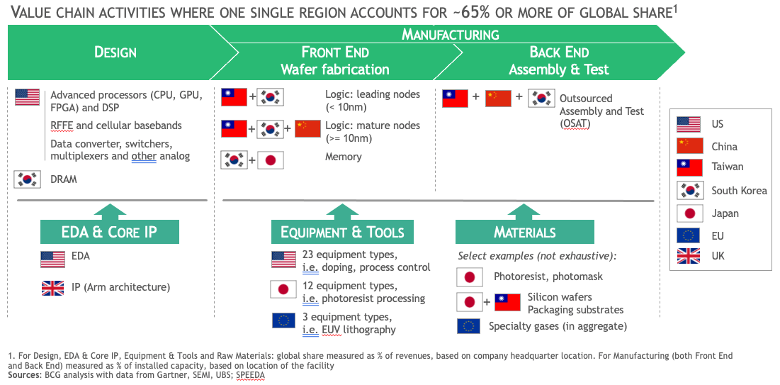
Global spread of the semiconductor production chain
In 2020, a microchip shortage began as part of a general economic decline, specifically due to delays in certain parts of this highly sensitive production chain. In order to boost production as well as ensure more of that production is located within their own borders, advanced capitalist countries are investing heavily as well as using subsidises and tax breaks to encourage growth in this sector in order to counteract the individual capitalists’ thirst for a greater expropriation of workers’ surplus value in the form of profit, which they could otherwise more easily achieve abroad using cheaper labour and without the massive subsidies.
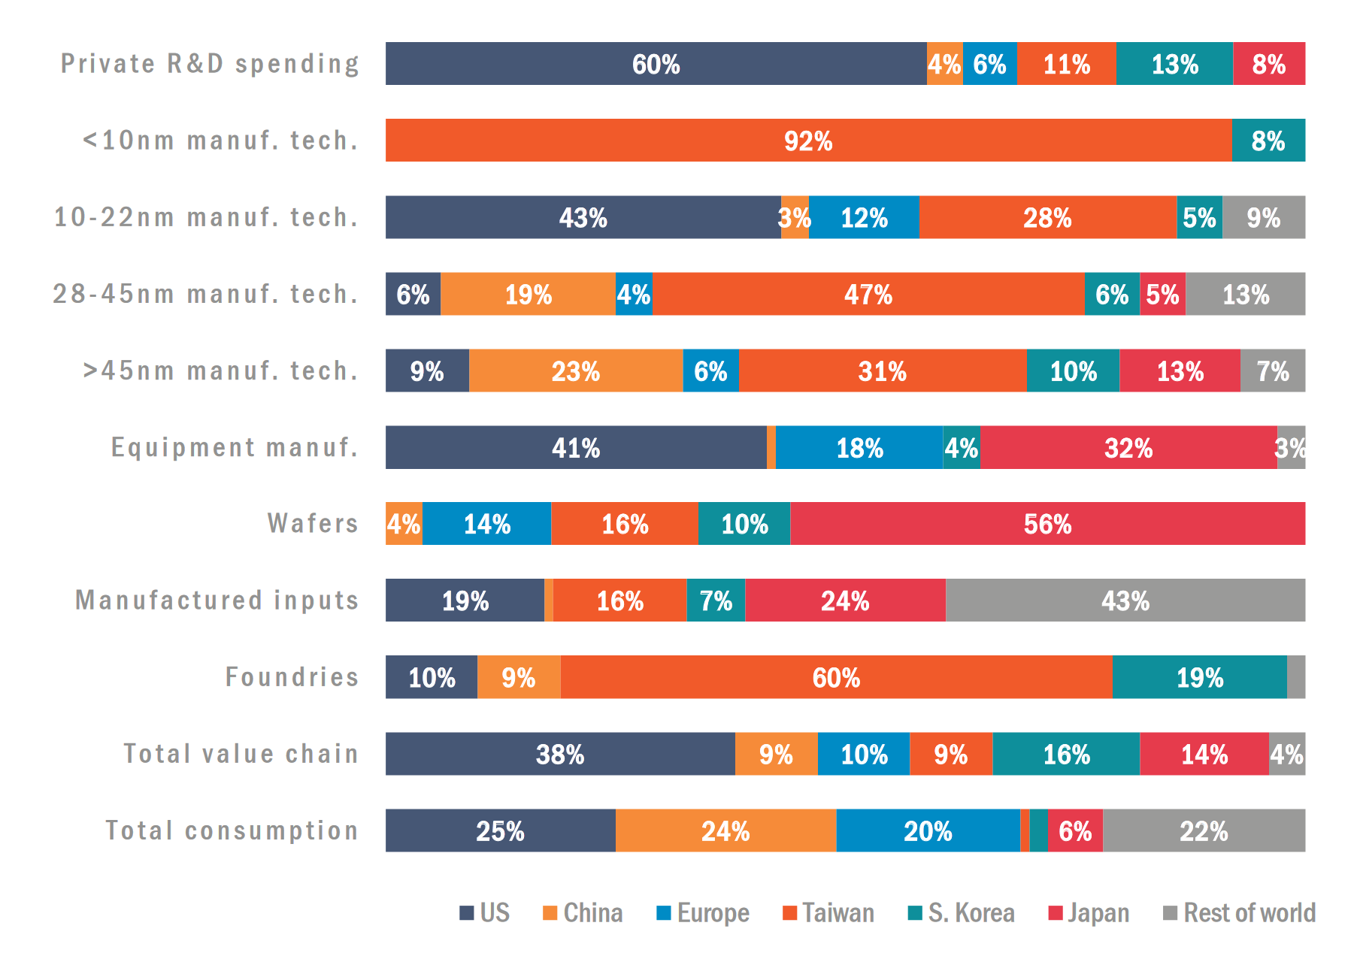
Global spread of the Semiconductor production market share
Microchip production is extremely capital and knowledge intensive, meaning a lower rate of profit for the capitalists. An advanced chip foundry would cost around $20 billion requiring at least 2,000 highly educated and trained engineers to run and maintain it as well as investing around 20% of their income in research and development [10]. For reference a state-of-the-art aircraft carrier costs around $13 billion, and a nuclear power plant around $6 billion. The laws of motion of capitalist development state that capital will naturally flow to the sectors of industry with the highest profitability, which is why capitalist states must offer large subsidies and tax breaks into order to stimulate semiconductor growth. Only states which are high-up in the pyramid of the imperialist world system, with access to the super profits drawn from transnational monopolies engaging in the double exploitation of their own working class within more profitable industries and the workers of dependant nations, can afford to spend billions in subsidies to incentivise semi-conductor production. This includes access to a certain niche of skilled labour, which is disinclined from employing itself in the conditions provided in these factories. American expert labour in this field, for example, has been retained by Taiwanese companies which previously had not adjusted their working conditions to meet the expectations of American ‘labour-aristocratic’ engineering and software workers. As such, wages are begrudgingly increased to balance out the lower conditions [11].
The capitalists collectively sacrifice a portion of their would-be profits, precisely because they realise the strategic value of maintaining and expanding their control over microchip production, which is the exact same reason the US is attempting to cut China out of the process with sanctions. Similarly, the other aforementioned countries and organisations in the Western imperialist bloc, namely Japan and the EU are participating in these sanctions as well as offering subsidies of their own in line with their own strategic ambitions.
“How to organise planning? In their [capitalist] system capital gets spontaneously distributed over the branches of the economy depending upon the profits. If we were to develop various sectors according to their profitability we would have a developed flour-grinding sector, toy production (they are expensive and give high profits), textiles, but we would not have had any heavy industry. It demands large investments and is loss-making in the beginning. Abandoning the development of heavy industry is the same as that which the Rykovites had proposed. We have turned the laws of development of the capitalist economy upside down, have put them on their head, or more precisely on their feet. We have begun with the development of heavy industry and machine building. Without planning of the economy nothing would work out.”
– I.V. Stalin, On Planning
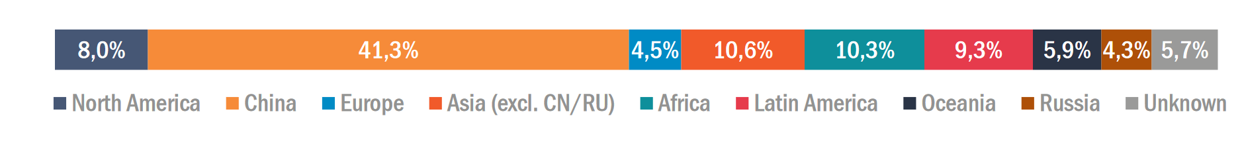
Global spread of semi-conductor raw material market shares.
While China is lagging behind with the manufacture of the most advanced chips and is dependent on importing them, their investment package in the sector is amongst the largest and they are essential in the production process for the older and larger chips as well as control over the raw material input flow. This includes the gallium and germanium production which they have recently announced export restrictions on. China holds the monopoly on the extraction of these metals and produces about 94% of the world’s gallium and 83% of germanium, according to an EU study [12].
These metals aren’t exceptionally rare or difficult to find, so how has this strategic situation come about? China holds the monopoly on their production as they are by-products from the processing other commodities (like coal and bauxite) which has been carried out extensively in the country. This allows China to process these metals at far cheaper costs than other countries. The US has no production of mineral gallium at all, but doesn’t rely on China for its domestic manufacturing, and only produces germanium in limited amounts at a single facility in Utah – whose gallium and germanium mine was shut down by neoliberal policies out-sourcing to China in the 1980s. However, with export restrictions on China’s supply, production of these metals elsewhere will gradually increase.
Over recent years, the US has imported 53% of its gallium, and 54% of its germanium from China, but that may change with increased sourcing from Canada, Japan and Western Europe. The US Defense Dept. initiated a recycling program to recover germanium from military equipment. Now, the company American Elements has announced it will “significantly expand” gallium and germanium production in Salt Lake City, Utah. However, China’s restrictions will still, for a while, have their intended effect – to slow down Western attempts to expand domestic semi-conductor production. At least 59 suppliers of products using germanium and its alloys, from semiconductor wafers to germanium foil for ship-building and defense, to optical crystals used in defense, aerospace, energy, medical, oil and gas industries, and 49 manufacturers of gallium thermal interface materials and coating for semiconductor photovoltaic switches, diodes, and integrated circuits,
Along with Gallium’s use in advanced semiconductors, the metal is also present in TV and mobile phone screens, solar panels and radars. Crucially it is also used in the next generation of advanced military aircraft radars [13], most advanced elements of the most important weapons behind US military dominance. Germanium is needed for manufacturing fibre-optics as well as thermal-sensing and infrared equipment, and most satellites are powered with germanium-based solar cells. This too is crucial militarily as most large-scale modern reconnaissance is done by military satellite imagery – a field in which China dominates the sky. These materials are clearly important for some of the most advanced technologies, and so a ban here reflects the severity of the US ban on chips which could advance Chinese A.I.
The immediate shortage of Gallium and Germanium will be made even more severe by the fact that the US and other Western bloc countries will prioritise the limited supply of the metals for its advanced military radars, which will further increase the price of the consumer goods that require these metals. Radars with gallium nitride integrated circuits operate at higher frequencies than previously possible, increasing effectiveness of radios, radar communication and jammers.
Electronic warfare is the current focus of the most advanced and expensive weapons systems, so obstacles in this field will have outgrowing effects on military innovation for years. This new obstacle arises at an inopportune phase of military development in the U.S., as the newest designs of aircraft are currently in production. Even the bans on transistors capable of hosting advanced A.I. have a military importance, since the most advanced U.S. aircraft models seek to utilize A.I. to coordinate between manned, computerized stealth planes and unmanned squadrons of drone bombers.
China is actively developing advanced microchip manufacturing capabilities. While China cannot match American air dominance directly, the field of electronic warfare will truly decide the usefulness of America’s most important weapons – every effort will be explored to reveal flaws in stealth fighter-aircraft invisibility, blind spots in their radar vision, frequencies which will jam its equipment, and methods to hack their software. Any one of these elements could turn the tide of a sudden military conflict, even with the numerical advantage on the US side.
It is a race against time between China’s development catching up to the US, so as to decrease their reliance on these sanction-risk imports, and the US establishing adequate chip production into reliable supply lines to consolidate their lead in the field and decrease their reliance on China’s production volume and raw materials monopoly. In this inter-imperialist competition, each will try to take the most advantageous position and act by whichever means necessary to ensure their interests. The world market is already fully divided and it can only be redivided. They will choose violence and war in order to do this, if necessary, or whichever methods will best suit them. The US is pushing China to seize the microchip production equipment as well as the designs and blueprints based in Taiwan [14], hoping to spark an early armed conflict while they retain military dominance. However, it is unlikely that China will invade Taiwan purely for the semiconductor facilities as by themselves they will not guarantee a Chinese lead.
China already has the edge in the economic sphere and is poise to overtake the US’s position in the world imperialist hierarchy, and the microchip supply chain is a fitting microcosm. Today, even American capitalists in the chip industry are begging the State Department to walk back from their chip war [15], since it is costing them heavily due to the importance of low-cost Chinese goods for the profitability of their business model.
China now has the capability and funds to build the scientific faculty in order to boost their research and development to catch up and surpass the Western bloc, and will only improve their position in this chip war by increasing the value of goods in the electronics market over which they hold a monopoly. China has increased the prestige and funding of its integrated circuit related university programmes [16] in order to train the next generation of semiconductor engineers, supplementing this by poaching Taiwanese chip engineers with larger pay offers [17]. These experienced engineers bring knowledge of the intellectual property of the company they previously worked for which can be used by China, like for example foundry blueprints [18] or chip architecture [19].
The microchip arms race will draw trillions of dollars into this industry with government subsidy and investment programs. But will national capitalists be able to plan their exit from this economic and military quagmire?
“Reference is sometimes made to American and German economic bodies which, it is alleged, also direct their national economy in a planned way. No, comrades, those countries have not yet achieved this, and never will achieve it, as long as the capitalist system exists there. To be able to lead in a planned way it is necessary to have a different system of industry, a socialist and not a capitalist system; it is necessary to have at least a nationalised industry, a nationalised credit system, nationalised land, a socialist bond with the countryside, working-class rule in the country, etc.
True, they also have something in the nature of plans; but these are forecast plans, guess-work plans, not binding on anybody, and they cannot serve as a basis for directing the country's economy. Things are different in our country. Our plans are not forecast plans, not guess-work plans, but directive plans, which are binding upon our leading bodies, and which determine the trend of our future economic development on a country-wide scale.”
– I.V. Stalin, The Party and the Opposition
Under capitalism, production is subordinated to the ‘unknowable’ whims of the market, and commodities are transformed into an alien overlord which commands the workers who create them. Microchip production is an especially clear embodiment of this, with the competition between producers mobilising hundreds of thousands of people with the potential even to lead to war. The opening of new factories for this industry into the United States has required major subsidies, to be paid from public tax funds to international capitalists, and protectionism, but can only be the socialist state-run economy which can best and most comprehensively organise resources for investment in such a critical industry to foster safe and stable industrial development internationally.
Sources: 1, 2, 3, 4, 5, 6, 7, 8, 9, 10, 11, 12, 13, 14, 15, 16, 17, 18, 19

Original article

