Michigan Dam Breaks and Flooding Cause 11,000 to Evacuate
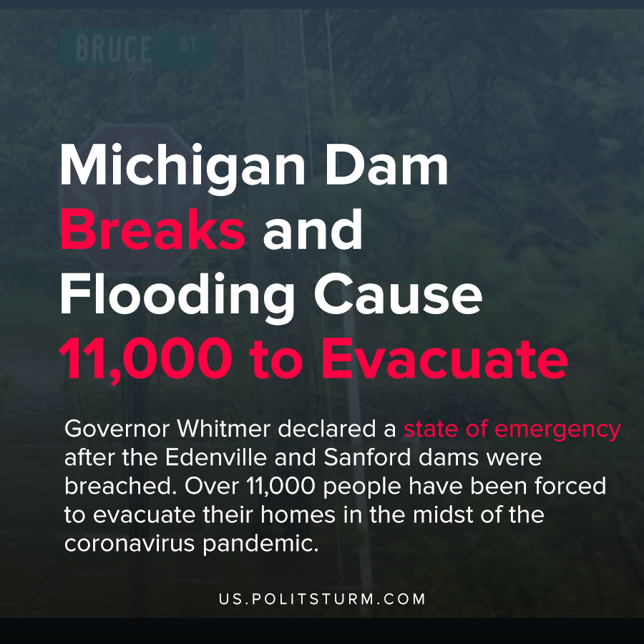

Original article
2020-05-21
1 min read

Central Michigan is experiencing severe flooding following dam failures. Governor Whitmer declared a state of emergency after the Edenville and Sanford dams were breached. Over 11,000 people have been forced to evacuate their homes in the midst of the coronavirus pandemic.
Governor Whitmer warned that the city of Midland could be under 9 feet of water at a press conference surrounding the dam failures.
One of the dams that failed was operated by Boyce Hydro Power LLC, which had its license revoked in 2018 by the Federal Energy Regulatory Commission. In its license denial, the agency cited that there was “inadequate spillway capacity” and that the company has a history of failing to comply with regulatory standards. The commission identified that the project was unlikely to pass the probable maximum flood and when flood conditions occurred the dam broke.
The capitalist economic system prioritizes the maximization of profits above all other metrics, including public safety. The dam failures in Michigan are an unfortunate demonstration of the inability of capitalist regulators to prevent the calamitous outcomes of capitalist production. Even when regulators identify problems in advance, this does not ensure that proper actions will be taken to prevent catastrophe. Compelling capitalists to make unprofitable actions is a fool’s errand.
https://twitter.com/MichStatePolice/status/1262924919836377092
https://www.ferc.gov/whats-new/comm-meet/2019/011719/H-2.pdf
https://www.michigan.gov/whitmer/0,9309,7-387-90499-529650–,00.html

Original article

