Memorial Day and the Myth of American Unity
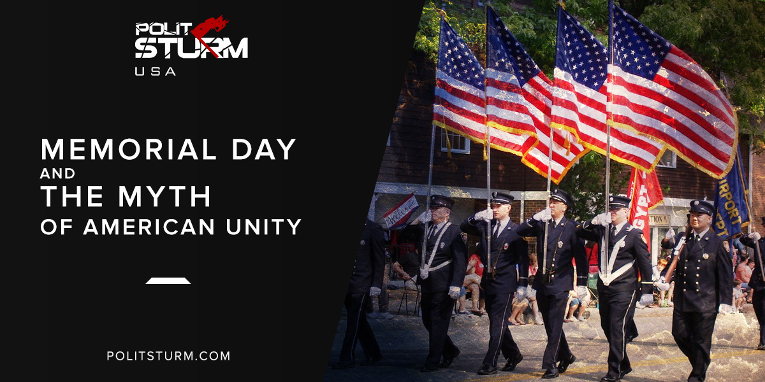

Original article
2018-05-28
5 min read

Memorial Day is something we Americans are supposed to take very seriously. Every year, countless civilians enjoying their three-day weekend are inevitably shamed by pundits, especially conservative ones, for forgetting what it’s «really about». What it’s «really about», of course, is mourning our brave men and women who made the ultimate sacrifice for our freedom or whatever. We’re supposed to believe that it’s not a time for beer and barbecue and it certainly isn’t a time for petty political differences. But what is Memorial Day really about?
Historically, Memorial Day had been a point of contention in the United States for almost half a century. The holiday began in Waterloo, New York when, on May 5th, 1866, the town’s citizens closed their businesses to allow everyone to decorate the graves of their loved ones who died during the Civil War. In 1868, a Union veterans association designated May 30th as National Decoration Day. Over 5,000 war widows came to Arlington National Cemetery on the first Decoration Day to place flowers and flags on the more than 20,000 graves and future presidents Ulysses S. Grant and James Garfield both attended the first ceremony. From the 1870s on, Decoration Day ceremonies grew larger and more extravagant, with memorials being held on major Civil War battlegrounds like Gettysburg and Antietam. By 1900, the day had become known simply as: Memorial Day.
In the South, however, this was seen as a Northern holiday for Union soldiers and an insult to the Southern dead. Most Southern states refused to adopt the holiday and, to this day, Confederate soldiers are still honored on specific decoration days in many southern states.
It was not until World War I that the whole of the US recognized Memorial Day. The holiday grew to encompass not only those who died in the Civil War and World War I but all American war dead, going as far back as the Revolutionary War. Thus, Memorial Day became yet another attempt to erase the irreconcilable contradictions between the American people and further venerate the military. What is it but a day to conflate American government’s imperial interests with our own? The children of the working class have never died for America’s freedom; they’ve only ever been pawns in the US’ imperial adventures. We, the working class, would rightfully oppose the US military if we didn’t constantly have militarist propaganda shoved down our throats.
And memorial day is not alone in this. Holidays have always been a great tool for American propagandists. Loyalty Day, a day to remember how uncritically we must support the United States and its government at all times, was celebrated on May 1st, 1921 to direct attention from International Workers Day (aka May Day) which has been held on the same day since 1886. It is no coincidence that Loyalty Day was first celebrated by staunch anti-Bolsheviks and that every president since Eisenhower has recognized and made an address on Loyalty Day. Law Day, a day to celebrate the role of law in American society, is also held on May 1st.
These were hardly the first attempts to erase working class America and our interests. Historian Howard Zinn recalls in A People’s History of the United States that, even before the United States existed, when the city of Boston conscripted eligible men to fight the British, those who couldn’t afford to pay their way out of the draft rioted, shouting: «Tyranny is tyranny let it come from whom it may». And we must not forget that, by all accounts, American revolutionary leaders were rich, landed white men who hugely distrusted the masses of the poor whites, many of whom demanded land redistribution and wrote passionately against the powerful and wealthy landowners as well as the British, and only appealed to white workers because they so obviously had nothing to offer the black slaves or indigenous peoples.
Attempts to erase the differences between the rich revolutionary leaders and the poor and landless rank and file can be seen in the Declaration of Independence when Thomas Jefferson, himself an extremely wealthy slave owner, writes: “He [King George] has excited domestic Insurrections amongst us.” Here, Jefferson completely glosses over the issues raised by the American working class, blaming them on the British. Samuel Adams would do the same later, blaming the mutiny of unpaid and debt ridden soldiers who were all but abandoned after the revolution on “British emissaries.” Capitalist ideologues accused working class movements of being orchestrated by Soviet or Chinese agents all throughout the Cold War.
Memorial Day is merely the specifically military oriented holiday that goes along with the rest of this propaganda. «Don’t focus on our differences, we’re told, unite against the rest of the world! The military is here to keep us safe from the scary foreigners.» Working people need to recognize that the US military has never been aligned with proletarian interests. Those who have died in the service of the US and it’s military did not die for their freedom but for others oppression. All talks of «fighting for our freedom» are merely an attempt to erase the fact that working people have died overseas for the same people who exploit and oppress them at home. It’s a hard truth, but true nonetheless.

Sources: 1, 2, 3, 4, 5, 6, 7

Original article

