Medicine Becomes More Expensive In Kazakhstan
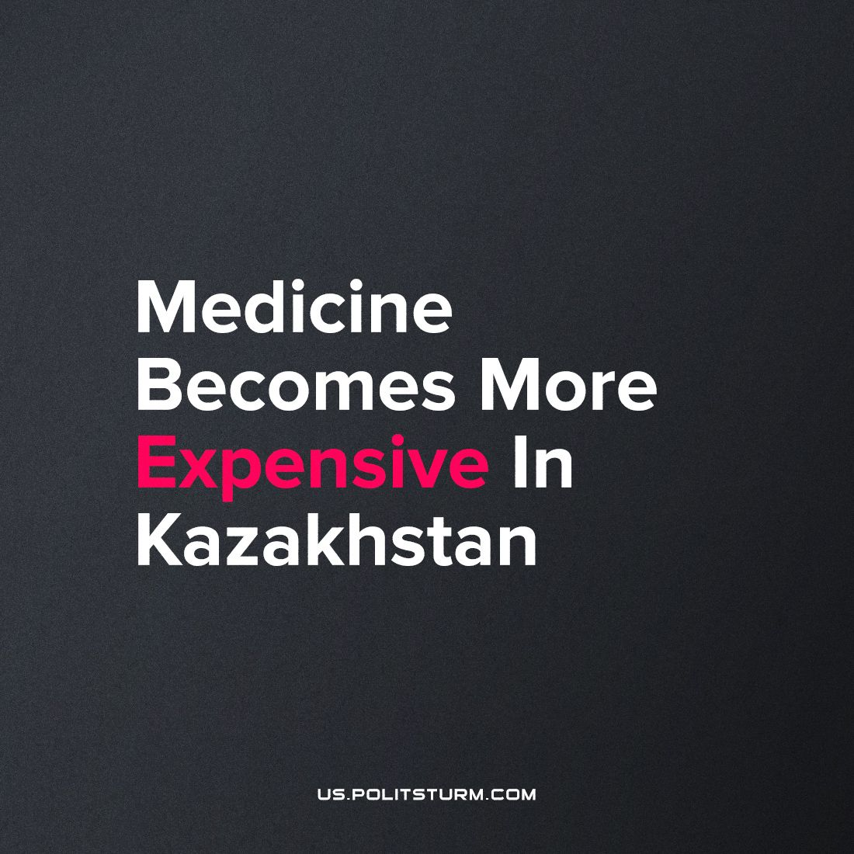

Original article
2023-10-08
1 min read

Kazakhstan has decided to raise prices for medical services. According to the Ministry of Health, this decision is due to the desire to increase staff salaries.
The state did not have any other tools. It is important to note that such “measures” are being introduced under an official pretext - an increase in prices for utilities, food, etc.
Because of such measures, the quality of life of the majority of the working population is deteriorating. Everything is getting more expensive from year to year, but the authorities either cannot or do not want to stop it.
The capitalist economy is not able to maintain a high standard of living and bring prosperity to ordinary people. Within its framework, only the owners of large businesses can increase their wealth.
Despite the criticism of the Soviet government in the CIS, practice shows that only socialism can bring prosperity and development to the whole society.
Source: KazInform - "Kazakhstan intends to increase tariffs for medical services" dated July 27, 2023.

Original article

