Western Media Portrays Trump as an “American Putin”
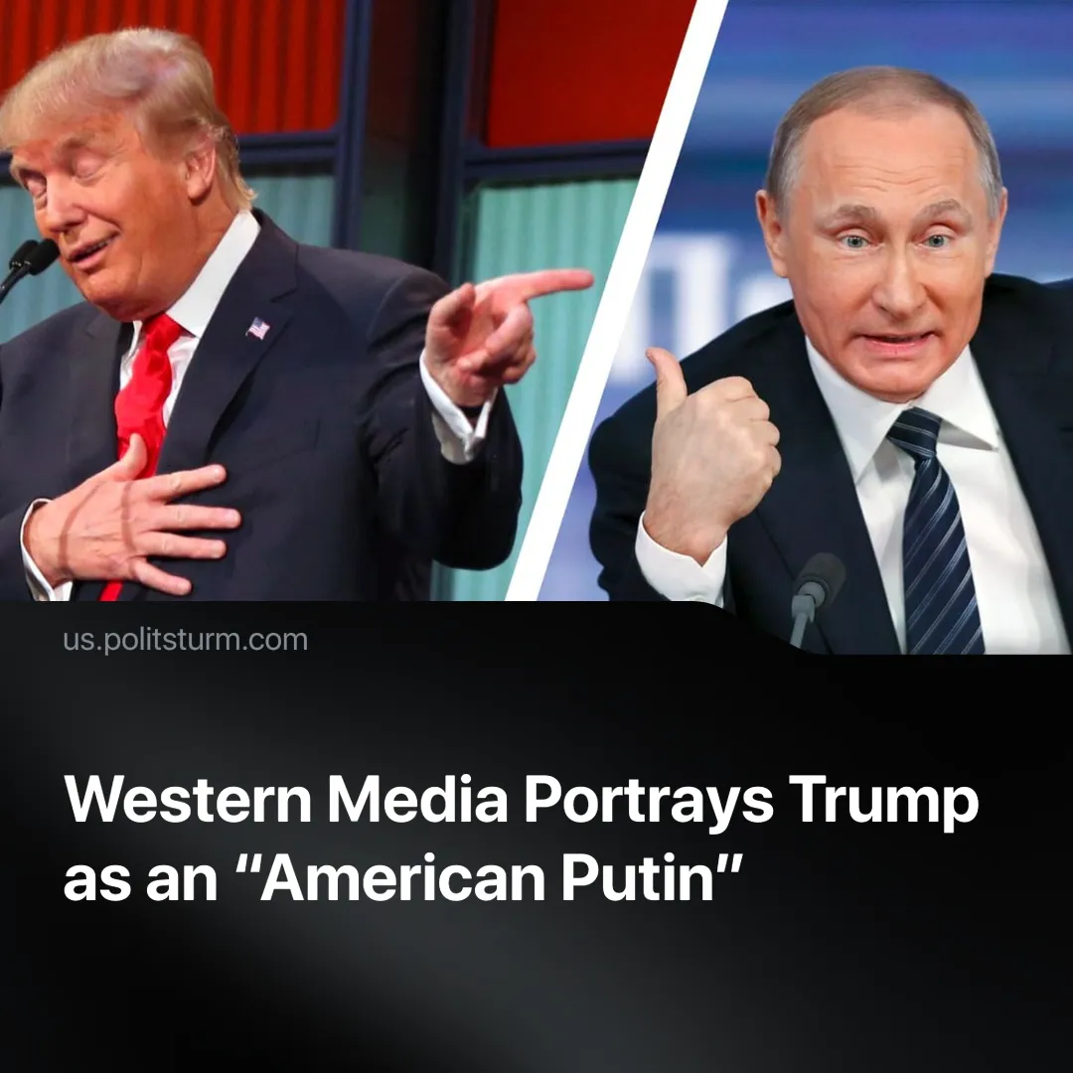

Original article
2025-03-06
2 min read

A month into Trump's second presidency, Western media outlets have begun portraying him as an "American Putin," drawing comparisons that emphasize Trump's growing “authoritarianism”, his approach to foreign policy, and his hostility toward liberal institutions.
Details. Western media has published several pieces establishing the Trump-Putin analogy.
► The New York Times, in an article titled “In Trump’s Washington, a Moscow-Like Chill Takes Hold,” claimed: “For those of us who reported there a quarter century ago, Mr. Trump’s Washington is bringing back memories of Mr. Putin’s Moscow in the early days.”
► The Atlantic, in “The Real Goal of the Trump Economy,” made multiple comparisons, stating: “He believes, like Putin, in political control of the economy’s commanding heights—success for those executives and companies who please him, failure for those who don’t. And he seems to be seeking that control more actively than he did in 2016.”
► The New Yorker, in “Trump’s Putinization of America,” expressed concern over Trump’s “pro-Putin” foreign policy, stating: “Equally alarming, in my opinion, has been Trump's adoption of Putin-like tactics domestically, a hallmark of his return to power, which has unfolded with a swiftness and intensity unmatched by his first term. This can be described as the 'Putinization of America.'”
► Western media outlets have revived a long-standing conspiracy theory that Trump was cultivated as an asset by Soviet intelligence in the 1980s. This theory has gained renewed popularity on social media, with one thread accumulating over 10 million views.
Context. Trump’s policies and rhetoric regarding Russia, Ukraine, and domestic governance have provided a basis for these comparisons:
► Trump has long signalled his willingness to work with Russia and has repeatedly expressed admiration for Putin. During his first presidency, he called Putin’s military moves “genius” and, in 2025, has continued to speak positively about cooperation with Russia.
► Trump has pressured Ukraine, most recently by freezing all military aid, and is pushing for a settlement to the conflict on terms that would benefit both Russia and the U.S.
► Trump’s second presidency has already seen a return to aggressive right-wing policies. His administration is rolling back social programs, attacking immigrants and minorities, and making significant cuts to federal government funding while eliminating 80,000 staff positions.
Important to Know. The Democratic Party and Trump’s other opponents are using this “American Putin” narrative to position themselves as the supposed alternative.
► The Democrats attempt to present themselves as defenders of “democracy” against Trump’s so-called “authoritarianism,” but this is a deliberate illusion. Their goal is to persuade the masses that the only way to counter Trump’s “senseless” domestic and foreign policies is to restore Democratic Party rule.
► They claim to oppose Trump’s policies, but history proves otherwise. Biden increased police spending, suppressed rail worker strikes, abused his presidential power to pardon his son, and oversaw rising billionaire wealth while maintaining consistent U.S. imperialist policies.
► The idea that U.S. democracy can be “fixed” by electing a Democratic president is false. Both the Republican and Democratic parties ultimately serve the interests of the capitalist class. They function as two factions of the same ruling elite, ensuring that the system remains intact regardless of electoral outcomes.
Conclusion. Western media’s portrayal of Trump as an "American Putin" personalizes the crisis and diverts attention from the fact that the entire U.S. political system is designed to serve capitalist interests. Replacing Trump with a Democrat does nothing to alter the fundamental structures of American imperialism and exploitation. The task of the working class is not to pick the "lesser of two evils" but to work to build independent power for themselves that challenges the dominance of the ruling class itself.

Original article

