Meat Company Pays Fines for Child Labor Violations
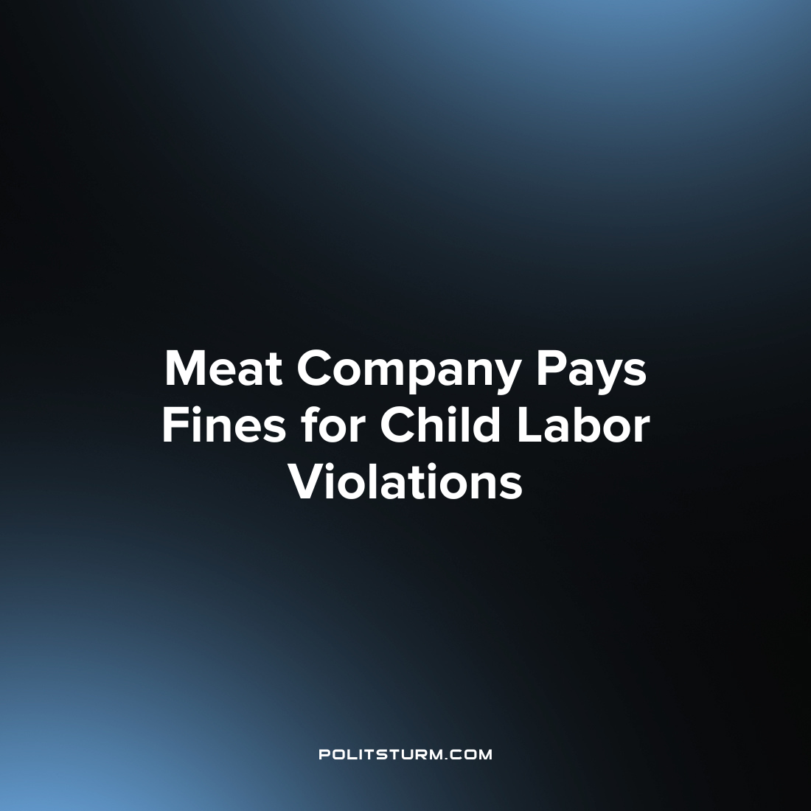

Original article
2023-07-11
1 min read

The U.S. Department of Labor has fined Monogram Food Solutions LLC, a national food manufacturer, $30,276 for violating child labor laws at its factory in Minnesota. Two minors, aged 16 and 17, were found operating hazardous meat processing equipment at the Chandler factory. The federal investigation started on March 28, 2023, and comes amidst a large wave of child labor violations across the United States. According to the Department of Labor, the number of child labor violations has increased by 69% since 2018.
As part of the consent judgment, the Labor Department invoked a provision called the "hot goods provision" to halt the shipment of any goods produced at the factory while the underage workers were employed. Monogram complied by withholding shipments and the prohibition was lifted after the company paid the fine and the consent order and judgment were executed.
Monogram alleged that the two minors used false identification to obtain employment and expressed its zero-tolerance policy for ineligible underage labor.
“This case shows we will use all of our legal resources, including invoking the ‘hot goods’ provision, as we announced as part of an increased emphasis on combating child labor, to prevent companies from profiting from illegal child labor. Regardless of age, all workers in the U.S. are protected under the Fair Labor Standards Act, and all employers must abide by all of its provisions”, said Solicitor of Labor Seema Nanda.
While the company will claim ignorance to the employment of child labor, there is undoubtedly a systematic rise in the amount of child labor violations. Capitalists will use all available methods, both legal and illegal, in order to increase their profits and exploit labor to the highest degree possible. Capitalist governance has not prevented the employment of child labor, on the contrary, we are witnessing a surge in child labor violations. As long as capitalism continues to exist, the exploitation of labor, including child labor, will be a persistent feature of society.
Source: 1

Original article

