May Day 2025
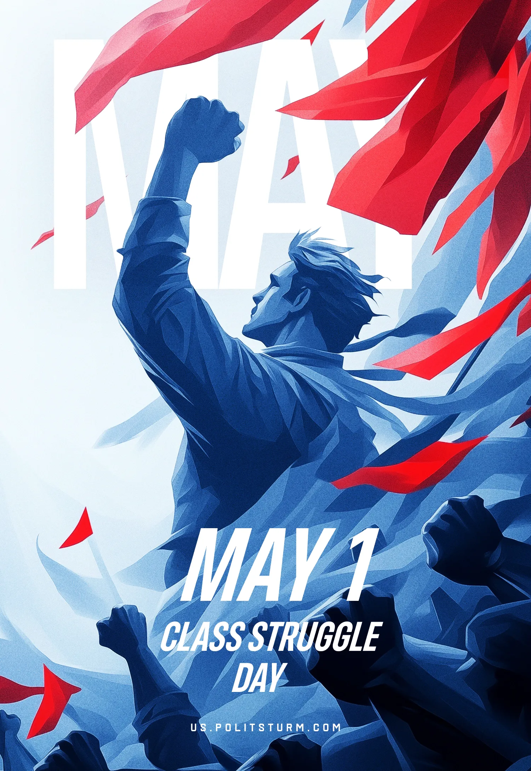

Original article
2025-05-12

As long as there is injustice – the struggle continues.

Original article

