May, 9 – Victory Day
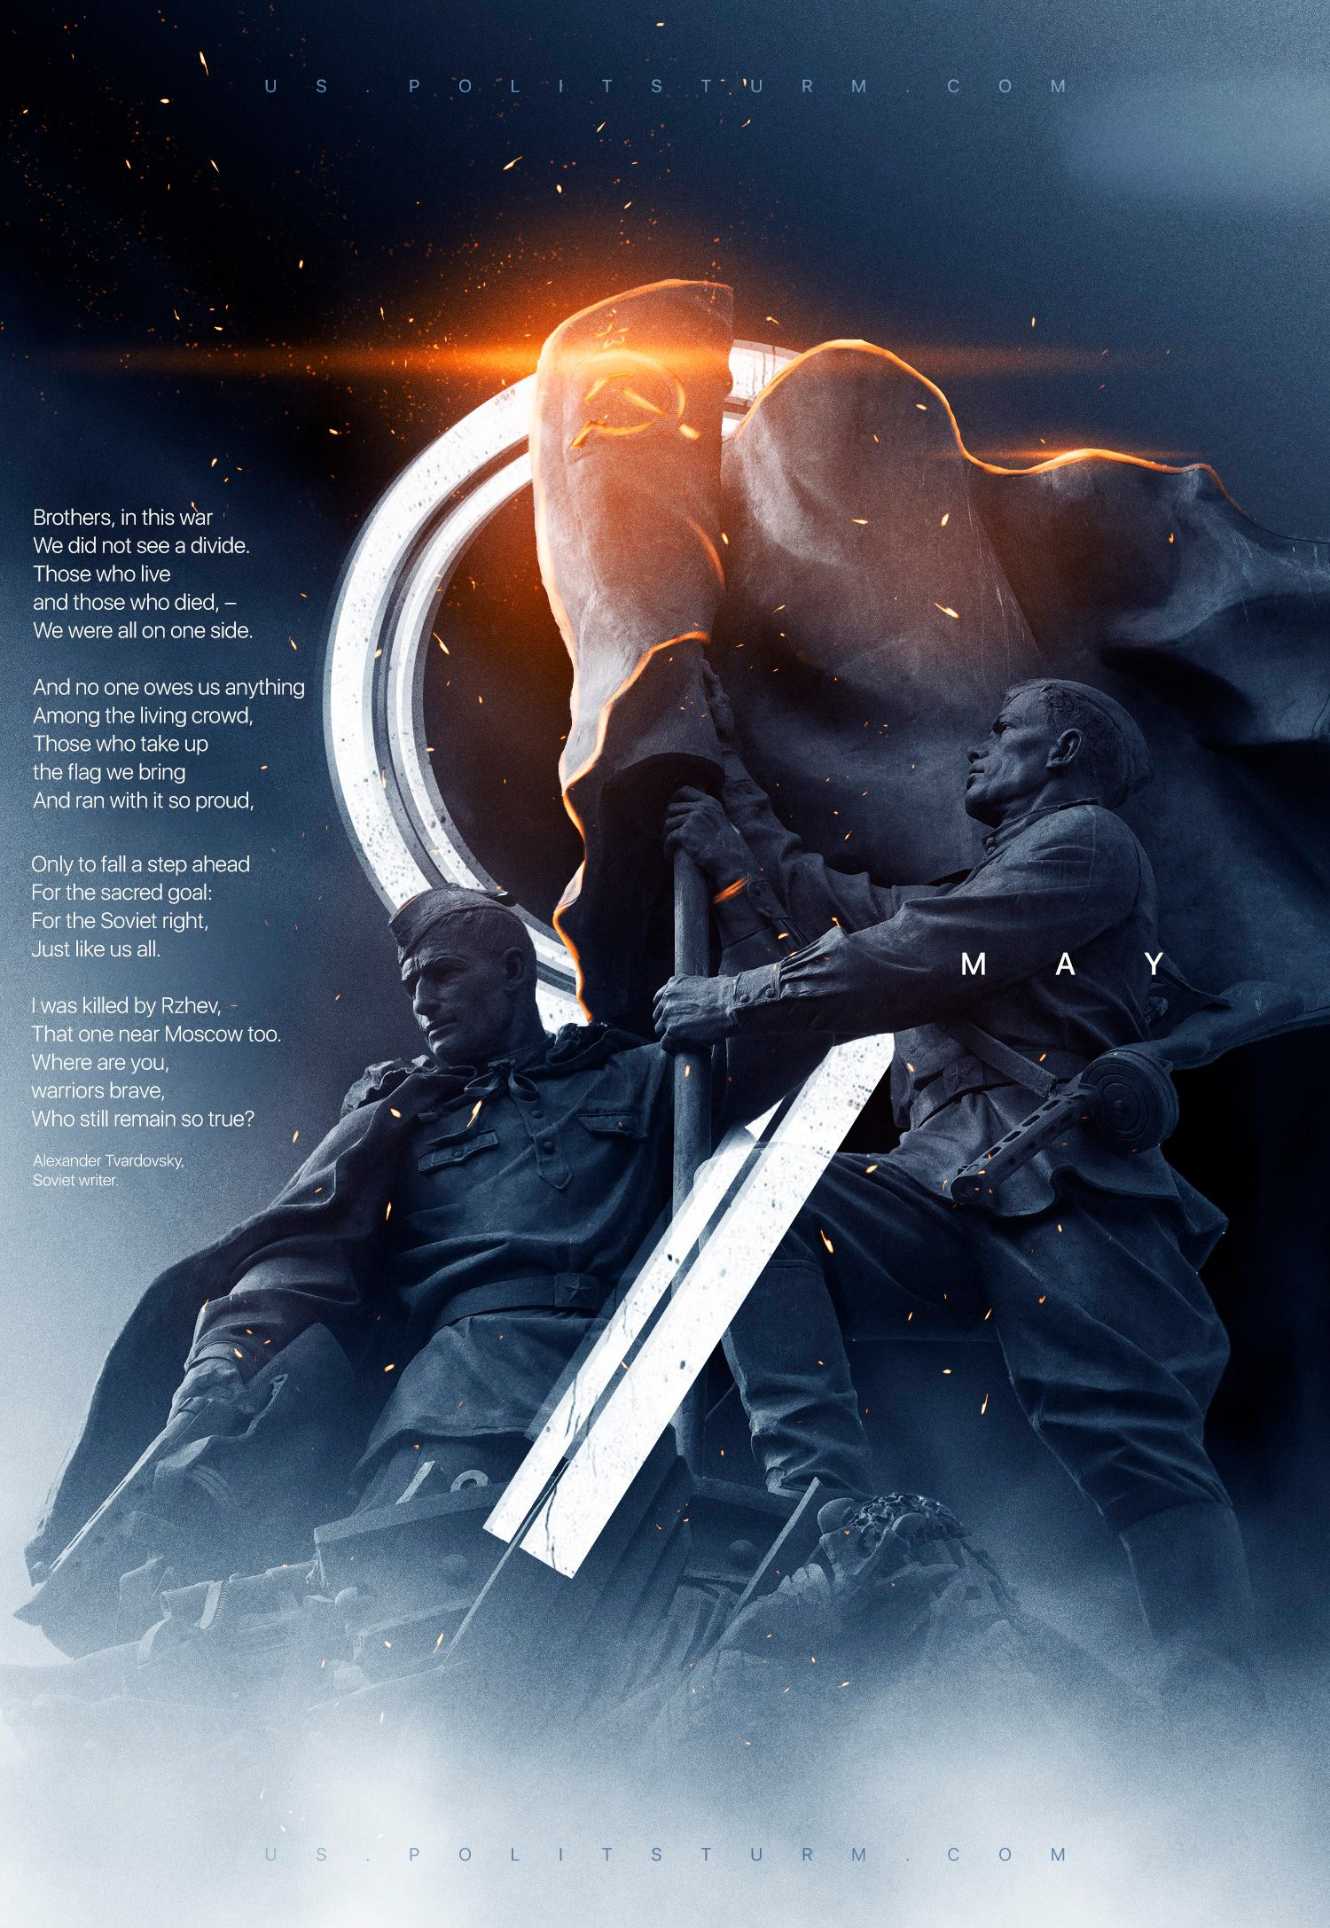

Original article
2023-05-09
5 min read

In this year the 9th of May holidays in Russia contrast sharply with the events taking place in both Russia and Ukraine – former Soviet republics. During the Great Patriotic War, Soviet people fought and died for peace on Earth and their land – the same land where hostilities are unfolding again.
The monstrous world war, unleashed then by world capital, at the same time became the only moment in history when hundreds of millions of people turned out to be united, practically monolithic in their efforts. The Soviet people won not because they were “chosen” by someone or because they had a special “spirituality”, as capitalist Russian propaganda claims. This was not a temporary “military compromise”, which is usually achieved in bourgeois states through intimidation and repression against the majority of the population. The unity of the Soviet people laid at the foundations of their state.
In contrast to the abstractions of the patriotism of modern capitalist states, the patriotism of the Soviet people was of a concrete nature. In just two decades, before the eyes of millions of people, a new country – the Union of Soviet Socialist Republics – has grown up through their own labor. In this country, measures such as the struggle against illiteracy, the formation and support of national cultures suppressed by Tsarism, the fight against unemployment and its elimination, and the improvement of the material and cultural conditions of life of all its citizens were elevated to the category of national policy.
Proletarian democracy, free education and healthcare, the fight against ignorance and the darkest prejudices were not only enshrined in the basic law of this country, but were actively implemented. For all its shortcomings, the Soviet Union — the world’s first successful attempt to build a socialist society — was, in the words of Lenin, a million times more democratic than the most democratic bourgeois republic.
Having inherited a huge territory destroyed by the First World War and the Civil War, the USSR grew into the largest and strongest state of workers and peasants in the world — a stronghold of world socialism. This path was traveled by the same people who went to fight for their country during the Great Patriotic War. The country they built with their own hands. They knew what they were going for and were ready to die for it. And they did: during the years of the war, among the tens of millions of Soviet citizens, the Communist party lost two million of its members. The Soviet people considered it an honor to fight against fascism, becoming members of the All-Union Communist Party, becoming part of the great army of communists — fighters for justice, progress and peace throughout the world.
They went to the fight not because they were “chosen”, but because they were aware of the commonality of their personal interests and the interests of their state — the working people, united as a class and defending the cause of freedom, peace and progress.
The modern Russian bourgeois government is persistently trying to raise the heroes of that war to its banners. In the Soviet patriotic agitation, the outstanding historical figures of the past ultimately served the cause of socialism. In modern Russia, the opposite process is taking place: the memory of the fighters for the country of the Soviets is being “adapted” to justify capitalist actions aimed at increasing inequality and curtailing bourgeois-democratic freedoms.
For decades, Russian media personalities have boastfully declared to their foreign opponents, referring to the Soviet victory: “We can do it again!”. And today, with a sour expression on their faces, Russian officials say: “after all, the USSR lived under sanctions for decades and achieved success, we can do it again”. This phrase sounds all the more vulgar and insulting today, since we are talking about something that the bourgeoisie in reality cannot repeat.
In order to “repeat” the achievements and victories of the past, not only a developed industrial and military potential is needed, but also a socialist state that embodied the will of the working people — the majority of society. The USSR was such a state. In contrast to the bourgeois states, in the Soviet Union, for decades, workers and peasants were introduced to art and culture, learned to work, create and manage their state. They gave their country many outstanding figures who ensured its development in all spheres of life.
The implementation of these phenomena in life is directly opposed to the interests of the capitalists, who, on the contrary, are interested in maintaining the majority of the population in a downtrodden and oppressed state. The western people should not be distracted with the Soviet symbols exploited by the current Russian government. The Russian capitalist state isn’t anti-fascist.
Indeed, those in power find the reactionary camp much more attractive. It is not surprising that the memory of the White Guards is being perpetuated, many of whom joined the Nazis; that there are attempts to popularize the fascist religious philosopher Ilyin; that media personalities speak positively even about Mussolini.
In essence, the whole policy lies in the deliberate distortion of the memory of the war, glossing over the role of the Communist Party and the Soviet state it created, turning the Great Patriotic War into a symbol of the “national unity” of modern, bourgeois Russia. The annual covering of Lenin’s mausoleum, where Nazi banners were thrown during Victory parade in 1945, is the most telling example. Putting the Soviet people against the Soviet power, depicting the Bolshevik Party as an inhuman and incompetent “totalitarian machine”; the exaggeration of the mistakes of the Red Army and the attribution of collusion with Hitler to Stalin are only a small part of the lies that the capitalists bring down on the USSR in school textbooks, through its’ media, “opinion leaders” and “cultural figures”.
Representatives of the authorities on this day like to talk about the feats of the Soviet people, but the flow of denigration and mythologizing of the Soviet past does not stop a single step. Moreover: in this difficult time, the entire Soviet history and the Great Patriotic War as part of it is distorted and used to justify the actions of the bourgeois authorities.
Against this background, it is clear that the Soviet Union and modern Russia stand on completely different grounds:
There — the expansion of social guarantees, here — their constant reduction and deception of ordinary citizens.
There — internationalism, here — the growth of chauvinism and nationalism.
There — the power of the workers, here — the power of an insignificant handful of rich people.
There — public property, here — private one.
There — socialism, here — capitalism.
And the more absurd are the attempts to shift the responsibility for the ongoing events onto the Bolsheviks and their national policy. Soviet policy was a policy of consistent internationalism, friendship of peoples, a stubborn struggle against reaction, chauvinism and nationalism — those phenomena that are raising their heads today. It was this policy that made victory over Nazism possible.
80 years ago, guided by these principles, the working people acted as creators of history and defenders of the past, present and future of humanity from fascist barbarism, which is a product of capitalism.
Behind a wave of distortions and falsifications, the real history of the struggle of the Soviet people remains little known. The governments, both in the West and in the East, are ready to pay attention and finances to various individual aspects of history, but when it comes to the key moments of this war, it cannot be hoped that they will remain objective.
It is necessary to carefully study history in order to understand what the Soviet people actually fought for and made huge sacrifices for. It is necessary to look around and compare modern life with this goal. Is this the life for which 30 million Soviet citizens died? And, of course, now more than ever it is important to understand the essence and danger of fascism — the phenomenon that started this war.
Fascism is created by capitalism.
To prevent the resurgence of fascism, it is necessary to deal with capitalism.
Without Red October, there is no Victorious May.

Original article

