May 1st – International Workers' Day 2022
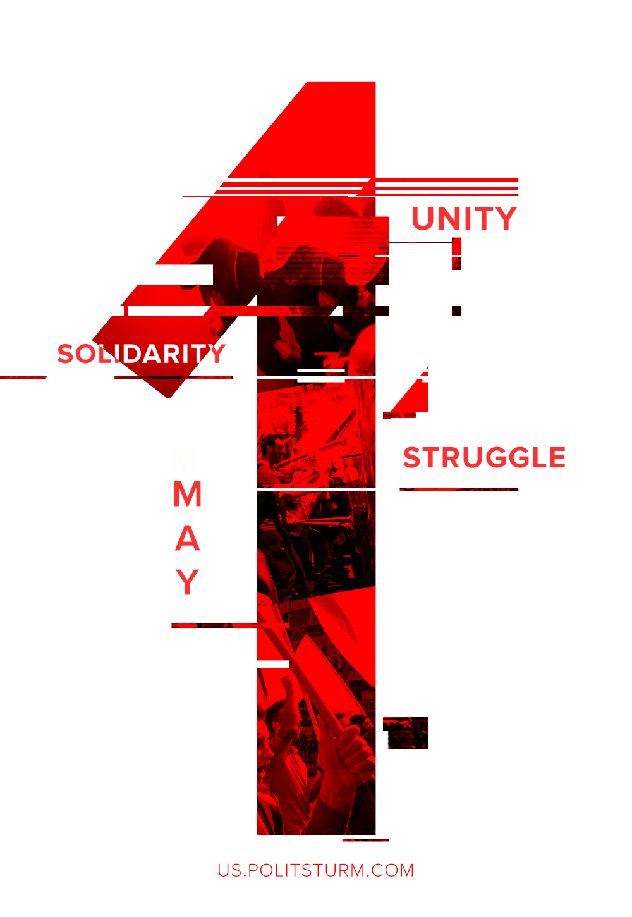

Original article
2022-05-01

Let the slogan which resounds today — “Workers of all countries, unite !” — reverberate through the world and unite the workers of all countries in the fight for socialism!
Over the heads of the capitalist robbers, over the heads of their predatory governments, we extend a hand to the workers of all countries, and cry:
Long live the First of May!
Long live the Brotherhood of Nations!
Long live the Socialist Revolution!
– Joseph Stalin, May Day, 1917.

Original article

