Maxim Gorky on the Struggle
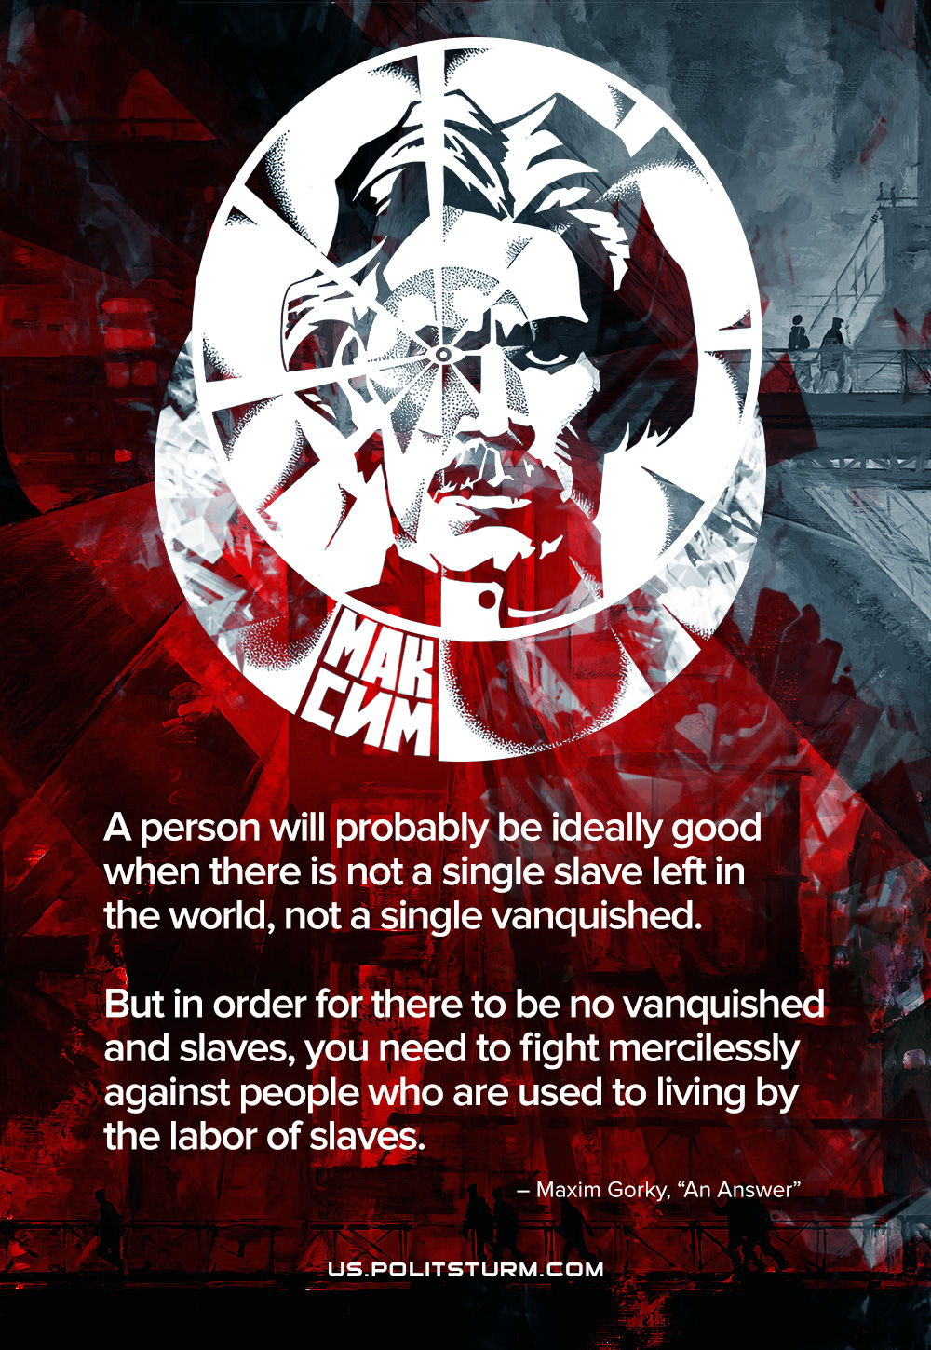

Original article
2022-03-28

A human will probably be ideally good when there is not a single slave left in the world, not a single vanquished. But in order for there to be no vanquished and slaves, you need to fight mercilessly against people who are used to living by the labor of slaves. Alexei Maximovich Peshkov, popularly known as Maxim Gorky, was a Russian writer and political activist. He was born on March 28, 1868.

Original article

