Mass Strikes in Germany: Workers and Trade Unions
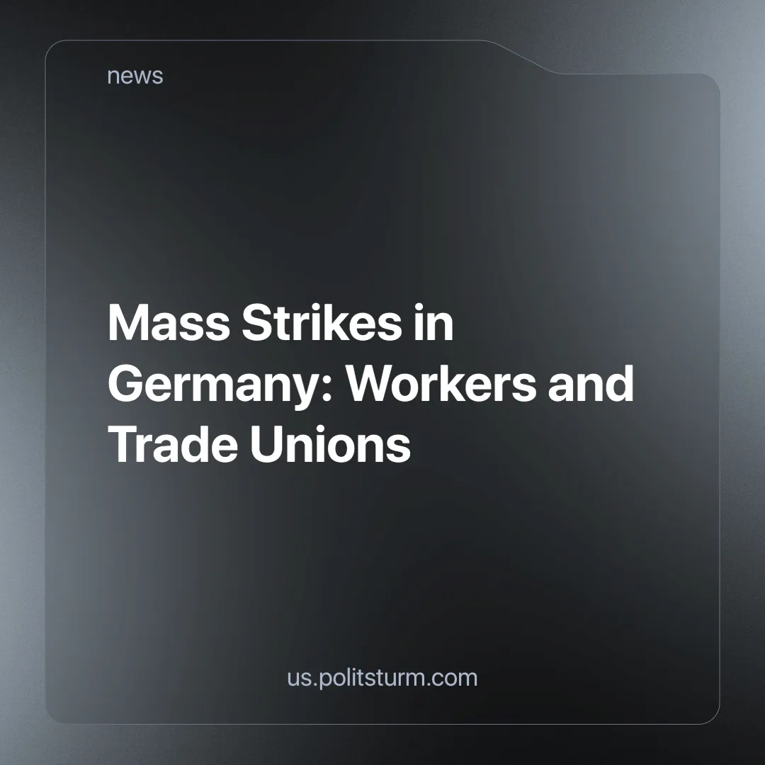

Original article
2025-05-20
6 min read

Recently, strikes erupted across Germany. In January, the service workers' union Verdi announced a series of warning strikes [1]. The reason for this was the employers' refusal to address the issue of wages.
Verdi is a large union, with approximately 2.5 million members, including doctors, teachers, daycare workers, garbage collectors, public transport employees, postal workers, and others [2].
The union's demands were [1][3]:
- An 8% wage increase (with a minimum of 350 euros),
- Higher allowances for apprentices,
- Three additional days off,
- More flexible shifts,
- A shorter workweek,
- Increased overtime pay.
The first round of negotiations failed, followed by strikes in several cities [4][5][6][7].
A new wave of strikes then began [8][9][10][11]. On March 21, negotiations failed for the sixth time.
Union members voted for an indefinite strike. Another round of negotiations was set for April 10, but three days before that, an agreement was reached [12][13][14].

Chronology of Events
Let’s review the sequence of events. In January, Verdi announced warning strikes just before the negotiations. Despite this, employers made no counteroffers. The first strikes began:
- A 24-hour strike by public transport workers (BVG) in Berlin on January 27.
- Strikes by public transport and postal workers in the Ruhr area and Rhineland on February 6 and 7.
- Strikes by hospital, transport, water supply workers, and other employees in Berlin on February 13-14.
On February 17, the second round of negotiations took place, but once again, without results. The Minister of the Interior cited a limited budget [10]. Employers did not present any counteroffers.
Strikes continued:
- Strikes on February 20-21 in Berlin and various regions: Baden-Wuerttemberg, Bremen, Hesse, Lower Saxony, North Rhine-Westphalia, Mecklenburg-Vorpommern, and Rhineland-Palatinate.
- Around 53,000 employees from 69 companies participated. Workers from healthcare, education, and other sectors were involved. The union threatened an indefinite strike.
- Strikes in Lower Saxony on February 25-26, involving public sector workers: transport, water supply, daycare centers, government agencies (service centers where individuals and businesses can access a wide range of public services), and others. About 1,000 people gathered in Hannover’s central square.
- Strikes at airports in Berlin, Frankfurt, Cologne, Munich, Hamburg, and other major cities on March 10. Around 23,000 workers went on strike. More than 3,400 flights were canceled, and over 510,000 passengers missed their flights. Compensation for passengers ranged from 250 to 600 euros per canceled flight [15].
- Strikes by drivers, train operators, garbage collectors, and daycare workers in Duesseldorf, Frankfurt, Hesse, Mecklenburg, Wuerttemberg, and other cities on March 11-15 [16].
- Strikes by public transport workers in Berlin on March 19-20, before new negotiations. The employer offered only minor concessions [16].
As a result, after negotiations on March 21, no agreement was reached. Multiple strikes across the country did not convince employers and the government to improve working conditions. Union members voted for an indefinite national strike [13].

Reasons for the Strikes
It’s important to understand why public sector workers are so widely fighting for their economic interests.
Since October, Verdi had been urging employers to address the issue of wages. Inflation had increased the prices of food, rent, utilities, and insurance; workers’ previous wages were no longer sufficient.
However, companies ignored the union's appeals. The local government referred to the limited budget. Employers were unwilling to make any concessions, and a peaceful solution seemed out of reach.
In the new year, the union started making demands. The threat of strikes, however, did not scare private owners or the state; they refused to compromise.
This is why workers so resolutely and collectively went on strike. They saw that dialogue alone would not bring about justice, as the government and business owners were unwilling to listen to them. Only after several failed attempts at peaceful negotiation did the union announce upcoming strikes.

Strike Tactics and Union Involvement
How did public sector workers go on strike? The strike movement was led by the Verdi union. The organization initially issued warnings, then moved to more active measures.
Verdi organized numerous short-term strikes lasting 24 to 48 hours in various cities. The most damaging strikes for business owners were those by public transport and airport workers, which paralyzed transportation networks and disrupted the functioning of many institutions, preventing employees from getting to work.
Public transportation plays a critical role, giving its workers significant leverage. For example, had a compromise on wages not been reached, most businesses across Germany would have simply ground to a halt.
Such a strike would have extended far beyond the service sector and impacted industry. Moreover, economic demands could have shifted to political ones: workers could have, for instance, demanded tax cuts or changes to labor laws.
But could Verdi have organized a full-scale national strike? Highly unlikely. With the elections approaching, a union representative stated that strikes would be carried out as carefully as possible, avoiding any harm to the voting process.
The elections, he said, needed to take place with maximum voter turnout, as this was the "foundation of democracy" [1]. A large-scale strike was never on the table — the union would have backed down, prioritizing smooth parliamentary elections over the workers’ movement.
Furthermore, much like Starbucks Workers United (SBWU), which we previously discussed [18], Verdi places the collective bargaining agreement (CBA) above all else. This document is an important step in securing workers' rights, but it cannot be the final goal of the struggle.
When workers fight for a collective bargaining agreement, they are formalizing their demands. In other words, the CBA is a formal expression of real struggle. Without a strong collective and decisive action, it is worth nothing.
However, neither Verdi nor SBWU seems to understand this. For them, the agreement marks the end of the fight, and they have no intention of pushing beyond it. Their strategy is to secure the agreement at any cost and then cease any further action — a betrayal that ultimately benefits employers.
Let’s also remember that SBWU actually calls Starbucks its "partner," which sheds light on their true role. While Verdi does not grovel before business and the state as SBWU does, it still bows to parliamentary elections, even when doing so harms the workers' movement.
Verdi and SBWU are two sides of the same coin. They may differ in form, but their role is identical: to act as a safety valve, releasing pressure when it becomes too high.
Workers are unhappy with the skyrocketing cost of living. Unions like Verdi make demands, conduct a few strikes (but never nationwide), and then businesses or the government make minor concessions. The union then quiets the workers' movement.
Beyond the new collective bargaining agreement, which offers only slight wage increases while banning further strikes, such unions do not achieve much.

Results of the Strikes
What were the results of Verdi's strikes?
Here's what happened:
- On March 6, postal workers were promised a 2% wage increase in April 2025 and another 2% in April 2026.
- On April 7, public transport workers were granted concessions. Starting June 1, their salaries will increase by 380 euros, with additional allowances for shift work and driving, as well as an increased Christmas bonus.
- Workers in other sectors will see a 3% wage increase in April 2025 and another 2.8% in May 2026 [17].
These improvements, however, are so minimal that they can barely be called adjustments. Considering inflation, by 2026, workers will be earning wages equivalent to those of 2024 [19].
Verdi extinguished the flames of workers' discontent, prohibited further strikes, and suggested that workers accept de facto impoverishment for the next two years. A true "people’s union," indeed. But whose interests does it actually represent? The people who work shifts to keep cities running, or the politicians sitting in parliament, who talk about "limited budgets" when it comes to wages?

Conclusion
After numerous strikes by public sector workers, employers and the government made small economic concessions. The union managed to calm public discontent by agreeing to new collective bargaining agreements. However, the wage increases will only partially offset inflation, and over the next two years, workers will continue to face financial hardship.
Unions like Verdi and SBWU, as we can see, are harming the workers' movement, bowing before business and the "democratic" state. It’s no surprise that such organizations are incapable of advancing the workers’ movement beyond collective bargaining agreements.
They are incapable of making serious economic demands, let alone political ones. Their role is to protect the interests of their “partners” and calm the masses.
It is becoming clear that transport workers are one of the most crucial forces in large-scale strikes. They are like a “bottleneck” in production, able to paralyze logistics, infrastructure, and traffic in cities and between them.
Finally, we return to the idea that only workers’ own unions can truly represent their interests — organizations that are not imposed from above. An effective union emerges when workers recognize their own interests and understand the theory of union struggle. There cannot be a union where management is handed over to “efficient managers” from outside.

Sources
- mknews.de: “German Trade Unions Threaten to Halt Transport and Healthcare,” January 21, 2025
- Vereinte Dienstleistungsgewerkschaft, “About Us”
- AUSNEWS: “Are New Strikes Expected in Germany?” February 17, 2025
- belta.by: “24-Hour Public Transport Strike Begins in Berlin,” January 27, 2025
- TASS.ru: “Trade Union Announces One-Day Strike of German Postal Workers,” January 28, 2025
- AUSNEWS: “Strikes in Germany in February 2025,” February 6, 2025
- AUSNEWS: “Berlin Transport Strike in February 2025,” February 7, 2025
- AK&M: “Major Strikes Hit Germany’s Public Sector,” February 14, 2025
- AUSNEWS: “Strikes in Berlin in February 2025,” February 11, 2025
- AUSNEWS: “Are New Strikes Expected in Germany?” February 17, 2025
- rg.ru: “Life in German Cities Paralyzed by Service Sector Strike” February 19, 2025
- Profcenter, post dated March 25, 2025
- OstWest Berlin: “Verdi Union Members Vote for Indefinite Strike at BVG — What It Means,” April 4, 2025
- Aussiedlerbote: “BVG and Verdi Reach Agreement: No Transport Strike,” April 7, 2025
- Forbes: “Strikes Begin at 13 German Airports: 3,400 Flights at Risk,” March 10, 2025
- Aussiedlerbote: “BVG Strike on March 19–20: What You Need to Know,” March 14, 2025
- AUSNEWS: “Changes to Wages in Germany Starting April 2025,” April 6, 2025
- Profcenter: “Failed Starbucks Union Strikes,” March 5, 2025
- rossaprimavera.ru: “Inflation in Germany Reached 2.2% in 2024,” January 6, 2025

Original article

